QUESTION PAPER
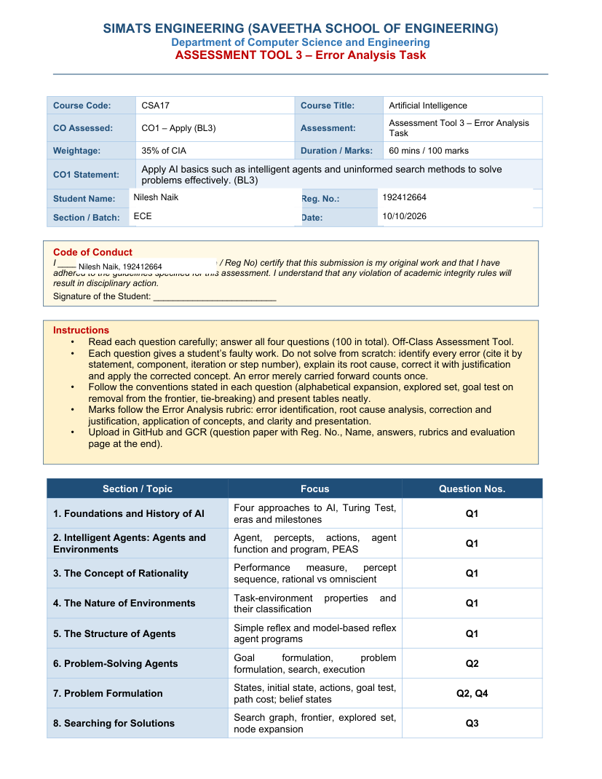



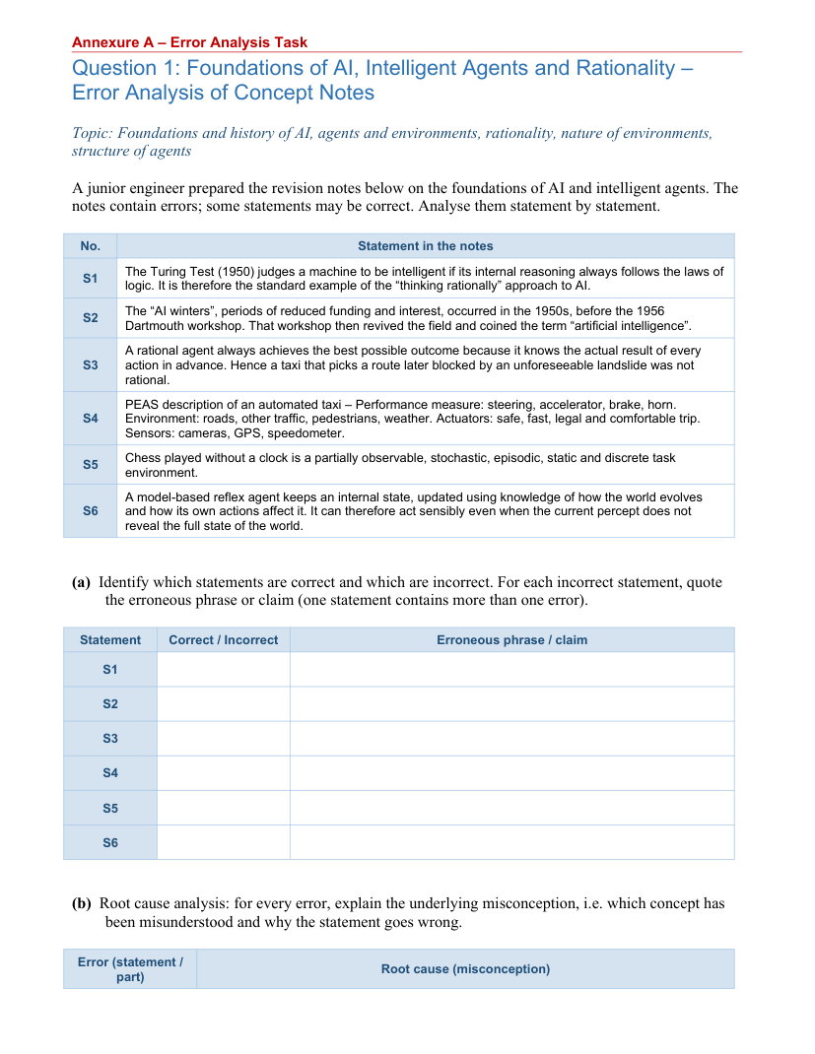

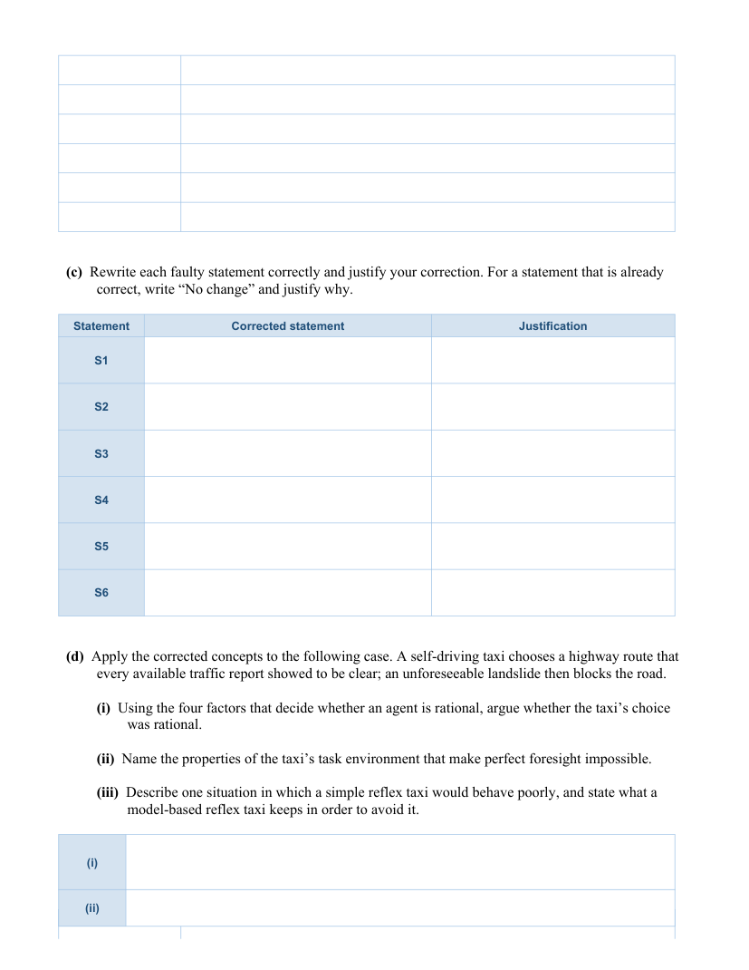



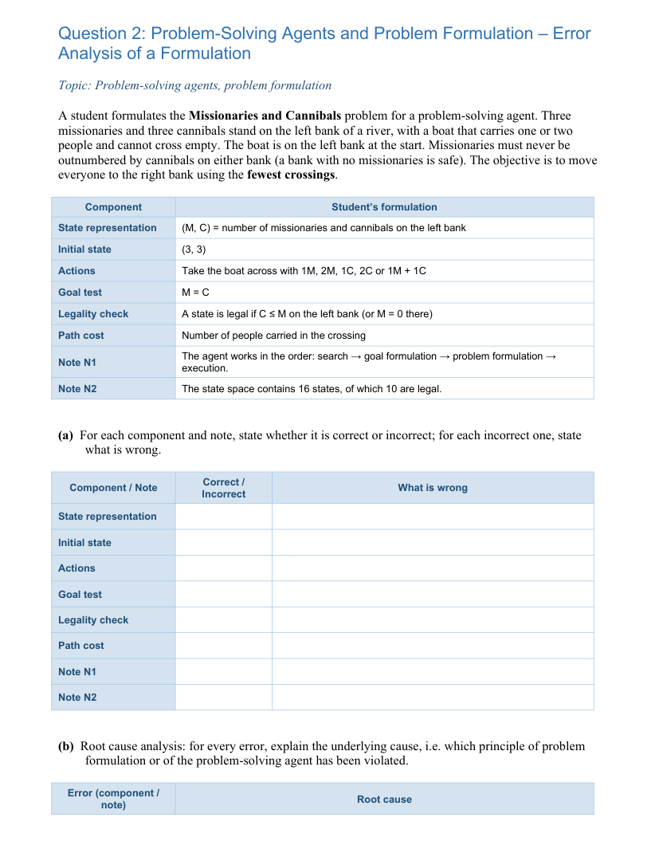

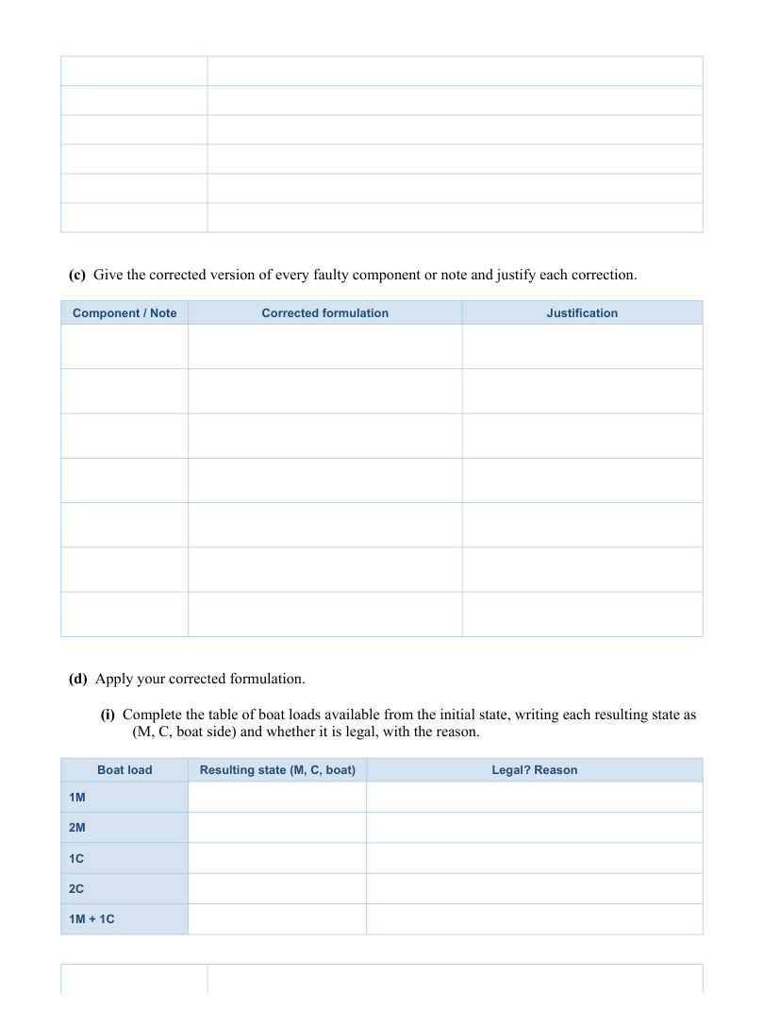



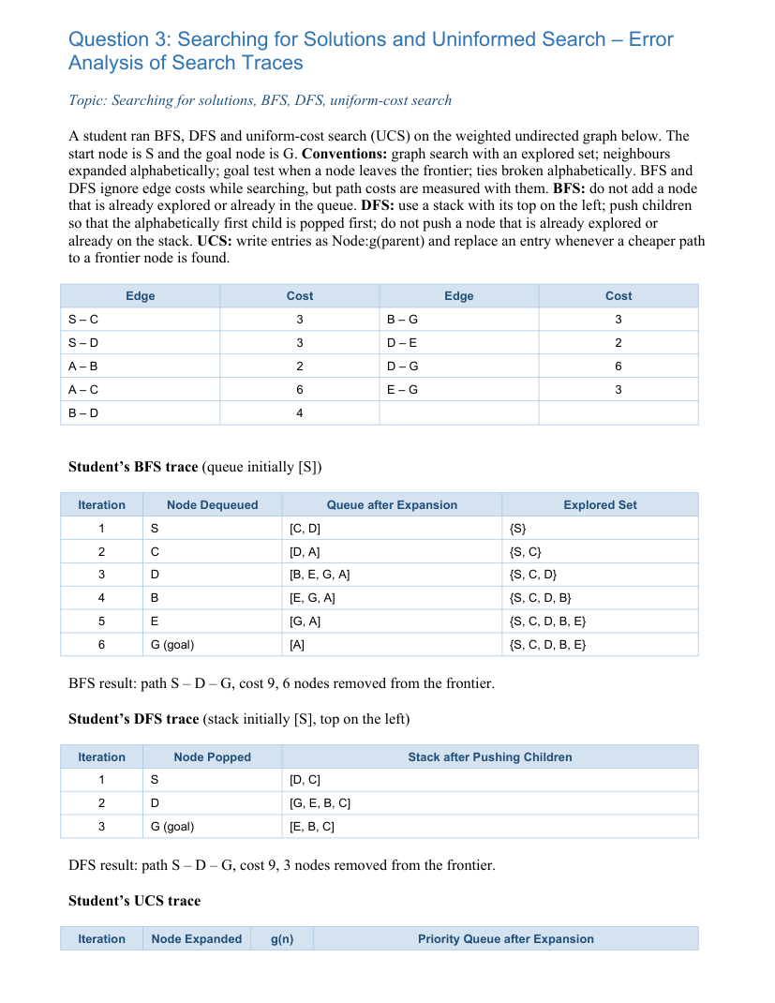

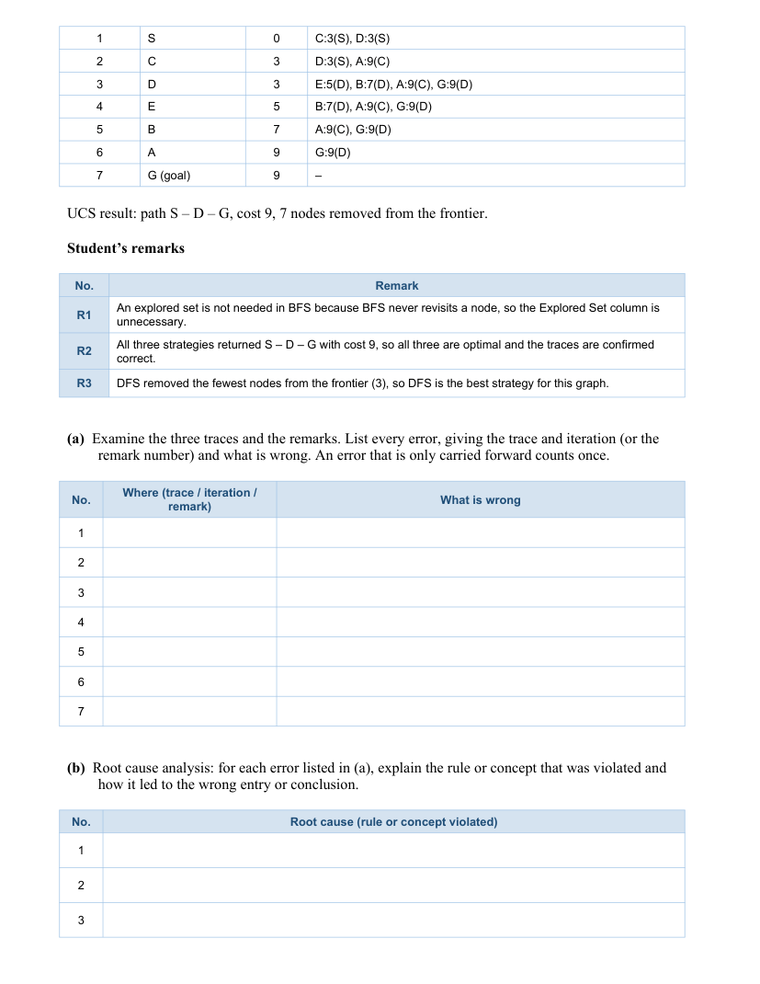

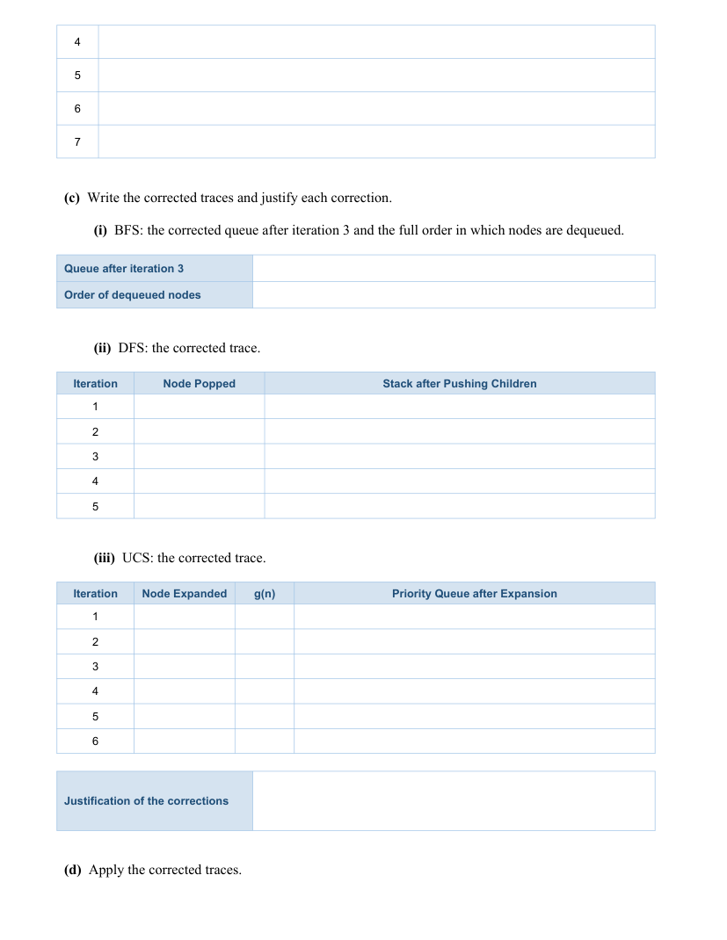

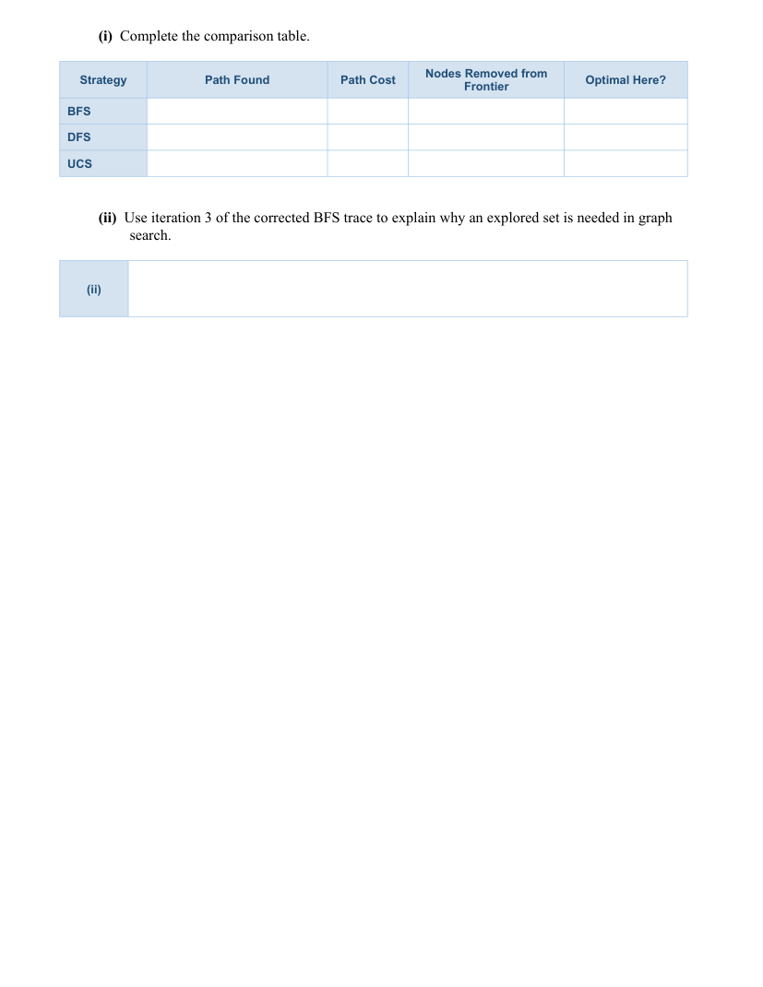

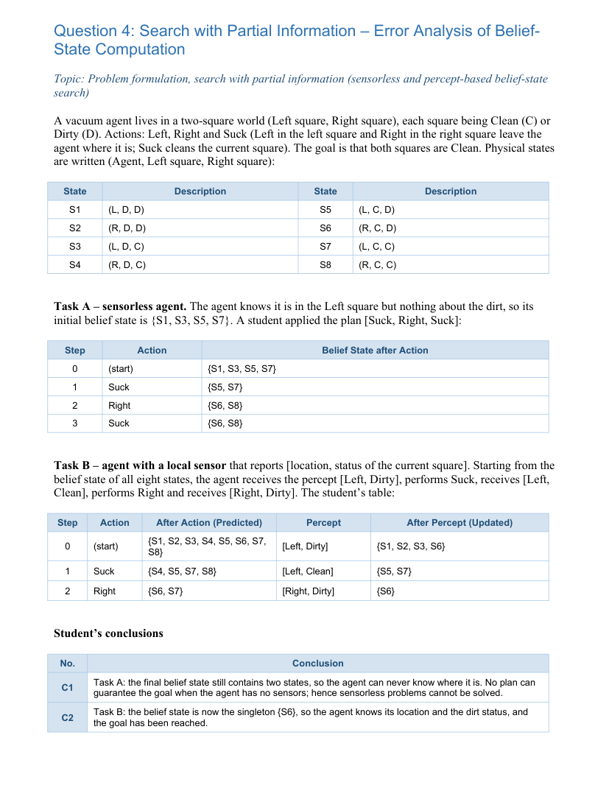

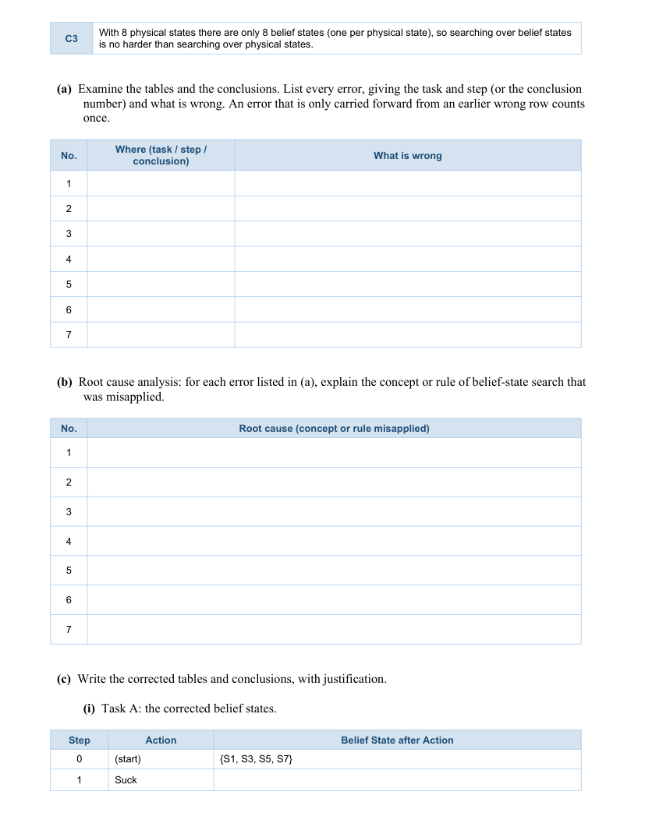

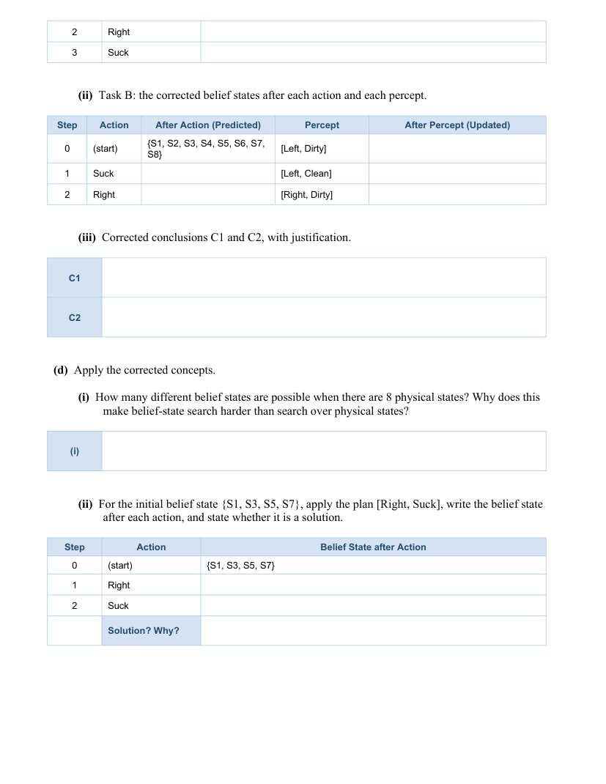

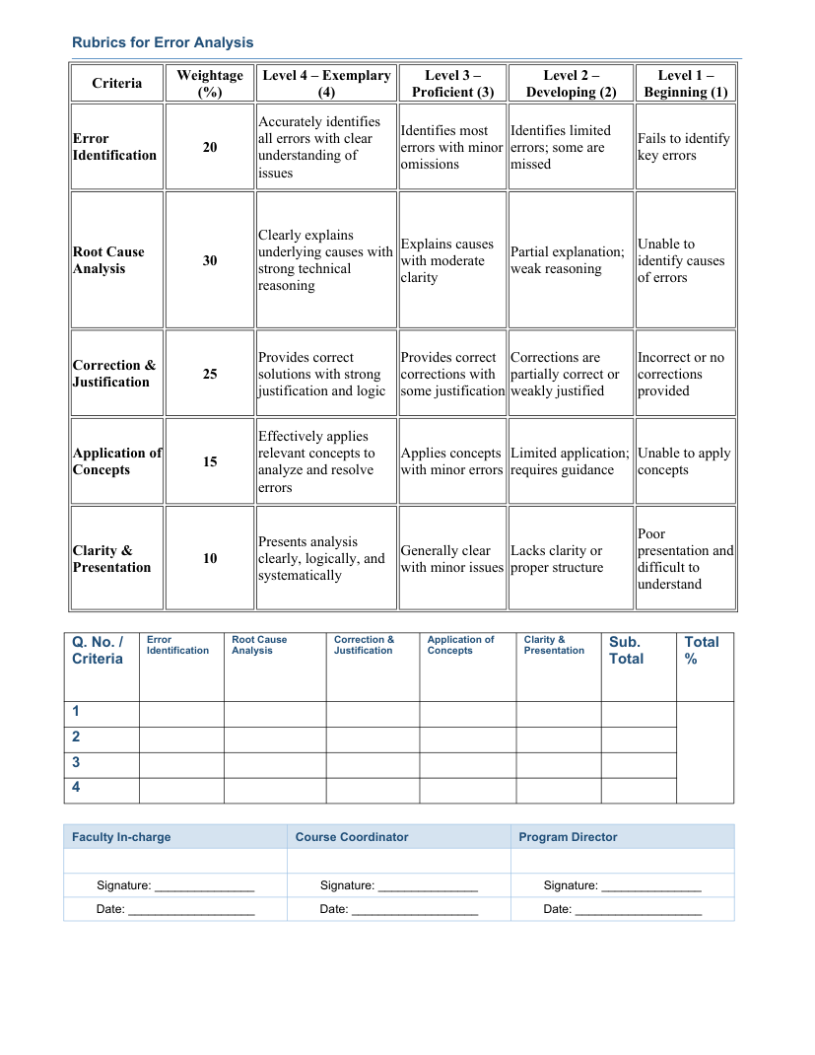

ANSWER SHEET – ASSIGNMENT 3
SIMATS ENGINEERING | CSA17 – ARTIFICIAL INTELLIGENCE | ASSESSMENT TOOL 3
Student Name | Nilesh Naik | Reg. No. | 192412664
Section / Batch | ECE | Date | 10/10/2026
QUESTION 1: FOUNDATIONS OF AI, INTELLIGENT AGENTS AND RATIONALITY
(a) Correct / incorrect statements
Statement | Status | Erroneous phrase / claim
S1 | Incorrect | The Turing Test does not test whether internal reasoning always follows logic; it is associated with acting humanly, not thinking rationally.
S2 | Incorrect | AI winters did not occur in the 1950s before Dartmouth. The Dartmouth workshop (1956) is associated with the introduction of the term AI; AI winters came later.
S3 | Incorrect | A rational agent does not know every outcome in advance and is not judged by unforeseeable outcomes alone.
S4 | Incorrect | PEAS categories are mixed up: steering/accelerator/brake/horn are actuators, while safe/fast/legal/comfortable trip are performance measures.
S5 | Incorrect | Chess without a clock is fully observable, deterministic, sequential, static and discrete—not partially observable, stochastic or episodic.
S6 | Correct | No change: this correctly describes a model-based reflex agent.
(b) Root-cause analysis
Error | Root cause
S1 | Confuses acting humanly (Turing Test) with thinking rationally (logical reasoning).
S2 | Confuses the birth of AI with later funding/interest declines; AI winters occurred after the field had developed.
S3 | Confuses rationality with omniscience; rational decisions use available percepts, knowledge and expected outcomes.
S4 | Does not distinguish PEAS categories: measures evaluate success, actuators perform actions, sensors gather information.
S5 | Misclassifies the environment: chess state and legal moves are visible, rules are deterministic, decisions depend on earlier moves, and no-clock board state does not change while waiting.
(c) Corrected statements and justification
Statement | Corrected statement | Justification
S1 | The Turing Test (1950) evaluates whether a machine's behaviour is indistinguishable from a human's in the test; it is an example of acting humanly. | It evaluates observable behaviour, not the internal use of formal logic.
S2 | The Dartmouth workshop took place in 1956 and is associated with coining the term artificial intelligence. AI winters were later periods of reduced funding and interest. | The chronology in the notes is incorrect.
S3 | A rational agent selects the action expected to maximize its performance measure based on its percept sequence and available knowledge. An unforeseeable landslide does not by itself make the route choice irrational. | Rationality is judged using information available at decision time, not perfect foresight.
S4 | Performance: safe, fast, legal, comfortable trip. Environment: roads, traffic, pedestrians, weather. Actuators: steering, accelerator, brake, horn. Sensors: cameras, GPS, speedometer. | This assigns each taxi feature to the proper PEAS category.
S5 | Chess without a clock is fully observable, deterministic, sequential, static and discrete. | The board is observable; rules determine outcomes; moves affect later states; and states/actions are discrete.
S6 | No change. A model-based reflex agent maintains an internal state using a model of how the world evolves and how actions affect it. | The statement correctly explains why internal state helps when a percept is incomplete.
(d) Apply the corrected concepts
(i) The taxi’s route choice was rational if it used the available traffic reports and selected the route expected to maximize safety, legality, time and comfort. The unforeseeable landslide is not evidence that the earlier decision was irrational.
(ii) Perfect foresight is impossible because the environment is partially observable, stochastic/uncertain and dynamic: reports cannot reveal every future event, and road conditions may change.
(iii) A simple reflex taxi may continue straight because the immediate percept shows a clear road, even though a previous warning indicated a lane closure. A model-based reflex taxi keeps an internal state/model of prior percepts, road conditions and the effects of its actions.
QUESTION 2: PROBLEM-SOLVING AGENTS AND PROBLEM FORMULATION
(a) Check each component and note
Component / note | Status | What is wrong
State representation | Incorrect / incomplete | (M,C) alone omits the boat side, which is necessary to determine legal actions and transitions.
Initial state | Incorrect / incomplete | Must include boat side: (3,3,L).
Actions | Incorrect / incomplete | The action list is missing the boat-side transition and should be defined as legal passenger loads of 1 or 2 people, including combinations that fit the boat.
Goal test | Incorrect | M=C does not mean everyone reached the right bank. Goal is M=0 and C=0 on the left, with boat on the right.
Legality check | Incorrect | Must check both banks: on each bank, missionaries must be zero or at least as numerous as cannibals.
Path cost | Incorrect | Minimize number of crossings, not number of people carried.
N1 | Incorrect | Correct order is goal formulation → problem formulation → search → execution.
N2 | Incorrect | With boat side included there are 4×4×2=32 raw states; the count of 16 omits boat location. Legal-state count must be based on both-bank safety.
(b) Root-cause analysis
Error | Root cause
State / initial state | State representation must contain every variable needed to predict transitions; boat location changes which crossings are possible.
Actions | Actions must specify passenger load and direction from the boat's current bank, while respecting capacity and availability.
Goal test | A goal test must express the requested final configuration, not an unrelated equality.
Legality check | Safety constraints apply independently to both banks, not only the left bank.
Path cost | The task says fewest crossings, so each crossing should have unit cost.
N1 | A problem-solving agent must establish a goal and formulate the problem before searching and executing.
N2 | Counting states without the boat-side variable undercounts the representation's raw state space.
(c) Corrected formulation
Component / note | Corrected formulation | Justification
State | (M,C,B), with M,C in {0,1,2,3} and B∈{L,R}. | Includes the boat side.
Initial state | (3,3,L). | Everyone begins on the left bank.
Actions | Cross with 1M, 2M, 1C, 2C or 1M+1C, moving from the bank where the boat is located. | These are all passenger loads of one or two people.
Goal test | (0,0,R). | All missionaries and cannibals are on the right bank.
Legality | On each bank: M=0 or M≥C; also counts must remain between 0 and 3. | Enforces safety on both banks.
Path cost | 1 per crossing; minimize total crossings. | Matches “fewest crossings.”
N1 | Goal formulation → problem formulation → search → execution. | Correct problem-solving sequence.
N2 | 32 raw states (4 choices for M × 4 for C × 2 boat positions); legality filters out unsafe states. | Boat location doubles the raw state representation.
(d) Apply corrected formulation
(i) Loads available from the initial state (3,3,L)
Load | Resulting state (M,C,boat) | Legal? Reason
1M | (2,3,R) | No. Left bank has 2M,3C; missionaries are outnumbered.
2M | (1,3,R) | No. Left bank has 1M,3C; unsafe.
1C | (3,2,R) | Yes. Left bank has 3M,2C; right bank has 0M,1C, which is safe because M=0.
2C | (3,1,R) | Yes. Left bank has 3M,1C; right bank has 0M,2C, safe because M=0.
1M+1C | (2,2,R) | Yes. Left bank has 2M,2C; right bank has 1M,1C.
(ii) Example accepted by the student's incorrect check but actually illegal: (M,C)=(1,2) on the left. The student’s rule C≤M rejects this example, so a better counterexample is (M,C)=(2,2) on the left with the right bank also containing 1M,0C? This is legal. The core flaw is that the student checks only the left bank; for example, left (3,1), right (0,2) passes the left-bank check but is actually legal as well. An actually illegal state accepted by the left-only rule is left (2,1), right (1,2): left passes, but on the right 1M is outnumbered by 2C.
(iii) The optimal classic 3-missionaries/3-cannibals solution takes 11 crossings. With unit cost per crossing, optimal path cost = 11.
QUESTION 3: SEARCHING FOR SOLUTIONS AND UNINFORMED SEARCH
Graph edges: S–C=3, S–D=3, A–B=2, A–C=6, B–D=4, B–G=3, D–E=2, D–G=6, E–G=3. Neighbours are expanded alphabetically; goal test is on removal from the frontier.
(a) Errors in traces and remarks
Where | What is wrong
BFS iteration 2 | Expanding C should add A after D if not explored/in queue; queue should become [D,A] (this row itself is consistent).
BFS iteration 3 | When expanding D, B, E and G are candidates; A is already in the queue, so the shown [B,E,G,A] is ordered incorrectly: existing A must remain before newly appended nodes, giving [A,B,E,G].
BFS iterations 4–6 / result | The later queue and explored entries carry forward the incorrect order from iteration 3; BFS reaches G via S–D–G only if goal ordering makes it leave first, but the corrected queue order gives the shallower goal path through D as G is enqueued by D. Check trace below.
DFS iteration 1 | Alphabetically first child must be popped first. With top on the left, children of S should be pushed as [C,D], not [D,C].
DFS iterations 2–3 / result | The incorrect child ordering causes D and then G to be popped; corrected DFS visits C first and follows C→A→B→G.
UCS iterations 3–7 / result | When D is expanded, B is already in the frontier at cost 7 via D; the shown B:7(D) is valid, but the UCS trace fails to replace G:9(D) when the cheaper route through E yields G at cost 8. The goal path is not S–D–G cost 9.
R1 | Explored sets are needed in graph search to avoid repeated expansion/cycles.
R2 | Same returned path does not prove all traces correct or all strategies optimal; BFS/DFS do not generally optimize weighted path cost.
R3 | Fewest frontier removals does not make DFS best generally; completeness and optimality matter.
(b) Root cause analysis
Error | Root cause
BFS queue ordering | BFS uses FIFO order: existing frontier entries remain ahead of newly generated successors.
DFS ordering | Stack top is left and the alphabetically first child must be popped first; push order must be reversed appropriately.
UCS cost update | UCS orders by cumulative path cost and replaces frontier entries if a cheaper path is found.
R1 | Graph search needs explored tracking because undirected edges and cycles can revisit states.
R2 | BFS minimizes number of edges, DFS is order-dependent, and UCS minimizes total cost for nonnegative edges.
R3 | Efficiency on one graph does not establish general superiority; DFS may be incomplete in infinite spaces and is not optimal.
(c) Corrected traces
(i) BFS
Correct queue after iteration 3: [A, B, E, G]. Dequeue order: S, C, D, A, B, E, G (goal).
(ii) DFS
Iteration | Node popped | Stack after pushing children (top left)
1 | S | [C,D]
2 | C | [A,D]
3 | A | [B,D]
4 | B | [G,D]
5 | G (goal) | [D]
(iii) UCS
Iteration | Expanded | g(n) | Priority queue after expansion
1 | S | 0 | [C:3(S), D:3(S)]
2 | C | 3 | [D:3(S), A:9(C)]
3 | D | 3 | [E:5(D), B:7(D), A:9(C), G:9(D)]
4 | E | 5 | [B:7(D), G:8(E), A:9(C)]
5 | B | 7 | [G:8(E), A:9(C)]
6 | G (goal) | 8 | [A:9(C)]
Justification: BFS preserves FIFO ordering. DFS pops the alphabetically first child first. UCS replaces the more expensive G:9(D) entry with G:8(E), because S→D→E→G costs 3+2+3=8.
(d) Apply corrected traces
Strategy | Path found | Path cost | Nodes removed | Optimal here?
BFS | S→D→G | 9 | 7 | No; minimizes edge count, not weighted cost.
DFS | S→C→A→B→G | 14 | 5 | No; depends on ordering.
UCS | S→D→E→G | 8 | 6 | Yes; nonnegative edge costs.
An explored set is necessary: when D is expanded in BFS, it can generate S again through the undirected edge D–S. Since S is already explored, it must not be re-enqueued; otherwise cycles cause redundant work and can prevent termination.
QUESTION 4: SEARCH WITH PARTIAL INFORMATION – BELIEF-STATE COMPUTATION
(a) Errors in the student's tables and conclusions
Where | What is wrong
Task A step 2 | From {S5,S7}, moving Right gives {S6,S8}; this row is correct.
Task A step 3 | Suck in states {S6,S8} cleans the right square: S6=(R,C,D) becomes S8=(R,C,C), while S8 remains S8. Result should be {S8}, not {S6,S8}.
Task B step 0 update | Percept [Left, Dirty] must retain states at Left with left square Dirty: {S1,S3}, not {S1,S2,S3,S6}.
Task B step 1 prediction | After Suck from {S1,S3}, predicted states are {S5,S7}; the student's {S4,S5,S7,S8} is wrong.
Task B step 2 prediction | From {S5,S7}, Right predicts {S6,S8}; the student's {S6,S7} is wrong.
C1 | Sensorless belief state may contain multiple states and still guarantee the goal; here the corrected plan reaches {S8}.
C2 | {S6} means right location, left clean, right dirty; it is not a goal state.
C3 | With 8 physical states there are 2^8=256 belief states, not 8.
(b) Root cause analysis
Error | Root cause
Task A step 3 | Belief-state prediction applies the action to every member and unions the resulting states.
Task B step 0 | Percept update filters the belief state to states consistent with both observed location and current-square status.
Task B step 1 | Suck cleans the current square but does not change location; prediction must follow each state's transition.
Task B step 2 | Right changes location to R while preserving both dirt statuses.
C1 / C2 | A belief set is a set of possible physical states; goal satisfaction requires all possible states to meet the goal, and a singleton is not automatically a goal.
C3 | Every subset of the physical-state set is a possible belief state, giving 2^n subsets.
(c) Corrected tables and conclusions
(i) Task A: sensorless
Step | Action | Belief state after action
0 | Start | {S1,S3,S5,S7}
1 | Suck | {S5,S7}
2 | Right | {S6,S8}
3 | Suck | {S8}
(ii) Task B: prediction and update
Step | Action | Predicted after action | Percept | Updated after percept
0 | Start | {S1,S2,S3,S4,S5,S6,S7,S8} | [Left, Dirty] | {S1,S3}
1 | Suck | {S5,S7} | [Left, Clean] | {S5,S7}
2 | Right | {S6,S8} | [Right, Dirty] | {S6}
(iii) Corrected conclusions
C1: Incorrect. The sensorless plan [Suck, Right, Suck] transforms the initial belief state to {S8}; both squares are clean, so it guarantees the goal even though the agent may not know its exact state at every intermediate step.
C2: Incorrect. {S6} identifies the agent at R with left square clean and right square dirty; the goal has not been reached.
(d) Apply corrected concepts
(i) Number of belief states = 2^8 = 256, including the empty subset. This is exponentially larger than the 8 physical states, making belief-state search harder.
(ii) Plan [Right, Suck] from {S1,S3,S5,S7}
Step | Action | Belief state after action
0 | Start | {S1,S3,S5,S7}
1 | Right | {S2,S4,S6,S8}
2 | Suck | {S4,S8}
Solution? No. State S4=(R,D,C) still has the left square dirty, so not every state in the final belief set has both squares clean.
END OF ANSWER SHEET
Student signature: __________________________________________

