8-PUZZLE PROBLEM
Course Outcome: CO1
Name | Nilesh Naik
Register Number | 192412664

AIM
To solve the 8-puzzle problem by finding a sequence of valid moves from an initial board configuration to the goal configuration.
ALGORITHM
- Represent the 3 × 3 board as a tuple containing the numbers 0–8, where 0 represents the blank space.
- Define the goal state and the possible moves of the blank space (up, down, left, and right).
- Use Breadth-First Search (BFS) to explore reachable states level by level.
- Store each state's parent and the move used to reach it.
- Stop when the goal state is reached, then reconstruct and display the solution path.
CORE LOGIC
BFS explores states in increasing order of move count. Because every move has equal cost, the first goal state found gives a shortest solution. A visited set prevents repeated exploration.
PSEUDOCODE
START
Set initial state and goal state
Create a queue containing the initial state
WHILE queue is not empty:
Remove the front state
IF it is the goal: reconstruct path and display it
Generate all legal next states
Add each unvisited state to queue and record its parent
IF goal was not reached, report no solution
STOP
PROGRAM
Save the following code in a .py file and run it using Python 3.9 or later.
from collections import deque

START = (1, 2, 3,
4, 0, 6,
7, 5, 8)
GOAL = (1, 2, 3,
4, 5, 6,
7, 8, 0)

def neighbors(state):
zero = state.index(0)
row, col = divmod(zero, 3)
moves = []
for name, dr, dc in [
("Up", -1, 0), ("Down", 1, 0),
("Left", 0, -1), ("Right", 0, 1)
]:
nr, nc = row + dr, col + dc
if 0 <= nr < 3 and 0 <= nc < 3:
j = nr * 3 + nc
board = list(state)
board[zero], board[j] = board[j], board[zero]
moves.append((name, tuple(board)))
return moves

def solve(start, goal):
queue = deque([start])
parent = {start: None}
action = {}
while queue:
state = queue.popleft()
if state == goal:
path = []
while state is not None:
path.append((state, action.get(state, "Start")))
state = parent[state]
return list(reversed(path))
for move, nxt in neighbors(state):
if nxt not in parent:
parent[nxt] = state
action[nxt] = move
queue.append(nxt)
return None

solution = solve(START, GOAL)
if solution:
print("8-Puzzle solution:")
for i, (state, move) in enumerate(solution):
print(f"Step {i} ({move}):")
for r in range(0, 9, 3):
print(state[r:r+3])
print("Total moves:", len(solution) - 1)
else:
print("No solution found.")

OUTPUT
The 8-puzzle was solved using BFS, and the shortest sequence of moves to reach the goal state was displayed.
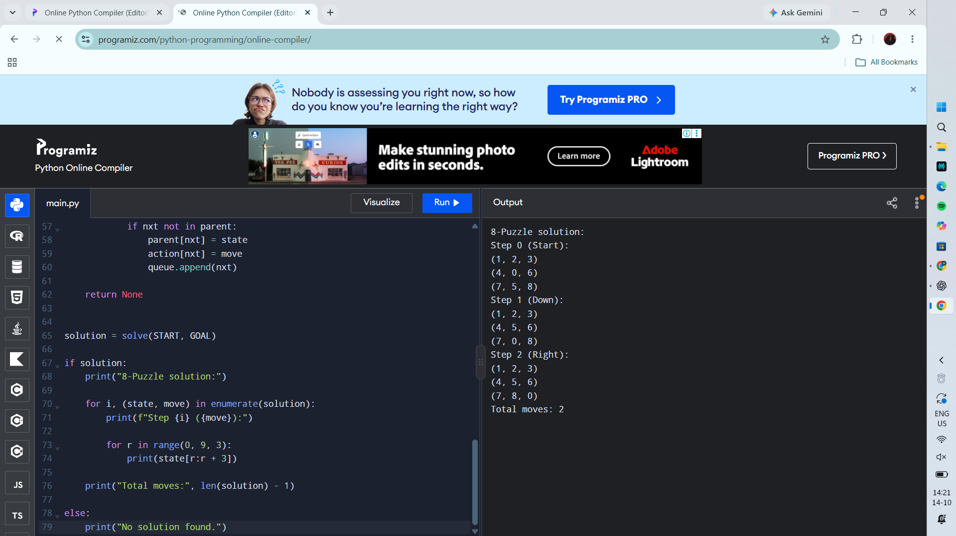
RESULT
Actual Programiz compiler output — Experiment 1

