WATER JUG PROBLEM
Course Outcome: CO2
Name | Nilesh Naik
Register Number | 192412664

AIM
To obtain a target quantity of water using two jugs of fixed capacities and the allowed fill, empty, and pour operations.
ALGORITHM
- Represent the state as the amount of water in the 4-litre jug and the 3-litre jug.
- Start with both jugs empty.
- Generate states by filling either jug, emptying either jug, or pouring water from one jug to the other.
- Use BFS to explore states while avoiding states already visited.
- Stop when either jug contains exactly 2 litres and print the path.
CORE LOGIC
Each state records the current quantities in the two jugs. BFS systematically explores legal operations and finds a shortest sequence of operations under the assumption that each operation has equal cost.
PSEUDOCODE
START
Set capacities to 4 and 3; target to 2
Put initial state (0, 0) in a queue
WHILE queue is not empty:
Remove a state
IF either jug contains target: reconstruct and display path
Generate fill, empty, and pour states
Add unvisited states to queue and record parent/action
STOP
PROGRAM
Save the following code in a .py file and run it using Python 3.9 or later.
from collections import deque

CAP_A, CAP_B, TARGET = 4, 3, 2
START = (0, 0)

def next_states(a, b):
pour_ab = min(a, CAP_B - b)
pour_ba = min(b, CAP_A - a)
return [
("Fill 4-litre jug", (CAP_A, b)),
("Fill 3-litre jug", (a, CAP_B)),
("Empty 4-litre jug", (0, b)),
("Empty 3-litre jug", (a, 0)),
("Pour 4-litre into 3-litre", (a - pour_ab, b + pour_ab)),
("Pour 3-litre into 4-litre", (a + pour_ba, b - pour_ba)),
]

queue = deque([START])
parent = {START: None}
action = {}
goal = None

while queue:
state = queue.popleft()
a, b = state
if a == TARGET or b == TARGET:
goal = state
break
for operation, nxt in next_states(a, b):
if nxt not in parent:
parent[nxt] = state
action[nxt] = operation
queue.append(nxt)

if goal is not None:
path = []
state = goal
while state is not None:
path.append((state, action.get(state, "Start")))
state = parent[state]
for state, operation in reversed(path):
print(f"{operation}: 4-litre jug={state[0]} L, "
f"3-litre jug={state[1]} L")
else:
print("Target quantity cannot be reached.")

OUTPUT
The target quantity of 2 litres was obtained using BFS and the permitted jug operations.
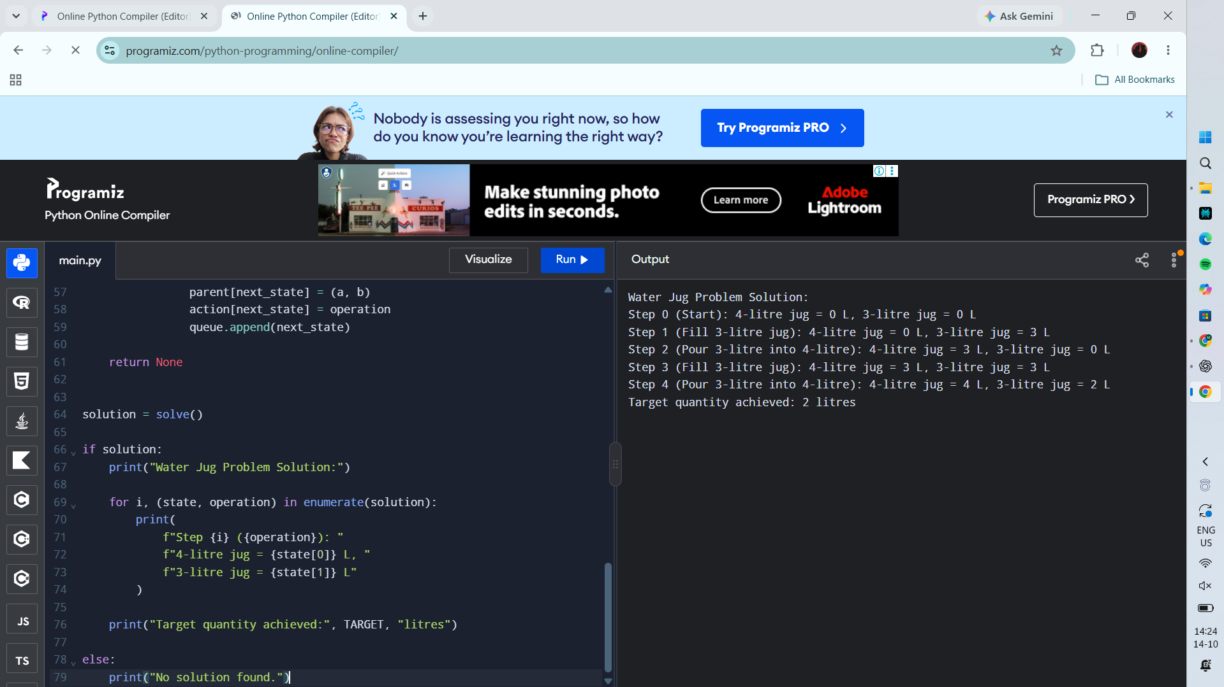
RESULT
Actual Programiz compiler output — Experiment 3

