CRYPT-ARITHMETIC PROBLEM
Course Outcome: CO2
Name | Nilesh Naik
Register Number | 192412664

AIM
To solve the crypt-arithmetic puzzle SEND + MORE = MONEY by assigning a unique digit to each letter.
ALGORITHM
- List the distinct letters in SEND + MORE = MONEY.
- Assign a different decimal digit to every letter.
- Do not allow S or M to be zero because they are leading digits.
- Convert each word to its numerical value and test whether SEND + MORE equals MONEY.
- Display the first valid digit assignment and the corresponding arithmetic equation.
CORE LOGIC
A crypt-arithmetic puzzle is a constraint-satisfaction problem. Each letter represents one digit, different letters must have different digits, and the arithmetic equation must hold. Permutation search tests candidate assignments until a valid one is found.
PSEUDOCODE
START
Collect all distinct letters
FOR each permutation of digits assigned to letters:
Reject assignments with leading zero
Convert SEND, MORE, and MONEY to numbers
IF SEND + MORE equals MONEY: display mapping and equation; stop
STOP
PROGRAM
Save the following code in a .py file and run it using Python 3.9 or later.
from itertools import permutations

letters = "SENDMORY"
digits = "0123456789"

solution = None
for p in permutations(digits, len(letters)):
mapping = dict(zip(letters, p))
if mapping["S"] == "0" or mapping["M"] == "0":
continue

send = int("".join(mapping[ch] for ch in "SEND"))
more = int("".join(mapping[ch] for ch in "MORE"))
money = int("".join(mapping[ch] for ch in "MONEY"))

if send + more == money:
solution = (mapping, send, more, money)
break

if solution:
mapping, send, more, money = solution
print("Digit assignment:")
for letter in sorted(mapping):
print(f"{letter} = {mapping[letter]}")
print(f"{send} + {more} = {money}")
else:
print("No solution found.")

OUTPUT
The crypt-arithmetic puzzle was solved by finding a distinct digit for each letter that satisfies SEND + MORE = MONEY.
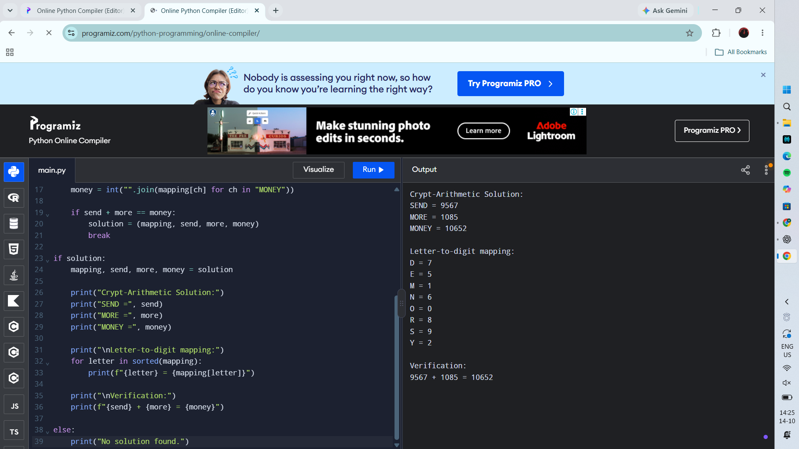
RESULT
Actual Programiz compiler output — Experiment 4

