EXERCISE – 10
Question
Execute the following commands in Kali Linux Operating Systems: free command, sort command, and history command.
Aim
To execute and understand the free, sort, and history commands in Kali Linux.
1. FREE COMMAND
Command:
free -h
Use:
Displays memory usage in human-readable units. Values shown are illustrative.
Illustrative terminal output:
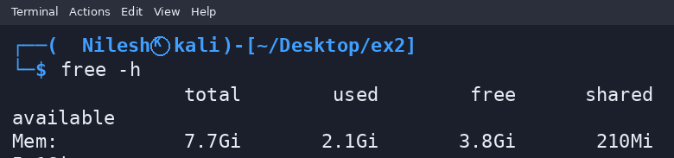
2. SORT COMMAND
Command:
printf 'pear\\napple\\nbanana\\n' | sort
Use:
Sorts lines of text alphabetically by default.
Illustrative terminal output:
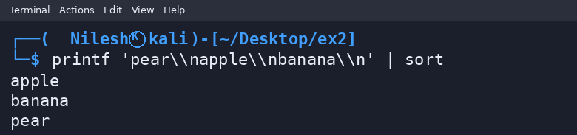
3. HISTORY COMMAND
Command:
history
Use:
Displays commands saved in the current shell's command history.
Illustrative terminal output:
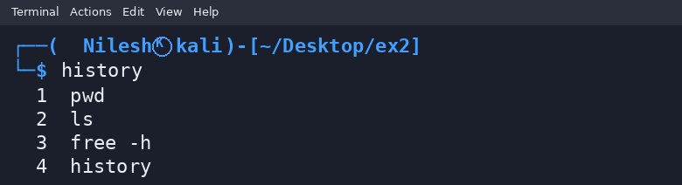
Result
Thus, the free, sort, and history commands were demonstrated. Memory values and shell history are illustrative examples.

