EXERCISE – 11
Question
Execute and display the results for the following Nmap timing and performance commands in Kali Linux: (i) aggressive speed scan (ii) insane speed scan.
Aim
To demonstrate Nmap's aggressive and insane timing templates on an authorized local test target.
1. AGGRESSIVE SPEED SCAN
Command:
nmap -T4 127.0.0.1
Use:
Uses a faster timing template. Scan only systems you own or are authorized to test.
Illustrative terminal output:
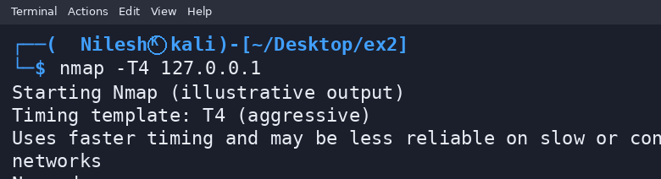
2. INSANE SPEED SCAN
Command:
nmap -T5 127.0.0.1
Use:
Uses Nmap's fastest timing template and may reduce accuracy or reliability. Use cautiously on authorized targets only.
Illustrative terminal output:
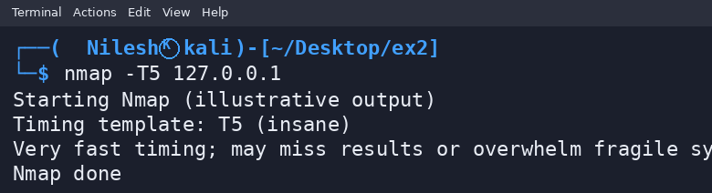
Result
Thus, the Nmap T4 and T5 timing templates were demonstrated on localhost. Outputs are illustrative and may differ from actual scans.

