EXERCISE – 3
Question
Execute and display the results of the following commands in Kali Linux Operating System:
1. tree command
2. head command
3. tail command
Aim
To execute and display the results of the tree, head, and tail commands in Kali Linux.
1. TREE COMMAND
Command:
tree
Use:
The tree command is used to display files and directories in a tree-like hierarchical structure.
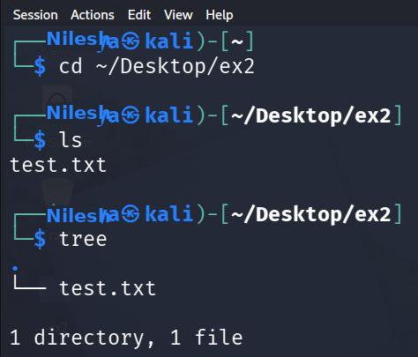
2. HEAD COMMAND
Command:
head sample.txt
Use:
The head command is used to display the beginning (first few lines) of a text file.
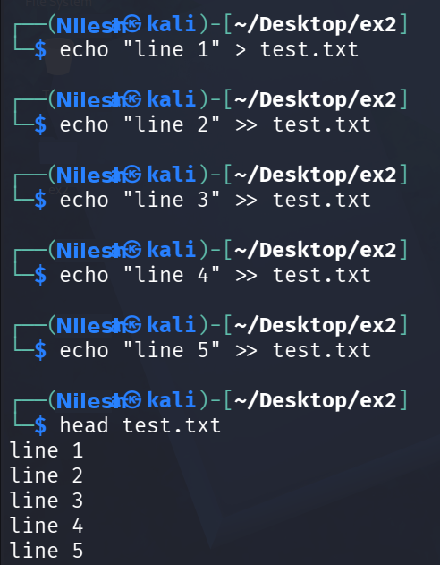

3. TAIL COMMAND
Command:
tail sample.txt
Use:
The tail command is used to display the end (last few lines) of a text file.
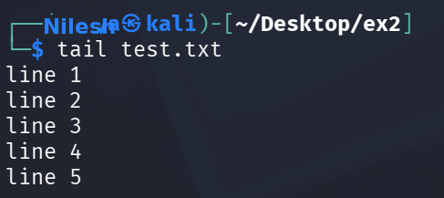
Result
Thus, the tree, head, and tail commands were successfully executed in Kali Linux and their results were displayed.

