EXERCISE – 4
Question
Execute and display the results of the following commands in Kali Linux Operating Systems: (i) ls (ii) cat (iii) mkdir.
Aim
To execute and display the results of the ls, cat, and mkdir commands in Kali Linux.
1. LS COMMAND
Command:
ls
Use:
Lists files and directories in the current directory.
Illustrative terminal output:
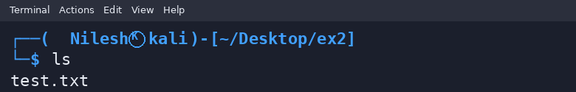
2. CAT COMMAND
Command:
cat test.txt
Use:
Displays the contents of a text file.
Illustrative terminal output:
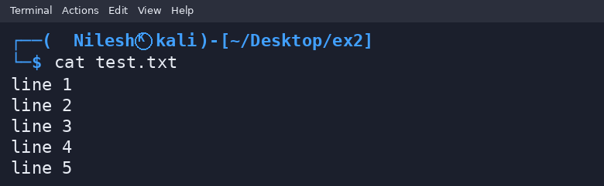
3. MKDIR COMMAND
Command:
mkdir newfolder
Use:
Creates a new directory named newfolder.
Illustrative terminal output:
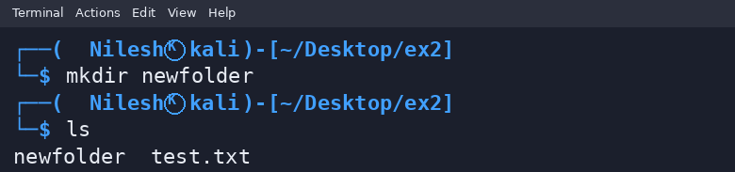
Result
Thus, the ls, cat, and mkdir commands were demonstrated in a Kali Linux-style terminal.

