EXERCISE – 5
Question
Execute and display the results of the following commands in Kali Linux Operating Systems: (i) uptime (ii) date (iii) mv.
Aim
To execute and understand the uptime, date, and mv commands in Kali Linux.
1. UPTIME COMMAND
Command:
uptime
Use:
Shows how long the system has been running, logged-in users, and system load averages.
Illustrative terminal output:
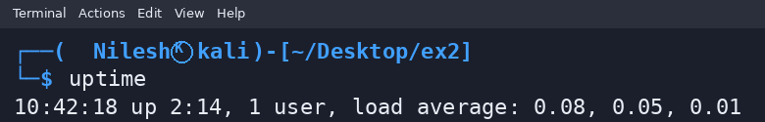
2. DATE COMMAND
Command:
date
Use:
Displays the current system date and time. The shown timestamp is illustrative.
Illustrative terminal output:
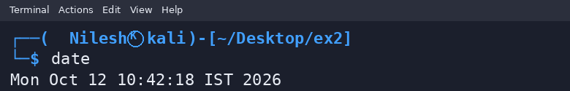
3. MV COMMAND
Command:
mv old.txt new.txt
Use:
Moves or renames a file or directory. The example renames old.txt to new.txt.
Illustrative terminal output:
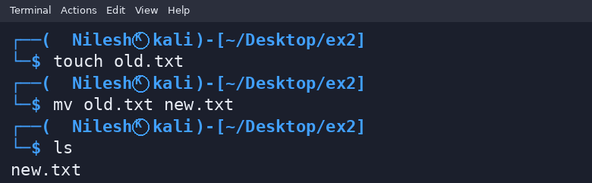
Result
Thus, the uptime, date, and mv commands were demonstrated. Terminal outputs are illustrative and may differ on the user's system.

