EXERCISE – 6
Question
Execute and display the results of the following commands in Kali Linux Operating Systems: (i) touch (ii) pwd (iii) wget.
Aim
To execute and understand the touch, pwd, and wget commands in Kali Linux.
1. TOUCH COMMAND
Command:
touch sample.txt
Use:
Creates an empty file if it does not exist, or updates its timestamp if it does.
Illustrative terminal output:
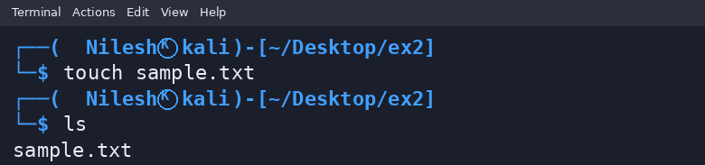
2. PWD COMMAND
Command:
pwd
Use:
Prints the full path of the current working directory.
Illustrative terminal output:
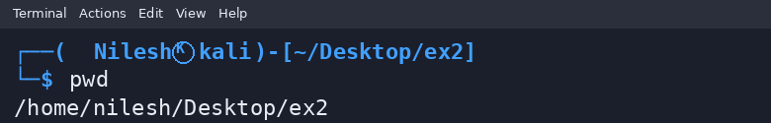
3. WGET COMMAND
Command:
wget https://example.com/
Use:
Downloads content from a URL. Network access and the actual output depend on the environment.
Illustrative terminal output:
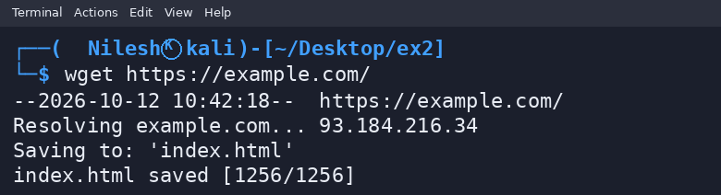
Result
Thus, the touch, pwd, and wget commands were demonstrated. The wget output is an illustrative example.

