EXERCISE – 7
Question
Execute and display the results of the following commands in Kali Linux Operating Systems: cd, cp, and ls.
Aim
To execute and understand the cd, cp, and ls commands in Kali Linux.
1. CD COMMAND
Command:
cd ~/Desktop/ex2
Use:
Changes the current working directory to the specified directory.
Illustrative terminal output:

2. CP COMMAND
Command:
cp source.txt backup.txt
Use:
Copies source.txt to backup.txt. The source file must exist before running the command.
Illustrative terminal output:
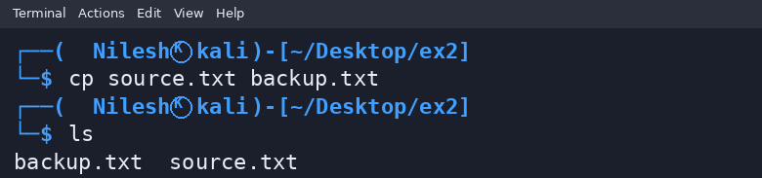
3. LS COMMAND
Command:
ls
Use:
Lists files and directories in the current directory.
Illustrative terminal output:

Result
Thus, the cd, cp, and ls commands were demonstrated. Example filenames are used for illustration.

