EXERCISE – 8
Question
Execute and display the results for the following Nmap service version and OS detection commands in Kali Linux: (i) detect the version of services running (ii) aggressive scan (iii) detect operating system of the target.
Aim
To demonstrate Nmap service-version detection, aggressive scanning, and operating-system detection on an authorized test target.
1. SERVICE VERSION DETECTION
Command:
nmap -sV 127.0.0.1
Use:
Attempts to identify service versions on the local machine. Scan only systems you own or are authorized to test.
Illustrative terminal output:
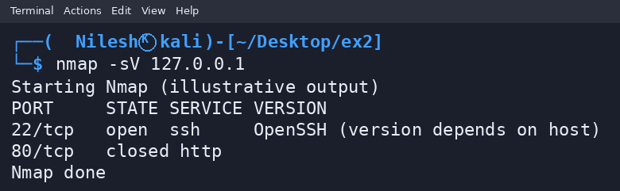
2. AGGRESSIVE SCAN
Command:
nmap -A 127.0.0.1
Use:
Enables OS detection, version detection, script scanning, and traceroute features. Use only on an authorized target.
Illustrative terminal output:
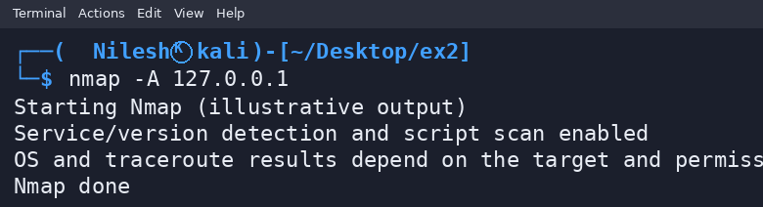
3. OPERATING SYSTEM DETECTION
Command:
sudo nmap -O 127.0.0.1
Use:
Attempts to infer the target operating system from network responses. Results may be inconclusive.
Illustrative terminal output:
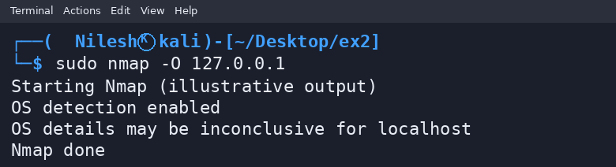
Result
Thus, the Nmap service-version, aggressive-scan, and OS-detection options were demonstrated against localhost. Outputs shown are illustrative, not captured from a live scan.

