EXERCISE – 9
Question
Execute and display the results for the following Nmap timing and performance commands in Kali Linux: (i) polite IDS evasion (ii) normal IDS evasion.
Aim
To demonstrate Nmap's polite and normal timing templates on an authorized local test target.
1. POLITE TIMING TEMPLATE
Command:
nmap -T2 127.0.0.1
Use:
Uses slower timing to reduce network load. T2 is a timing profile, not a guarantee of IDS evasion.
Illustrative terminal output:
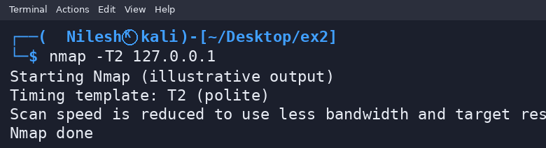
2. NORMAL TIMING TEMPLATE
Command:
nmap -T3 127.0.0.1
Use:
Uses Nmap's normal/default timing profile. It does not guarantee IDS evasion.
Illustrative terminal output:
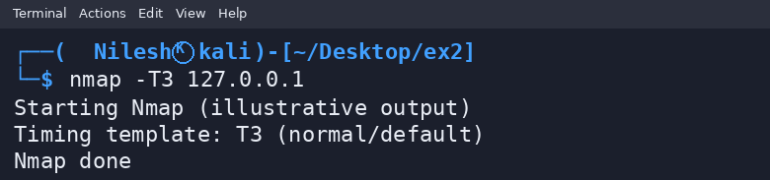
Result
Thus, the Nmap T2 and T3 timing templates were demonstrated on localhost. Outputs are illustrative; these options should not be described as guaranteed IDS evasion.

