EXERCISE – 12
Port Scanning Tools
Question
Demonstrate port scanning tools in Kali Linux.
Aim
To identify port states on a system authorized for testing.
1. TCP CONNECT SCAN
Command / Method:
nmap -sT -p 22,80,443 127.0.0.1
Use:
Checks selected TCP ports on localhost.
Illustrative terminal output:
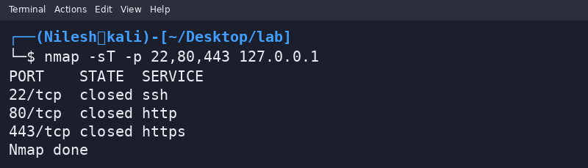
2. SERVICE SCAN
Command / Method:
nmap -sV -p 1-100 127.0.0.1
Use:
Attempts to identify services and versions on the first 100 ports.
Illustrative terminal output:
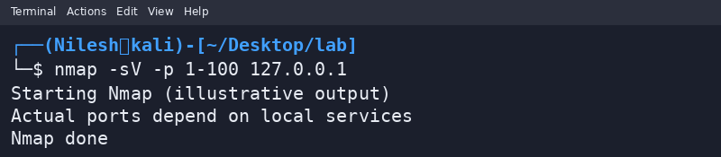
Safety / Notes
Only scan systems for which you have permission.
Result
Port scanning was demonstrated on localhost. Outputs are illustrative.

