EXERCISE – 13
Host Discovery
Question
Demonstrate host discovery commands in Kali Linux.
Aim
To check host reachability using ping and Nmap.
1. PING TEST
Command / Method:
ping -c 4 127.0.0.1
Use:
Sends four ICMP echo requests to localhost.
Illustrative terminal output:
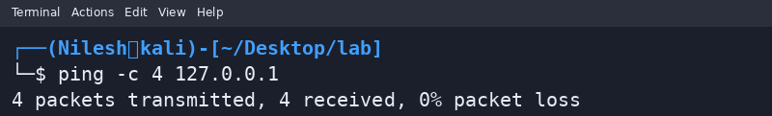
2. NMAP PING SCAN
Command / Method:
nmap -sn 127.0.0.1
Use:
Checks whether localhost is up without port scanning.
Illustrative terminal output:
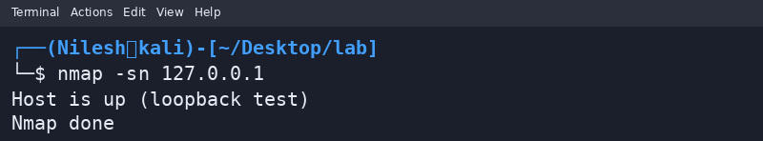
Safety / Notes
Use only your own network or an authorized lab.
Result
Host discovery was demonstrated on localhost. Outputs are illustrative.

