EXERCISE – 14
Password Auditing Using Hydra
Question
Explain Hydra for password auditing in an isolated training lab.
Aim
To understand password-auditing tools and defensive authentication controls.
1. VIEW HELP
Command / Method:
hydra -h
Use:
Shows options without attempting logins.
Illustrative terminal output:
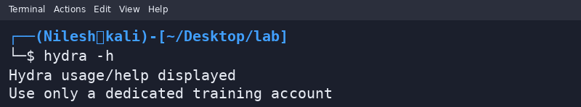
2. SAFE AUDIT CHECKLIST
Command / Method:
Review a dedicated test account and service configuration
Use:
Use an instructor-approved lab service; this exercise does not brute-force accounts.
Illustrative terminal output:
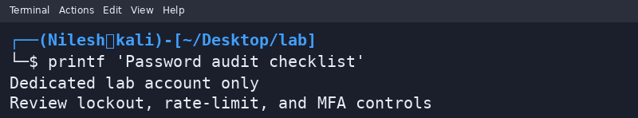
Safety / Notes
Never guess passwords against public systems or accounts without permission. Use MFA and rate limits.
Result
Hydra help and a safe audit workflow were reviewed.

