EXERCISE – 15
Information Gathering Using theHarvester
Question
Demonstrate passive information gathering using a reserved example domain.
Aim
To understand how theHarvester gathers publicly indexed domain-related information.
1. VIEW HELP
Command / Method:
theHarvester -h
Use:
Lists available sources and options.
Illustrative terminal output:
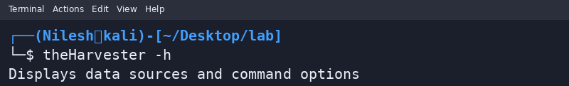
2. EXAMPLE LOOKUP
Command / Method:
theHarvester -d example.com -b crtsh
Use:
Illustrates a lookup for the reserved example.com documentation domain.
Illustrative terminal output:
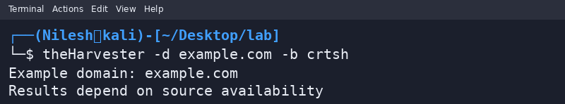
Safety / Notes
Use only approved domains and sources.
Result
theHarvester usage was demonstrated with a documentation-only domain.

