EXERCISE – 16
Google and WHOIS for Reconnaissance
Question
Use search-engine operators and WHOIS on a reserved example domain.
Aim
To learn passive reconnaissance using public search results and domain records.
1. GOOGLE SEARCH OPERATOR
Command / Method:
Search: site:example.com
Use:
Limits search results to indexed pages for a specified domain.
Illustrative terminal output:
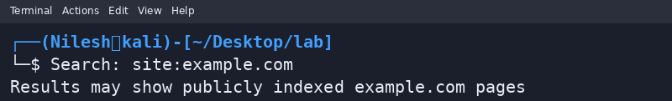
2. WHOIS LOOKUP
Command / Method:
whois example.com
Use:
Displays available domain registration details.
Illustrative terminal output:
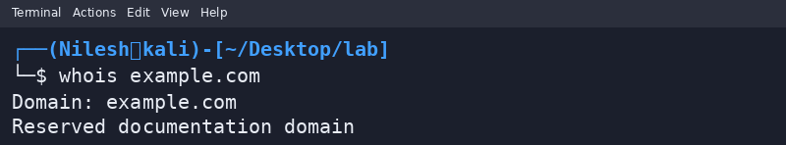
Safety / Notes
Do not use gathered information to target systems without authorization.
Result
Passive reconnaissance methods were reviewed using example.com.

