EXERCISE – 17
Windows OS Commands Execution
Question
Execute Windows equivalents of traceroute, ping, ifconfig, and netstat.
Aim
To practice basic network troubleshooting in Windows Command Prompt.
1. PING
Command / Method:
ping 127.0.0.1
Use:
Tests connectivity to the local host.
Illustrative terminal output:
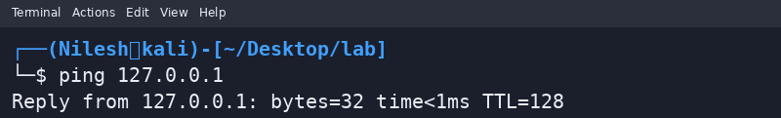
2. TRACEROUTE
Command / Method:
tracert 127.0.0.1
Use:
Windows uses tracert rather than traceroute.
Illustrative terminal output:
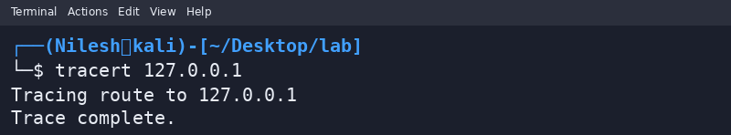
3. IP CONFIGURATION
Command / Method:
ipconfig
Use:
Windows equivalent commonly used instead of Linux ifconfig.
Illustrative terminal output:
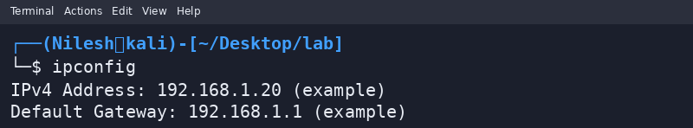
4. NETWORK STATISTICS
Command / Method:
netstat -ano
Use:
Shows network connections, listening ports, and process IDs.
Illustrative terminal output:
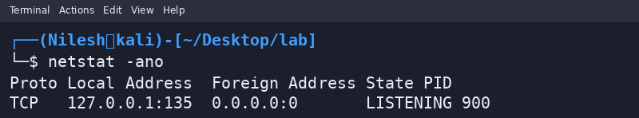
Safety / Notes
Screenshots are illustrative; actual output differs by system.
Result
Windows network commands were demonstrated with example output.

