EXERCISE – 18
Vulnerability Analysis Using Nikto
Question
Demonstrate Nikto web-server checks against a local training server.
Aim
To understand how Nikto checks web servers for risky configurations and known files.
1. VIEW HELP
Command / Method:
nikto -Help
Use:
Displays scanner options.
Illustrative terminal output:
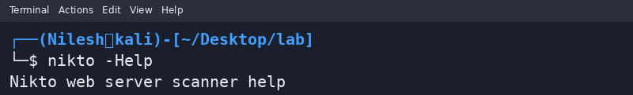
2. LOCAL SCAN
Command / Method:
nikto -h http://127.0.0.1:8080
Use:
Scans a local training server on port 8080; results depend on its configuration.
Illustrative terminal output:
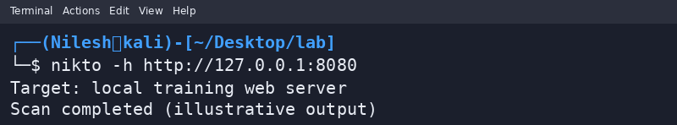
Safety / Notes
Do not scan third-party systems without explicit permission.
Result
An authorized local Nikto scan workflow was demonstrated.

