EXERCISE – 19
Wireshark Network Traffic Sniffing and Analysis
Question
Capture and analyze network traffic with Wireshark in a local lab.
Aim
To inspect interfaces, capture authorized traffic, and review packet headers.
1. LIST INTERFACES
Command / Method:
tshark -D
Use:
Lists available capture interfaces.
Illustrative terminal output:
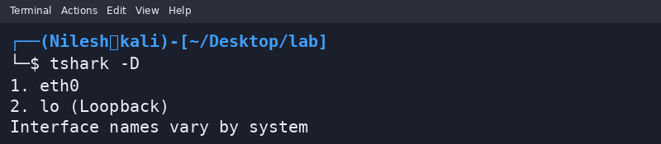
2. CAPTURE AND INSPECT
Command / Method:
In Wireshark, capture loopback traffic; use display filter: icmp
Use:
Generate localhost ping traffic and inspect ICMP packet fields.
Illustrative terminal output:
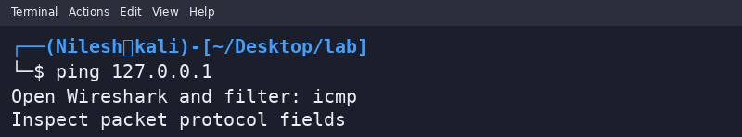
Safety / Notes
Capture only traffic you own or are authorized to inspect.
Result
Wireshark capture and packet inspection were outlined for localhost traffic.

