EXERCISE – 20
Understanding Msfvenom and Boot-Sector Malware Risks
Question
Study msfvenom help and boot-sector malware risks using a safe, non-deploying demonstration.
Aim
To understand payload tooling at a high level and defensive precautions against boot-sector threats.
1. VIEW HELP
Command / Method:
msfvenom --help
Use:
Displays help only; does not generate or deploy a payload.
Illustrative terminal output:
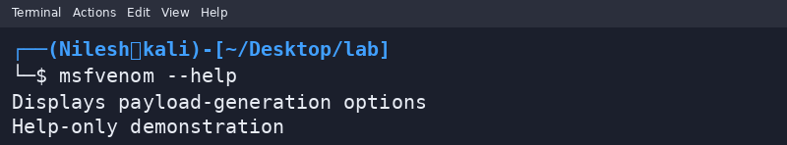
2. DEFENSIVE FILE ANALYSIS
Command / Method:
file sample.bin
Use:
Shows how to identify a harmless lab file; do not write payloads to a boot sector.
Illustrative terminal output:
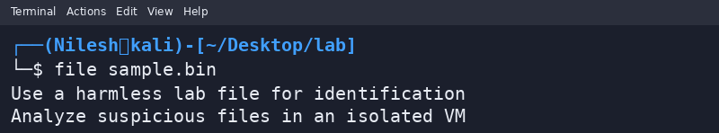
Safety / Notes
This exercise intentionally excludes instructions for creating or deploying a boot-sector virus.
Result
Msfvenom help and defensive precautions were reviewed without creating or deploying malware.

