UNIVERSITI TUN HUSSEIN ONN MALAYSIA

BIC21203: WEB DEVELOPMENT

LAB 2

NAME: NABIHA AISHAH BINTI KAMARUZZAMAN

MATRIC NUMBER: AI220110

SECTION: 3

LECTURE NAME: DR. NUR ARIFFIN BIN MOHD ZIN

**CODE HTML FOR BIODATA FORM**

<!DOCTYPE html>

<html lang="en">

<head>

    <meta charset="UTF-8">

    <meta name="viewport" content="width=device-width, initial-scale=1.0">

    <title>BIODATA FORM</FORM></title>

    <style>

        table {

            width: 100%;

            border-collapse: collapse;

        }

        td {

            border: 1px solid black;

            padding: 8px;

        }

        .photo-cell {

            width: 30%;

        }

    </style>

</head>

<body>

    <h2>BIODATA FORM</h2>

    <table border="1" style="width: 100%;" bgcolor="#daa59a">

        <tr>

            <td>Name</td>

            <td>NABIHA AISHAH BINTI KAMARUZZAMAN</td>

            <td class="photo-cell">

                <div>Photo</div>

                <img src="gambar.jpg" width="50" length="50">

            </td>

        </tr>

        <tr>

            <td>Date of birth</td>

            <td colspan="2">26 April 2003</td>

        </tr>

        <tr>

            <td>Religion</td>

            <td colspan="2">ISLAM</td>

        </tr>

        <tr>

            <td>Race</td>

            <td colspan="2">MALAY</td>

        </tr>

        <tr>

            <td rowspan="4" width="20%">Address</td>

            <td>Street</td>

            <td>BKB 25/4 KAMPUNG BARU</td>

        </tr>

        </tr>

        <tr>

            <td>Town</td>

            <td>JALAN BAKRI BATU 6</td>

        </tr>

        <tr>

            <td>District</td>

            <td>MUAR</td>

        </tr>

        <tr>

            <td>State</td>

            <td>JOHOR</td>

        </tr>

        <tr>

            <td rowspan="3" width="28.5%">Contact</td>

            <td>Mobile Phone</td>

            <td>013-6377404</td>

        </tr>

        <tr>

            <td>Social Media</td>

            <td>ig = naikamaruzz

            </td>

        </tr>

        <tr>

            <td>Website</td>

            <td>

                <a href="https://www.linkedin.com/in/nabiha-kamaruzzaman-6239b5256/">LinkedIn</a>

                <a href="https://github.com/naikamaruzz">Github</a>

            </td>

        </tr>

        <tr>

            <td>Course and Institution</td>

            <td colspan="2"> Bachelor of Computer Science (Software Engineering), UTHM</td>

        </tr>

        <tr>

            <td>Programming Skills</td>

            <td colspan="2">1. Java

                2. C Programming

                3. PHP, HTML, CSS

                4. Phyton

                5.C#

                6. Dart

            </td>

        </tr>

        <tr>

            <td>Personal Interest</td>

            <td colspan="2">1. Volunteer Work 2. Programming</td>

        </tr>

        <tr>

            <td>Future plan in 2025</td>

            <td colspan="2">I want to finish my PSM and intern at Intel</td>

        </tr>

    </table>

</body>

</html>

**Screenshot of the web page (Github Pages)**

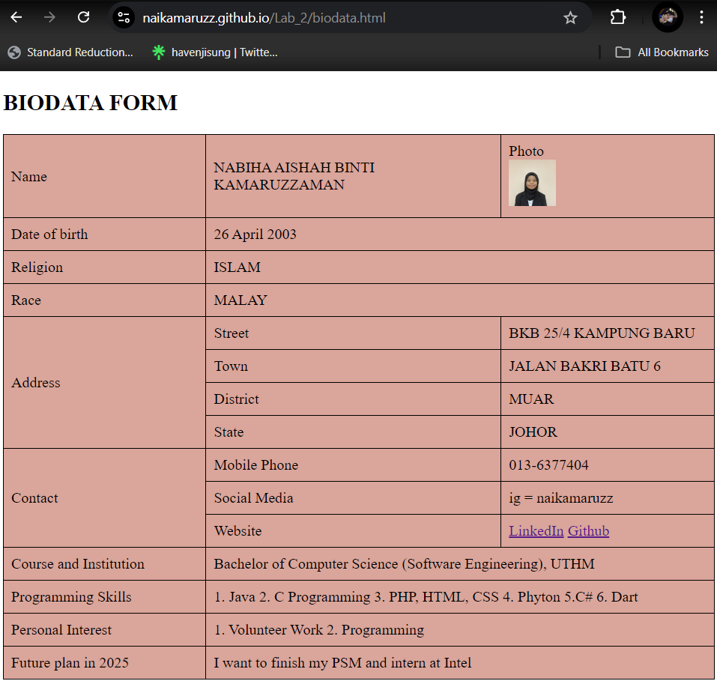

**Github Link:** [**https://naikamaruzz.github.io/Lab_2/biodata.html**](https://naikamaruzz.github.io/Lab_2/biodata.html)