Master’s Thesis – Health and Artificial Intelligence

Automation of Ringed Sideroblast Identification by Deep Learning
UNIVERSITY OF BURGUNDY

Isen Naiken
Supervised by Julien Guy
Medical Biology Platform – Dijon University Hospital (CHU Dijon)

September 2025

Abstract
Introduction : The identification of ring sideroblasts is crucial for the diagnosis of sideroblastic anemia, particularly in the context of myelodysplastic syndromes. However, the current technique lacks precision and shows limited inter-observer reproducibility. In this study, we propose an automated approach using computer vision to address these limitations.
Materials and Methods : This study was conducted at the Dijon University Hospital (CHU Dijon) and included 30 patients diagnosed between 2017 and 2024. For each case, cytological fields were extracted and subsequently annotated by a panel of cytology experts (medical biologists) using the LabelImg software. Two deep learning models were implemented: (i) an object detector based on Faster R-CNN ResNet50 FPN v2 pretrained on the COCO dataset, and (ii) a classifier based on ResNet-18 pretrained on ImageNet1K_V1. A supervised learning approach was applied to train and evaluate the models.
Results : The object detector showed good performance in identifying erythroblasts (mean IoU = 0.84, F1-score = 0.80), while the classification model achieved strong results in distinguishing ring sideroblasts (RS) from normal sideroblasts (NS), with an accuracy of 0.9067 and an F1-score of 0.9207 on the test dataset.
Conclusion : This model could be implemented within an automated platform to enable large-scale industrial application.
Table of Contents
Acknowledgements 3
Introduction 4
Sideroblastic anemia 4
Myelodysplastic Syndrome 5
Diagnosis criteria 5
Cytology 5
Molecular biology 6
Limitations of current diagnostic methods 6
Inter-observer variability 6
A time-consuming analysis 7
Risk for patient management 7
Contribution of image processing through Deep Learning 7
Reduction of inter-observer variability 8
Reduction of analysis time 8
Patient data archiving 8
Remote reading by a practitioner 8
Study objectives 8
Materials and Methods 9
Dataset Construction 9
Image Capture 9
Image Annotation 9
General principles of image analysis 9
From the “linear” classifier to the convolutional neural network classifier 10
Principle of Object Detection 10
Principle of Finetuning 11
Fine-tuning a Faster R-CNN model coupled with a ResNet-18 backbone 11
Design of a Pipeline and Streamlit Integration 12
Results 14
Dataset characteristics 14
Performance of the FasterRCNN model 14
Performance of the ResNet18 model 14
Discussion 17
Validation by a medical biologist still required 17
Technical constraints 18
Disadvantages of manual image capture 18
Depth of field limitations 18
Addressing the technical constraints 18
Conclusion 19
Bibliographie 20

Acknowledgements

Julien Baumeyer provided excellent guidance on the classification and object detection aspects, and Cécile Rossé, a laboratory technician, generated the images for the dataset.

Introduction
The field of medical biology has been revolutionized by the arrival of laboratory automation systems. Practices in clinical biochemistry, hemostasis, and hematology have radically changed. The medical biologist, whose work consisted of observing and counting cells to produce a blood count, now finds themselves validating the results provided by automated cell detection and classification systems. This transition has enabled the standardization of medical biology laboratories, to the extent that an ISO certification has been established to qualify these laboratories. This ISO qualification has completely restructured the profession. Independent laboratories, unable to meet the imposed standards, have merged into groups. Whereas each sampling center previously had its own laboratory, today private laboratories are organized into platforms that consolidate all automation systems for a network of sampling centers. Technology thus plays a central role in medical biology, particularly image analysis tools. However, one area remains “artisanal” today: the analysis of myelograms. Currently, laboratories do not have any automated systems for the detection and classification of bone marrow cells.

Sideroblastic anemia
A well-known bone marrow pathology is called sideroblastic anemia. Sideroblastic anemia is investigated in patients presenting with refractory anemia, meaning anemia that cannot be explained by the complete blood count and for which no cause has been identified (such as vitamin deficiency or iron deficiency). The physician then requests a myelogram. This involves collecting bone marrow using a needle from the iliac crest or the mediastinal area. Once the sample is taken, it is spread on a slide to be stained. The staining used, Perls’ stain, highlights the iron accumulated in the precursors of red blood cells. These precursors, called erythroblasts, naturally accumulate iron in their mitochondria. However, in pathological situations such as sideroblastic anemia, this accumulation is abnormal. Thus, sideroblastic anemia is characterized by the presence of ringed sideroblasts in the bone marrow. A ringed sideroblast is an erythroblast with iron granules (siderotic granules) arranged in a ring around the nucleus, covering at least one-third of the nuclear circumference. For a cell to be classified as a ringed sideroblast, it must have at least 5 iron granules in a perinuclear arrangement (Lours, C. et al, 2022).
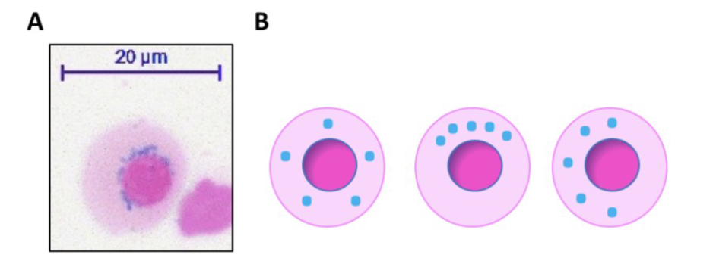
Figure 1: Representation of the appearance of ring sideroblasts

Myelodysplastic Syndrome
Sideroblastic anemia can be a symptom of a condition called "myelodysplastic syndrome" (MDS). MDS is a heterogeneous group of clonal hematopoietic disorders characterized by morphological dysplasia, peripheral cytopenias, and ineffective bone marrow. This malignant hematologic disease can progress to much more aggressive conditions, such as acute myelodysplastic leukemia. Therefore, diagnosis is a priority.

Diagnosis criteria
The diagnosis is primarily based on observation using an optical microscope.

Cytology
Four cell types are identified:
Type 0: no visible granules;
Type 1: fewer than 5 granules in the cytoplasm;
Type 2: 5 or more granules in the cytoplasm but not arranged around the nucleus;
Type 3: 5 or more granules in the cytoplasm arranged around the nucleus.
The test is considered positive if 15 or more ringed sideroblasts (Type 3) are found among 100 analyzed erythroblasts.
The test is negative if fewer than 5 ringed sideroblasts (Type 3) are observed among 100 erythroblasts analyzed.

Molecular biology
The test is also considered negative if between 5 and 14 ringed sideroblasts (Type 3) are observed among 100 analyzed erythroblasts, but this situation requires genetic testing to confirm a positive diagnosis. However, this genetic analysis is time-consuming and costly. In practice, it is therefore rarely performed for practical reasons. As a result, patients are primarily monitored based on their clinical progression.

Limitations of current diagnostic methods
Optical microscopy analysis also has its limitations. Two major challenges currently faced by medical biologists are inter-observer variability and the duration of the analysis.

Inter-observer variability
At the medical biology laboratory of the Dijon University Hospital, where our study takes place, slides deemed negative during the first reading are always reviewed by a second technician. Similarly, slides deemed positive during the first reading are reviewed by a medical doctor specialized in medical biology or a pharmacist specialized in medical biology. It turns out that in almost 100% of cases, the count varies between observers. What is more problematic is that in over 20% of cases, the counting discrepancy is significant enough to change the diagnostic outcome (positive or negative).

A time-consuming analysis
Another limitation of this test is the analysis time. Indeed, each observer must count 100 cells to provide a result. However, identifying erythroblasts can be difficult as they may be confused with lymphocytes. The same applies to the identification of ringed sideroblasts, since the distribution and number of granules around the nucleus are often uncertain.

Risk for patient management
As mentioned earlier, in-depth genetic analyses are very rarely performed. Consequently, a false positive with a value close to 15 sideroblasts will not be diagnosed. It is therefore crucial today to improve the accuracy of this diagnosis, given the existing variability and the consequences for the patient.

Contribution of image processing through Deep Learning
In this context, we propose in this study to use Deep Learning models to address the main challenges of this test. Deep learning models have revolutionized the field of image processing. Their performance is close to that of a human in image processing tasks that were considered impossible to automate just ten years ago. In some tasks, their performance even surpasses that of a human operator.
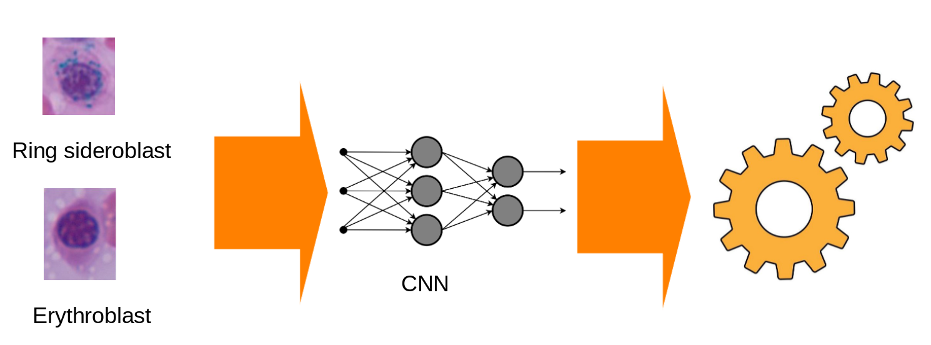
Figure 2 : A schematic representation of the principle of supervised learning

Reduction of inter-observer variability
A supervised approach could overcome inter-observer variability. Indeed, annotating the training images through a consensus of cytology experts would create a sufficiently robust database for academic image analysis. The analyses would no longer rely solely on the experience of a technician or biologist, but rather on the decision of a panel of experts in the field.

Reduction of analysis time
Moreover, the use of an object detector/classifier would allow identifying the minimum 100 cells in record time.

Patient data archiving
Furthermore, the slides, which must be digitized to allow analysis by the model, can be archived in the computerized patient record for pathology follow-up. The slides are indeed kept in the laboratory to allow for re-examination in case of doubt or to study the progression of the pathology. The availability of digital images in the record would greatly facilitate this process. Additionally, physical slides tend to degrade over time, making them almost impossible to read. This is yet another advantage of digital archiving.

Remote reading by a practitioner
Finally, this digital archiving of results can contribute to better patient care. On one hand, by allowing expert practitioners to remotely review the slides from the center managing the patient. On the other hand, by facilitating the transfer of the medical record in case of patient mobility.

Study objectives
To our knowledge, there is no research work on the automation of ring sideroblast identification using Deep Learning. The prospects offered by these powerful algorithms could address the shortcomings highlighted in previous studies, notably the low specificity and sensitivity.
The primary objective of our study is to design a model to detect erythroblasts and classify them as ring sideroblasts. The results could enable the development of tools that not only speed up the processing time of results but also improve the accuracy of the test by avoiding human errors.

Materials and Methods

Dataset Construction

Image Capture
To create this model, we assembled a dataset from images of bone marrow slides observed under an optical microscope. 30 patients were included to form a sufficiently large dataset for model development. For each patient, 10 fields will be captured using an optical microscope. The image acquisition period spanned 4 months. The laboratory’s slide archives were used to build the dataset, and patients diagnosed between 2017 and 2024 were included.

Image Annotation
Each field were then labeled by a panel of cytology experts (medical biologists) using the LabelImg software. The JPEG and XML files containing the annotations were stored in a relational database of the SQLite3 type.

General principles of image analysis
In this study, to identify and classify erythroblasts — normal or ring sideroblasts — we used so-called convolutional models.
Two models were used:
- a classifier
- an object detector.
We followed a supervised learning approach.

From the “linear” classifier to the convolutional neural network classifier
A linear classifier applies an affine function y=Wx+by=Wx+b, where WW is a weight matrix representing global “templates” and b is a bias term, to map a complete feature vector to a prediction. This approach essentially compares the entire input to a globally learned pattern without considering spatial structure.
A convolutional neural network (CNN) is based on the same mathematical principle of an affine operation but applies it locally: filters, which are small weight matrices, process only a portion of the image at a time. Unlike the linear classifier where each output depends on all inputs, the CNN exploits locality and weight sharing—meaning the same filter is applied across all spatial positions to detect a pattern wherever it appears.
If one vectorizes an image, the convolution can be seen as a linear classifier with a very sparse WW matrix (mostly zeros) and repetitive weights (the same filter weights repeated at different locations). This structure enables the CNN to perform more flexible and robust “template matching” by first detecting simple local features and then combining them through layers to recognize increasingly complex shapes.
In summary, a CNN is a structured and optimized version of a linear classifier, specially adapted for visual data, capable of learning hierarchies of spatial features and achieving better generalization.

Principle of Object Detection
An object detector is a model capable not only of recognizing the presence of objects in an image but also of precisely locating their positions using bounding boxes. It typically relies on a convolutional neural network (CNN) that extracts visual features at multiple scales, followed by a prediction head that simultaneously outputs two types of information: the object’s class and the coordinates of its bounding box.
The process begins by passing the image through the CNN to produce a feature map rich in spatial and semantic information. Candidate regions (anchors or proposals) are then evaluated by the model to determine whether they contain an object and to refine the localization. Modern architectures, such as YOLO or Faster R-CNN, optimize this step by processing the image almost entirely in parallel, enabling real-time detection of multiple objects.
At its core, the method applies learned filters to identify characteristic object patterns, combined with regression techniques that precisely adjust their positions.

Principle of Finetuning
Fine-tuning is a learning technique where you start from a model already trained on a large dataset (for example, a CNN trained on ImageNet) and continue training it on a new, more specific task. The idea is that the initial layers of the model have already learned general features (edges, textures, simple patterns) useful for almost any image, so it is more efficient to reuse this knowledge than to start from scratch.
Concretely, the pretrained model weights are loaded, and then certain layers (often the last ones) are adapted to the new task, for example by changing the output layer to match the desired number of classes. The model is then retrained with a low learning rate to avoid “destroying” the representations already learned. This approach saves time, helps prevent overfitting when data are scarce, and yields better performance than training the entire network from scratch.

Fine-tuning a Faster R-CNN model coupled with a ResNet-18 backbone
Our approach consists of three steps: detection, classification, and calculation of the final ratio.
The AI development method was based on convolutional neural networks (CNNs), focusing on object detection. Currently, we have fine-tuned:
- a neural network dedicated to cell identification (erythroblast detection model);
- a neural network dedicated to classification of the identified cells (erythroblast classification model).
For the Datathon, we were able to use servers provided by GOOGLE, which helped improve our computation times. The framework used was PyTorch.
For the erythroblast detection model:
We used an object detection model based on Faster R-CNN with a ResNet-50 backbone, a deep convolutional neural network complemented by a feature pyramid network (FPN) that improves detection of objects at different scales. This backbone was pre-trained on the COCO dataset (Common Objects in Context) with the option to partially or fully freeze the backbone layers. A stochastic gradient descent algorithm was used with a learning rate of 0.001. A scheduler was implemented to reduce the optimizer’s learning rate every 15 epochs. The loss function was automatically computed by the model.
For the erythroblast classification model:
The backbone was a ResNet-18 pre-trained on IMAGENET1K V1. The loss function used was cross-entropy. The optimizer was Adam. The best model was selected based on the F1 score. Using the weighted average argument allowed us to account for and correct class imbalance.
The model was then tested on a test set, composed of images not used during training. The evaluation metrics were sensitivity and specificity.

Design of a Pipeline and Streamlit Integration
Once the weights of the two models are obtained, a pipeline enabling the simultaneous use of both models for detection and classification will be created. For this purpose, PASCAL VOC files will be used to extract the images passed to the second model. An annotation system will then be implemented to relabel the PASCAL VOC files with the correct labels (predictions from the classifier model).
More specifically, the PASCAL VOC XML files generated by the erythroblast detection model are used to extract erythroblasts from the analyzed field. Each PASCAL VOC coordinate is annotated to indicate which image it belongs to. The second step consists of performing inference with the sideroblast-in-ring classification model. The inference results (sideroblast-in-ring or erythroblast) are then used to annotate the previous PASCAL VOC XML files. Finally, bounding boxes are generated and overlaid on the original field.
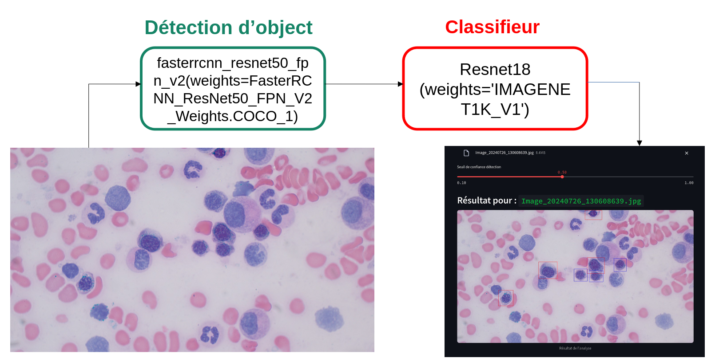
Figure 3 : Schematic figure of the pipeline used for prediction by our object detector and classifier

Results

Dataset characteristics
The dataset currently consists of:
2,813 fields at 3840 x 2160 resolution, acquired with optical microscopy using Pearl’s staining
3390 images of erythroblasts
669 images of erythroblasts labeled as sideroblasts in rings (SC)
2730 images of erythroblasts labeled as normal sideroblasts (SN)
This dataset will be split into training, validation, and test sets.
Below are the characteristics of our datasets:
train | valid | test
SC = 513 | SC = 136 | SC = 20
SN = 2043 | SN = 439 | SN = 248

Table 1. Datasets used for training, validation, and testing of the erythroblast classification model

Performance of the FasterRCNN model
The evaluation of our object detection model was conducted on a test set of 15 images. The model achieved a mean Intersection over Union (IoU) of 0.84, indicating a high degree of overlap between predicted and ground truth bounding boxes. The F1-score reached 0.80, demonstrating a strong balance between precision and recall in detecting the target objects. The overall accuracy was 0.67, reflecting the proportion of correct predictions among all evaluated instances. The average inference speed was 0.50 frames per second (FPS), which is reasonable given the computational complexity of the model.

Performance of the ResNet18 model
Figure 4 details the performance evaluation of the model for classifying ring sideroblasts (RS, labeled as 'SC' in the figure) and normal sideroblasts (NS, labeled as 'SN'). The model demonstrated strong classification performance across the three datasets. On the training set (Figure 4A), it achieved an accuracy of 0.9190 and an F1-score of 0.9207. These metrics improved on the validation set (Figure 4B), with an accuracy of 0.9339 and an F1-score of 0.9349. During the final evaluation on the independent test set (Figure 4C), the model maintained a robust performance, obtaining an accuracy of 0.9067 and an F1-score of 0.9207, confirming its ability to generalize. More specifically, the test set confusion matrix shows that the model correctly classified 18 out of 20 ring sideroblasts and 225 out of 248 normal sideroblasts.
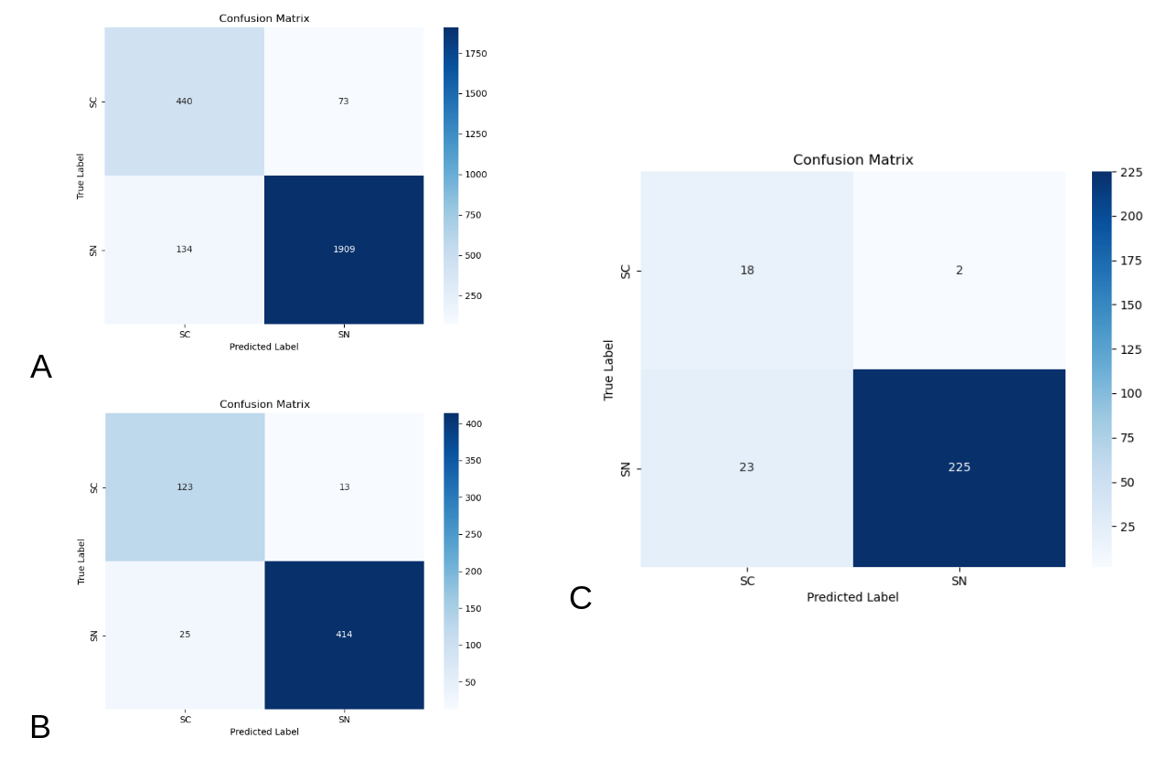
Figure 4. Performance evaluation of the model for classifying ring sideroblasts (RS) and normal sideroblasts (NS) on the training, validation, and test sets, showing an accuracy of 0.9190 and F1-score of 0.9207 on the training set, 0.9339 and 0.9349 on the validation set, and 0.9067 and 0.9207 on the test set.

Discussion
Currently, algorithms have been developed to detect cells exhibiting dysmorphism in bone marrow smears using conventional staining methods (Lee N. et al., 2022).
Other studies have explored bone marrow biopsies (Oscar E. et al., 2021); however, such procedures are not routinely performed in the early stages of myelodysplastic syndromes (MDS).
Research has also investigated erythrograms, based on red cell volume and hemoglobin concentration (Arrovo et al., 2010), although these approaches remain considerably less reliable than the reference standard of Pearl’s staining.
To the best of our knowledge, the present study is the first to apply deep learning for the identification of ring sideroblasts, employing both an object detector and a classifier on Pearl-stained bone marrow smears.
We presented the model’s performance to medical biologists at Dijon University Hospital, as well as to laboratory technicians, who reported that, from their subjective perspective, the model demonstrated very good performance. Comparative studies against human experts are currently underway, and the forthcoming results are expected to confirm these observations.
On the test set, there are 18 false positives. However, given the high number of true negatives, this effect is diluted and does not significantly impact the overall performance of the model.

Validation by a medical biologist still required
Although our model demonstrated excellent performance, the validation of its results will inevitably require confirmation by a medical biologist. Indeed, several limitations must be considered when applying such an approach in routine practice. Technical factors, such as inadequate staining or slide degradation, may significantly affect detection quality. In addition, concomitant clinical conditions associated with morphological abnormalities of the bone marrow could introduce further sources of bias. These considerations highlight the necessity of maintaining expert review in order to ensure diagnostic reliability, even when integrating advanced deep learning methods.

Technical constraints

Disadvantages of manual image capture
Manual image acquisition is a time-consuming process, as each slide requires capturing between five and ten microscopic fields, with each acquisition taking several seconds. Consequently, the reliance on manual image capture presents clear limitations for large-scale or routine implementation.

Depth of field limitations
A key step in the identification of ring sideroblasts lies in the detection of iron granules. However, immune cells on the slide are not perfectly flat, and there is a certain depth of field. As a result, iron granules, as well as cellular organelles, may be located at different focal planes. To achieve accurate identification of sideroblasts, it is therefore essential to visualize all cellular components, including both organelles and iron granules. In routine practice, technicians address this challenge by dynamically adjusting the focus during slide examination. With our current system, however, such dynamic focusing is not feasible. A potential solution would be to acquire multiple images at different focal planes and aggregate them, thereby reconstructing a more comprehensive representation of the cell.

Addressing the technical constraints
To overcome these technical constraints, the use of an automated slide scanner could be envisaged. Such a system would be able to capture images across different focal depths and generate a sharp composite image that preserves the integrity of all cellular structures.

Conclusion
The current model performs as expected; therefore, our next goal is to retrain it using a database automatically generated by an automated system with automatic slide scanning. The idea is to enable the incorporation of the model into the software of such an automated device.
The planned business model involves developing the model and then certifying it as an in vitro diagnostic medical device through a notified body. To achieve this, we will prepare a submission dossier with the help of a specialized consulting firm in order to obtain this certification
A direct human-versus-machine comparative analysis will also be necessary in order to quantitatively assess the potential gain in accuracy.

Bibliographie
Brück OE, Lallukka-Brück SE, Hohtari HR, et al. Machine Learning of Bone Marrow Histopathology Identifies Genetic and Clinical Determinants in Patients with MDS. Blood Cancer Discov. 2021;2(3):238-249. Published 2021 Mar 22. doi:10.1158/2643-3230.BCD-20-0162
Rovó A, Stüssi G, Meyer-Monard S, et al. Sideroblastic changes of the bone marrow can be predicted by the erythrogram of peripheral blood. Int J Lab Hematol. 2010;32(3):329-335. doi:10.1111/j.1751-553X.2009.01185.x

Lee, N., Jeong, S., Park, MJ. et al. Deep learning application of the discrimination of bone marrow aspiration cells in patients with myelodysplastic syndromes. Sci Rep 12, 18677 (2022). https://doi.org/10.1038/s41598-022-21887-w

Lours, C., Cottin, L., Wiber, M., Andrieu, V., Baccini, V., Baseggio, L., Brouzes, C., Chatelain, B., Daliphard, S., Fenneteau, O., Geneviève, F., Girard, S., Leymarie, V., Maloum, K., Rieu, J.-B., Sebahoun, G., Sudaka, I., Troussard, X., Wagner-Ballon, O., Lesesve, J.-F. (2022). Perls’ Stain Guidelines from the French-Speaking Cellular Hematology Group (GFHC). Diagnostics, 12(7), 1698. https://doi.org/10.3390/diagnostics12071698

Mufti, G. J., Bennett, J. M., Goasguen, J., Bain, B. J., Baumann, I., Brunning, R., Cazzola, M., Fenaux, P., Germing, U., Hellstrom-Lindberg, E., Jinnai, I., Manabe, A., Matsuda, A., Niemeyer, C. M., Sanz, G., Tomonaga, M., Vallespi, T., & Yoshimi, A. (2008). Diagnosis and classification of myelodysplastic syndrome: International Working Group on Morphology of myelodysplastic syndrome (IWGM-MDS) consensus proposals for the definition and enumeration of myeloblasts and ring sideroblasts. Haematologica, 93(11), 1712–1717. https://doi.org/10.3324/haematol.13405.

