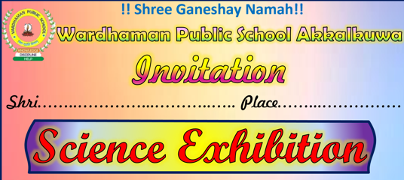
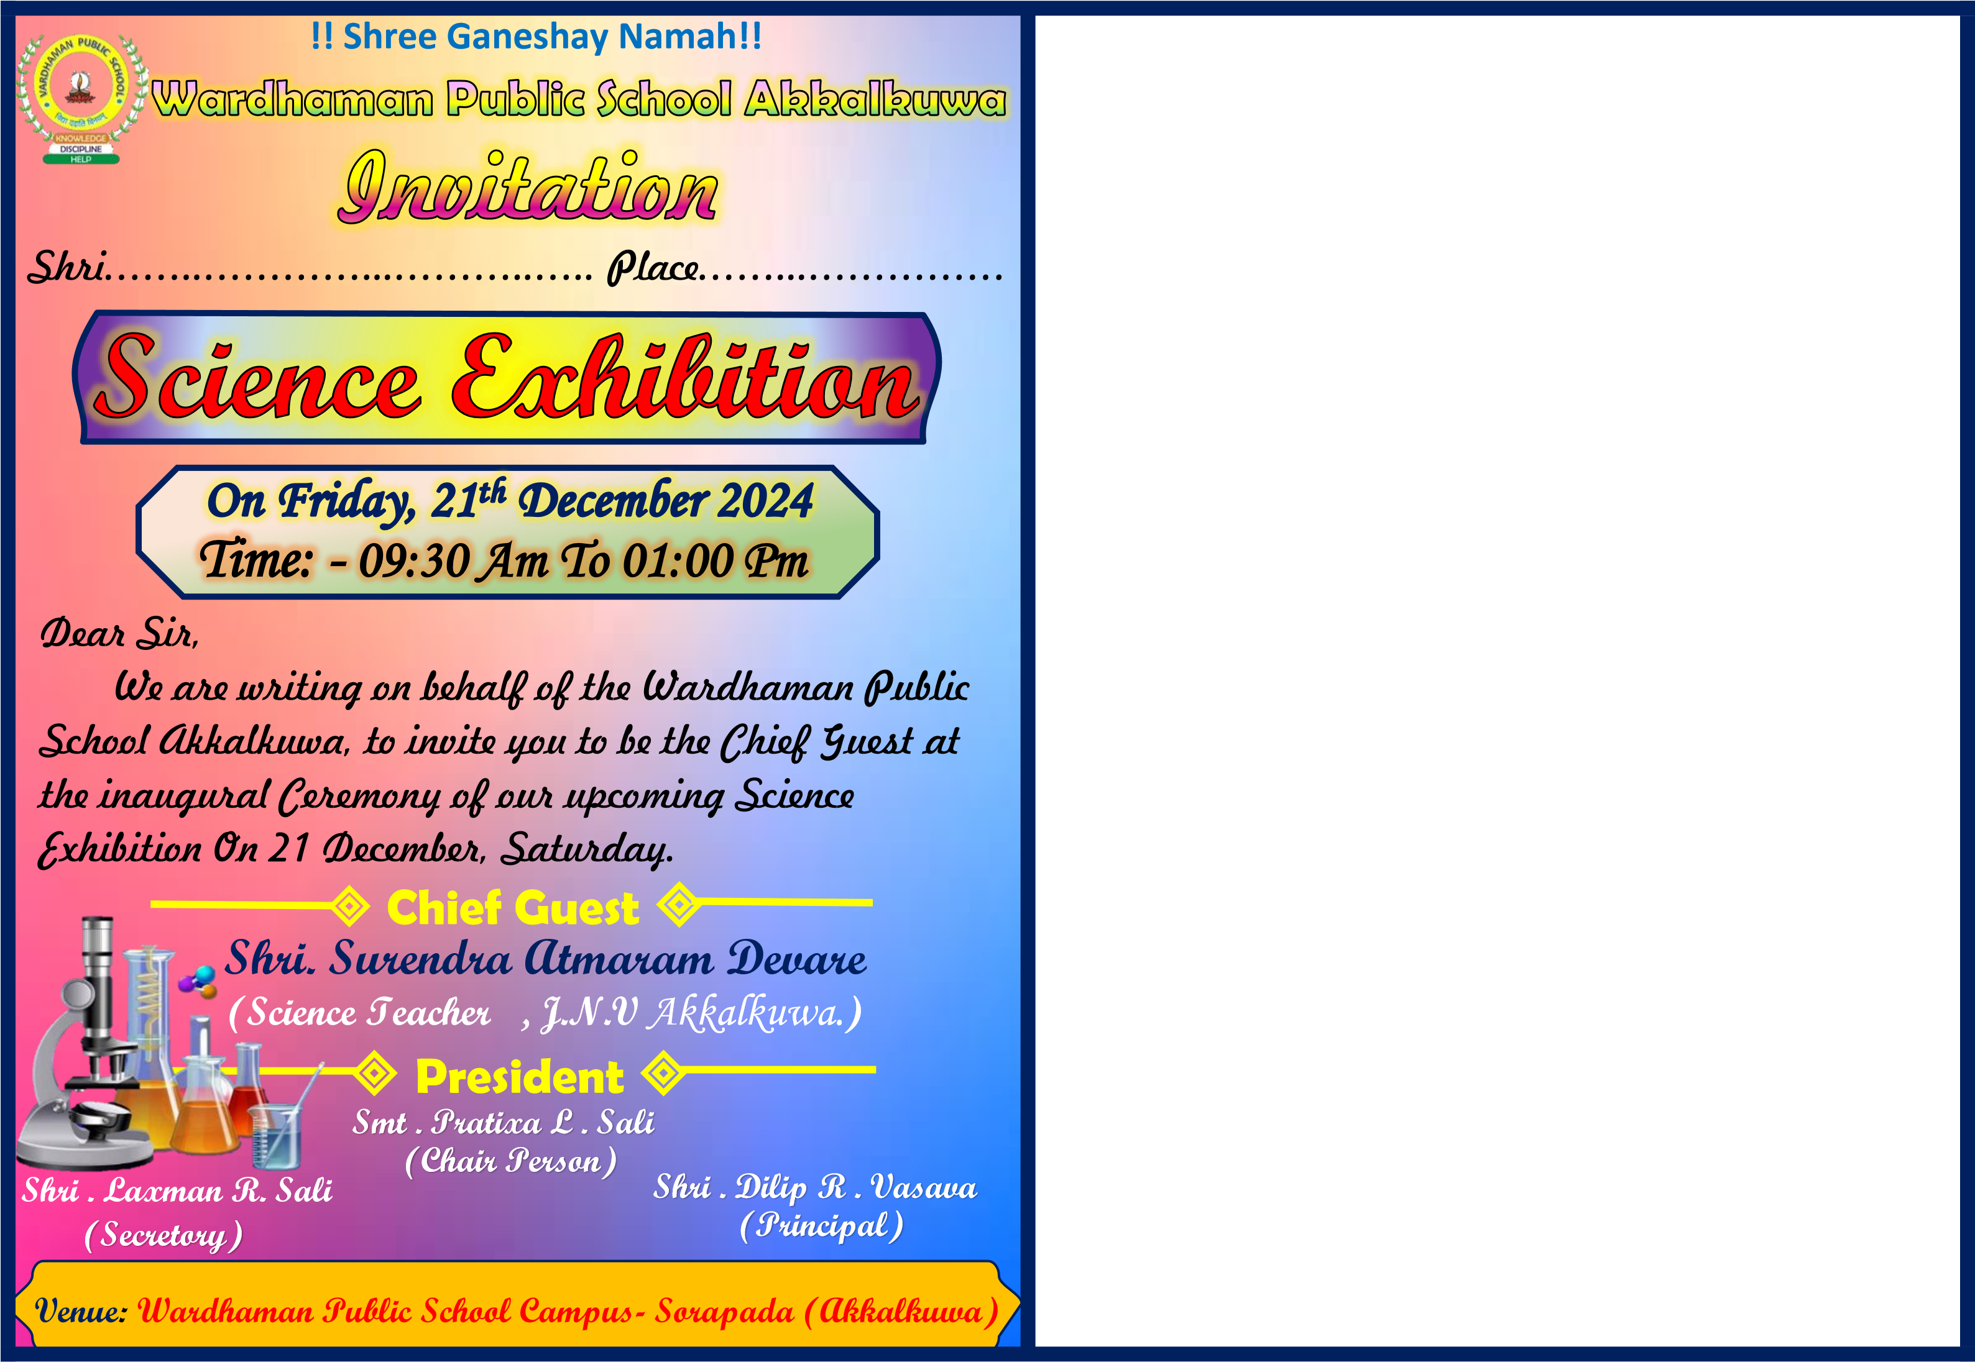


Time: 09:30 Am To 12:00

On Wednesday, 24th December 2025

Shri.kailas lohar Sir (Extension Officer Akkalkuwa ) )

Shri.Arif pinjari Sir (Cluster Head , Akkalkuwa ) )

Shri. Dilip R.Vasava

(Principal)

Shri. Laxman R.Sali

(Secretary )

(Chair Parson)

Smt.Pratixa L. Sali

Chief Guest

President

Dear Sir,
We are writing on behalf of the Wardhaman Public School Akkalkuwa, to invite you to be the Chief Guest at the inaugural Ceremony of our upcoming Science Exhibition On 24 December, Wednesday .

