Modeling Chemical Reactions

The law of mass action has its origin in modeling chemical reactions. Consider the chemical reaction between the molecules of type A and B:

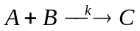

The quantities A and B on the left-hand side are called the reactants; the quantity C is called the product. The parameter k is the rate constant. A macroscopic model of this reaction assumes that the concentrations and reaction constants are well-defined. Furthermore, the concentrations vary deterministically and continuously. This leads us to describing the reaction by a differential equation. We model this reaction as

(1) 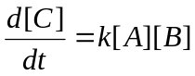

where brackets denote concentrations. The idea behind this law is that this reaction rate depends on how often the molecules A and B collide. In a well-mixed vessel, this collision rate is proportional to the product of the concentrations of A and B, denoted by [A] and [B], respectively. The law of mass action is not a law in the strict sense, but it is a good approximation when the assumptions for the macroscopic model description hold. To determine the units of the rate constant, we compare the left-hand side and the right-hand side of Equation (1). The concentration of the reactants A and B and the product C are measured in [moles/liter]. Hence, the unit on the left-hand side is [moles/liter][time]⁻¹. On the right-hand side, the unit of [A][B] is [moles/liter]². Hence, the unit of k must be [moles/liter]⁻¹[time]⁻¹.

Task 1

Consider the following chemical reaction
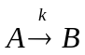
(a) Use the macroscopic modeling approach and determine the differential equation that describes how the concentration of B changes over time. (b) Use the macroscopic modeling approach and determine the differential equation that describes how the concentration of A changes over time. (c) What are the units of k if the concentrations of A and B are measured in [moles/liter]?

Chemical reactions may be linked. For instance, consider the set of chemical reactions

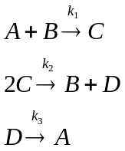
There are four types of molecules. To describe the changes in concentration of these four molecules, we need four differential equations.

(2) 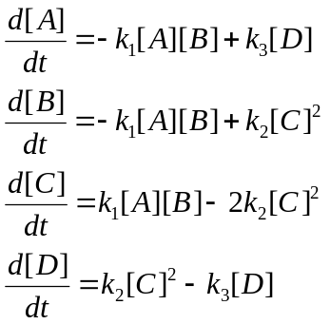

Task 2

Determine the units of the rate constants 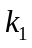, 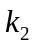 and 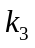 in Equation (2).

Task 3

Consider the following set of chemical reactions

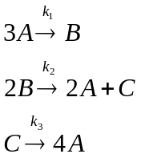

Assume that the assumptions for the macroscopic modeling apply. Find the system of differential equations that describes these chemical reactions. Determine the units of the rate constants , and .

Enzymatic Reactions

Many biochemical reactions utilize enzymes. An enzymatic reaction that transforms the substrate S into a product P requires the formation of a complex C between the substrate and the enzyme E. After formation of the product P, the enzyme E is released. This is summarized in the reaction

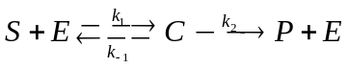

We assume that the reaction from substrate plus enzyme to substrate/enzyme complex occurs at rate 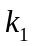 and the reverse reaction at rate 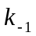. The reaction from the substrate/enzyme complex to the product plus enzyme occurs at rate 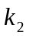. Models for this reaction were first studied by Michaelis and Menten (1913) under simplified assumptions. A more realistic model was developed by Briggs and Haldane (1925), which is still the basis for models of more complicated enzymatic reactions.
If we use the notation 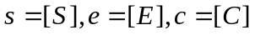, and 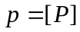, then an application of the mass action law yields

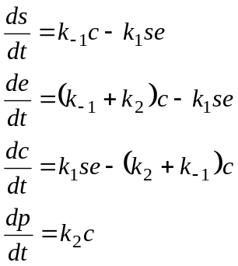

We see from this system of equations that 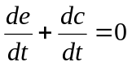. This implies that 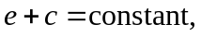 and we say that 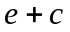 is a conserved quantity. At time 0, we assume that 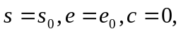 and 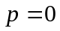. This implies that the constant is equal to 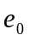. Since 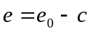, we no longer need an equation for the enzyme concentration e. This reduces the system to three equations.
Using , we can write the first two equations of the system of differential equations so that they will only contain the variables s and c:

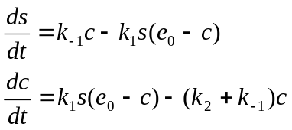

Rearranging terms, the system of three equations can be written as

(3) 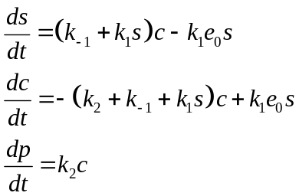

with initial conditions 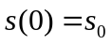, 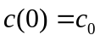, and 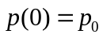. The following Matlab code solves these three equations with the given initial condition and rate constants.

% Solving the Michaelis-Menten Model mm.m

k1=1e3;
km1=1;
k2=0.05;
e0=0.5e-3;
options=[];

[t,y]=ode23(@mmfunc,[0,1000],[1e-3 0 0],options,k1,km1,k2,e0);

s=y(:,1);
c=y(:,2);
e=e0-c;
p=y(:,3);

semilogx(t,s,'r',t,e,'b',t,c,'g',t,p,'c');
legend('[S]','[E]','[C]','[P]');

% Michaelis-Menten Function mmfunc.m

function dydt = f(t,y,k1,km1,k2,e0)
% s=y(1), c=y(2), p=y(3)

dydt=zeros(3,1);

dydt(1) = (km1+k1*y(1))*y(2)-k1*e0*y(1);
dydt(2) = -(k2+km1+k1*y(1))*y(2)+k1*e0*y(1);
dydt(3) = k2*y(2);

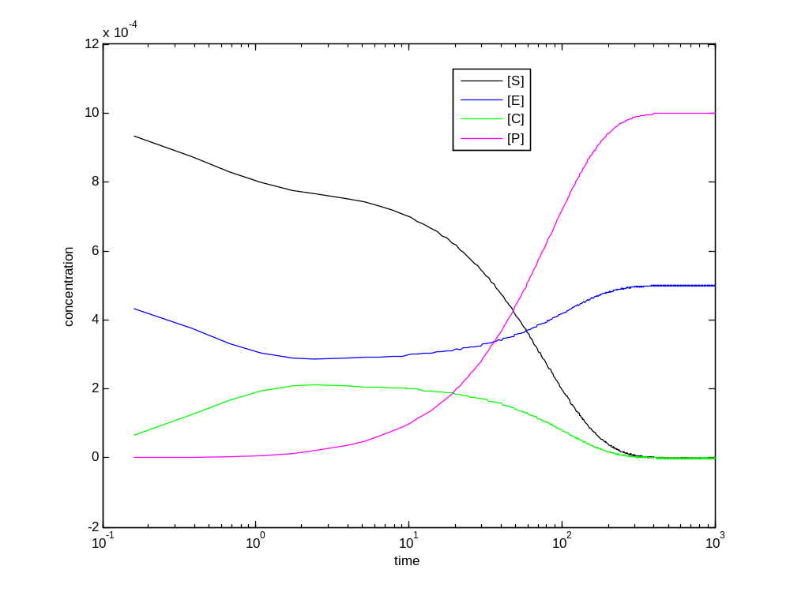
Figure 1: Time dependence of the solution of the Michaelis-Menten model with parameters given in the Matlab code.

We see that eventually all the substrate is used up and the reaction ceases. That is, as 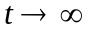, 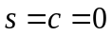, 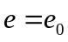, and 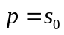.

Analytical Solution under Quasi-steady State Approximation

To analyze this system further, we will use the technique of non-dimensionalization. The idea is to change the variables appropriately so that they are dimensionless. There is no unique way of doing this and it takes experience and intuition on how to proceed. Segel (1972) wrote an excellent article on the art of scaling and simplification.
We start by dividing the differential equations for s and c by 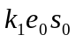:

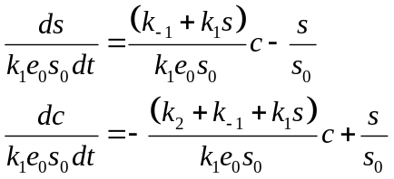

If we set 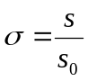 and 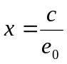, then

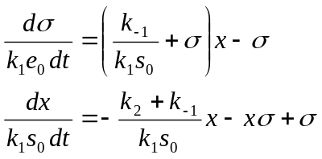

Let’s change the time scale and introduce 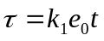, then, with 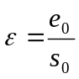, we have

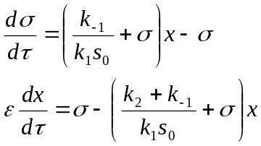

If we set 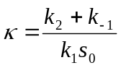 and 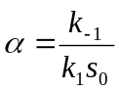, then

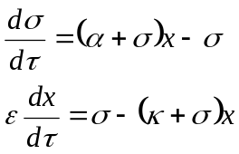

Quasi-steady State Approximation

In biochemical reactions, typically, e₀ is much smaller than s₀, which makes ε a very small quantity. It follows that 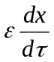 is close to 0 and this insight was used by Briggs and Haldane (1925) to justify the “quasi-steady state approximation” 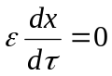. It follows that

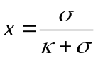

and hence

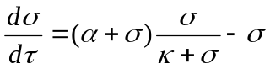

or, after simplifying,

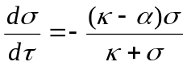

Now, 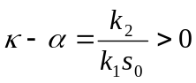 and we set 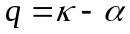. Then

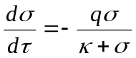

Using the original variables, we find for the velocity of the reaction

(4) 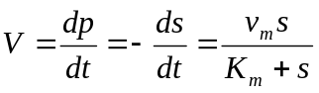

where 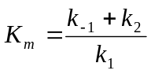 is the half-saturation constant and 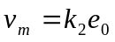 is the maximal reaction rate. Equation (4) is the classical Michaelis-Menten equation. This equation models the initial rate at which substrate is converted into the product. During this initial period, the formation and the break-up of the enzyme-substrate complex reaches a quasi-steady state before product formation becomes noticeable.

Lineweaver-Burk transformation

The function 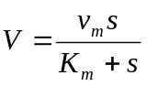 is called the Michaelis-Menten function. It is an important function and it is used to fit data to determine 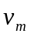 and 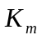.
To determine and 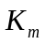, the Lineweaver-Burk transformation is frequently applied. Writing

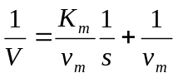

we see that in a graph where the horizontal axis is 1/s and the vertical axis is 1/V, the relationship is a straight line. The intercepts allow us to estimate and .

Reading Assignment (due on _________________________)

Read the paper by Hasty et al. 2000.

Computer Lab (Homework due _________________________)

Step 1

The following data set describes the degradation of a substance with concentration s. The velocity of the reaction V as a function of s was measured. Use the Lineweaver-Burk transformation to find and . That is, plot 1/V as a function of 1/s and use a regression line to find the equation of the straight line fitted to this transformed data. Use the equation to then find the two parameters and .

Velocity V | Substrate Concentration s
0.025 | 0.04
0.033 | 0.07
0.042 | 0.12
0.081 | 0.25
0.11 | 0.42
0.175 | 0.8
0.17 | 0.92
0.2 | 1.7
0.21 | 2.9
0.22 | 4.3

Step 2

The half-saturation constant K_{m} is called the affinity. We found
Use EXCEL to graph K_{m} as a function of k₁ and use calculus to show that K_{m} is a decreasing function of k₁, i.e., differentiate K_{m} with respect to k₁, and show that the derivative is negative. (For the graph, set 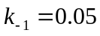 and 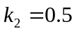 and let vary between 0.3 and 5.0 in steps of 0.1.)

Step 3

(a) Set 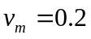, 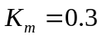, and 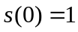. Use the Euler method to numerically approximate the solution of

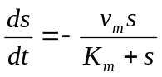

for 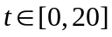 (set the step size equal to 0.01).
(b) Now vary K_{m} between 0.1 and 0.9 (stepsize equal to 0.2). For each value of K_{m}, find the time at which the concentration of the substrate is half its initial value (i.e., 0.5). Graph this time as a function of K_{m} and use a linear regression line to predict the time when 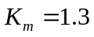. Check your prediction using the numerical approximation.

Step 4

Complete Tasks 1-3.

Gene Regulatory Networks

Cells control their functions through regulating gene expressions. Many of these regulatory processes are at the level of gene transcription. A common framework for modeling these interactions is biochemical reactions. This deterministic framework ignores fluctuations and can be considered as describing the time evolution of the means of various quantities of interest.
We will use the example given in Hasty et al. (2000) to introduce this kind of modeling. Their work is motivated by the lysis-lysogeny decision of the bacterial phage lambda. Their first model, which we will study, is a mutant system with two operators, OR2 and OR3. The gene encodes for a repressor protein that dimerizes and binds to either operator. The dimerized protein enhances transcription if it binds to OR2, and represses transcription when it binds to OR3. We use the notation in Hasty et al. to explain the dynamics. We denote by X the repressor, by X₂ the dimerized repressor, and by D the DNA promoter site. Then

(5) 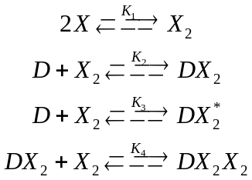

Here, 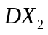 and 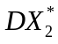 denote the dimerized proteins that bind to OR2 and OR3, respectively. 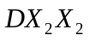 denotes binding to both operators. The constants 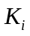 are forward equilibrium constants. That is, if a biochemical reaction is described by

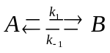

then, the corresponding rate equation is

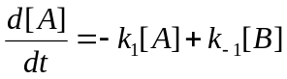

and at equilibrium,

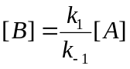

The forward equilibrium constant would be 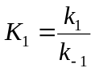.

The reactions in (5) are fast compared to transcription and degradation, the slow reactions. These are given by

(6) 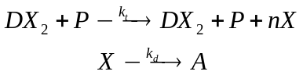

where P is the concentration of RNA polymerase and n is the number of proteins per mRNA transcript. Note that the arrows in these two reactions only point in one direction, reflecting that these reactions are irreversible.

Hasty et al. (2000) considered an in vitro system where this small gene regulatory network is contained in a plasmid and the whole system contains a large number of plasmids to justify the rate equation approach. We define the following variables: 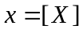, 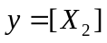, 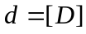, 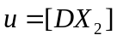, 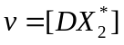, and 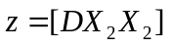. Then the evolution of the repressor protein is given by

(7) 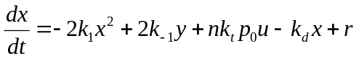

where r is the expression rate of the gene in the absence of transcription factors. Assuming that the reaction in (5) are fast compared to the ones in (6), we can again use a quasi-steady state approach and assume that the reactions in (5) are at equilibrium. We assume that 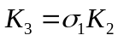 and 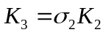. This implies that

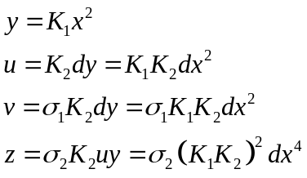

It is further assumed that the total concentration of DNA promoter sites, denoted by 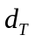, is constant. That is,

It can be shown that Equation (7) simplifies to

(8) 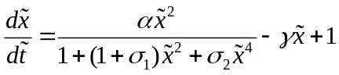

where 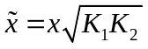, 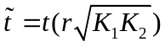, 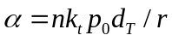, and 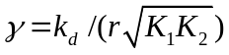.
To find equilibria, we set the right hand side of (8) equal to 0. that is,

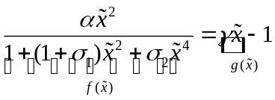

If we plot  and 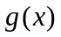 in the same coordinate system, the points of intersection are the respective equilibria.
The following Matlab program both solves the differential equation (6) and plots the two functions and in the same coordinate system.

% Solving the Hasty Model hasty.m

alpha=50;
gamma=5;
sigma1=1;
sigma2=5;
options=[];

[t1,y1]=ode23(@hastyfunc,[0,10],[0],options,alpha,gamma,sigma1,sigma2);
[t2,y2]=ode23(@hastyfunc,[0,10],[1],options,alpha,gamma,sigma1,sigma2);

x=0:0.01:2;
f=alpha*x.^2./(1+(1+sigma1)*x.^2+sigma2*x.^4);
g=gamma*x-1;
subplot(1,2,1), plot(x,f,'k',x,g,':k');
xlabel('repressor concentration');ylabel('f(x) and g(x)');legend('f(x)','g(x)');title('Equilibria');
subplot(1,2,2), plot(t1,y1,'--k',t2,y2,'k');
xlabel('time');ylabel('repressor concentration');legend('x(0)=0','x(0)=1');title('Dynamics');

% Hasty Model hastyfunc.m

function dydt = f(t,y,alpha,gamma,sigma1,sigma2)
% x=y(1)

dydt=alpha*y(1)^2/(1+(1+sigma1)*y(1)^2+sigma2*y(1)^4)-gamma*y(1)+1;

We will investigate this model for different values of to understand Figure 1 in Hasty et al.

Task 4

Use the Matlab code and simulate the model for 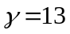, 15, and 17. Relate the outcome of your simulations to Figure 1B (mutant case).

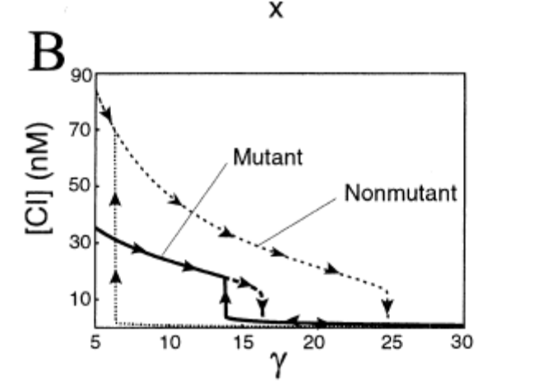
Figure 2: Figure 1B from Hasty et al. 2000

Introducing Noise (Optional)

Hasty et al. introduce noise into this system. While we will not numerically solve the dynamics of the other models in this paper, we will introduce the notion of noise. Noise is often modeled using Brownian motion or the Wiener process. The standard Wiener process is denoted by 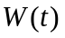. It is a stochastic process defined on the interval 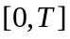 with the following properties:

(1) 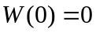
(2) For 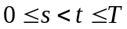,

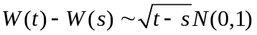

where 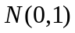 is a normal distribution with mean 0 and variance 1.
(3) For 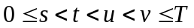, 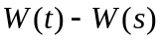 and 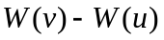 are independent.

To simulate this process in Matlab, note that randn generates a realization of the distribution .

%Simulation of the Wiener process brown.m

T=1;
n=500;
dt=T/n;
randn('state',100); %initializing random number generator

dW=sqrt(dt)*randn(1,n); %generating increments
W=cumsum(dW); %computing cumulative sum

plot([0:dt:T],[0,W],'-k');
xlabel('Time t'); ylabel('W(t)');

This noise process can be added to a deterministic differential equation in the following way

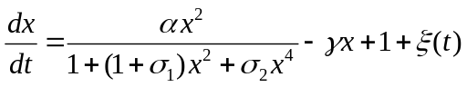

where we dropped the “tilde” throughout. The term 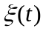 is white noise. Its mean is 0 and its covariance is 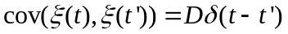 where D is proportional to the strength of perturbation. We can also write formally

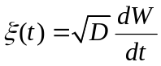

(This is only a formal derivative since the derivative of the Wiener process does not exist with probability 1.)

Michaelis, L. and M.I. Menten. 1913. Die Kinetik der Invertinwirkung. Biochem. Z. 49: 333-369.
Briggs, G.E. and J.B.S. Haldane. 1925. A note on the kinematics of enzyme actions. Biochemical Journal 19: 338-339.
Segel, L.A. 1972. Simplification and Scaling. SIAM Rev. 14: 547-571.
Hasty, J., J. Pradines, M. Dolnik, and J.J. Collins. 2000. Noise-based switches and amplifiers for gene expression. PNAS, 97(5): 2075-2080.

