Investigating the impact of social engineering attacks and developing defense mechanisms

Naila Andalive
Information Technology
Gateway Business College
Sydney, Australia
nailarafsa121@gmail.com

Bandana Lamichhane
Information Technology
Gateway Business College
Sydney, Australia bandannalamixane@gmail.com
Shova Bhujel
Information Technology
Gateway Business College
Sydney, Australia
shovabhujel250@gmail.com

Dr Fazla Rabby
Information Technology
Gateway Business College
Sydney, Australia fazla@gatewaycollege.edu.au
Rojina Lama Syangtan
Information Technology
Gateway Business College
Sydney, Australia
tractorlama@gmail.com

Dr Sabira Khatun
Information Technology
Gateway Business College
Sydney, Australia
sabira@gatewaycollege.edu.au

Abstract— Sensitive information or any system is frequently compromised through social engineering attacks which exploit human psychology and integrity. This project aims to investigate different techniques implemented in social engineering attacks, their potential attacks, effective and reliable defenses. By administering a comprehensive analysis and examination of existing case studies, we will figure out the common vulnerabilities and invent tactics and decent blueprints to moderate their outcome. The aim is to develop functional defense mechanisms that can help industries and organizations protect their systems from advanced attacks and protect their significant assets.

Keyword: Social Engineering, Defense Mechanism, Human Psychology

Introduction
Social engineering attacks are one of the most prominent and constantly developing threats as of now in the sphere of cybersecurity (Gururaj, 2024). Social engineering is different from conventional hacking in that instead of aiming at the technical flaws of a system, the former exploits the psychological ones, which probably makes it even more dangerous (Griffiths, 2023). The growing complexity of such tactics combined with the enhanced use of communication technology has enhanced the risk of such attacks (Schneier, 2023). It is not only the high number of social engineering attacks but the level of volatility they bring to human life and all corporations. Their losses include material loss, identity theft, and damage to reputation (Zaoui, 2024). For the organizations, the consequences can be even more drastic such as losing the whole data or having legal troubles or most importantly the customer’s trust. To this extent, this research intends to investigate the processes through which social engineering is carried out, evaluate the impact of these processes, and finally, seek ways of managing these threats.

Literature Review
Scholars have written comprehensive articles that would provide an overview on social engineering attacks which are actually a good number of studies that would seek to shed light on the methods and principles associated with such attacks. Academics have explored various techniques including phishing, spear-phishing, baiting, and pretexting and more specifically how the attacker leverages trust, fear, and time pressure. Social engineering attacks have quickly become a significant security issue in the field of cybersecurity, aiming to attack individuals themselves for gaining unauthorized information (Hadnagy, 2018). These attacks rely on phishing, pretexting, and baiting techniques, exploiting the human factor in ways that technological defences cannot fully protect against (Krombholz et al., 2015).
Many data breaches attributed to social engineering are often due to human errors and insufficient security awareness training (Sheng et al., 2010). To mitigate these threats, defence mechanisms have evolved. User education and training are crucial for preventing the effects of social engineering (Tischer et al., 2016). Companies increasingly implement regular security awareness programs to update employees on the latest attacker techniques. Furthermore, technical defences like email filtering, multi-factor authentication (MFA), and anomaly detection systems significantly reduce the chances of successful attacks (Wang et al., 2019).
Social engineering is that psychological trick which is done on individuals to make them perform tasks or give out confidential information (Mitnick & Simon). Imagine a human trust element with cognitive biases and little awareness making it possible for attackers to penetrate the strongest technological defences. As Hadnagy (2018) states, a successful social engineering technique would involve manipulators using fear combined with urgency and empathy.

(Abawajy, 2021), states that social engineering attacks have increased because of the COVID-19 global pandemic since most people work online and interact virtually. New-age cyber attackers now use sophisticated techniques, including deepfake and AI-generated fake emails, followed by meticulous social engineering sequences in actual methods.

More than 82 people commit breaches due to human error, which is combined with social attacks and user mistakes or misuse of systems. Mobile-first communication has brought new forms such as smishing (SMS phishing), which complicates the detection, as described by (Kaabouch, 2019)
The total losses for cybercrime in the world stood at over $1 trillion by 2018 (Ibrahim 2019). The first six months of 2018 were particularly dreadful as 4,553,172,708 records were breached as per the Breach Level Index's 2018 First Half Review report. It was reported that the most significant contributors to these data breaches are negligent errors and deficient safety protocols (Keepnet Labs 2018). According to Figure 3, 65% out of the stated incidents dealt with identity theft, while 56% of all these breaches by outsiders were of malicious origin (Keepnet Labs 2018). Other losses of this kind, usually related to people's mistakes, accounted for 34% of breaches due to pioneered practices in the industry (Keepnet Labs 2018). Unauthorized access to confidential information and financial access were about 13% and 17% of all cases, whereas 7% of breaches occurred due to the activities of malicious insiders (Keepnet Labs 2018). In the time of digitalization coupled with the very expansion of cybercrime, it has become more paramount to have and understand the need for security measures in order to reduce the overall losses resulting from the said form of crime.
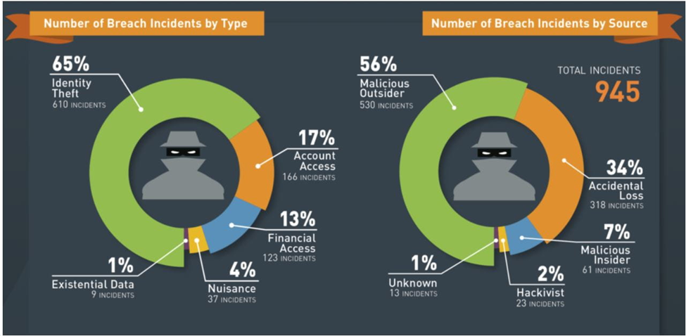

Methodology

Primary research
The primary research concerning the SE attack aimed at acquiring first-hand information concerning the state of SE presence in healthcare, including nursing. This research supported the secondary research which involved the analysis of literature on the SE attacks; by gathering primary data from the professionals in the field of cybersecurity and health care.
Survey Methodology
The online survey was conducted with participants including 50 professionals working in healthcare organizations and in cybersecurity related jobs. The survey was intended to establish the various SE attacks experienced, the prevalence of such attacks, and measures which are currently in place to prevent SE attacks. The type of questions used were such that they could elicit numerical responses, that is, how many times such incidences happen? And narrative type of responses, that is, anecdotes and the precautions people take to avoid such incidents. In line with its objectives, the survey employed quantitative methods of data collection in line with the secondary research.
Interview Methodology
Semi-structured interviews were carried out with 10 cybersecurity practitioners and IT administrators who worked in healthcare organizations. SE attacks affect many organizations across the globe; these interviews were focused on understanding their consequences on organizations and more so on the nursing staff. The interviews centered on issues that were identified in the secondary research that included the SE vulnerabilities and the efficiency of defence strategies. Primary and secondary data Both quantitative and qualitative data for this, the questionnaires developed were helpful in yielding quantitative data. Having the primary data enhanced the result by including this qualitative data (Creswell & Creswell, 2017).

Data Analysis
The collected surveys were then only analysed by descriptive statistics just like the quantitative data analysis done on secondary data collection. In the interviews, thematic analysis was conducted to compare the findings with the primary data with the findings obtained from the secondary research. Whenever possible, the results produced were checked against earlier research to confirm or otherwise the conclusions or listed as a primary or secondary source.
To conduct this study, only articles published in English, in articles that were authored or co-authored by the PI and research team members between 2011 and 2020 were included. It was composed of studies that examined the impact of South-Eastern (SE) attacks on the nursing discipline while at the same time excluding qualitative studies. This criterion helped in making sure that the research was anchored on quantitative approach and available data.

Key Findings
Research results demonstrated that social engineering attacks are one of the most serious and rapidly developing cybersecurity threats affecting human psychology rather than technology vulnerabilities. They can capitalize on psychological biases, emotional responses, and social trust to deceive people into revealing confidential information or taking actions that put security at risk. Addressing different attack scenarios such as phishing, baiting, and pretexting, the study elucidates how these strategies are becoming increasingly sophisticated because of advances in communication technology. Organizations suffer major financial damages, data breaches, and even smaller enterprises have their reputational damage at stake due to an IT mess-up—a risk usually assumed by individuals—on the brighter side! The findings highlight the importance of a defense in-depth strategy involving technical controls such as multi-factor authentication and email filtering combined with consistent employee training and awareness efforts. It also reinforces the need for organizations to refresh their defense strategies more continuously to match the evolution of social engineering tactics.

Conclusion
Social engineering attacks remain a big threat in the digital era, exploits to gain unauthorized access to the sensitive information. In Spite of evaluations in technology, social engineering attacks continue to be efficient due to integrity and weakness. The research also finds that dealing with SE attacks needs a mix between consciousness of technology and human responsibility. However, the results highlight that defense mechanisms must be about human behavior to provide adequate security. In their paper, authors recommend a Web Platform for data mining of human responses to SE attacks. ( Gan, D., 2016.) By analyzing this research, we can gain more knowledge into the ongoing vulnerability to SE attacks and suggest both technological as well as human-centric measures for their representation.

Acknowledgment
The authors would like to acknowledge the Gateway Business College (GBC) Australia for providing the facilities and support to conduct this project/work. GBC, https://gatewaycollege.edu.au/.

References

- G. Eason, B. Noble, and I. N. Sneddon, “On certain integrals of Lipschitz-Hankel type involving products of Bessel functions,” Phil. Trans. Roy. Soc. London, vol. A247, pp. 529–551, April 1955. (references)
- J. Clerk Maxwell, A Treatise on Electricity and Magnetism, 3rd ed., vol. 2. Oxford: Clarendon, 1892, pp.68–73.
- I. S. Jacobs and C. P. Bean, “Fine particles, thin films and exchange anisotropy,” in Magnetism, vol. III, G. T. Rado and H. Suhl, Eds. New York: Academic, 1963, pp. 271–350.
- K. Elissa, “Title of paper if known,” unpublished.
- R. Nicole, “Title of paper with only first word capitalized,” J. Name Stand. Abbrev., in press.
- Y. Yorozu, M. Hirano, K. Oka, and Y. Tagawa, “Electron spectroscopy studies on magneto-optical media and plastic substrate interface,” IEEE Transl. J. Magn. Japan, vol. 2, pp. 740–741, August 1987 [Digests 9th Annual Conf. Magnetics Japan, p. 301, 1982].
- M. Young, The Technical Writer’s Handbook. Mill Valley, CA: University Science, 1989.

