\*\*\*\*\*\*\*\*\*\*\*\*\*\*\*\*\*\*\*\*\*\*\*\*\*\*\*\*\*\*\*\*\*\*\*README\*\*\*\*\*\*\*\*\*\*\*\*\*\*\*\*\*\*\*\*\*\*\*\*\*\*\*\*\*\*\*\*\*\*\*\*

Step by step instruction

1. First download the latest version of the python and build the tkinter modules

For create tables and load values into the database, run the code (python v3 already installed

For the Windows users –*Pip install tkinter or pip install tk*

For the Linux and Mac users –*app-get install python – 3*

1. Create and activate the Python Virtual environment

*Python3 -m venv venv*

*Source ./venv/bin/activate*

*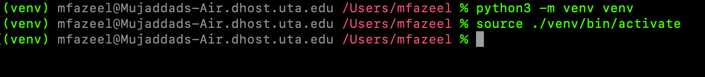*

1. Next, Install all the requirements from the requirements.txt file

*pip install -r requirements.txt*

1. Run the Python file

*Python CarRental.py*

And it will show you GUI Interface and after that you just need to follow prompts in the GUI.

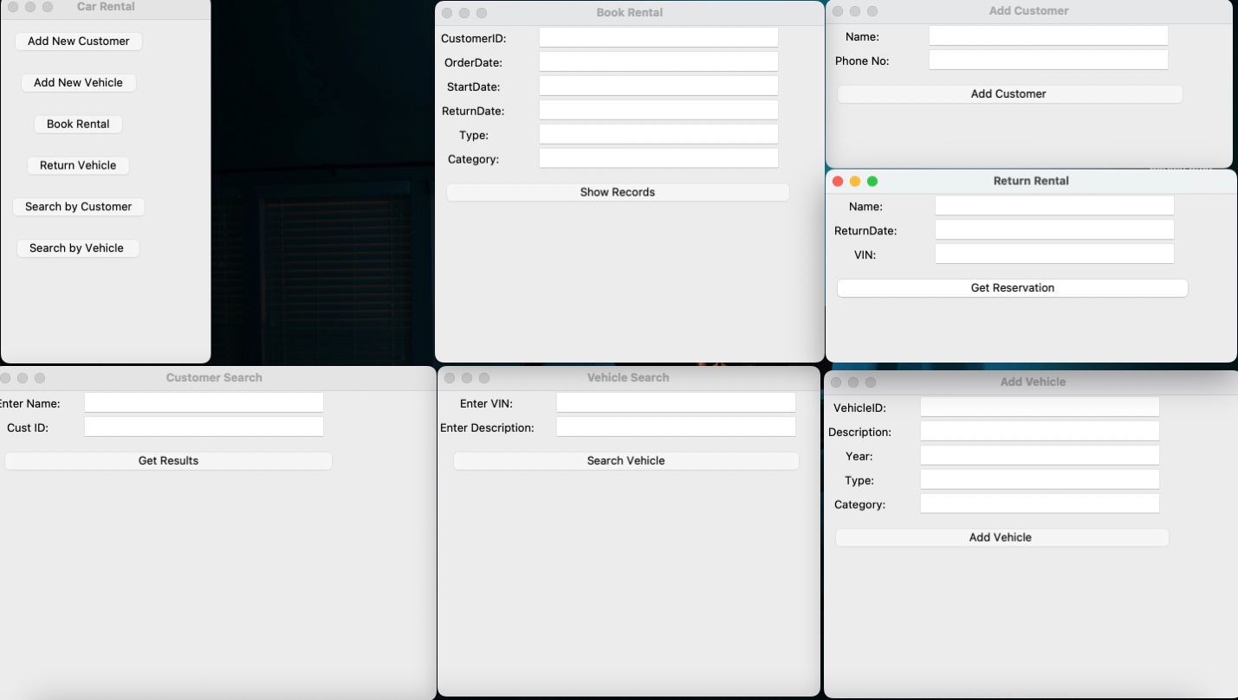

From this we can take the customer input in any of the windows and get the desired results as shown

