Classifying Cats and Dogs with Transfer Learning
An automated recognition of species can be used in practices like surveillance and security measures of wildlife. In this posting, we outline our method of classification of binary images in a 10,000 image set of cats and dogs.

1. Data Overview
The set of training was balanced (5,000 per class). Images were divided in two (70/30) training and validation (random_state=100).
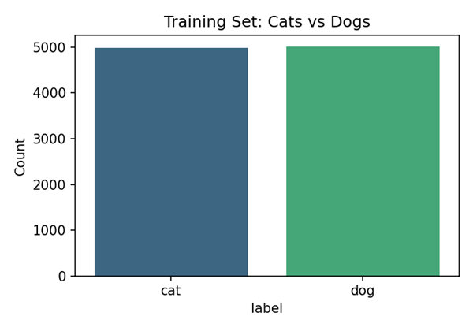
Class Balance

2. Classical Baseline: Random Forest on Colour Histograms
In the case of deep learning, a classical pipeline was tried before. The images have been resized to 64x64 and converted to HSV colour space. Per-channel histograms (32 bins, a total of 96 features) were obtained and inputted into a Random Forest (200 trees). Distribution of colours did not work well in fine-grained classification with a mere 63.67% accuracy.

3. Transfer Learning: MobileNetV2
We used MobileNetV2 that was pretrained on ImageNet, and only a lightweight head (GlobalAveragePooling, 30% Dropout, single Sigmoid neuron) was trained. Pictures were rescaled to 150x150 and normalised to [0, 1]. The augmentation of training consisted of 15-degree rotation, 10% width height shifts and horizontal flipping. Overfitting was avoided by EarlyStopping (patience 3).
Model | Validation Accuracy
Random Forest + colour histograms | 63.67%
MobileNetV2 (transfer learning) | 95.93%

4. Discussion
MobileNetV2 was more than 32 points ahead of the baseline. ImageNet pretraining has deep higher-level features (edges, textures, shapes) which are useful to animal classification. The frozen-base approach continued training quickly (5 epochs) and the Dropout layer helped counter the overfitting on our relatively small dataset. The confusion matrix indicated that the performance was close to symmetric in both classes and this supported the presence of good generalisation. Our final model to use in the 1,000 test predictions was MobileNetV2.
Code Notebook
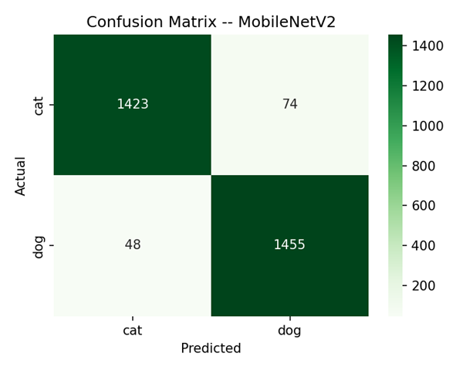
Confusion Matrix – MobileNetV2

