Detecting Offensive Language in Tweets
Identification of Offending Language in Tweets. Abuse over the internet has a highly adverse impact on internet community setups. Our 3-way classification pipeline (NOT = Not Offensive; TIN = Targeted Insult; UNT = Untargeted profanity) of tweets is presented to you in this post
1. Data and Proprocessing
There were 13,240 tweets in the training set, and they were extremely skewed in the favor of the NOT class.
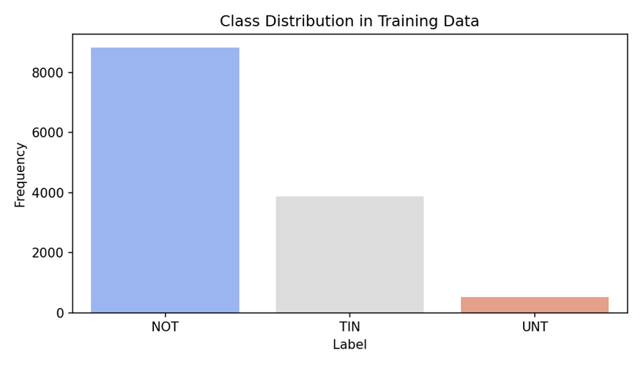
Class Distribution
The following were the pre-processing steps used on all the tweets: - Conversion of the tweets into lower case to ensure uniformity. - Elimination of placeholders+non alpha characters (username, URL) - Porter reducing inflection to root words (i.e. attacking = attack). - Stop words were not eliminated on purpose; the reason behind this is that in the majority of abusive language pronouns (i.e. you, your) provide a definite indication of an intended abuse, and they would be missing useful signals by eliminating them.
2. Feature Extraction
In order to be consistent to our probabilistic and linear classifiers (associated with raw count of items, rather than term frequency-inverse document frequency) and with a Bag-of-Words (CountVectorizer) representation bounded by a vocabulary of 5,000 unigrams we used a vocabulary of 5,000 unigrams. The limit on this vocabulary is used in order to overcome possible overfitting with rare tokens.
3. Models and Results
We randomly divided data in 7080 (random state =100) and measured the performances of 3 classifiers.
Model | Accuracy | Weighted F1
Logistic Regression | 0.6921 | 0.7014
Decision Tree | 0.6511 | 0.6367
SGD Classifier | 0.7059 | 0.7063
Considering the high level of imbalance between classes, we laid stress on the weighted F1 metric. On the weighted F1 and the accuracy, the SGD Classifier (hinge loss with balanced class weights) had the highest performance rating.
4. Discussion
SGD classifier worked well with the high-dimensional sparse feature space because of the high-dimensional sparsity of the data and the capabilities of the algorithm to operate with a linear decision boundary as well as a stochastic optimization algorithm. Balanced class weights contributed greatly to recall of the extreme minority class UNT of about zero to 24%. But the accuracy remained low (17) with UNT due to its rarity. The decision tree model is most likely not to generalize well as the model will overfit regardless of depth limitations. This implies that tree-based techniques might not be very suitable in the representation of sparsely represented text data.
Code Notebook
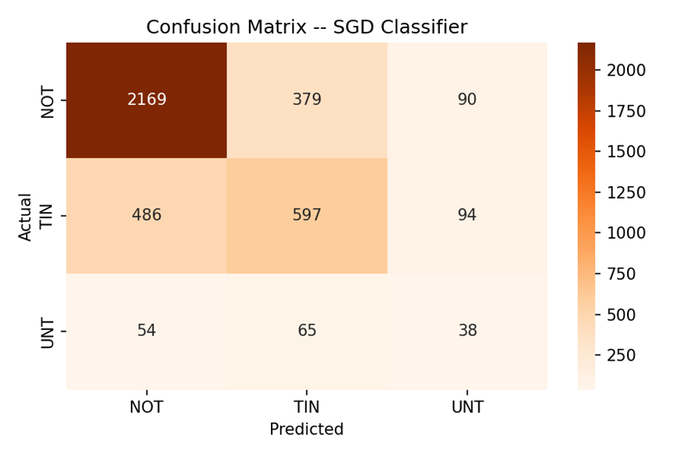
Confusion Matrix

