Forecasting Patient Heart Rate
The heart rate monitors are helpful in the early identification of cardiac abnormalities. This post describes how we use sensor data of a patient to make predictions about the next 20 minutes of heart rate based on the sensor data made within the span of around four hours.
1. Data Preparation
There were 226 minute-by-minute Lifetouch Heart Rate data in the dataset. Eight sensor-error data samples (~61,441 bpm) were located and imputed with forward-fill, which imputes with the final valid value instead of the average of the neighbours. The purified series was between 106-172 bpm.
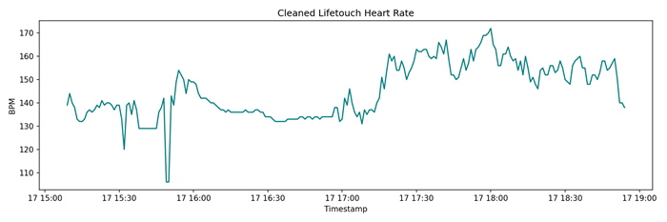
Cleaned Heart Rate Series2.
Stationarity Analysis
An Augmented Dickey-Fuller test gave a p-value of 0.28, which is greater than the value of 0.05. This implied that the series was not still and hence we needed to add a differencing term (d=1) to our ARIMA-family candidates. There was inspection of ACF and PACF plots to inform selection of lags.

3. Models and Evaluation
The last 20 observations were withheld to validate which is equal to the necessary prediction horizon. There were three benchmarked models:
1. ARIMA(1,1,1) – a small diffused model.
2. SARIMA(1,1,1)(0,0,0,0) – checking improvement of fit of a seasonal component (there was none).
3. Simple Exponential Smoothing (SES) – a pure level-based smoother.
Model | RMSE | MAE | MAPE
ARIMA(1,1,1) | 6.855 | 4.861 | 3.32%
SARIMA | 6.855 | 4.861 | 3.32%
SES | 7.938 | 5.734 | 3.93%

4. Conclusion
SARIMA as well as ARIMA (1,1,1) gave exact results (seasonal component added no value), as compared to SES. The last model chosen was the parsimonious ARIMA(1,1,1). Trained on the entire 226 data, it opened a 20-step prediction with a mean of 146bpm, which agrees with the series tail.
Code Notebook
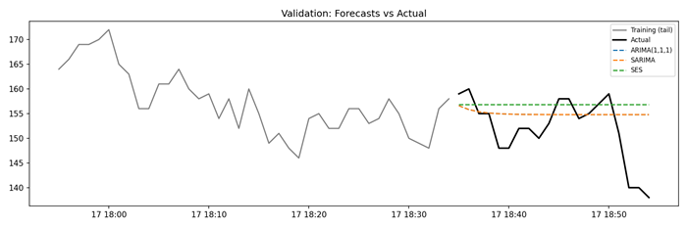
Validation Forecasts

