

**APPLIED COMPUTER SCIENCE DEPARTMENT**

**FACULTY OF INFORMATION TECHNOLOGY AND COMMUNICATION**

**Lab session 3: Multi-Screens Design using Flutter**

**NAME :** Adrien Esther

**MODULE:** PMH

**DATE:** 10/04/2023

**Task 1**

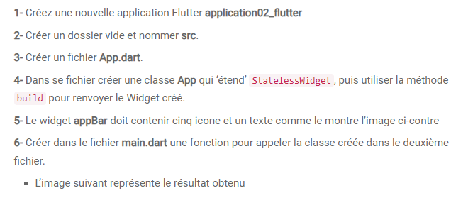

**Step 1:** I’ve created a flutter project name: **application02_flutter**

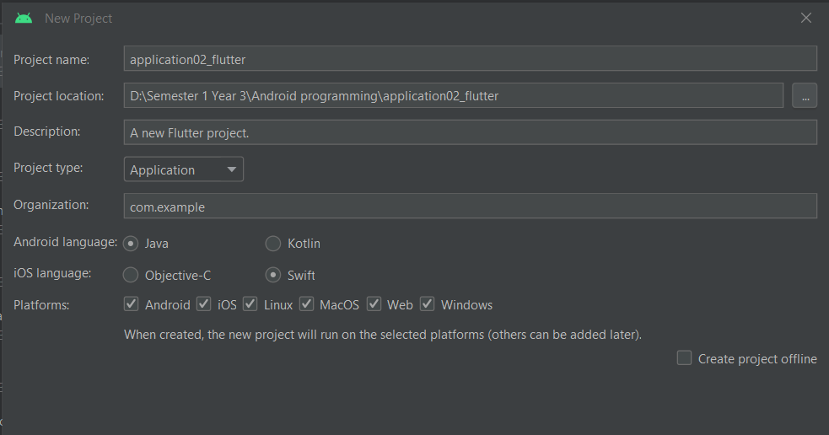

**Step 2:** Create a folder src in lib directory

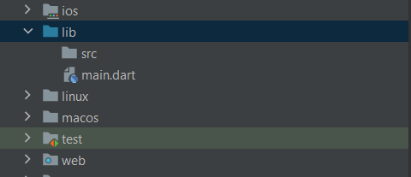

**Step 3:** Create a dart file name: **App.dart**

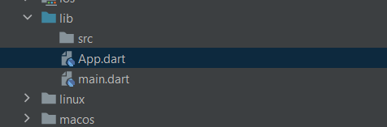

**Step 4:** I’ve created a class name **MyApp** then use the build method which is an overridden method from the StatelessWidget class which returns MaterialApp

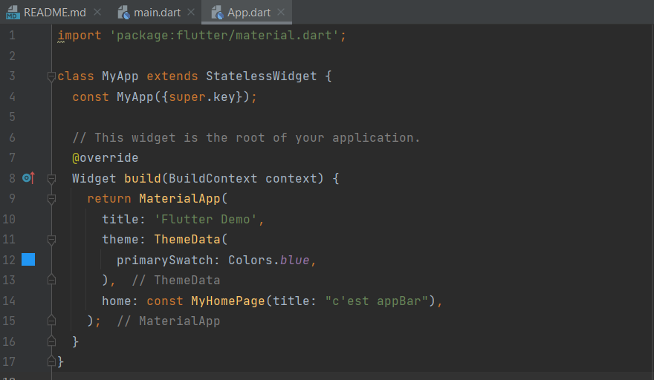

**Step 5:** Create 5 icons and 1 text in the widget appBar.

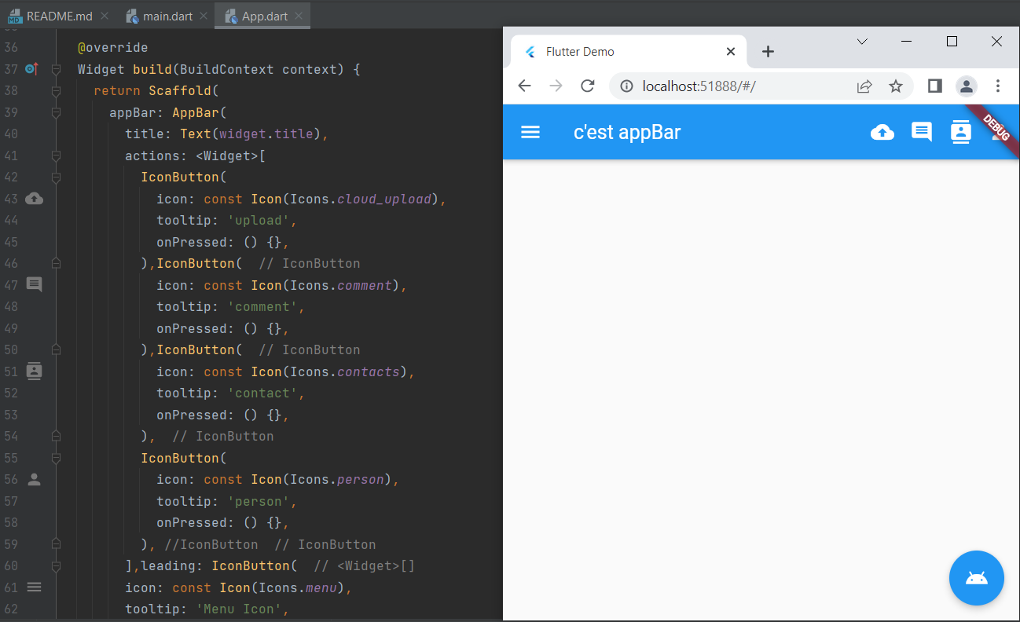

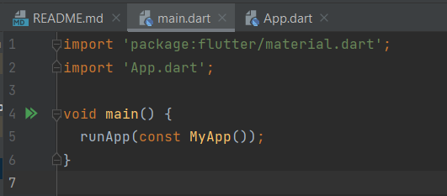**Step 6:** Create a function in the **main.dart** file that will call the class **myApp** in the **App.dart** file.

**Task 2**



I’ve created a folder name **screens** from where I’ll add all necessary dart file for the multi-screen app.

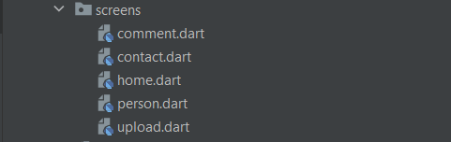

In the folder screens, I’ve created 5 dart files which will be used to navigate from any 1 file to another.

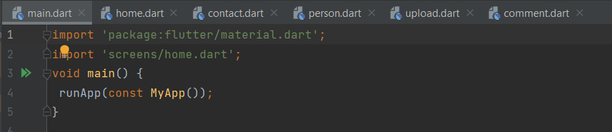

In this case, the home property is set to a widget named Home, which is defined in another file, likely home.dart. This means that the **Home widget** will be the first screen displayed when the app is launched.

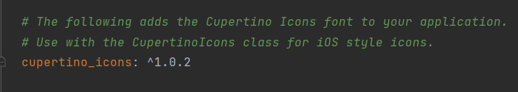

In the **pubspec.yaml** , we’ll need to import the **Cupertino_icons** as we are working with icons on the code lab.

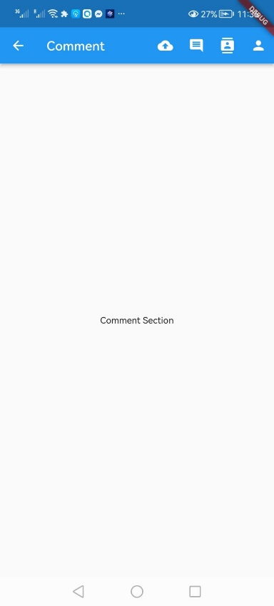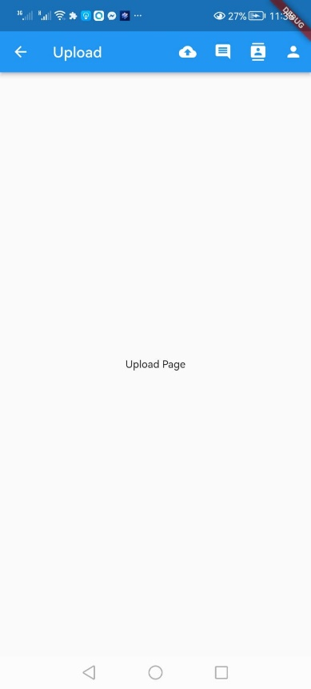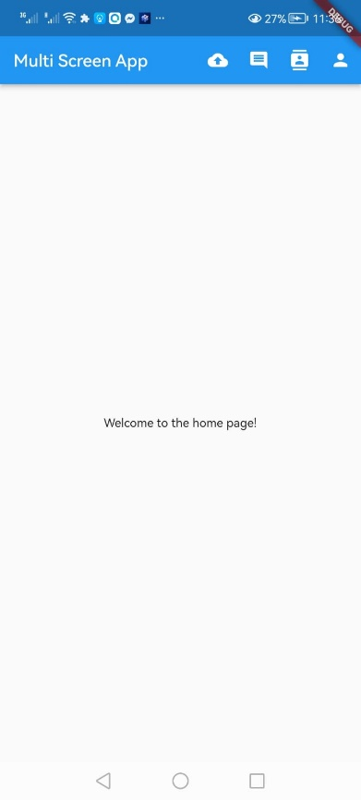**Final Layout:**

