Valorant: A Sentinel’s Eagle Eye

**Commands for Router Configuration:**

**Bind:**

enable

config t

interface Serial2/0

ip address 192.168.32.17 255.255.255.248

no shutdown

exit

interface Serial3/0

ip address 192.168.32.13 255.255.255.248

no shutdown

exit

interface FastEthernet0/0

ip address 192.168.0.1 255.255.248.0

no shutdown

exit

**Ascent:**

enable

config t

interface Serial2/0

ip address 192.168.32.1 255.255.255.248

no shutdown

exit

interface FastEthernet0/0

ip address 192.168.16.1 255.255.252.0

no shutdown

exit

**Fracture:**

enable

config t

Interface Serial3/0

ip address 192.168.32.27 255.255.255.248

no shutdown

exit

Interface FastEthernet0/0

ip address 192.168.8.1 255.255.248.0

no shutdown

exit

**Breeze:**

enable

config t

Interface serial2/0

ip address 192.168.32.43 255.255.255.248

no shutdown

exit

Interface serial3/0

ip address 192.168.32.35 255.255.255.248

no shutdown

exit

Interface FastEthernet0/0

ip address 192.68.24.1 255.255.252.0

no shutdown

exit

**Icebox:**

enable

config t

interface Serial2/0

ip address 192.168.32.9 255.255.255.248

no shutdown

exit

interface Serial3/0

ip address 192.168.32.3 255.255.255.248

no shutdown

exit

interface Serial6/0

ip address 192.168.32.33 255.255.255.248

no shutdown

exit

interface FastEthernet0/0

ip address 192.168.20.1 255.255.252.0

no shutdown

exit

**Heaven:**

enable

config t

interface Serial2/0

ip address 192.168.32.25 255.255.255.248

no shutdown

exit

interface Serial3/0

ip address 192.168.32.19 255.255.255.248

no shutdown

exit

interface serial 6/0

ip address 192.168.32.41 255.255.255.248

no shutdown

exit

interface FastEthernet0/0

ip address 192.168.28.1 255.255.252.0

no shutdown

exit

**VLSM Tree:**

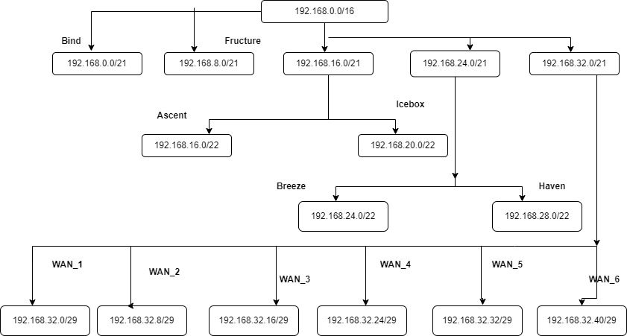

**IP Address:**

| **Device** | **Interface** | **IPv4 Address** | **Subnet Mask** | **Default Gateway** |
| --- | --- | --- | --- | --- |
| Bind | Serial2/0  Serial3/0  Fe0/0 | 192.168.32.17  192.168.32.13  192.168.0.1 | 255.255.255.248  255.255.255.248  255.255.248.0 |  |
| Ascent | Serial2/0  Fe0/0 | 192.168.32.1  192.168.16.1 | 255.255.255.248  255.255.252.0 |  |
| Fracture | Serial3/0  Fe0/0 | 192.168.32.27  192.168.8.1 | 255.255.255.248  255.255.248.0 |  |
| Breeze | Serial2/0  Serial3/0  Fe0/0 | 192.168.32.43  192.168.32.35  192.168.24.1 | 255.255.255.248  255.255.255.248  255.255.252.0 |  |
| Icebox | Serial2/0  Serial3/0  Serial6/0  Fe0/0 | 192.168.32.9  192.168.32.3  192.168.32.33  192.168.20.1 | 255.255.255.248  255.255.255.248  255.255.255.248  255.255.252.0 |  |
| Heaven | Serial2/0  Serial3/0  Serial6/0  Fe0/0 | 192.168.32.25  192.168.32.19  192.168.32.41  192.168.28.1 | 255.255.255.248  255.255.255.248  255.255.255.248  255.255.252.0 |  |
| PC0 | fe0 | 192.168.24.3 | 255.255.252.0 | 192.168.24.1 |
| PC1 | fe0 | 192.168.24.5 | 255.255.252.0 | 192.168.24.1 |
| Laptop1 | fe0 | 192.168.24.4 | 255.255.252.0 | 192.168.24.1 |
| PC2 | fe0 | 192.168.0.2 | 255.255.248.0 | 192.168.0.1 |
| PC3 | fe0 | 192.168.0.3 | 255.255.248.0 | 192.168.0.1 |
| PC4 | fe0 | 192.168.20.3 | 255.255.252.0 | 192.168.20.1 |
| PC5 | fe0 | 192.168.20.5 | 255.255.252.0 | 192.168.20.1 |
| Laptop0 | fe0 | 192.168.20.4 | 255.255.252.0 | 192.168.20.1 |
| PC6 | fe0 | 192.168.16.2 | 255.255.252.0 | 192.168.16.1 |
| PC7 | fe0 | 192.168.16.3 | 255.255.252.0 | 192.168.16.1 |
| PC8 | fe0 | 192.168.28.4 | 255.255.252.0 | 192.168.28.1 |
| PC9 | fe0 | 192.168.28.3 | 255.255.252.0 | 192.168.28.1 |
| PC10 | fe0 | 192.168.8.4 | 255.255.248.0 | 192.168.8.1 |
| PC11 | fe0 | 192.168.8.3 | 255.255.248.0 | 192.168.8.1 |