Features Selection Methods

Univariate Feature Selection Correlation Between Features With Heat-Map
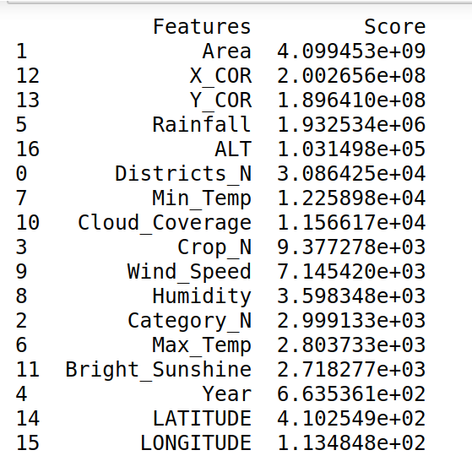
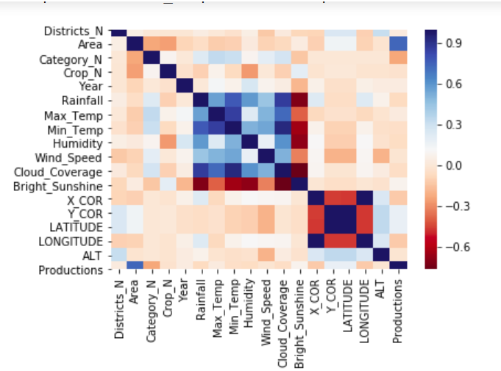

1. Best 12 Features: ( Area, X_Cor, Y_Cor, Rainfall, Alt, Districts_N, Min_Temp, Cloud_Coverage, Crop_N, Wind_Speed, Humidity, Category_N )

2. Best 10 Features: ( Area, X_Cor, Y_Cor, Rainfall, Alt, Districts_N, Min_Temp, Cloud_Coverage, Crop_N, Wind_Speed )

Variance Inflation Factor
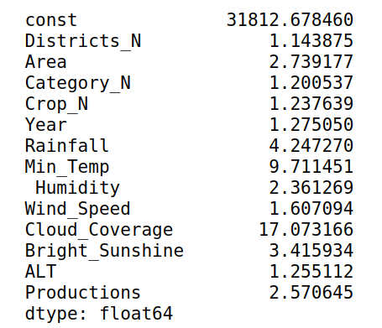

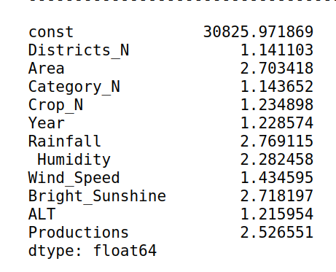

1. Best 12 Features: ( Districts_N, Area, Category_N, Crop_N, Year, Rainfall, Min_Temp, Humidity, Wind_Speed, Cloud_Coverage, Bright_Sunshine, Alt )

2. Best 10 Features: ( Districts_N, Area, Category_N, Crop_N, Year, Rainfall, Humidity, Wind_Speed, Bright_Sunshine, Alt )

Regression Model Analysis

1. Linear Regression

Features | Training Set | Test Set | Feature Selection | Accuracy
10 | 80% | 20% | Variance Inflation Factor | 56 %
12 | 80% | 20% | Variance Inflation Factor | 60 %
17 | 80% | 20% | Variance Inflation Factor | 68 %
10 | 80% | 20% | Univariate | 61 %
12 | 80% | 20% | Univariate | 58 %

2. Lasso Regression

Features | Training Set | Test Set | Feature Selection | Parameter | Accuracy
10 | 80% | 20% | Variance Inflation Factor | 0.1 | 53 %
12 | 80% | 20% | Variance Inflation Factor | 0.1 | 59 %
17 | 80% | 20% | Variance Inflation Factor | 0.1 | 57 %
10 | 80% | 20% | Univariate | 0.1 | 56 %
12 | 80% | 20% | Univariate | 0.1 | 54 %
10 | 80% | 20% | Variance Inflation Factor | 0.2 | 49 %
12 | 80% | 20% | Variance Inflation Factor | 0.2 | 54 %
17 | 80% | 20% | Variance Inflation Factor | 0.2 | 52 %
10 | 80% | 20% | Univariate | 0.2 | 51 %
12 | 80% | 20% | Univariate | 0.2 | 49 %
10 | 80% | 20% | Variance Inflation Factor | 0.3 | 43 %
12 | 80% | 20% | Variance Inflation Factor | 0.3 | 48 %
17 | 80% | 20% | Variance Inflation Factor | 0.3 | 47 %
10 | 80% | 20% | Univariate | 0.3 | 46 %
12 | 80% | 20% | Univariate | 0.3 | 44 %
10 | 80% | 20% | Variance Inflation Factor | 0.4 | 36 %
12 | 80% | 20% | Variance Inflation Factor | 0.4 | 40 %
17 | 80% | 20% | Variance Inflation Factor | 0.4 | 40 %
10 | 80% | 20% | Univariate | 0.4 | 38 %
12 | 80% | 20% | Univariate | 0.4 | 36 %

3. Ridge Regression

Features | Training Set | Test Set | Feature Selection | Parameter | Accuracy
10 | 80% | 20% | Variance Inflation Factor | 0.1 | 57 %
12 | 80% | 20% | Variance Inflation Factor | 0.1 | 60 %
17 | 80% | 20% | Variance Inflation Factor | 0.1 | 59 %
10 | 80% | 20% | Univariate | 0.1 | 55 %
12 | 80% | 20% | Univariate | 0.1 | 56 %
5
10 | 80% | 20% | Variance Inflation Factor | 0.2 | 57 %
12 | 80% | 20% | Variance Inflation Factor | 0.2 | 60 %
17 | 80% | 20% | Variance Inflation Factor | 0.2 | 59 %
10 | 80% | 20% | Univariate | 0.2 | 55 %
12 | 80% | 20% | Univariate | 0.2 | 56 %
10 | 80% | 20% | Variance Inflation Factor | 0.3 | 57 %
12 | 80% | 20% | Variance Inflation Factor | 0.3 | 60 %
17 | 80% | 20% | Variance Inflation Factor | 0.3 | 59 %
10 | 80% | 20% | Univariate | 0.3 | 55 %
12 | 80% | 20% | Univariate | 0.3 | 56 %
10 | 80% | 20% | Variance Inflation Factor | 0.4 | 57 %
12 | 80% | 20% | Variance Inflation Factor | 0.4 | 60 %
17 | 80% | 20% | Variance Inflation Factor | 0.4 | 59 %
10 | 80% | 20% | Univariate | 0.4 | 55 %
12 | 80% | 20% | Univariate | 0.4 | 56 %

4. Bayesian Ridge

Features | Training Set | Test Set | Feature Selection | Accuracy
10 | 80% | 20% | Variance Inflation Factor | 57 %
12 | 80% | 20% | Variance Inflation Factor | 56 %
17 | 80% | 20% | Variance Inflation Factor | 62 %
10 | 80% | 20% | Univariate | 58 %
12 | 80% | 20% | Univariate | 58 %

5. Support Vector Regressor

Features | Training Set | Test Set | Feature Selection | Accuracy | CV = 10
10 | 80% | 20% | Variance Inflation Factor | 91 % | 59 %
12 | 80% | 20% | Variance Inflation Factor | 90 % | 62 %
17 | 80% | 20% | Variance Inflation Factor | 88 % | 66 %
10 | 80% | 20% | Univariate | 86 % | 58 %
12 | 80% | 20% | Univariate | 88 % | 60 %

6. K-Nearest Neighbor ( n_neighbors =5 )

Features | Training Set | Test Set | Feature Selection | Accuracy | CV =10
10 | 80% | 20% | Variance Inflation Factor | 92 % | 51 %
12 | 80% | 20% | Variance Inflation Factor | 92 % | 50 %
17 | 80% | 20% | Variance Inflation Factor | 93 % | 27 %
10 | 80% | 20% | Univariate | 86 % | 21 %
12 | 80% | 20% | Univariate | 91 % | 35 %

7. Decision Tree

Features | Training Set | Test Set | Feature Selection | Accuracy | CV =10
10 | 80% | 20% | Variance Inflation Factor | 95 % | 54 %
12 | 80% | 20% | Variance Inflation Factor | 95 % | 48 %
17 | 80% | 20% | Variance Inflation Factor | 95 % | 48 %
10 | 80% | 20% | Univariate | 91 % | 43 %
12 | 80% | 20% | Univariate | 93 % | 52 %

8. Random Forest ( n_estimators =5 )

Features | Training Set | Test Set | Feature Selection | Accuracy | CV =10
10 | 80% | 20% | Variance Inflation Factor | 97 % | 54 %
12 | 80% | 20% | Variance Inflation Factor | 95 % | 60 %
17 | 80% | 20% | Variance Inflation Factor | 96 % | 58 %
10 | 80% | 20% | Univariate | 95 % | 45 %
12 | 80% | 20% | Univariate | 97 % | 62 %

9. Artificial Neural Network (hidden_layer_sizes = [ 100, 75, 50, 25 ] )

Features | Training Set | Test Set | Feature Selection | Accuracy
10 | 80% | 20% | Variance Inflation Factor | 95 %
12 | 80% | 20% | Variance Inflation Factor | 94 %
17 | 80% | 20% | Variance Inflation Factor | 96 %
10 | 80% | 20% | Univariate | 90 %
12 | 80% | 20% | Univariate | 96 %

Summery:

SL | Models | Features | Feature Selection Model | Accuracy
1 | Linear Regression | 17 | Variance Inflation Factor | 68 %
2 | Lasso Regression | 12 | Variance Inflation Factor | 59 %
3 | Ridge Regression | 12 | Variance Inflation Factor | 60 %
4 | Bayesian Ridge | 17 | Variance Inflation Factor | 62 %
5 | Support Vector Regressor | 10 | Variance Inflation Factor | 91 %
6 | Random Forest | 10 | Variance Inflation Factor | 97 %
7 | K-Nearest Neighbor | 17 | Variance Inflation Factor | 93 %
8 | Decision Tree | 10 | Variance Inflation Factor | 95 %
9 | Artificial Neural Network | 17 | Variance Inflation Factor | 96 %

Cross Validation Summery :

SL | Models | Features | Feature Selection Model | Accuracy | Cross Validation = 10 | Cross Validation
1 | Support Vector Regressor | 10 | Variance Inflation Factor | 91 % | 59 % | 84 % ( cv = 200 )
2 | Support Vector Regressor | 12 | Variance Inflation Factor | 90 % | 62 % | 85 % ( cv = 200 )
3 | Random Forest | 10 | Variance Inflation Factor | 97 % | 54 % | 88 % ( cv = 57 )
4 | Random Forest | 12 | Variance Inflation Factor | 95 % | 60 % | 90 % ( cv = 57 )
5 | K-Nearest Neighbor | 10 | Variance Inflation Factor | 92 % | 51 % | 91 % ( cv = 3500 )
6 | K-Nearest Neighbor | 12 | Variance Inflation Factor | 92 % | 50 % | 91 % ( cv = 3500 )
7 | Decision Tree | 10 | Variance Inflation Factor | 95 % | 54 % | 88 % ( cv = 200 )
8 | Decision Tree | 12 | Variance Inflation Factor | 95 % | 48 % | 83 % ( cv = 200 )

Recommendation Machine Learning Models

1. Altitude
SL | Models | Features | Feature Selection Model | Accuracy
1 | Support Vector Regressor | 12 | Variance Inflation Factor
2 | Random Forest | 12 | Variance Inflation Factor
3 | K-Nearest Neighbor | 12 | Variance Inflation Factor
4 | Decision Tree | 12 | Variance Inflation Factor
5 | Artificial Neural Network | 12 | Variance Inflation Factor

2. Bright Sunshine
SL | Models | Features | Feature Selection Model | Accuracy
1 | Support Vector Regressor | 12 | Variance Inflation Factor
2 | Random Forest | 12 | Variance Inflation Factor
3 | K-Nearest Neighbor | 12 | Variance Inflation Factor
4 | Decision Tree | 12 | Variance Inflation Factor
5 | Artificial Neural Network | 12 | Variance Inflation Factor

3. Cloud Coverage
SL | Models | Features | Feature Selection Model | Accuracy
1 | Support Vector Regressor | 12 | Variance Inflation Factor
2 | Random Forest | 12 | Variance Inflation Factor
3 | K-Nearest Neighbor | 12 | Variance Inflation Factor
4 | Decision Tree | 12 | Variance Inflation Factor
5 | Artificial Neural Network | 12 | Variance Inflation Factor

4. Humidity
SL | Models | Features | Feature Selection Model | Accuracy
1 | Support Vector Regressor | 12 | Variance Inflation Factor
2 | Random Forest | 12 | Variance Inflation Factor
3 | K-Nearest Neighbor | 12 | Variance Inflation Factor
4 | Decision Tree | 12 | Variance Inflation Factor
5 | Artificial Neural Network | 12 | Variance Inflation Factor

5. Minimum Temperature
SL | Models | Features | Feature Selection Model | Accuracy
1 | Support Vector Regressor | 12 | Variance Inflation Factor
2 | Random Forest | 12 | Variance Inflation Factor
3 | K-Nearest Neighbor | 12 | Variance Inflation Factor
4 | Decision Tree | 12 | Variance Inflation Factor
5 | Artificial Neural Network | 12 | Variance Inflation Factor

6. Rainfall
SL | Models | Features | Feature Selection Model | Accuracy
1 | Support Vector Regressor | 12 | Variance Inflation Factor
2 | Random Forest | 12 | Variance Inflation Factor
3 | K-Nearest Neighbor | 12 | Variance Inflation Factor
4 | Decision Tree | 12 | Variance Inflation Factor
5 | Artificial Neural Network | 12 | Variance Inflation Factor

7. Wind Speed
SL | Models | Features | Feature Selection Model | Accuracy
1 | Support Vector Regressor | 12 | Variance Inflation Factor
2 | Random Forest | 12 | Variance Inflation Factor
3 | K-Nearest Neighbor | 12 | Variance Inflation Factor
4 | Decision Tree | 12 | Variance Inflation Factor
5 | Artificial Neural Network | 12 | Variance Inflation Factor

