Predicting diabetes using machine learning and explainable artificial intelligence [XAI]

**Abstract**

Diabetes is a metabolic disorder defined by long-term and chronic elevation of blood sugar levels, known as hyperglycemia. The symptoms encompass frequent urination, dehydration, increased appetite, and weight swings. generally, diabetes prediction can be determined using either a glucometer or an A1C blood sugar test. Diabetes has become increasingly challenging to treat and, as a result, has become a disease that poses a significant risk to life. Presently, artificial intelligence and machine learning (AI/ML) are widely utilized for the detection and management of such illnesses. In this study, we employed artificial intelligence AI and ML approaches to diagnose diabetes using clinical markers. Among the eight machine learning models employed, the random forest model and lightgbm produced the most favorable results, attaining an accuracy of 0.77. Explainable artificial intelligence pertains to the capacity of an AI system to offer lucid and comprehensible justifications for its decisions and behaviors. Explainable Artificial Intelligence (XAI) refers to a set of methods aimed at improving the transparency and understandability of the results produced by AI/ML algorithms for users. This project utilizes XAI techniques such as SHAP, ELI5, Qlattice, and LIME to guarantee an interpretable and transparent result. This model facilitates the detection of individuals with a high-risk characteristic, enabling the implementation of early detection.

**Keywords**: diabetes, explainable artificial intelligence (XAI), machine learning (ML), artificial intelligence (AI), hyperglycemia, A1C blood sugar test

1. **Introduction**

Diabetes is a chronic medical disorder that occurs when the pancreas does not create sufficient insulin, referred to as type I diabetes, or when the body is unable to properly utilize the insulin it produces, known as type II diabetes [1]. Type II diabetes primarily leads to significant harm to the body, particularly the vessels. More than 95% of individuals diagnosed with diabetes have type II diabetes [2]. Hyperglycaemia, also referred to as high blood glucose levels, is a common result of uncontrolled diabetes and progressively leads to significant harm to several sections of the body, especially the nerve cells and blood vessels [2]. Thus, diabetes has become a significant risk factor that leads to mortality and impairment worldwide [3]. The World Health Organization [4] projected that in 2021, there were 529 million individuals worldwide with diabetes, and in 2019, diabetes was responsible for about 1.5 million fatalities. According to the International Diabetes Federation (IDF), it is projected that by 2045, around 783 million individuals, or 1 in 8 people, will be impacted by diabetes. This is a 46% increase compared to the current number of cases [5].

Usually, the prediction of diabetes is established by employing either a glucometer or an A1C blood sugar test [2]. Scientists categorized individuals' A1C levels of 6.5% and higher as indicative of type II diabetes, levels ranging from 5.5% to 6.5% as indicative of prediabetes, and levels below 5.5% as indicative of optimal health [6]. While there is no definitive remedy for diabetes, it can be managed by adopting good lifestyle practices, engaging in regular physical activity, reducing sugar intake, and adhering to the prescribed medications recommended by your healthcare provider [7]. Insulin continues to be the principal therapeutic approach for diabetes.

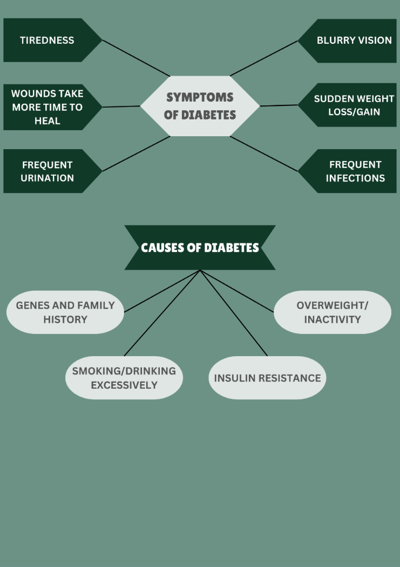

Fig 1. Diabetes symptoms and causes

This study employs ML techniques and interpretable AI approaches to precisely detect and evaluate diabetes. AI is the dominant driving factor in the current technology landscape and is commonly applied in areas such as Engineering and Healthcare [8]. Machine learning (ML) has been extensively studied and implemented in various areas of diabetes treatment and research, including basic biomedical research, applied science, and clinical practice [9]. The United States Food and Drug Administration (FDA) has granted approval to multiple medical devices that utilize artificial intelligence and machine learning (AI/ML) technology for the treatment of diabetes. These devices include automated retinal screening tools, clinical diagnosis assistance systems, and patient self-management tools [10].

Several AI experiments were previously utilized in the evaluation of diabetes. Varad et al. (2022) introduced XAI and interpretable machine learning techniques that provide insights into the internal mechanisms of learning models and provide explanations for the decisions they make. They possess significant worth, particularly in the realm of healthcare and medical diagnosis. This research offers a machine learning model that has been trained with an accuracy of 82.23%. It utilizes explainable artificial intelligence (XAI) approaches, including the ELI5 XAI toolkit, LIME, and SHAP algorithmic frameworks, to determine whether a patient has diabetes. The primary objective of their study is to develop a data analytics system that is responsible, transparent, and robust by leveraging XAI and Interpretable Machine Learning [11].

Francesco Curia (2023) has created a machine learning model utilizing XAI to forecast the probability of an individual developing type I diabetes. The model incorporates many techniques such as support vector classifier (SVC), decision trees, deep neural networks (DNN), Xgboost, logistic regression, and K-nearest neighbors (KNN). The accuracy of logistic regression and SVC was 98.3%. AI techniques like LIME assist in quantifying the significance of each feature and analyzing the elements that influence the likelihood of being ill. Utilizing explainable artificial intelligence (XAI), the used clinical decision support system (CDSS) has the potential to enhance the decision-making process of medical personnel, leading to improved patient care and treatment outcomes for individuals with type 1 diabetes [12].

According to Leon Kopitar et al. (2020), Type II diabetes screening tools currently employ multivariate regression approaches that are simplified into scoring formulas to enable early detection. The increased availability of electronically obtained data has facilitated the development of more sophisticated and precise prediction models that can be continuously updated through ML techniques. The study compares machine learning-based prediction models such as Glmnet, RF, XGBoost, and LightGBM with regression models to predict undiagnosed type II diabetes. The prediction of fasting plasma glucose was evaluated by doing 100 bootstrap iterations on various data subsets. The random forest model achieved an accuracy of 84.2% [13].

Md. Kamrul Hasan et al. (2020) presented a comprehensive framework for predicting diabetes. The framework incorporates outlier rejection, missing value filling, data standardization, feature selection, K-fold cross-validation, and a range of ML classifiers such as k-nearest neighbor, Decision Trees, Random Forest, AdaBoost, Naive Bayes, and Xgboost. This literature proposes the use of weighted ensembling of ML models to improve the accuracy of diabetes prediction. The weights for each model are determined based on the Area Under the Receiver Operating Characteristic Curve (AUC) of the machine learning model. During hyperparameter tweaking using grid search, the performance metric AUC is optimized. Following thorough experimentation, their research suggested ensembling classifier achieved superior results compared to the current leading methods, with a 2% increase in AUC. The classifier also showed enhanced sensitivity, specificity, false omission rate, diagnostic odds ratio, and AUC values of 0.789, 0.934, 0.092, 66.234, and 0.950, respectively [14].

Upon completing the literature evaluation, numerous gaps in research were observed. Research has primarily examined the transparency of machine learning models, but there is an absence of studies comparing various strategies and assessing their efficacy. A more efficient approach would involve illustrating the methods to tackle the challenges related to managing missing data or imbalanced datasets. Furthermore, the article demonstrates the use of ensemble methods with several classifiers for predicting diabetes. However, it does not include a thorough analysis of model calibration and uncertainty estimation. The aim of our research is to tackle these difficulties, and the results of our research are outlined below:

* "Mutual information" method has been employed to ascertain the important characteristics in the dataset.
* The core code employs robust validation mechanisms to ensure a broader range of application.
* XAI techniques including QLattice, SHAP, LIME, and Eli5 are employed. They improve the ability to forecast and make the model's operations more clear and understandable.
* Multiple classifiers are utilized and compared, revealing their distinctions.

In Section 2, the article goes into great depth about the materials and method used. In Section 3, the results are shown. Discussions make up Section 4, and the last part of the essay, Section 5, is the end.

1. **Materials and methods:** 
   1. *Dataset description*

The dataset was acquired from the "Pima Indians diabetes database" which is available on Kaggle. The dataset originates from the National Institute of Diabetes and Digestive and Kidney Diseases [15]. The dataset consists of numerous predictor variables and one target variable, 'Outcome', with a total of 768 patients. The dataset comprises 8 predictor variables: the patient's number of pregnancies, BMI, insulin level, age, glucose, skin thickness, blood pressure, and diabetes pedigree function. The target variable represents the outcome of the diagnostic test for the patient. The variable is categorical and consists of binary values, where 0 represents non-diabetic and 1 represents diabetes. The dataset was devoid of any null values, hence necessitating little preprocessing. Table 1 provides a concise overview of the properties that are utilized.

Table 1. Description of diabetes dataset

|  |  |  |  |
| --- | --- | --- | --- |
| Sl no. | Attribute name | description | Type |
| 1 | Glucose | Plasma glucose concentration a 2 hours in an oral glucose tolerance test | Continuous |
| 2 | BMI | Body mass index (weight in kg/(height in m)^2) | Continuous |
| 3 | Pregnancies | Number of times pregnant | Continuous |
| 4 | Age | Age (years) | Continuous |
| 5 | Skin thickness | Triceps skin fold thickness (mm) | Continuous |
| 6 | insulin | 2-Hour serum insulin (mu U/ml) | Continuous |
| 7 | Diabetes pedigree function | Diabetes pedigree function (hereditary) | Continuous |
| 8 | Blood pressure | Diastolic blood pressure (mm Hg) | Continuous |

* 1. *Data preprocessing and feature selection*

Before starting training, few operations are required to be executed on the dataset. Data scaling is essential in machine learning because models can show a bias towards columns that have higher values [16]. The process of standardization was utilized in this investigation. This method applies the mean and standard deviation of each value within the range of '-1' to '1' to convert them [17]. Encoding is unnecessary in this investigation because all the attributes are composed of continuous data [18]. There are characteristics that aren't needed make the models less accurate and less useful [19]. In this case, the Mutual information method was used to find the most important parts. The amount of information received increases as decay decreases. In other words, it gives a number value to the statistical connection between two factors [20]. We also did a statistics study that involved finding the mean, the standard deviation, the minimum value, and the maximum value. Table 2 shows the data and gives more information about them. Machine learning can be used to figure out how important a trait is in relation to the objective value. Extra-wide features may be more useful than other features compared to broader features. The most significant features that were found by using mutual information are highlighted in figure 3. The variables are also grouped in an order based on how useful they are. Diabetes, body mass index (BMI), pregnancy, age, skin thickness, and insulin are the most important factors. All the features were chosen for training the model in this investigation. The dataset was divided into training and testing data sets at a ratio of 80:20 [21]. There were 501 people without diabetes and 268 persons with diabetes. The classes were almost evenly distributed without any additional preprocessing methods.

Table 2. Measures of descriptive statistics for the continuous characteristics

|  |  |  |  |  |  |  |
| --- | --- | --- | --- | --- | --- | --- |
| Attributes | N | Missing | mean | Standard Deviation | minimum | maximum |
| Glucose | 768 | 0 | 120.89 | 31.97 | 0 | 199 |
| BMI | 768 | 0 | 31.99 | 7.88 | 0 | 67 |
| Pregnancies | 768 | 0 | 3.84 | 3.36 | 0 | 17 |
| Age | 768 | 0 | 33.24 | 11.76 | 21 | 81 |
| Skin thickness | 768 | 0 | 20.53 | 15.95 | 0 | 99 |
| insulin | 768 | 0 | 79.79 | 115.24 | 0 | 846 |
| Diabetes pedigree function | 768 | 0 | 0.47 | 0.33 | 0.07 | 2.42 |
| Blood pressure | 768 | 0 | 69.10 | 19.35 | 0 | 122 |

Fig 3. feature selection using mutual information analysis.

This study involved training and testing eight classifiers, which were subsequently combined using a stacking approach. Bagging and boosting models were utilized. Bagging is a technique that includes running multiple classifiers at the same time, and then combining and pooling their results to create predictions [22]. Boosting use the same process as bagging. During the boosting process, the output of each model is transferred consecutively, with each model attempting to surpass the performance of the previous one [23]. The stacking architecture has the ability to incorporate many machine learning models, hence enhancing its overall performance [24]. The study provides the stacking process, which is seen in Figure 4. Hyperparameter adjustment is crucial for obtaining optimal predictions from the model. Prior to training the models, hyperparameters are specified [25]. The analysis utilized the grid-based search approach to determine the most suitable hyperparameters [26]. Furthermore, a 5-fold cross-validation technique was utilized to minimize both variation and bias [27]. Different classification and loss criteria were used to assess the models [28]. This study utilizes four Explainable Artificial Intelligence (XAI) approaches to optimize the process of predicting diabetes [29]. SHapley Additive Explanations (SHAP) utilizes cooperative game theory to determine the significant features [30].

The significance of each feature is evaluated by analyzing the model's performance without and with that specific feature. The SHAP methodology could be employed to elucidate both overarching and specific elements. The LIME methodology can be employed to provide localized explanations [31]. Eli5 is a Python module specifically created to serve as a tool for providing explanations [32]. Which is utilized for regression as well as classification scenarios. QLattice employs principles of quantum computing to detect significant characteristics [33]. Results are generated through the use of registers and activation functions. The model created has the capacity to be employed for real-time diabetes forecasting following the procedures of training, testing, and assessing the models [30]. Figure 5 illustrates the diagram of the machine learning process.

Fig 4. customized stacking architecture with algorithms used.

Fig 5. methodology flow diagram

**3**. **Results**

* 1. *Analysis of Model performance and XAI.*

This study employs eight classifiers to forecast the occurrence of diabetes. The algorithms were enhanced through the utilization of the stacking technique. Table 3 presents the performance metrics of the classifiers. Out of all the approaches, random forest, and light gradient boosting (lightgbm) yielded statistically substantial outcomes with an accuracy rate of 77%. The random forest model attained an F1-score of 63%, but the lightgbm model demonstrated an F1-score of 67%. Among all the approaches, the KNN classifier and Xgboost had the poorest performance, achieving an accuracy rate of 72%. The logistic regression model produced positive results, with an accuracy rate of 74% and a FI-score of 61%. The STACK model ensemble attained a precision rate of 74% and an F1-score of 61%. Furthermore, Table 4 presents a comprehensive explanation of the most effective hyperparameters achieved by each algorithm. The grid search method was utilized to ascertain these hyperparameters. Figure 6 exhibits the AUC curves. Models that can accurately distinguish between the classes achieve higher AUCs. All the algorithms used in this study achieved an Area Under the Curve (AUC) value greater than 0.7. The applied ML techniques attained a peak AUC of 0.85.

Table 3. Assessment of models employing 8 machine learning classifiers.

|  |  |  |  |  |  |  |  |  |  |
| --- | --- | --- | --- | --- | --- | --- | --- | --- | --- |
| Algorithm | Accuracy (%) | Precision (%) | Recall (%) | F1-score (%) | Area under curve (AUC) | Hamming loss | Jaccard score | Log loss | Mathew’s correlation coefficient |
| Random forest | 77 | 76 | 54 | 63 | 85 | 0.23 | 0.46 | 8.07 | 0.48 |
| Logistic regression | 74 | 69 | 54 | 61 | 83 | 0.25 | 0.43 | 8.97 | 0.42 |
| Decision tree | 74 | 76 | 44 | 56 | 77 | 0.25 | 0.38 | 8.97 | 0.41 |
| KNN | 72 | 68 | 47 | 56 | 78 | 0.27 | 0.38 | 9.64 | 0.37 |
| Adaboost | 74 | 71 | 51 | 59 | 83 | 0.25 | 0.42 | 8.97 | 0.42 |
| Catboost | 75 | 72 | 51 | 60 | 85 | 0.25 | 0.42 | 8.74 | 0.43 |
| Lightgbm | 77 | 71 | 63 | 67 | 83 | 0.23 | 0.5 | 8.07 | 0.48 |
| Xgboost | 72 | 68 | 47 | 56 | 81 | 0.27 | 0.38 | 9.64 | 0.37 |
| Stacking | 74 | 69 | 54 | 61 | 82 | 0.25 | 0.43 | 8.97 | 0.42 |

Table 4. Optimizing hyperparameters using grid search

|  |  |
| --- | --- |
| Algorithms | Hyperparameter values |
| Random forest | {'bootstrap': True,  'max_depth': 100,  'max_features': 2,  'min_samples_leaf': 4,  'Min_samples_split': 12,  'n_estimators': 200} |
| Logistic regression | {'C': 100, 'penalty': 'l2'} |
| Decision tree | {'criterion': 'gini',  'Max_depth': 8,  'Max_features': 'log2',  'min_samples_leaf': 8,  'min_samples_split': 30,  'splitter': 'best'} |
| KNN | {'n_neighbors': 11} |
| Adaboost | {'learning_rate': 0.1,  'n_estimators': 300} |
| Catboost | {‘border_count’: 32  ‘depth’: 3,  ‘iterations’: 250  ‘l2_leaf_reg’: 3,  ‘learning_rate’: 0.03} |
| Lightgbm | {'lambda_l1': 1,  'Lambda_l2': 1,  'min_data_in_leaf': 100,  'num_leaves': 31,  'reg_alpha': 0.1} |
| Xgboost | {'colsample_bytree': 0.3,  'gamma': 0.1,  'learning_rate': 0.05,  'max_depth': 5,  'min_child_weight': 3} |

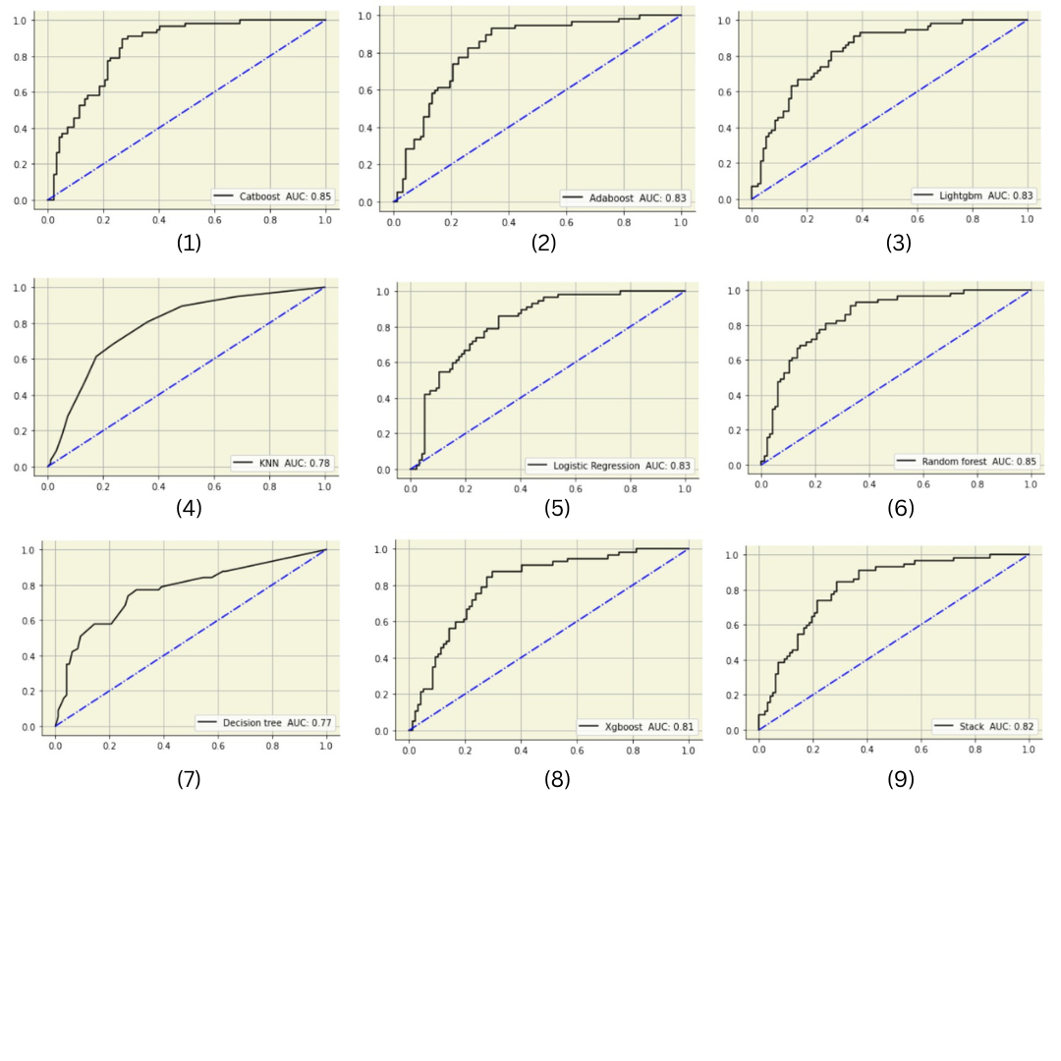

Fig 6. AUC curves (1) Catboost (2) Adaboost (3) Lightgbm (4) KNN (5) Logistic regression (6) Random Forest (7) Decision tree (8) Xgboost (9) Stacking model.

Figure 7 depicts the precision-recall curves. The Random Forest model attained a precision of 0.73, which is the highest value obtained. Figure 8 displays the confusion matrix derived from the final STACK model. The occurrence of false positive and false negative outcomes was significantly reduced, leading to improved accuracy, precision, and memory. The outcomes of the models were elucidated utilizing SHAP, LIME, Eli5, and QLattice. The final STACK model was chosen for XAI analysis based on its exceptional reliability and trust. Figures 9(a) and (b) display the projected values generated by the SHAP model using beeswarm plot and mean bar plot, respectively. The attributes are sorted in descending order based on their influence on the model's output. A hyperplane is employed in the beeswarm plot to distinguish between the two groups. The color red represents higher feature values, whereas the color blue represents lower feature values. The most significant predictors observed were glucose levels, BMI, age, and diabetes pedigree function. Similarly, blood pressure and skin thickness were identified as the least significant features.

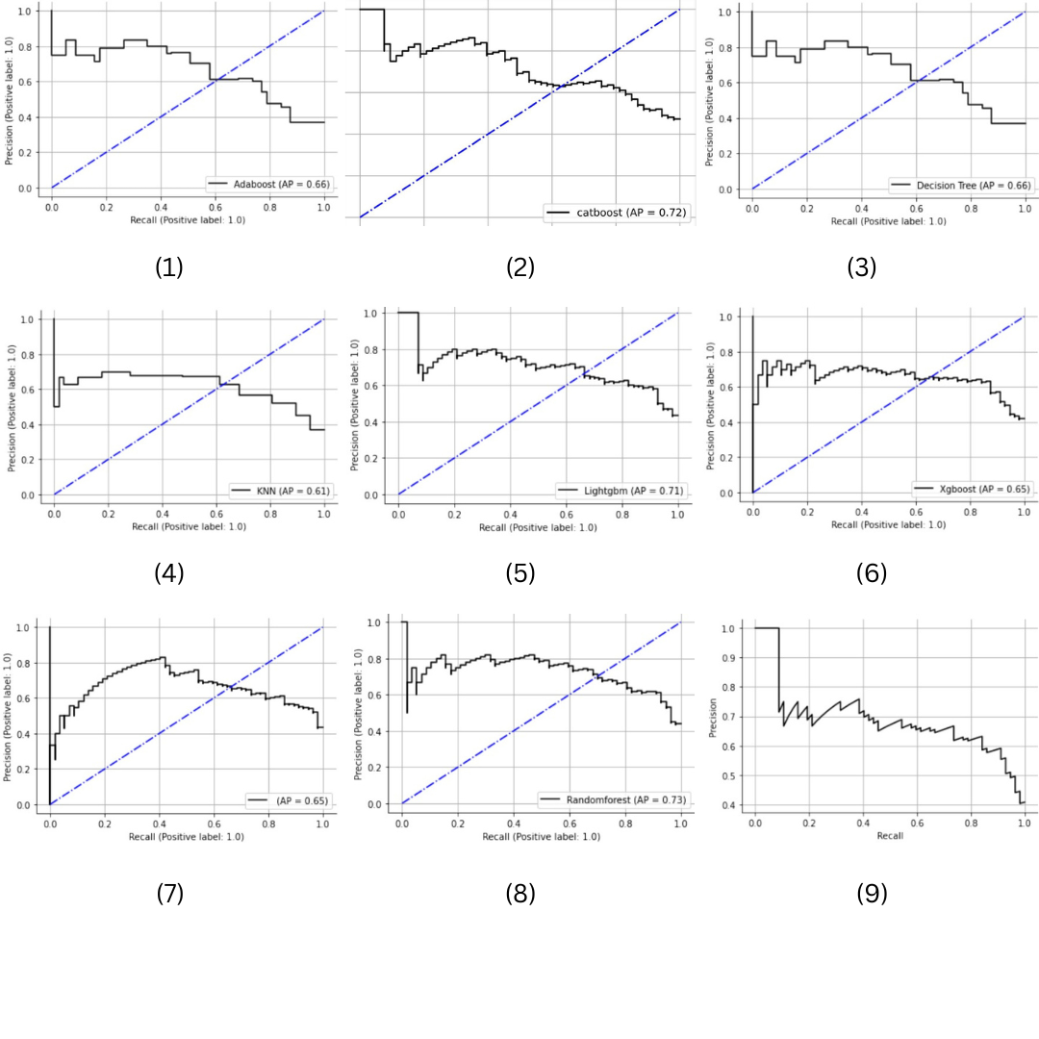

Fig 7. precision curves (1) Adaboost (2) Catboost (3) Decision tree (4) KNN (5) Lightgbm (6) Xgboost (7) Logistic regression (8) Random Forest (9) Stacked model.

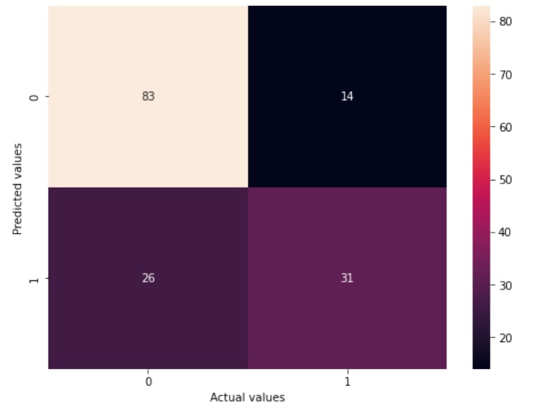

Fig 8. Stack model’s confusion matrix

Fig 9 (a). predicting models with SHAP (Beeswarm plot)

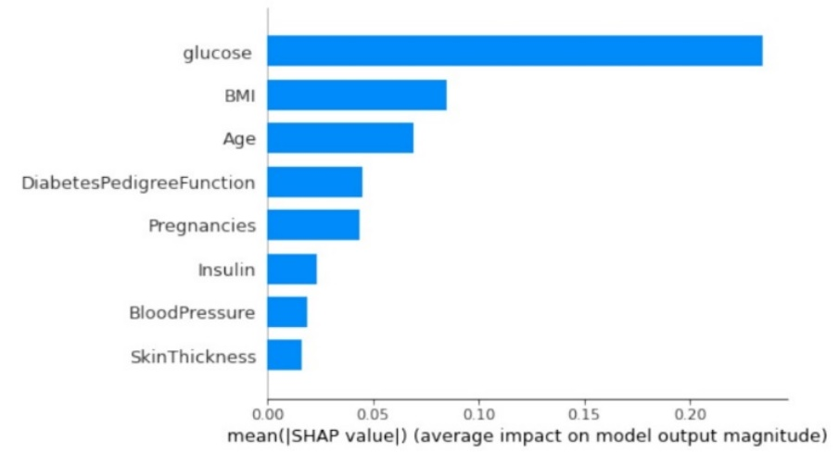

Fig 9 (b). predicting models with SHAP (Mean bar plot)

A thorough review of the predictions offered by the explainers will be conducted in the discussion section. The subsequent elucidation utilized was LIME. Figures 10(a) and (b) show a visual representation of non-diabetic and diabetic states, respectively. LIME has identified glucose and insulin as the important indicators. The Eli5 tool was employed to assess the STACK model, as depicted in Figure 11. Table 5 displays the key determinants of XAI prediction, namely glucose, age, BMI, diabetes pedigree function, and insulin. Eli5 takes into account bias when analysing the models. The QLattice model is the latest model employed for interpretation. The technique utilizes QGraphs to examine and comprehend the models depicted in Figure 12. The study examined variables such as BMI, pregnancy status, and glucose levels. This investigation utilized four explanatory techniques. The most significant markers observed were glucose, BMI, Diabetes pedigree function, and pregnancy. These markers can be utilized in conjunction with machine learning classifiers to forecast the occurrence of diabetes. Furthermore, we performed a comparative analysis of the results obtained from employing mutual information and XAI approaches. Table 5 presents a comprehensive summary of the significant indicators chosen by these methods.

Figure 10 (a): Demystifying diabetes predictions using LIME (non-diabetic)

Figure 10 (b): Demystifying diabetes predictions using LIME (diabetic)

Fig 11. diabetes prediction using Eli5

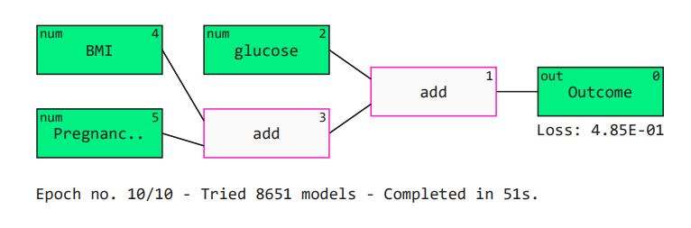

logreg (5.2𝐵𝑀𝐼 + 2.1𝑃𝑟𝑒𝑔𝑛𝑎𝑛𝑐𝑖𝑒𝑠 + 7.0𝑔𝑙𝑢𝑐𝑜𝑠𝑒 − 8.0)

Figure 12: diabetes prediction using QGraph

Table 5: XAI model results

|  |  |  |  |
| --- | --- | --- | --- |
| Shap | Lime | Qlattice | Eli5 |
| 1. Glucose 2. BMI 3. Age 4. Diabetes pedigree function 5. Pregnancies | |  |  | | --- | --- | | Non-diabetic | Diabetic | | 1. Insulin | 1. Glucose 2. Insulin | | 1. Glucose 2. BMI 3. Pregnancies | 1. Glucose 2. Age 3. BMI 4. Diabetes pedigree function 5. Pregnancies |

1. **Discussion**

The study combines ML and XAI techniques to predict and assess whether an individual has diabetes or not.  Firstly, a descriptive and statistical evaluation of the data was conducted. After finishing the initial data processing, mutual information method was used to choose the most significant features. A total of eight machine learning classifiers, along with a customized ensemble model, were employed to make predictions regarding diabetes. The findings were examined using SHAP, LIME, Eli5, and QLattice explanations. Additionally, we compared those significant indicators produced by implicit statistical methods, such as mutual information and XAI techniques. Out of all the algorithms, random forest and Lightgbm demonstrated the highest performance, with an accuracy of 77%. And Xgboost exhibited comparatively lower accuracy. XAI identifies glucose, BMI, Diabetes pedigree function, and pregnancies as the most prominent indicators. Based on the SHAP analysis, most patients diagnosed with diabetes have increased glucose levels. The Body Mass Index (BMI) was ranked as the second most important feature. Controlling BMI is essential for managing diabetes because being overweight is a substantial contributing factor to the onset of diabetes. The SHAP values in this research go from -0.4 to 0.6. Higher results imply an increased likelihood of diabetes in the individual. Thus, glucose, BMI, and age produced higher values. The following factors exert the greatest influence on probability of being diabetic. Skin thickness and blood pressure have exhibited the lowest measurements, indicating that they have the least possibility.

The previously mentioned features have been considered significant in related studies [34,35,36,13]. The integration of these attributes and classifiers could be employed to distinguish diabetes from other conditions. Only a few published research have employed machine learning to predict diabetes using these characteristics. Rani KM [34] employs machine learning techniques to accurately forecast the onset of diabetes in its early stages. The dataset contained information on 2,000 patients, with a selection of 8 attributes. Their focus was on combining outcomes from several algorithms in order to increase the precision. They have achieved a 95.4% accuracy. Soni M et al. [35] concentrated on constructing classification and ensembling models using collected datasets to accumulate knowledge. The researchers gathered data from a sample of 768 patients, consisting of 8 different variables, in order to predict the occurrence of diabetes. The dataset was evaluated using classification and ensemble methods to make predictions. The results obtained were 77% accuracy. A study conducted by Joshi RD et al. [36] that focuses on predicting diabetes mellitus is being analyzed. The researchers utilized a dataset consisting of 268 patients and 5 distinct features. Their accuracy stands at 78.26%. Leon Kopitar et al. [13] state that screening instruments for Type II diabetes include multivariate regression approaches that are reduced into scoring formulas to enable early detection. The proliferation of electronic data has enabled the advancement of increasingly sophisticated and accurate predictive models that can be continuously updated through machine learning. They have compared regression models for undiagnosed type II diabetes with ML based prediction models such as Glmnet, Random forest, Xgboost, and LightGBM. The prediction of fasting plasma glucose was tested using hundred iterations of data subset bootstrap. Their accuracy rate was 84.2%. Table 6 presents a comparison of the above mentioned studies. Our study stands apart from those mentioned previously due to our utilization of XAI approaches to highlight the significant parameter, resulting in an improved outcome.

Table 6. Results Comparison

|  |  |  |  |  |
| --- | --- | --- | --- | --- |
| References | Size of the  dataset | Used ML models | Best accuracy obtained | XAI techniques |
| [13] | 27,050 patients | 4 classifiers | 84.2% | - |
| [34] | 2000 patients | Several classifiers | 95.4% | - |
| [35] | 768 patients | 6 classifiers | 77% | - |
| [36] | 268 patients | 2 classifiers | 78.26% | - |
| Our study | 768 patients | Nine classifiers including a customized STACK model | 77% | SHAP, LIME, Eli5, Qlattice |

Nevertheless, this research is subject to some constraints. The dataset acquired from Kaggle consisted of a total of 768 patients. An augmentation in the sample size would enhance the performance of the models. This study exclusively utilized supervised learning. It is possible to evaluate and compare unsupervised and reinforcement learning algorithms [37]. This study did not utilize deep learning methodologies [38]. However, deep learning algorithms depend on a significant quantity of data to thrive. In our investigation, we only took into account a restricted set of attributes. Subsequent inquiries could explore clinical and analytical signs. In the future, it is feasible to offer cloud-based functionalities for the storage of data and the execution of training and testing procedures for models [39]. By employing cryptography and steganographic techniques, patient information can be effectively protected [40]. An interface could be developed to enhance accessibility to the algorithms. Further research should be conducted on additional algorithms for explainable artificial intelligence (XAI), including Anchor and Prototype-based Explanations [30].

1. **Conclusion**

Diabetes is a medical condition characterized by hyperglycemia, which is the presence of abnormally high quantities of sugar in the body. The diagnosis of diabetes entails performing a blood glucose test. Presently, the primary strategies for diabetes management encompass participating in physical activity, embracing a healthful way of life, and complying with prescribed medications. This study utilizes a unique methodology that integrates ML and XAI to forecast the occurrence of diabetes, various classifiers were employed to categorize individuals as either diabetic or non-diabetic using a publicly available dataset. Various XAI techniques were used to interpret the results produced by the classifiers. Given the escalating prevalence of diabetes and its consequential effects on persons, it is imperative to promptly identify and control the condition.

References:

1. Tuomi T. Type 1 and type 2 diabetes: what do they have in common?. Diabetes. 2005 Dec 1;54(suppl_2):S40-5.
2. Roglic G. WHO Global report on diabetes: A summary. International Journal of Noncommunicable Diseases. 2016 Apr 1;1(1):3-8.
3. Ong KL, Stafford LK, McLaughlin SA, Boyko EJ, Vollset SE, Smith AE, Dalton BE, Duprey J, Cruz JA, Hagins H, Lindstedt PA. Global, regional, and national burden of diabetes from 1990 to 2021, with projections of prevalence to 2050: a systematic analysis for the Global Burden of Disease Study 2021. The Lancet. 2023 Jul 15;402(10397):203-34.
4. Saydah SH, Geiss LS, Tierney ED, Benjamin SM, Engelgau M, Brancati F. Review of the performance of methods to identify diabetes cases among vital statistics, administrative, and survey data. Annals of epidemiology. 2004 Aug 1;14(7):507-16.
5. American Diabetes Association. Diabetes facts and figures. http://www. diabetes. org. 2000.
6. Peiris PD, Heenkenda HM. A Review on Type II Diabetes Prediction using Machine Learning Techniques. Information Technology Research Unit.:44.
7. M. Mayo clinic on managing diabetes. Orient Paperbacks; 2008.
8. Reddy S, Allan S, Coghlan S, Cooper P. A governance model for the application of AI in health care. J Am Med Inform Assoc 2020;27(3):491–7. https://doi.org/ 10.1093/jamia/ocz192. Mar.
9. Guan Z, Li H, Liu R, Cai C, Liu Y, Li J, Wang X, Huang S, Wu L, Liu D, Yu S. Artificial intelligence in diabetes management: advancements, opportunities, and challenges. Cell Reports Medicine. 2023 Oct 2.
10. Nomura A, Noguchi M, Kometani M, Furukawa K, Yoneda T. Artificial intelligence in current diabetes management and prediction. Current Diabetes Reports. 2021 Dec;21(12):61.
11. Vishwarupe V, Joshi PM, Mathias N, Maheshwari S, Mhaisalkar S, Pawar V. Explainable AI and interpretable machine learning: A case study in perspective. Procedia Computer Science. 2022 Jan 1;204:869-76.
12. Curia F. Explainable and transparency machine learning approach to predict diabetes develop. Health and Technology. 2023 Sep;13(5):769-80.
13. Kopitar L, Kocbek P, Cilar L, Sheikh A, Stiglic G. Early detection of type 2 diabetes mellitus using machine learning-based prediction models. Scientific reports. 20
14. Hasan MK, Alam MA, Das D, Hossain E, Hasan M. Diabetes prediction using ensembling of different machine learning classifiers. IEEE Access. 2020 Apr 23;8:76516-31.
15. [Pima Indians Diabetes Database (kaggle.com)](https://www.kaggle.com/datasets/uciml/pima-indians-diabetes-database)
16. Schulz MA, Yeo BT, Vogelstein JT, Mourao-Miranada J, Kather JN, Kording K, Richards B, Bzdok D. Different scaling of linear models and deep learning in UKBiobank brain images versus machine-learning datasets. Nature communications. 2020 Aug 25;11(1):4238.
17. Raju VG, Lakshmi KP, Jain VM, Kalidindi A, Padma V. Study the influence of normalization/transformation process on the accuracy of supervised classification. In2020 Third International Conference on Smart Systems and Inventive Technology (ICSSIT) 2020 Aug 20 (pp. 729-735). IEEE.
18. Lopez-Arevalo I, Aldana-Bobadilla E, Molina-Villegas A, Galeana-Zapién H, Muñiz-Sanchez V, Gausin-Valle S. A memory-efficient encoding method for processing mixed-type data on machine learning. Entropy. 2020 Dec 9;22(12):1391.
19. Cai J, Luo J, Wang S, Yang S. Feature selection in machine learning: A new perspective. Neurocomputing. 2018 Jul 26;300:70-9.
20. Belghazi MI, Baratin A, Rajeshwar S, Ozair S, Bengio Y, Courville A, Hjelm D. Mutual information neural estimation. InInternational conference on machine learning 2018 Jul 3 (pp. 531-540). PMLR.
21. Birba DE. A Comparative study of data splitting algorithms for machine learning model selection.
22. Sutton CD. Classification and regression trees, bagging, and boosting. Handbook of statistics. 2005 Jan 1;24:303-29.
23. González S, García S, Del Ser J, Rokach L, Herrera F. A practical tutorial on bagging and boosting based ensembles for machine learning: Algorithms, software tools, performance study, practical perspectives and opportunities. Information Fusion. 2020 Dec 1;64:205-37.
24. Pavlyshenko B. Using stacking approaches for machine learning models. In2018 IEEE second international conference on data stream mining & processing (DSMP) 2018 Aug 21 (pp. 255-258). IEEE.
25. Schratz P, Muenchow J, Iturritxa E, Richter J, Brenning A. Hyperparameter tuning and performance assessment of statistical and machine-learning algorithms using spatial data. Ecological Modelling. 2019 Aug 24;406:109-20.
26. Belete DM, Huchaiah MD. Grid search in hyperparameter optimization of machine learning models for prediction of HIV/AIDS test results. International Journal of Computers and Applications. 2022 Sep 2;44(9):875-86.
27. Xiong Z, Cui Y, Liu Z, Zhao Y, Hu M, Hu J. Evaluating explorative prediction power of machine learning algorithms for materials discovery using k-fold forward cross-validation. Computational Materials Science. 2020 Jan 1;171:109203.
28. Erickson BJ, Kitamura F. Magician’s corner: 9. Performance metrics for machine learning models. Radiology: Artificial Intelligence. 2021 May 12;3(3):e200126.
29. So C. Understanding the prediction mechanism of sentiments by XAI visualization. InProceedings of the 4th international conference on natural language processing and information retrieval 2020 Dec 18 (pp. 75-80).
30. Chadaga K, Prabhu S, Sampathila N, Chadaga R, Bhat D, Sharma AK, Swathi KS. SADXAI: Predicting social anxiety disorder using multiple interpretable artificial intelligence techniques. SLAS technology. 2024 Apr 1;29(2):100129.
31. Kumarakulasinghe NB, Blomberg T, Liu J, Leao AS, Papapetrou P. Evaluating local interpretable model-agnostic explanations on clinical machine learning classification models. In2020 IEEE 33rd International Symposium on Computer-Based Medical Systems (CBMS) 2020 Jul 28 (pp. 7-12). IEEE.
32. Python-based EU, Mishra P. Practical Explainable AI Using Python.
33. Palkar A, Dias CC, Chadaga K, Sampathila N. Empowering Glioma Prognosis With Transparent Machine Learning and Interpretative Insights Using Explainable AI. IEEE Access. 2024 Feb 26;12:31697-718.
34. Rani KJ. Diabetes prediction using machine learning. International Journal of Scientific Research in Computer Science Engineering and Information Technology. 2020 Jul;6:294-305.
35. Soni M, Varma S. Diabetes prediction using machine learning techniques. International Journal of Engineering Research & Technology (IJERT). 2020 Sep;9(9):921-5.
36. Joshi RD, Dhakal CK. Predicting type 2 diabetes using logistic regression and machine learning approaches. International journal of environmental research and public health. 2021 Jul 9;18(14):7346.
37. Ozgur A. Supervised and unsupervised machine learning techniques for text document categorization. Unpublished Master’s Thesis, İstanbul: Boğaziçi University. 2004.
38. Shrestha A, Mahmood A. Review of deep learning algorithms and architectures. IEEE access. 2019 Apr 22;7:53040-65.
39. Butt UA, Mehmood M, Shah SB, Amin R, Shaukat MW, Raza SM, Suh DY, Piran MJ. A review of machine learning algorithms for cloud computing security. Electronics. 2020 Aug 26;9(9):1379.
40. Taha MS, Mohd Rahim MS, Lafta SA, Hashim MM, Alzuabidi HM. Combination of steganography and cryptography: A short survey. InIOP conference series: materials science and engineering 2019 May 1 (Vol. 518, No. 5, p. 052003). IOP Publishing.