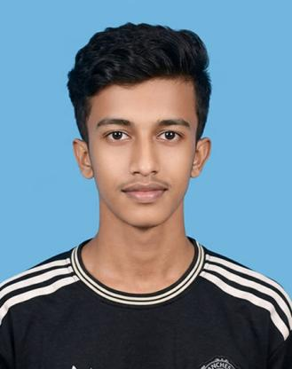
```Md. Rakib Talukder’s curriculum vitae

 Home : Ashulia, Savar, Dhaka
 Phone Number : (+880)1400-941638
 Email Address : rakibtalukder789@gmail.com

CARRER OBJECTIVE:
To be successful in my area of expertise through working properly in global standard organization with a vision of dedication and long term commitment to works the organization where jobs satisfaction further carrier progression could be achieved successfully.

ACADEMIC QUALIFICATION:
S.S.C
Institution : Abu Hurairah Dakhil Madrasah
Board : Madrasah Board
Group : Humanities
Result : 3.63
Year : 2023

Key qualities:
1. Comfortable to be communicative with an unknown person in any situation in an almost new environment can persuade others towards a point of view.
2. Strong analytical and decision-making skills.
3. Hard working, Sincere and easier to learn.
4. Strong desire to achieve results.
5. Ability to take responsibility and work with a team.
6. Strong Organizational skill can corporate with leading capability.
Language skills:
Language | Reading | Writing | Speaking
English | Medium | Medium | Low
Bangla | High | High | High

Job Experience:

- Experience : 1 year and 6 months
Designation : Machine-operator (Flexo and Screen print label cutting and folding, Mid- Folding plus Two side lable folding )
Company Name : Maxim Label and Packaging.

Personal Information:
Name : Md. Rakib Talukder
Father's Name : Md. Fulmia Talukder
Mother's Name : Ms. Reshma Akter
Permanent Address : Vill: Vaijora P.O: Morelgonj
P.S: Morelgonj Dist: Bagherhat
Present Address. : Vill: Ashulia, P.O: Ashulia,
P.S: Savar, Dist: Dhaka.
Date Of Birth : 10 Jan 2004
Religions : Islam
Nationality : Bangladeshi (By Birth)
Marital Status : Unmarried
Gender : Male
Height : 5ft 5 inches
Weight : 60 Kg
Blood Group : B+ (Positive)
NID NO : 7830848318

Declaration:
I therefore declare that the detail furnished above is true to the best of my knowledge.
(Md. Rakib Talukder)

Date:____________

