Modeling the dynamic heat inactivation of Vibrio parahaemolyticus in oyster digestive diverticula
Weifan Wu, et al.
2026-07-08
Table of contents

1. Global Environment & Session Info
# Set Seed
set.seed(5025)
# Limit the number of significant digits to 3
options(digits = 3)
# Packages
## Data Entry and Manipulation
library(tidyverse)
── Attaching core tidyverse packages ──────────────────────── tidyverse 2.0.0 ──
✔ dplyr 1.2.1 ✔ readr 2.2.0
✔ forcats 1.0.1 ✔ stringr 1.6.0
✔ ggplot2 4.0.3 ✔ tibble 3.3.1
✔ lubridate 1.9.5 ✔ tidyr 1.3.2
✔ purrr 1.2.2
── Conflicts ────────────────────────────────────────── tidyverse_conflicts() ──
✖ dplyr::filter() masks stats::filter()
✖ dplyr::lag() masks stats::lag()
ℹ Use the conflicted package (<http://conflicted.r-lib.org/>) to force all conflicts to become errors
library(here)
here() starts at /Users/weifan.wu/Library/CloudStorage/Dropbox-UF/Weifan Wu/NoVOysR/WW/Vibrio_Project
library(readxl)
library(skimr)
library(nlme)
Attaching package: 'nlme'
The following object is masked from 'package:dplyr':
collapse
library(glmmTMB)
library(fitdistrplus)
Loading required package: MASS
Attaching package: 'MASS'
The following object is masked from 'package:dplyr':
select
Loading required package: survival
## Bioinactivation
library(bioinactivation)
library(mvtnorm) # For calc CI and PI for graphs
library(FME) # for performing global fit on dynamic data
Loading required package: deSolve
Loading required package: rootSolve
Loading required package: coda
library(cowplot)
Attaching package: 'cowplot'
The following object is masked from 'package:lubridate':
stamp
library(emmeans)
Welcome to emmeans.
Caution: You lose important information if you filter this package's results.
See '? untidy'
## Data Visualization
library(patchwork)
Attaching package: 'patchwork'
The following object is masked from 'package:cowplot':
align_plots
The following object is masked from 'package:MASS':
area
## Session Info
library(sessioninfo)
sessioninfo::session_info (pkgs = c("attached"))
─ Session info ───────────────────────────────────────────────────────────────
setting value
version R version 4.6.1 (2026-06-24)
os macOS Tahoe 26.4
system aarch64, darwin23
ui X11
language (EN)
collate en_US.UTF-8
ctype en_US.UTF-8
tz America/New_York
date 2026-07-08
pandoc 3.8.3 @ /Applications/RStudio.app/Contents/Resources/app/quarto/bin/tools/aarch64/ (via rmarkdown)
quarto 1.9.37 @ /Applications/RStudio.app/Contents/Resources/app/quarto/bin/quarto
─ Packages ───────────────────────────────────────────────────────────────────
package * version date (UTC) lib source
bioinactivation * 1.3.1 2025-11-03 [1] CRAN (R 4.6.0)
coda * 0.19-4.1 2024-01-31 [1] CRAN (R 4.6.0)
cowplot * 1.2.0 2025-07-07 [1] CRAN (R 4.6.0)
deSolve * 1.42 2026-03-20 [1] CRAN (R 4.6.0)
dplyr * 1.2.1 2026-04-03 [1] CRAN (R 4.6.0)
emmeans * 2.0.3 2026-04-09 [1] CRAN (R 4.6.0)
fitdistrplus * 1.2-6 2026-01-24 [1] CRAN (R 4.6.0)
FME * 1.3.6.4 2025-07-25 [1] CRAN (R 4.6.0)
forcats * 1.0.1 2025-09-25 [1] CRAN (R 4.6.0)
ggplot2 * 4.0.3 2026-04-22 [1] CRAN (R 4.6.0)
glmmTMB * 1.1.14 2026-01-15 [1] CRAN (R 4.6.0)
here * 1.0.2 2025-09-15 [1] CRAN (R 4.6.0)
lubridate * 1.9.5 2026-02-04 [1] CRAN (R 4.6.0)
MASS * 7.3-65 2025-02-28 [1] CRAN (R 4.6.1)
mvtnorm * 1.4-1 2026-06-06 [1] CRAN (R 4.6.0)
nlme * 3.1-169 2026-03-27 [1] CRAN (R 4.6.1)
patchwork * 1.3.2 2025-08-25 [1] CRAN (R 4.6.0)
purrr * 1.2.2 2026-04-10 [1] CRAN (R 4.6.0)
readr * 2.2.0 2026-02-19 [1] CRAN (R 4.6.0)
readxl * 1.5.0 2026-05-16 [1] CRAN (R 4.6.0)
rootSolve * 1.8.2.4 2023-09-21 [1] CRAN (R 4.6.0)
sessioninfo * 1.2.4 2026-06-04 [1] CRAN (R 4.6.0)
skimr * 2.2.2 2026-01-10 [1] CRAN (R 4.6.0)
stringr * 1.6.0 2025-11-04 [1] CRAN (R 4.6.0)
survival * 3.8-6 2026-01-16 [1] CRAN (R 4.6.1)
tibble * 3.3.1 2026-01-11 [1] CRAN (R 4.6.0)
tidyr * 1.3.2 2025-12-19 [1] CRAN (R 4.6.0)
tidyverse * 2.0.0 2023-02-22 [1] CRAN (R 4.6.0)
[1] /Library/Frameworks/R.framework/Versions/4.6/Resources/library
* ── Packages attached to the search path.
──────────────────────────────────────────────────────────────────────────────
knitr::opts_chunk$set(error = TRUE, warning = FALSE, message = FALSE)
quiet_predict_inactivation <- function(...) {
result <- NULL
invisible(capture.output(
result <- suppressWarnings(bioinactivation::predict_inactivation(...)),
type = "output"
))
result
}

2. Data Import
df_dyn <- readRDS(here("Data", "df_dyn.RDS")) %>%
mutate(
# CFU and plated_ml are stored as the total count and volume across two plates.
count = as.integer(round(cfu)),
plate_fraction = plated_ml * dilution,
lod_log_cfu = log10(1 / plate_fraction),
no_colonies = count == 0L,
log_cfu_plot = if_else(no_colonies, 0.5, as.numeric(log_cfu))
)
LOD <- df_dyn %>%
filter(dilution == max(dilution, na.rm = TRUE)) %>%
summarise(lod = min(lod_log_cfu, na.rm = TRUE), .groups = "drop") %>%
pull(lod)
df_comeup <- readRDS (here("Data", "df_comeup.RDS"))
skim(df_dyn)
Data summary
Name | df_dyn
Number of rows | 132
Number of columns | 13
_______________________
Column type frequency:
factor | 2
logical | 1
numeric | 10
________________________
Group variables | None
Variable type: factor
skim_variable | n_missing | complete_rate | ordered | n_unique | top_counts
temp_target_c | 0 | 1 | FALSE | 3 | 98: 48, 63: 42, 74: 42
strain | 0 | 1 | FALSE | 2 | FDA: 66, TX_: 66
Variable type: logical
skim_variable | n_missing | complete_rate | mean | count
no_colonies | 0 | 1 | 0.33 | FAL: 89, TRU: 43
Variable type: numeric
skim_variable | n_missing | complete_rate | mean | sd | p0 | p25 | p50 | p75 | p100 | hist
time_min | 0 | 1 | 5.14 | 3.72 | 0.0 | 2.00 | 4.50 | 8.00 | 12.00 | ▇▅▅▃▅
log_cfu | 0 | 1 | 3.20 | 1.48 | 1.7 | 1.70 | 2.89 | 4.28 | 6.09 | ▇▂▃▂▂
rep | 0 | 1 | 2.00 | 0.82 | 1.0 | 1.00 | 2.00 | 3.00 | 3.00 | ▇▁▇▁▇
cfu | 0 | 1 | 92.63 | 129.08 | 0.0 | 0.00 | 15.50 | 159.25 | 496.00 | ▇▂▁▁▁
dilution | 0 | 1 | 0.14 | 0.09 | 0.0 | 0.02 | 0.20 | 0.20 | 0.20 | ▅▁▁▁▇
plated_ml | 0 | 1 | 0.20 | 0.00 | 0.2 | 0.20 | 0.20 | 0.20 | 0.20 | ▁▁▇▁▁
count | 0 | 1 | 92.63 | 129.08 | 0.0 | 0.00 | 15.50 | 159.25 | 496.00 | ▇▂▁▁▁
plate_fraction | 0 | 1 | 0.03 | 0.02 | 0.0 | 0.00 | 0.04 | 0.04 | 0.04 | ▅▁▁▁▇
lod_log_cfu | 0 | 1 | 1.90 | 0.76 | 1.4 | 1.40 | 1.40 | 2.40 | 3.40 | ▇▁▂▁▂
log_cfu_plot | 0 | 1 | 2.81 | 1.92 | 0.5 | 0.50 | 2.89 | 4.28 | 6.09 | ▇▅▅▃▃
skim(df_comeup)
Data summary
Name | df_comeup
Number of rows | 793
Number of columns | 4
_______________________
Column type frequency:
factor | 2
numeric | 2
________________________
Group variables | None
Variable type: factor
skim_variable | n_missing | complete_rate | ordered | n_unique | top_counts
temp_target_c | 0 | 1 | FALSE | 3 | 63: 297, 74: 296, 98: 200
strain | 0 | 1 | FALSE | 2 | VP3: 400, VP2: 393
Variable type: numeric
skim_variable | n_missing | complete_rate | mean | sd | p0 | p25 | p50 | p75 | p100 | hist
time_min | 0 | 1 | 5.63 | 3.43 | 0.0 | 2.75 | 5.5 | 8.25 | 12.3 | ▇▇▇▆▅
temp_recorded_c_ave | 0 | 1 | 68.54 | 17.71 | 20.4 | 61.80 | 65.2 | 74.40 | 98.8 | ▁▂▇▆▃

3. Statistical comparison between two different media
df_media <- read_excel(here("Data", "Vibrio Parahaemolyticus on PBS at 74C April 2026.xlsx"), sheet = 3) %>%
mutate(plate = as.factor(plate)) %>%
filter(plate != "TCBS")
# Model with strain-by-temperature fixed effect
fit_media_lm <- lm(log_cfu ~ plate * time, data = df_media)
emm <- emmeans(fit_media_lm, ~ plate)
contrast_df <- as.data.frame(
summary(pairs(emm), infer = TRUE)
)
contrast_df
contrast estimate SE df lower.CL upper.CL t.ratio p.value
ChromAgar - TSA -0.326 0.304 14 -0.979 0.327 -1.072 0.3019
Confidence level used: 0.95

4. Data Visualization

4.1 Inactivation data facet by both target temp and strain
df_dyn %>%
ggplot(aes(x = time_min, y = log_cfu_plot)) +
geom_hline(
yintercept = LOD,
linetype = "dashed",
color = "gray50"
) +
geom_point(data = ~ filter(.x, !no_colonies), shape = 16, color = "black") +
geom_point(data = ~ filter(.x, no_colonies), shape = 1, color = "black", alpha = 0.5) +
labs(y = expression(Log[10]~"CFU/g")) +
facet_grid(strain~temp_target_c)
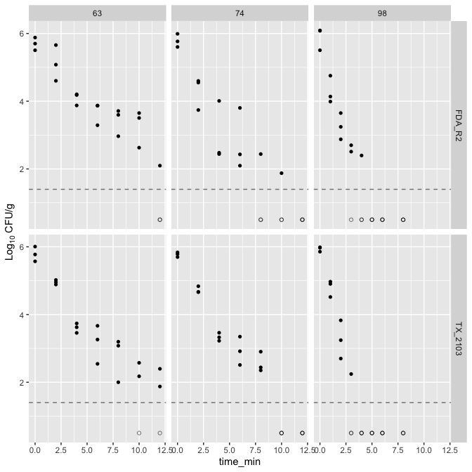

4.1.1 Statistical comparison of 2 strains
# Negative-binomial GLMM for colony counts.
# No-colony observations remain count = 0.
df_dyn_test <- df_dyn %>%
mutate(
cond = interaction(temp_target_c, time_min, drop = TRUE)
)
# Model with strain-by-temperature fixed effect.
fit <- glmmTMB(
count ~ strain * temp_target_c + offset(log(plate_fraction)) + (1 | cond),
family = nbinom2,
data = df_dyn_test
)
drop1(fit, test = "Chisq")
Single term deletions
Model:
count ~ strain * temp_target_c + offset(log(plate_fraction)) +
(1 | cond)
Df AIC LRT Pr(>Chi)
<none> 1157
strain:temp_target_c 2 1156 3.02 0.22
# Estimated strain contrasts within each target temperature. The NB model uses
# a natural-log link, so divide by log(10) to report the contrast on a log10 scale.
emm <- emmeans(fit, ~ strain | temp_target_c)
contrast_df <- as.data.frame(
summary(pairs(emm), infer = TRUE)
) %>%
rename(
lower.CL = any_of("asymp.LCL"),
upper.CL = any_of("asymp.UCL")
) %>%
mutate(
estimate_log10 = estimate / log(10),
lower_log10 = lower.CL / log(10),
upper_log10 = upper.CL / log(10)
)
contrast_df
contrast temp_target_c estimate SE df lower.CL upper.CL z.ratio
1 FDA_R2 - TX_2103 63 0.90708 0.350 Inf 0.222 1.592 2.5942
2 FDA_R2 - TX_2103 74 0.00429 0.383 Inf -0.746 0.754 0.0112
3 FDA_R2 - TX_2103 98 0.33514 0.426 Inf -0.500 1.171 0.7863
p.value estimate_log10 lower_log10 upper_log10
1 0.00948 0.39394 0.0963 0.692
2 0.99105 0.00186 -0.3238 0.327
3 0.43171 0.14555 -0.2173 0.508
plot_strain_temp <- ggplot(contrast_df, aes(x = estimate_log10, y = temp_target_c)) +
geom_vline(xintercept = 0, linetype = "dashed", linewidth = 0.8) +
geom_errorbar(aes(xmin = lower_log10, xmax = upper_log10), orientation = "y", width = 0.15, linewidth = 0.9) +
scale_x_continuous(breaks = seq(-1, 1, by = 0.1)) +
geom_point(size = 3) +
labs(x = expression("FDA_R2 - TX_2103 ("*log[10]*" CFU/g)"),
y = expression("Target temperature ("*degree*C*")")) +
theme_classic(base_size = 14) +
theme(axis.text=element_text(size=14,color="black"))
plot_strain_temp
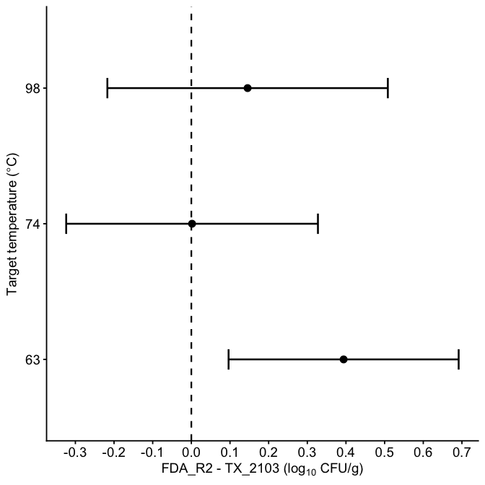
df_63 <- df_dyn %>%
filter(temp_target_c == 63) %>%
mutate(
time_min = factor(time_min)
)
fit_63 <- glmmTMB(
count ~ strain * time_min + offset(log(plate_fraction)) + (1 | rep),
family = nbinom2,
data = df_63
)
drop1(fit_63, test = "Chisq")
Single term deletions
Model:
count ~ strain * time_min + offset(log(plate_fraction)) + (1 |
rep)
Df AIC LRT Pr(>Chi)
<none> 449
strain:time_min 6 455 18.5 0.005 **
---
Signif. codes: 0 '***' 0.001 '**' 0.01 '*' 0.05 '.' 0.1 ' ' 1
emm_63 <- emmeans(fit_63, ~ strain | time_min)
contrast_63 <- as.data.frame(
summary(pairs(emm_63), infer = TRUE)
) %>%
rename(
lower.CL = any_of("asymp.LCL"),
upper.CL = any_of("asymp.UCL")
) %>%
mutate(
estimate_log10 = estimate / log(10),
lower_log10 = lower.CL / log(10),
upper_log10 = upper.CL / log(10)
)
plot_strain_time <- ggplot(contrast_63, aes(x = as.numeric(as.character(time_min)), y = estimate_log10)) +
geom_hline(yintercept = 0, linetype = "dashed", linewidth = 0.8) +
geom_errorbar(aes(ymin = lower_log10, ymax = upper_log10), width = 0.3, linewidth = 0.9) +
geom_point(size = 3) +
geom_line(linewidth = 1) +
scale_x_continuous(breaks = seq(0, 12, 2)) +
labs(
x = "Time (min)",
y = expression("FDA_R2 - TX_2103 ("*log[10]*" CFU/g)")
) +
theme_classic(base_size = 14)+
theme(axis.text=element_text(size=14,color="black"))
combined_plot <- plot_strain_temp + plot_strain_time +
plot_annotation(tag_levels = "A") &
theme(
plot.tag = element_text(size = 16, face = "bold")
)
combined_plot
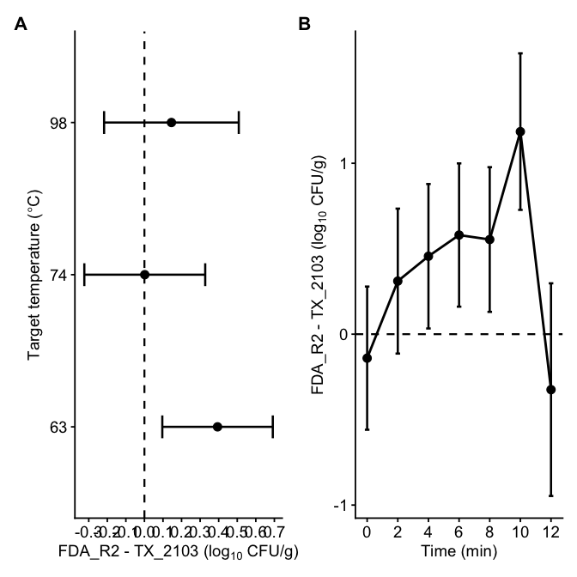
ggsave(
here("Plot", "Figure_strain_comparison_combined.tiff"),
plot = combined_plot,
width = 11,
height = 5,
units = "in",
dpi = 600,
compression = "lzw"
)
The count-based negative-binomial GLMM did not indicate a significant difference between VP2 and VP3. Strain variable will be removed.

4.2 Inactivation data with strain combined
df_dyn %>%
ggplot(aes(x = time_min, y = log_cfu_plot)) +
geom_hline(
yintercept = LOD,
linetype = "dashed",
color = "gray50"
) +
geom_point(data = ~ filter(.x, !no_colonies), shape = 16, color = "black") +
geom_point(data = ~ filter(.x, no_colonies), shape = 1, color = "black", alpha = 0.5) +
labs(y = expression(Log[10]~"CFU/g")) +
facet_grid(~temp_target_c)
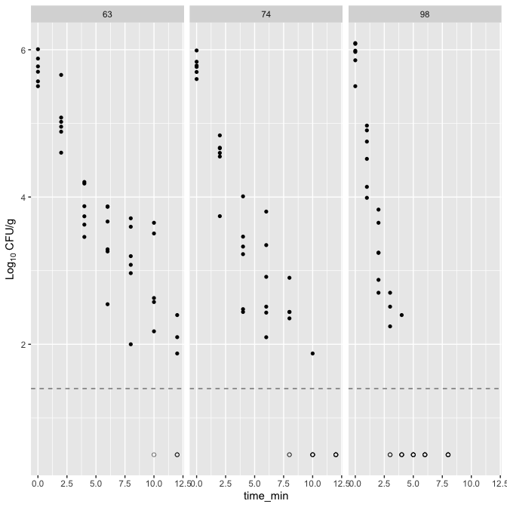

4.3 time-temperature profile
df_temp <- df_comeup %>%
group_by(temp_target_c, time_min) %>%
summarise(temp_mean = mean(temp_recorded_c_ave),
temp_sd = sd(temp_recorded_c_ave), .groups = "drop")
p_temp <- df_temp %>%
ggplot(aes(
x = time_min, y = temp_mean,
color = temp_target_c,
linetype = temp_target_c,
group = temp_target_c
)) +
# Mean and SD ribbon
geom_ribbon(aes(
ymin = temp_mean - temp_sd,
ymax = temp_mean + temp_sd,
fill = temp_target_c
),
alpha = 0.15, color = NA) +
geom_line(size = 0.5) +
geom_point(size = 1) +
labs(
y = bquote(Temperature~(degree*C)),
x = "Time (min)",
color = bquote(Target~Temperature~(degree*C)),
linetype = bquote(Target~Temperature~(degree*C))
) +
scale_color_manual(values = c("63" = "#ED0F54", "74" = "#52DD12", "98" = "#2998E2")) +
scale_fill_manual(values = c("63" = "#ED0F54", "74" = "#52DD12", "98" = "#2998E2")) +
scale_linetype_manual(values = c("63" = "solid", "74" = "dashed", "98" = "longdash")) +
scale_x_continuous(breaks = seq(0, 13, by = 1)) +
scale_y_continuous(breaks = seq(20, 100, by = 10)) +
coord_cartesian(xlim = c(0, 13), ylim = c(20, 100)) +
theme_bw() +
theme(
legend.position = "bottom",
legend.justification = "center",
legend.margin = margin(t = 0, r = 0, b = 0, l = 0),
legend.box.margin = margin(t = -8, r = 0, b = 0, l = 0),
legend.title = element_text(size = 9),
legend.text = element_text(size = 9),
axis.title = element_text(size = 12),
axis.text = element_text(size = 12)) +
guides(fill = "none")
p_temp
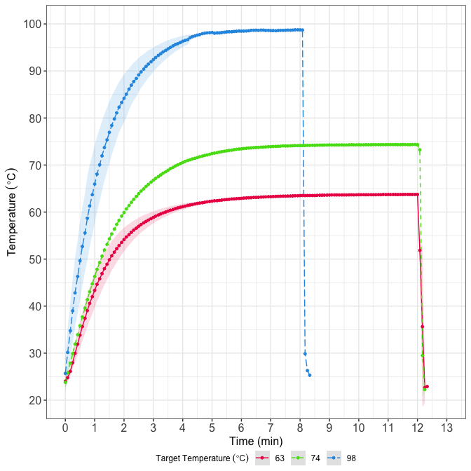
ggsave(file = here("Plot", "ComeUp_Temp_Plot.tiff"), plot = p_temp, width = 6, height = 4, units = "in", dpi = 400)

5. Data preprocessing for modeling
# Left join the come up time df to get the measured temperature
df_dyn2 <- df_dyn %>%
left_join(
df_temp %>% dplyr::select(temp_target_c, time_min, temp_mean),
by = c("temp_target_c", "time_min")
)
saveRDS (df_dyn2, here("Data", "df_dyn2.RDS"))
The CFU column is stored as the total colony count from two 0.1 mL plates, with plated_ml = 0.2. Observations with no colonies on the lowest-dilution plates are modeled as count = 0; log_cfu_plot is used only for visualization, placing those observations below the effective two-plate LOD on log-scale plots.

5.1 Checking distribution of count
df_dyn2 <- readRDS(here("Data", "df_dyn2.RDS"))
# start with ggplot
ggplot(df_dyn2, aes(count)) +
geom_histogram(binwidth = 10) +
theme_light()
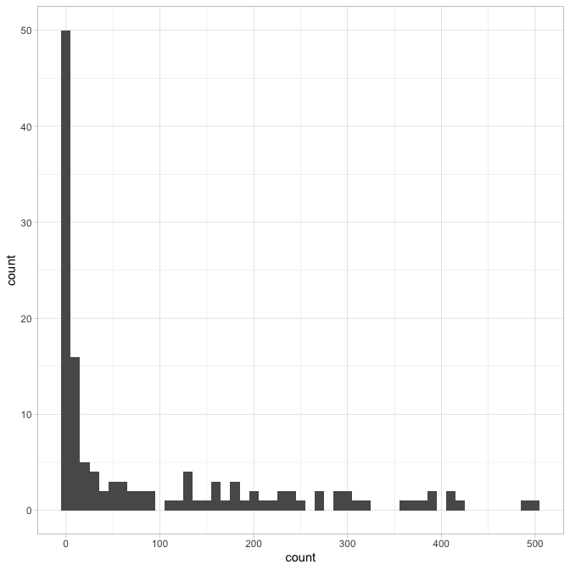
# Check if variance = mean
g <- df_dyn2 %>%
group_by(temp_target_c, time_min, dilution, plated_ml) %>%
summarise(
n = n(),
mean = mean(count, na.rm = TRUE),
var = var(count, na.rm = TRUE),
vmr = var / mean, # variance-to-mean ratio
.groups = "drop"
)
summary(g$vmr)
Min. 1st Qu. Median Mean 3rd Qu. Max. NAs
3.00 9.76 33.93 52.58 96.27 190.37 4
quantile(g$vmr, c(.5, .75, .9), na.rm = TRUE)
50% 75% 90%
33.9 96.3 109.5
# Variance estimation
g2 <- g %>%
filter(mean > 0, vmr > 1) %>%
mutate(size_hat = mean / (vmr - 1))
# confirm the distribution type with fitdistrplus package
fit_pois <- fitdist(df_dyn2$count, "pois")
fit_nb <- fitdist(df_dyn2$count, "nbinom")
plot(fit_pois)
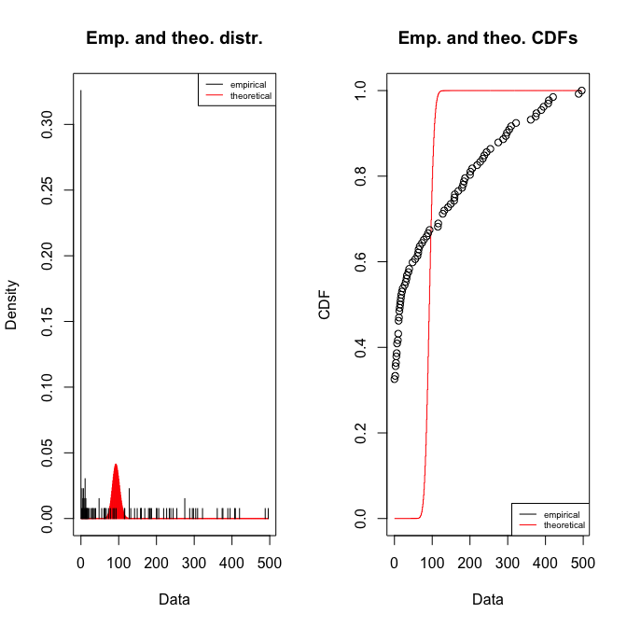
gofstat(fit_pois)
Chi-squared statistic: Inf
Degree of freedom of the Chi-squared distribution: 7
Chi-squared p-value: 0
the p-value may be wrong with some theoretical counts < 5
Chi-squared table:
obscounts theocounts
<= 0 4.30e+01 7.81e-39
<= 7 1.10e+01 9.79e-29
<= 14 1.10e+01 3.60e-22
<= 37 1.10e+01 5.49e-09
<= 85 1.10e+01 3.06e+01
<= 158 1.10e+01 1.01e+02
<= 219 1.10e+01 3.21e-08
<= 304 1.10e+01 0.00e+00
> 304 1.20e+01 0.00e+00
Goodness-of-fit criteria
1-mle-pois
Akaike's Information Criterion 22334
Bayesian Information Criterion 22337
plot(fit_nb)
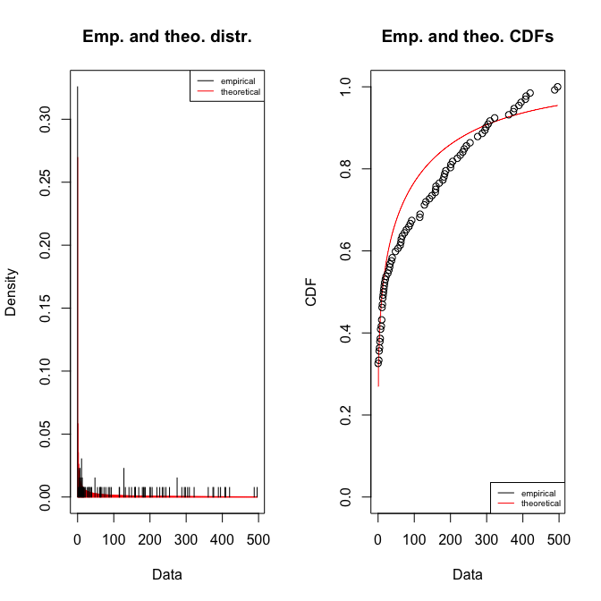
gofstat(fit_nb)
Chi-squared statistic: 24.2
Degree of freedom of the Chi-squared distribution: 6
Chi-squared p-value: 0.000488
Chi-squared table:
obscounts theocounts
<= 0 43.00 35.58
<= 7 11.00 24.62
<= 14 11.00 8.91
<= 37 11.00 14.89
<= 85 11.00 14.48
<= 158 11.00 11.02
<= 219 11.00 5.48
<= 304 11.00 5.00
> 304 12.00 12.00
Goodness-of-fit criteria
1-mle-nbinom
Akaike's Information Criterion 1238
Bayesian Information Criterion 1244
exp(0.25)
[1] 1.28
# initial size estimation
summary(g2$size_hat)
Min. 1st Qu. Median Mean 3rd Qu. Max.
0.185 0.673 1.276 5.291 5.740 48.516
quantile(g2$size_hat, c(0.25, 0.5, 0.75), na.rm = TRUE)
25% 50% 75%
0.673 1.276 5.740
Variance-to-mean ratios far exceeding 1, violating Poisson assumptions, also, fitdist function confirms the selection of negative binomial. Therefore, a negative binomial likelihood was used for all subsequent model fitting.

6. Functions for modeling

6.1 Model Fitting
get_nll <- function(p, this_data, known, times,
model_name = "Geeraerd") {
# if (this_data$temp_target_c[1] == 74) {
# browser()
# }
all_pars <- as.list(c(p, known))
# unlog transformation
if ("logN0" %in% names(all_pars)) {
all_pars$N0 <- 10^all_pars$logN0
all_pars$logN0 <- NULL
}
if ("logNmin" %in% names(all_pars)) {
all_pars$N_min <- 10^all_pars$logNmin
all_pars$logNmin <- NULL
}
# Negative binomial distribution require size (dispersion) as parameter estimate
size <- exp(all_pars$log_size)
all_pars$log_size <- NULL
# Temp profile for this target temperature condition
this_temp <- this_data %>%
dplyr::select(time, temperature) %>%
distinct() %>%
arrange(time)
# Predicted data
pred <- predict_inactivation(
simulation_model = model_name,
times = times,
parms = all_pars,
temp_profile = this_temp
)$simulation %>%
as.data.frame()
# Observed data
obs <- this_data %>%
dplyr::select(time, count, dilution, plated_ml)
merged <- merge(
x = obs,
y = pred[, c("time", "logN")],
by = "time",
all.x = TRUE,
suffixes = c("_obs", "_mod")
)
# if (any(is.na(merged$logN)) || any(!is.finite(merged$logN))) return(Inf)
# Predicted concentration from predicted log10 CFU/ml
pred_N <- 10^merged$logN
pred_count <- pred_N * merged$plated_ml * merged$dilution
# if (any(!is.finite(pred_count)) || any(pred_count <= 0)) return(Inf)
pred_count <- pmax(pred_count, 1e-12)
# NB log-likelihood
ll <- dnbinom(merged$count, mu = pred_count, size = size, log = TRUE)
# if (any(!is.finite(ll))) {
# print("out")
# return(Inf)
# }
# print(sum(ll))
-sum(ll, na.rm = TRUE)
}
get_total_nll <- function(p, split_data, known, times_list,
model_name = "Geeraerd") {
nlls <- mapply(
FUN = function(dat, times) {
get_nll(p = p, this_data = dat, known = known, times = times,
model_name = model_name)},
dat = split_data,
times = times_list,
SIMPLIFY = TRUE
)
# if (any(!is.finite(nlls))) return(Inf)
sum(nlls, na.rm = TRUE)
}
global_fit <- function(d, guess, known, model_name = "Geeraerd", upper = Inf, lower = -Inf, niter = 5000) {
d2 <- d %>%
mutate(
time = as.numeric(time_min),
temperature = as.numeric(temp_mean),
time = ifelse(time < 2e-5, 2e-5, time),
temp_target_c = as.factor(temp_target_c)
)
## Split by target temperature
split_data <- split(d2, d2$temp_target_c)
## Precompute times per condition
times_list <- lapply(split_data, function(df) {
df$time %>% unique() %>% sort() %>% na.omit()
})
modMCMC(f = get_total_nll, p = guess, split_data = split_data,
known = known, times_list = times_list, model_name = model_name,
upper = upper, lower = lower, niter = niter
)
}
##Goodness-of-fit
compute_residuals_dyn <- function(data, model_name, bestpar, known_pars) {
bp <- as.list(bestpar)
size <- exp(as.numeric(bp$log_size))
bp$log_size <- NULL
# Unlog parameters if present
if ("logN0" %in% names(bp)) {
bp$N0 <- 10^bp$logN0
bp$logN0 <- NULL
}
if ("logNmin" %in% names(bp)) {
bp$N_min <- 10^bp$logNmin
bp$logNmin <- NULL
}
d2 <- data %>%
mutate(
cond = as.factor(temp_target_c),
time = round(as.numeric(time_min), 3),
temperature = as.numeric(temp_mean)
)
preds <- d2 %>%
split(.$cond) %>%
map_df(function(df) {
temp_prof <- df %>%
dplyr::select(time, temperature) %>%
distinct() %>%
arrange(time)
times_use <- sort(unique(df$time))
sim <- quiet_predict_inactivation(
simulation_model = model_name,
times = times_use,
parms = c(bp, as.list(known_pars)),
temp_profile = temp_prof
)$simulation %>%
as.data.frame() %>%
mutate(time = round(time, 3))
data.frame(cond = df$cond, time = sim$time, m = sim$logN)
}) %>%
distinct(cond, time, .keep_all = TRUE)
d2 %>%
left_join(preds, by = c("cond", "time")) %>%
mutate(pred_count = (10^m) * plated_ml * dilution,
pred_count = ifelse(is.finite(pred_count) & pred_count > 0, pred_count, NA_real_))
}
# AIC and AICc calculation from log-likelihood
compute_fitstats <- function(res_df, bestpar, k, comm_df = NULL) {
size <- exp(bestpar[["log_size"]])
# If comm_df is provided, restrict to exactly those rows
if (!is.null(comm_df)) {
res_df <- res_df %>%
dplyr::semi_join(
comm_df %>% dplyr::distinct(cond, time, dilution, plated_ml, count),
by = c("cond", "time", "dilution", "plated_ml", "count")
)
}
ll <- dnbinom(
x = res_df$count,
mu = res_df$pred_count,
size = size,
log = TRUE
)
logLik <- sum(ll)
n_all <- nrow(res_df)
AIC <- 2 * k - 2 * logLik
AICc <- AIC + (2 * k * (k + 1)) / (n_all - k - 1)
list(logLik = logLik, AIC = AIC, AICc = AICc, n_used = n_all)
}

7. Modeling
##Peleg Weibull - Best fit
df_dyn2 <- readRDS(here("Data", "df_dyn2.RDS"))
# Plotting-only data: zero colony observations are modeled as count = 0,
# but displayed below the LOD on log-scale concentration plots.
df_dyn_plot <- df_dyn2 %>%
mutate(
no_colonies = count == 0L,
log_cfu_plot = if_else(no_colonies, 0.5, as.numeric(log_cfu))
)
known_pe <- c()
guess_pe <- c(k_b = 0.1, n = 1.0, temp_crit = 50, logN0 = 6,log_size = log(1.9))
lower_pe <- c(k_b = 0.001, n = 0.1, temp_crit = 45, logN0 = 5, log_size = log(0.05))
upper_pe <- c(k_b = 20, n = 5, temp_crit = 65, logN0 = 7, log_size = log(20))
set.seed(5025)
invisible(capture.output(my_model_pe <- global_fit(
d = df_dyn2, guess = guess_pe, known = known_pe, model_name = "Peleg",
niter = 5000, lower = lower_pe, upper = upper_pe),type = "output"))
plot(my_model_pe)
summary(my_model_pe)
k_b n temp_crit logN0 log_size
mean 0.07119 0.3884 48.72 5.7276 0.00561
sd 0.00777 0.0665 3.68 0.0919 0.27446
min 0.05394 0.3141 45.06 5.3397 -0.69863
max 0.11522 1.0000 64.35 6.7311 0.66588
q025 0.06632 0.3512 45.74 5.6764 -0.23689
q050 0.06948 0.3766 48.73 5.7510 -0.02567
q075 0.07587 0.4116 49.76 5.7720 0.20006
apply(my_model_pe$pars, 2, quantile, probs = c(0.025, 0.975))
k_b n temp_crit logN0 log_size
2.5% 0.0645 0.314 45.1 5.54 -0.487
97.5% 0.0856 0.625 59.6 5.94 0.529
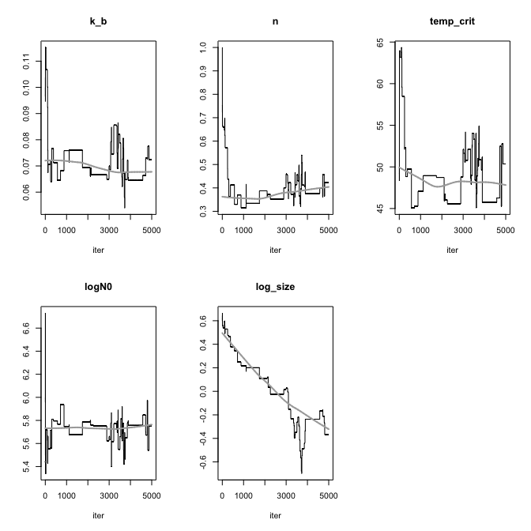

7.0.1 Decimal reduction time calculation
temps <- c(63, 74, 90, 98)
pars <- as.data.frame(my_model_pe$pars)
pars$s <- exp(pars$log_size)
mean(pars$s)
[1] 1.04
sd(pars$s)
[1] 0.29
quantile(pars$s, probs = c(0.025, 0.975))
2.5% 97.5%
0.615 1.697
# compute b(T)
calc_b <- function(T, k_b, temp_crit){
log1p(exp(k_b * (T - temp_crit)))
}
# compute D-value
calc_D <- function(b, n){
(log(10) / b)^(1 / n)
}
# compute posterior samples
post_samples <- pars %>%
mutate(
b63 = calc_b(63, k_b, temp_crit),
b74 = calc_b(74, k_b, temp_crit),
b98 = calc_b(98, k_b, temp_crit),
D63 = calc_D(b63, n),
D74 = calc_D(b74, n),
D98 = calc_D(b98, n)
)
# summarize mean + 95% CrI
summary_table <- post_samples %>%
summarise(
b63_mean = mean(b63),
b63_lwr = quantile(b63, 0.025),
b63_upr = quantile(b63, 0.975),
b63_sd = sd(b63),
b74_mean = mean(b74),
b74_lwr = quantile(b74, 0.025),
b74_upr = quantile(b74, 0.975),
b74_sd = sd(b74),
b98_mean = mean(b98),
b98_lwr = quantile(b98, 0.025),
b98_upr = quantile(b98, 0.975),
b98_sd = sd(b98),
D63_mean = mean(D63),
D63_lwr = quantile(D63, 0.025),
D63_upr = quantile(D63, 0.975),
D63_sd = sd(D63),
D74_mean = mean(D74),
D74_lwr = quantile(D74, 0.025),
D74_upr = quantile(D74, 0.975),
D74_sd = sd(D74),
D98_mean = mean(D98),
D98_lwr = quantile(D98, 0.025),
D98_upr = quantile(D98, 0.975),
D98_sd = sd(D98),
)
summary_table
b63_mean b63_lwr b63_upr b63_sd b74_mean b74_lwr b74_upr b74_sd b98_mean
1 1.32 0.815 1.47 0.16 1.94 1.39 2.17 0.172 3.52
b98_lwr b98_upr b98_sd D63_mean D63_lwr D63_upr D63_sd D74_mean D74_lwr
1 2.85 3.94 0.243 4.32 3.37 5.62 0.655 1.56 1.22
D74_upr D74_sd D98_mean D98_lwr D98_upr D98_sd
1 2.43 0.263 0.339 0.189 0.689 0.103

7.0.2 Prediction of reduction
### Predicted log10 reduction from model parameters only
#| message: false
#| warning: false
pars <- as.data.frame(my_model_pe$pars)
predict_reduction_one_draw <- function(profile_df, draw_row) {
p <- as.list(draw_row)
p$log_size <- NULL
# Arbitrary starting value only used as a reference point.
# It cancels out when calculating log10 reduction.
p$N0 <- 10^6
p$logN0 <- NULL
temp_prof <- profile_df %>%
dplyr::select(time = time_min, temperature = temp_mean) %>%
dplyr::distinct() %>%
dplyr::arrange(time)
times_use <- seq(0, max(temp_prof$time), by = 0.01)
sim <- suppressWarnings(
quiet_predict_inactivation(
simulation_model = "Peleg",
times = times_use,
parms = p,
temp_profile = temp_prof
)$simulation %>%
as.data.frame()
)
sim %>%
dplyr::mutate(
log_reduction = logN[which.min(time)] - logN
)
}
profiles_split <- split(df_temp, df_temp$temp_target_c)
reduction_all <- purrr::imap_dfr(profiles_split, function(prof, target_name) {
purrr::map_dfr(seq_len(nrow(pars)), function(i) {
predict_reduction_one_draw(
profile_df = prof,
draw_row = pars[i, ]
) %>%
dplyr::mutate(
draw = i,
temp_target_c = target_name
)
})
})
reduction_table_1min <- reduction_all %>%
dplyr::group_by(temp_target_c, time) %>%
dplyr::summarise(
mean_log_reduction = mean(log_reduction, na.rm = TRUE),
lwr_log_reduction = quantile(log_reduction, 0.025, na.rm = TRUE),
upr_log_reduction = quantile(log_reduction, 0.975, na.rm = TRUE),
.groups = "drop"
) %>%
dplyr::filter(abs(time - round(time)) < 1e-8) %>%
dplyr::arrange(temp_target_c, time)
print(reduction_table_1min, n = Inf, width = Inf)
# A tibble: 32 × 5
temp_target_c time mean_log_reduction lwr_log_reduction upr_log_reduction
<chr> <dbl> <dbl> <dbl> <dbl>
1 63 1 0.348 0.177 0.444
2 63 2 0.778 0.480 0.910
3 63 3 1.19 0.841 1.36
4 63 4 1.54 1.19 1.73
5 63 5 1.84 1.51 2.05
6 63 6 2.10 1.81 2.32
7 63 7 2.32 2.04 2.55
8 63 8 2.52 2.24 2.77
9 63 9 2.70 2.42 2.97
10 63 10 2.87 2.58 3.15
11 63 11 3.02 2.76 3.32
12 63 12 3.16 2.89 3.47
13 74 1 0.397 0.203 0.500
14 74 2 0.962 0.602 1.10
15 74 3 1.55 1.13 1.73
16 74 4 2.08 1.68 2.27
17 74 5 2.54 2.21 2.74
18 74 6 2.94 2.69 3.14
19 74 7 3.29 3.01 3.49
20 74 8 3.59 3.30 3.94
21 74 9 3.87 3.56 4.23
22 74 10 4.11 3.80 4.53
23 74 11 4.34 3.98 4.87
24 74 12 4.55 4.15 5.24
25 98 1 0.904 0.488 1.04
26 98 2 2.22 1.67 2.44
27 98 3 3.40 2.95 3.67
28 98 4 4.38 3.94 4.89
29 98 5 5.20 4.71 5.79
30 98 6 5.89 5.30 6.60
31 98 7 6.48 5.75 7.31
32 98 8 7.00 6.14 8.20

7.0.3 Plot using the best parameter set with observed value overlaid
# Plotting-only data for observed points.
df_dyn_plot <- df_dyn2 %>%
mutate(
no_colonies = count == 0L,
log_cfu_plot = if_else(no_colonies, 0.5, as.numeric(log_cfu))
)
df_dyn_fit <- df_dyn_plot %>%
mutate(
temp_target_c = as.factor(temp_target_c),
time = as.numeric(time_min),
temperature = as.numeric(temp_mean)
)
# un-log
fit_p_pe <- as.list(my_model_pe$bestpar)
if ("logN0" %in% names(fit_p_pe)) {
fit_p_pe$N0 <- 10^fit_p_pe$logN0
fit_p_pe$logN0 <- NULL
}
if ("logNmin" %in% names(fit_p_pe)) {
fit_p_pe$N_min <- 10^fit_p_pe$logNmin
fit_p_pe$logNmin <- NULL
}
if ("log_size" %in% names(fit_p_pe)) {
fit_p_pe$log_size <- NULL
}
plots <- df_dyn_fit %>%
split(.$temp_target_c) %>%
purrr::map(~{
temp_prof <- .x %>%
dplyr::select(time, temperature) %>%
distinct() %>%
arrange(time)
times_pred <- seq(0, max(.x$time, na.rm = TRUE), length.out = 200)
pred <- quiet_predict_inactivation(
simulation_model = "Peleg",
times = times_pred,
parms = c(fit_p_pe, as.list(known_pe)),
temp_profile = temp_prof
)
sim <- pred$simulation %>%
as.data.frame() %>%
mutate(logN_clip = pmax(logN, LOD))
ggplot() +
geom_hline(yintercept = LOD, linetype = "dashed", color = "gray50") +
geom_line(data = sim, aes(x = time, y = logN), linewidth = 0.9) +
geom_point(data = filter(.x, !no_colonies), aes(x = time, y = log_cfu_plot),
size = 1.6, shape = 16, color = "black") +
geom_point(data = filter(.x, no_colonies), aes(x = time, y = log_cfu_plot),
size = 1.6, shape = 1, color = "black", alpha = 0.5) +
labs(
title = paste0("Target ", as.character(unique(.x$temp_target_c)), "°C"),
x = "time (min)",
y = expression(Log[10]~"CFU/g")
) +
coord_cartesian(ylim = c(0, 6.5)) +
theme_classic()
})
cowplot::plot_grid(plotlist = plots)
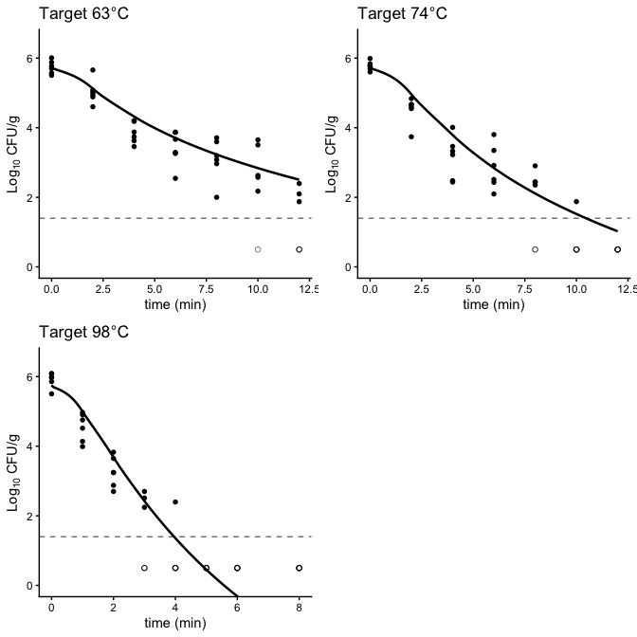

7.0.4 Goodness-of-fit check
df_resid_pe <- compute_residuals_dyn(
data = df_dyn2,
model_name = "Peleg",
bestpar = my_model_pe$bestpar,
known_pars = known_pe
)
# fit stats
fitstats_pe <- compute_fitstats(
res_df = df_resid_pe,
bestpar = my_model_pe$bestpar,
k = 4
)
fitstats_pe$AIC
[1] 1087
fitstats_pe$AICc
[1] 1088

7.0.5 Bacterial reduction estimation given different initial conc.

7.1 Plot for publication
make_interv_pe <- function(m, data, known, model = "Peleg") {
p <- unlist(m)
p <- p[!names(p) %in% c("log_size", "i")]
p["N0"] <- 10^p["logN0"]
data %>%
split(.$temp_target_c) %>%
map(~{
dat <- .x %>%
mutate(
time = as.numeric(time_min),
temperature = as.numeric(temp_mean)
)
temp_prof <- dat %>%
dplyr::select(time, temperature) %>%
distinct() %>%
arrange(time)
times_pred <- seq(0, max(dat$time, na.rm = TRUE), length.out = 200)
predict_inactivation(
simulation_model = model,
times = times_pred,
parms = c(p, known),
temp_profile = temp_prof
)$simulation %>%
as.data.frame()
}) %>%
imap_dfr(~ mutate(.x, temp_target_c = .y))
}
## Posterior predictions
MCMC_preds_pe <- my_model_pe$pars %>%
as_tibble() %>%
slice_sample(n = 1000, replace = TRUE) %>%
mutate(i = row_number()) %>%
split(.$i) %>%
purrr::map_dfr(
~ {
invisible(capture.output(
pred <- make_interv_pe(.x, data = df_dyn2, known = known_pe, model = "Peleg"),
type = "output"
))
pred
},
.id = "i"
) %>%
summarise(
m = median(logN, na.rm = TRUE),
q2.5 = quantile(logN, 0.025, na.rm = TRUE),
q97.5 = quantile(logN, 0.975, na.rm = TRUE),
.by = c("temp_target_c", "time")
)
## rescale temperature to match CFU axis
temp_scaled <- df_temp %>%
mutate(temp_target_c=factor(temp_target_c),
time=as.numeric(time_min),
scal_temp=(temp_mean-20)/(100-20)*6)
# Plotting-only data for observed points.
df_dyn_plot <- df_dyn2 %>%
mutate(
no_colonies = count == 0L,
log_cfu_plot = if_else(no_colonies, 0.5, as.numeric(log_cfu))
)
make_panel <- function(Ttarget, xlim=NULL, xbreaks=NULL,
show_left_axis=FALSE,
show_right_axis=FALSE,
show_temp_title=FALSE){
## model predictions (clip at 0 for plotting)
pred_sub <- MCMC_preds_pe %>%
filter(temp_target_c==Ttarget) %>%
mutate(m_plot=pmax(m,0),
q2.5_plot=pmax(q2.5,0),
q97.5_plot=pmax(q97.5,0))
## observed data
dat_sub <- df_dyn_plot %>%
filter(temp_target_c==Ttarget) %>%
mutate(time=as.numeric(time_min),
logN=as.numeric(log_cfu_plot),
strain=factor(strain))
## temperature profile (already rescaled)
temp_sub <- temp_scaled %>%
filter(temp_target_c==Ttarget)
ggplot() +
## uncertainty ribbon (95% CI)
geom_ribbon(data=pred_sub,
aes(x=time,ymin=q2.5_plot,ymax=q97.5_plot),
fill="gray80",alpha=0.8) +
## median prediction line
geom_line(data=pred_sub,
aes(x=time,y=m_plot),
linewidth=0.9,color="black") +
## observed points; no-colony observations are plotted below the LOD line
geom_point(data=filter(dat_sub,!no_colonies),
aes(x=time,y=logN,shape=strain),
size=1.8,stroke=0.5,color="black",fill="black") +
geom_point(data=filter(dat_sub,no_colonies),
aes(x=time,y=logN),
shape=1,size=1.8,stroke=0.5,color="black",alpha=0.5) +
## temperature curve (scaled to same axis)
geom_line(data=temp_sub,
aes(x=time,y=scal_temp),
linetype="longdash",linewidth=0.6,color="gray35") +
## LOD horizontal line
geom_hline(yintercept=LOD,
linetype="dashed",linewidth=0.6,color="gray45") +
## shape mapping for strains
scale_shape_manual(values=c(16,2)) +
## primary + optional secondary axis
scale_y_continuous(
name=if(show_left_axis) expression(Log[10]~"CFU/g") else NULL, # left axis only for first panel
breaks=seq(0,6,1),
sec.axis=if(show_right_axis) sec_axis( # right axis only for last panel
~./6*80+20,
breaks=seq(20,100,20),
name=if(show_temp_title) "Temperature (°C)" else NULL
) else waiver()
) +
## x-axis
scale_x_continuous(breaks=xbreaks) +
## limits
coord_cartesian(xlim=xlim,ylim=c(0,6)) +
labs(x= "Time (min)",title=paste0("Target ",as.character(Ttarget),"°C")) +
## styling
theme_bw(base_size=12) +
theme(
plot.title=element_text(size=10,face="bold",hjust=0.5),
axis.text.x=element_text(size=12,color="black"),
## left axis visibility control
axis.text.y.left=if(show_left_axis) element_text(size=12,color="black") else element_blank(),
axis.ticks.y.left=if(show_left_axis) element_line(color="black") else element_blank(),
axis.title.y.left=if(show_left_axis) element_text(size=12) else element_blank(),
## right axis visibility control
axis.text.y.right=if(show_right_axis) element_text(size=12,color="gray25") else element_blank(),
axis.ticks.y.right=if(show_right_axis) element_line(color="gray25") else element_blank(),
axis.title.y.right=if(show_right_axis && show_temp_title)
element_text(size=12,margin=margin(l=6)) else element_blank(),
## remove grids + legend
panel.grid.minor=element_blank(),
panel.grid.major=element_blank(),
panel.border=element_rect(linewidth=0.6,color="black"),
legend.position="none"
)
}
## build panels
p1 <- make_panel("63", xlim=c(0,13), xbreaks=seq(0,12,2), show_left_axis=TRUE)
p2 <- make_panel("74", xlim=c(0,13), xbreaks=seq(0,12,2))
p3 <- make_panel("98", xlim=c(0,13), xbreaks=seq(0,12,2), show_right_axis=TRUE, show_temp_title=TRUE)
## combine (tight layout)
p_all <- p1 + p2 + p3 + plot_layout(ncol=3)
p_all
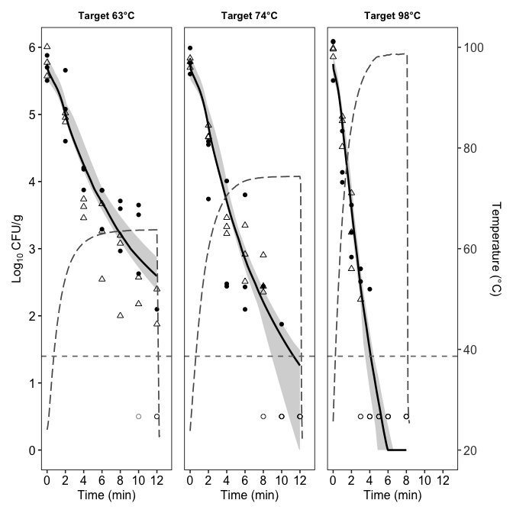
## save
ggsave(filename=here("Plot","Vibrio_Oys_PE_Plot.tiff"),
plot=p_all, width=10, height=4, units="in",
dpi=1000,bg="white")

7.2 Geeraerd
model_name <- "Geeraerd"
known_ge_1 <- c(temp_ref = 63)
lower_ge_1 <- c(D_R = .3, z = 2, logN0 = 5, logNmin = -1, log_size = log(0.05), C_c0 = 1e-6)
upper_ge_1 <- c(D_R = 6, z = 15, logN0 = 7, logNmin = 1.7, log_size = log(20), C_c0 = 1e3)
# Initial guess from the inactivation data plot
guess_ge_1 <- c(D_R = 2.4, z = 6, logN0 = 6, logNmin = 0, log_size = log(1.9), C_c0 = 1)
set.seed(5025)
my_model_ge_1 <- global_fit(df_dyn2, guess_ge_1, known_ge_1, niter = 5000,
lower = lower_ge_1,
upper = upper_ge_1)
number of accepted runs: 729 out of 5000 (14.6%)
saveRDS(my_model_ge_1, here("Result", "model_Geeraerd_1.RDS"))
plot(my_model_ge_1)
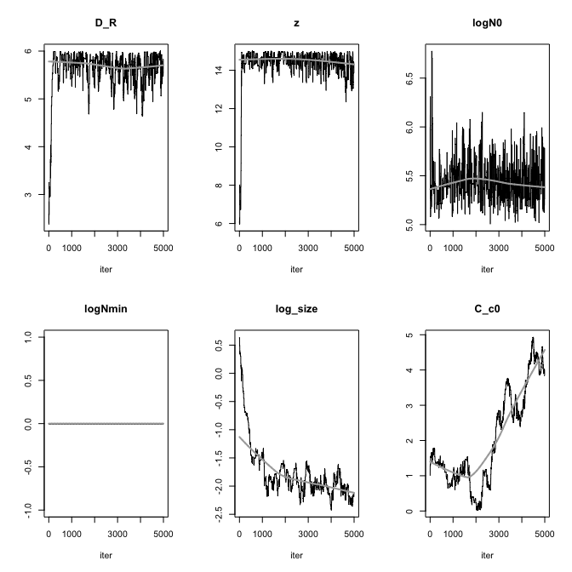
apply(my_model_ge_1$pars, 2, quantile, probs = c(0.025, 0.975))
D_R z logN0 logNmin log_size C_c0
2.5% 4.68 13.1 5.12 0 -2.2871 0.134
97.5% 5.99 15.0 5.90 0 -0.0201 4.566
summary(my_model_ge_1)
D_R z logN0 logNmin log_size C_c0
mean 5.61 14.369 5.447 0 -1.754 2.0446
sd 0.45 0.974 0.207 0 0.497 1.3420
min 2.38 5.970 5.005 0 -2.425 0.0261
max 6.00 15.000 6.776 0 0.642 4.9321
q025 5.47 14.246 5.296 0 -2.047 0.9842
q050 5.73 14.572 5.421 0 -1.894 1.5319
q075 5.87 14.812 5.560 0 -1.630 3.0707
From the summary, the logNmin is unidentifiable in the censored-likelihood formulation, so MCMC pins it to the boundary 0. Let’s try put N_min as the known value 10^0
model_name <- "Geeraerd"
known_ge <- c(temp_ref = 63, N_min = 10^0)
lower_ge <- c(D_R = .3, z = 2, logN0 = 5, log_size = log(0.05), C_c0 = 1e-6)
upper_ge <- c(D_R = 6, z = 15, logN0 = 7, log_size = log(20), C_c0 = 1e3)
# Initial guess from the inactivation data plot
guess_ge <- c(D_R = 2.4, z = 6, logN0 = 6, log_size = log(1.9), C_c0 = 1)
my_model_ge <- global_fit(df_dyn2, guess_ge, known_ge, niter = 5000,
lower = lower_ge,
upper = upper_ge)
number of accepted runs: 763 out of 5000 (15.3%)
saveRDS(my_model_ge, here("Result", "model_Geeraerd.RDS"))
plot(my_model_ge)
summary(my_model_ge)
D_R z logN0 log_size C_c0
mean 5.393 14.04 5.552 -1.886 1.09298
sd 0.921 1.75 0.263 0.480 0.86428
min 1.751 5.67 5.037 -2.994 0.00376
max 5.998 15.00 6.984 0.655 3.15972
q025 5.368 14.20 5.358 -2.099 0.33279
q050 5.687 14.56 5.522 -1.904 0.81137
q075 5.878 14.80 5.697 -1.688 1.86726
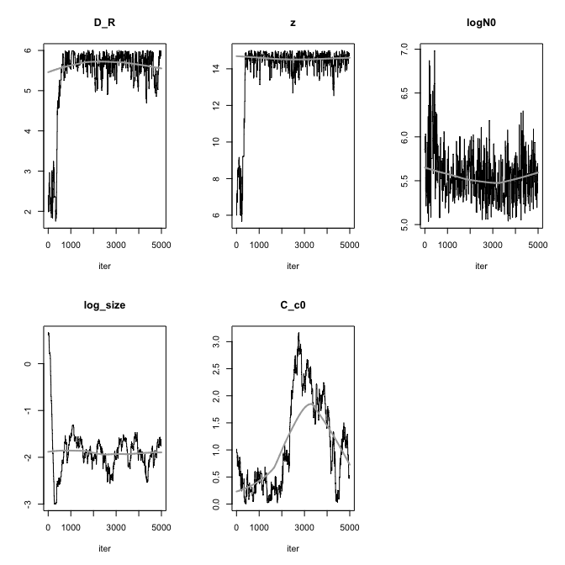

7.3 Geeraerd with no shoulder
model_name <- "Geeraerd"
known_ge_ns <- c(temp_ref = 63, N_min = 10^0, C_c0 = 1e-3)
lower_ge_ns <- c(D_R = .3, z = 2, logN0 = 5, log_size = log(0.05))
upper_ge_ns <- c(D_R = 6, z = 15, logN0 = 7, log_size = log(20))
# Initial guess from the inactivation data plot
guess_ge_ns <- c(D_R = 2.4, z = 6, logN0 = 6, log_size = log(1.9))
set.seed(5025)
my_model_ge_ns <- global_fit(df_dyn2, guess_ge_ns, known_ge_ns, niter = 5000,
lower = lower_ge_ns,
upper = upper_ge_ns)
number of accepted runs: 554 out of 5000 (11.1%)
saveRDS(my_model_ge_ns, here("Result", "model_Geeraerd_no_shoulder.RDS"))
plot(my_model_ge_ns)
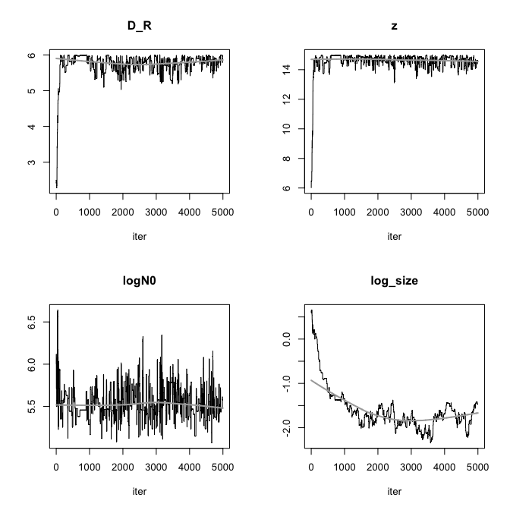
summary(my_model_ge_ns)
D_R z logN0 log_size
mean 5.728 14.562 5.539 -1.596
sd 0.344 0.727 0.191 0.493
min 2.280 6.000 5.068 -2.345
max 6.000 14.999 6.642 0.658
q025 5.619 14.439 5.426 -1.877
q050 5.805 14.718 5.507 -1.702
q075 5.925 14.876 5.637 -1.462

7.3.1 Plot using the best parameter set with observed value overlaid (with shoulder)
# un-log
fit_p_ge <- as.list(my_model_ge$bestpar)
if ("logN0" %in% names(fit_p_ge)) {
fit_p_ge$N0 <- 10^fit_p_ge$logN0
fit_p_ge$logN0 <- NULL
}
if ("logNmin" %in% names(fit_p_ge)) {
fit_p_ge$N_min <- 10^fit_p_ge$logNmin
fit_p_ge$logNmin <- NULL
}
if ("log_size" %in% names(fit_p_ge)) {
fit_p_ge$log_size <- NULL
}
plots <- df_dyn_fit %>%
split(.$temp_target_c) %>%
purrr::map(~{
temp_prof <- .x %>%
dplyr::select(time, temperature) %>%
distinct() %>%
arrange(time)
times_pred <- seq(0, max(.x$time, na.rm = TRUE), length.out = 200)
pred <- quiet_predict_inactivation(
simulation_model = "Geeraerd",
times = times_pred,
parms = c(fit_p_ge, as.list(known_ge)),
temp_profile = temp_prof
)
sim <- pred$simulation %>%
as.data.frame() %>%
mutate(logN_clip = pmax(logN, LOD))
ggplot() +
geom_hline(yintercept = LOD, linetype = "dashed", color = "gray50") +
geom_line(data = sim, aes(x = time, y = logN), linewidth = 0.9) +
geom_point(data = filter(.x, !no_colonies), aes(x = time, y = log_cfu_plot),
size = 1.6, shape = 16, color = "black") +
geom_point(data = filter(.x, no_colonies), aes(x = time, y = log_cfu_plot),
size = 1.6, shape = 1, color = "black", alpha = 0.5) +
labs(
title = paste0("Target ", as.character(unique(.x$temp_target_c)), "°C"),
x = "time (min)",
y = expression(Log[10]~"CFU/g")
) +
coord_cartesian(ylim = c(0, 6.5)) +
theme_classic()
})
cowplot::plot_grid(plotlist = plots)
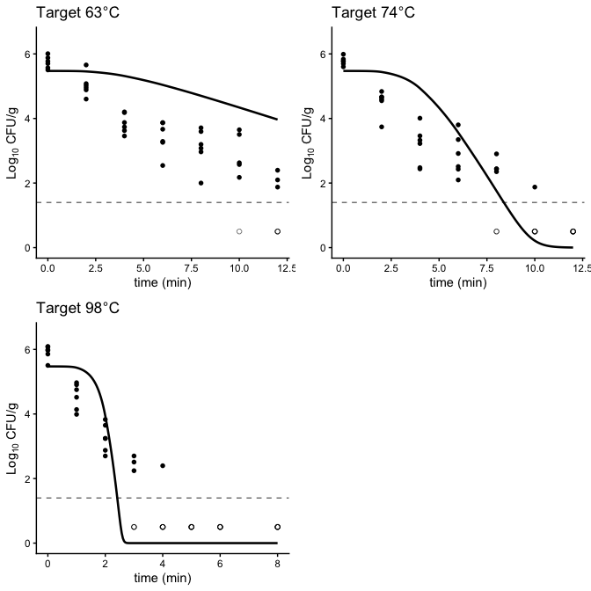

7.3.2 Plot using the best parameter set with observed value overlaid (with no shoulder)
# un-log
fit_p_ge_ns <- as.list(my_model_ge_ns$bestpar)
if ("logN0" %in% names(fit_p_ge_ns)) {
fit_p_ge_ns$N0 <- 10^fit_p_ge_ns$logN0
fit_p_ge_ns$logN0 <- NULL
}
if ("logNmin" %in% names(fit_p_ge_ns)) {
fit_p_ge_ns$N_min <- 10^fit_p_ge_ns$logNmin
fit_p_ge_ns$logNmin <- NULL
}
if ("log_size" %in% names(fit_p_ge_ns)) {
fit_p_ge_ns$log_size <- NULL
}
plots <- df_dyn_fit %>%
split(.$temp_target_c) %>%
purrr::map(~{
temp_prof <- .x %>%
dplyr::select(time, temperature) %>%
distinct() %>%
arrange(time)
times_pred <- seq(0, max(.x$time, na.rm = TRUE), length.out = 200)
pred <- quiet_predict_inactivation(
simulation_model = "Geeraerd",
times = times_pred,
parms = c(fit_p_ge_ns, as.list(known_ge_ns)),
temp_profile = temp_prof
)
sim <- pred$simulation %>%
as.data.frame() %>%
mutate(logN_clip = pmax(logN, LOD))
ggplot() +
geom_hline(yintercept = LOD, linetype = "dashed", color = "gray50") +
geom_line(data = sim, aes(x = time, y = logN), linewidth = 0.9) +
geom_point(data = filter(.x, !no_colonies), aes(x = time, y = log_cfu_plot),
size = 1.6, shape = 16, color = "black") +
geom_point(data = filter(.x, no_colonies), aes(x = time, y = log_cfu_plot),
size = 1.6, shape = 1, color = "black", alpha = 0.5) +
labs(
title = paste0("Target ", as.character(unique(.x$temp_target_c)), "°C"),
x = "time (min)",
y = expression(Log[10]~"CFU/g")
) +
coord_cartesian(ylim = c(0, 6.5)) +
theme_classic()
})
cowplot::plot_grid(plotlist = plots)
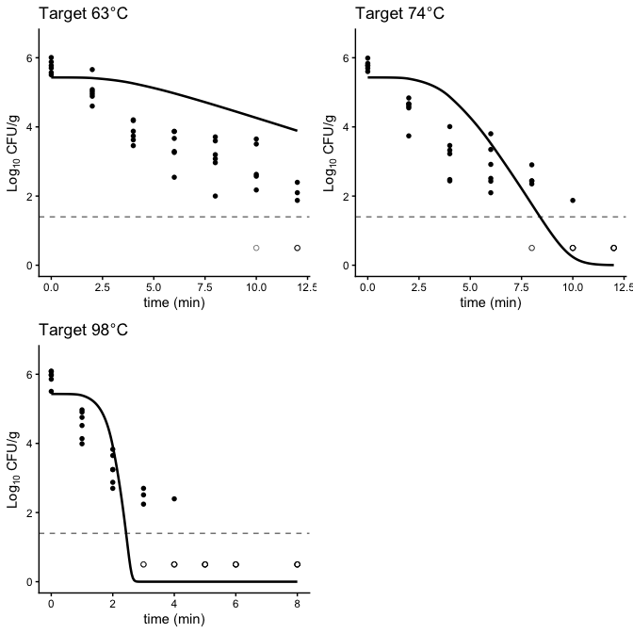

7.3.3 Goodness-of-fit check (with shoulder)
df_resid_ge <- compute_residuals_dyn(
data = df_dyn2,
model_name = "Geeraerd",
bestpar = my_model_ge$bestpar,
known_pars = known_ge
)
# fit stats
fitstats_ge <- compute_fitstats(
res_df = df_resid_ge,
bestpar = my_model_ge$bestpar,
k = 4
)
fitstats_ge$AIC
[1] 1357
fitstats_ge$AICc
[1] 1358

7.3.4 Goodness-of-fit check (with no shoulder)
df_resid_ge_ns <- compute_residuals_dyn(
data = df_dyn2,
model_name = "Geeraerd",
bestpar = my_model_ge_ns$bestpar,
known_pars = known_ge_ns
)
# fit stats
fitstats_ge_ns <- compute_fitstats(
res_df = df_resid_ge_ns,
bestpar = my_model_ge_ns$bestpar,
k = 4
)
fitstats_ge_ns$AIC
[1] 1355
fitstats_ge_ns$AICc
[1] 1355

7.4 Log-linear (Bigelow)
known_b <- c(temp_ref = 63)
guess_b <- c(D_R = 2.5, z = 6, logN0 = 6, log_size = log(1.9))
set.seed(5025)
my_model_b <- global_fit(df_dyn2, guess_b, known_b, model_name ="Bigelow",
niter = 5000,
lower = c(D_R = 2, z = 5, logN0 = 5, log_size = log(0.05)),
upper = c(D_R = 20, z = 15, logN0 = 7, log_size = log(20)))
number of accepted runs: 393 out of 5000 (7.86%)
plot(my_model_b) # check convergence
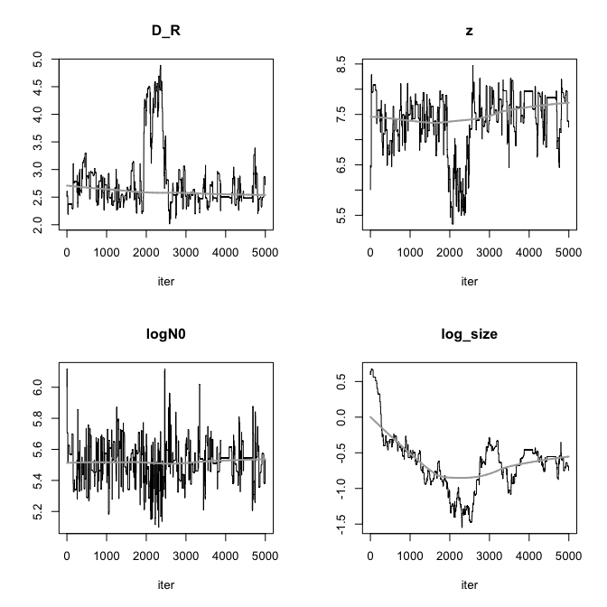
summary(my_model_b)
D_R z logN0 log_size
mean 2.770 7.371 5.520 -0.642
sd 0.543 0.588 0.131 0.393
min 2.018 5.332 5.098 -1.544
max 4.886 8.473 6.119 0.677
q025 2.482 7.164 5.443 -0.868
q050 2.565 7.482 5.531 -0.619
q075 2.861 7.832 5.597 -0.458

7.4.1 Plot using the best parameter set with observed value overlaid
# un-log
fit_p_b <- as.list(my_model_b$bestpar)
if ("logN0" %in% names(fit_p_b)) {
fit_p_b$N0 <- 10^fit_p_b$logN0
fit_p_b$logN0 <- NULL
}
if ("logNmin" %in% names(fit_p_b)) {
fit_p_b$N_min <- 10^fit_p_b$logNmin
fit_p_b$logNmin <- NULL
}
if ("log_size" %in% names(fit_p_b)) {
fit_p_b$log_size <- NULL
}
plots <- df_dyn_fit %>%
split(.$temp_target_c) %>%
purrr::map(~{
temp_prof <- .x %>%
dplyr::select(time, temperature) %>%
distinct() %>%
arrange(time)
times_pred <- seq(0, max(.x$time, na.rm = TRUE), length.out = 200)
pred <- quiet_predict_inactivation(
simulation_model = "Bigelow",
times = times_pred,
parms = c(fit_p_b, as.list(known_b)),
temp_profile = temp_prof
)
sim <- pred$simulation %>%
as.data.frame() %>%
mutate(logN_clip = pmax(logN, LOD))
ggplot() +
geom_hline(yintercept = LOD, linetype = "dashed", color = "gray50") +
geom_line(data = sim, aes(x = time, y = logN), linewidth = 0.9) +
geom_point(data = filter(.x, !no_colonies), aes(x = time, y = log_cfu_plot),
size = 1.6, shape = 16, color = "black") +
geom_point(data = filter(.x, no_colonies), aes(x = time, y = log_cfu_plot),
size = 1.6, shape = 1, color = "black", alpha = 0.5) +
labs(
title = paste0("Target ", as.character(unique(.x$temp_target_c)), "°C"),
x = "time (min)",
y = expression(Log[10]~"CFU/g")
) +
coord_cartesian(ylim = c(0, 6.5)) +
theme_classic()
})
cowplot::plot_grid(plotlist = plots)

7.4.2 Goodness-of-fit check
df_resid_b <- compute_residuals_dyn(
data = df_dyn2,
model_name = "Bigelow",
bestpar = my_model_b$bestpar,
known_pars = known_b
)
# NA prediction was produced
df_resid_b %>%
dplyr::filter(!is.finite(pred_count) | is.na(pred_count) | pred_count <= 0)

