Modeling the dynamic heat inactivation of Vibrio parahaemolyticus in oyster digestive diverticula
Weifan Wu, et al.
2026-06-05
Table of contents

1. Global Environment & Session Info
# Set Seed
set.seed(5025)
# Limit the number of significant digits to 3
options(digits = 3)
# Packages
## Data Entry and Manipulation
library(tidyverse)
── Attaching core tidyverse packages ──────────────────────── tidyverse 2.0.0 ──
✔ dplyr 1.2.1 ✔ readr 2.2.0
✔ forcats 1.0.1 ✔ stringr 1.6.0
✔ ggplot2 4.0.3 ✔ tibble 3.3.1
✔ lubridate 1.9.5 ✔ tidyr 1.3.2
✔ purrr 1.2.2
── Conflicts ────────────────────────────────────────── tidyverse_conflicts() ──
✖ dplyr::filter() masks stats::filter()
✖ dplyr::lag() masks stats::lag()
ℹ Use the conflicted package (<http://conflicted.r-lib.org/>) to force all conflicts to become errors
library(here)
here() starts at /Users/nm/UF Dropbox/Naim Montazeri/NoVOysR R scripts (internal)/WW/Vibrio_Project
library(readxl)
library(skimr)
library(nlme)
Attaching package: 'nlme'
The following object is masked from 'package:dplyr':
collapse
library(fitdistrplus)
Loading required package: MASS
Attaching package: 'MASS'
The following object is masked from 'package:dplyr':
select
Loading required package: survival
## Bioinactivation
library(bioinactivation)
library(mvtnorm) # For calc CI and PI for graphs
library(FME) # for performing global fit on dynamic data
Loading required package: deSolve
Loading required package: rootSolve
Loading required package: coda
library(cowplot)
Attaching package: 'cowplot'
The following object is masked from 'package:lubridate':
stamp
library(emmeans)
Welcome to emmeans.
Caution: You lose important information if you filter this package's results.
See '? untidy'
## Data Visualization
library(patchwork)
Attaching package: 'patchwork'
The following object is masked from 'package:cowplot':
align_plots
The following object is masked from 'package:MASS':
area
## Session Info
library(sessioninfo)
sessioninfo::session_info (pkgs = c("attached"))
─ Session info ───────────────────────────────────────────────────────────────
setting value
version R version 4.6.0 (2026-04-24)
os macOS Tahoe 26.5.1
system aarch64, darwin23
ui X11
language (EN)
collate en_US.UTF-8
ctype en_US.UTF-8
tz America/New_York
date 2026-06-05
pandoc 3.8.3 @ /Applications/RStudio.app/Contents/Resources/app/quarto/bin/tools/aarch64/ (via rmarkdown)
quarto 1.3.433 @ /usr/local/bin/quarto
─ Packages ───────────────────────────────────────────────────────────────────
package * version date (UTC) lib source
bioinactivation * 1.3.1 2025-11-03 [1] CRAN (R 4.6.0)
coda * 0.19-4.1 2024-01-31 [1] CRAN (R 4.6.0)
cowplot * 1.2.0 2025-07-07 [1] CRAN (R 4.6.0)
deSolve * 1.42 2026-03-20 [1] CRAN (R 4.6.0)
dplyr * 1.2.1 2026-04-03 [1] CRAN (R 4.6.0)
emmeans * 2.0.3 2026-04-09 [1] CRAN (R 4.6.0)
fitdistrplus * 1.2-6 2026-01-24 [1] CRAN (R 4.6.0)
FME * 1.3.6.4 2025-07-25 [1] CRAN (R 4.6.0)
forcats * 1.0.1 2025-09-25 [1] CRAN (R 4.6.0)
ggplot2 * 4.0.3 2026-04-22 [1] CRAN (R 4.6.0)
here * 1.0.2 2025-09-15 [1] CRAN (R 4.6.0)
lubridate * 1.9.5 2026-02-04 [1] CRAN (R 4.6.0)
MASS * 7.3-65 2025-02-28 [1] CRAN (R 4.6.0)
mvtnorm * 1.4-0 2026-05-29 [1] CRAN (R 4.6.0)
nlme * 3.1-169 2026-03-27 [1] CRAN (R 4.6.0)
patchwork * 1.3.2 2025-08-25 [1] CRAN (R 4.6.0)
purrr * 1.2.2 2026-04-10 [1] CRAN (R 4.6.0)
readr * 2.2.0 2026-02-19 [1] CRAN (R 4.6.0)
readxl * 1.5.0 2026-05-16 [1] CRAN (R 4.6.0)
rootSolve * 1.8.2.4 2023-09-21 [1] CRAN (R 4.6.0)
sessioninfo * 1.2.4 2026-06-04 [1] CRAN (R 4.6.0)
skimr * 2.2.2 2026-01-10 [1] CRAN (R 4.6.0)
stringr * 1.6.0 2025-11-04 [1] CRAN (R 4.6.0)
survival * 3.8-6 2026-01-16 [1] CRAN (R 4.6.0)
tibble * 3.3.1 2026-01-11 [1] CRAN (R 4.6.0)
tidyr * 1.3.2 2025-12-19 [1] CRAN (R 4.6.0)
tidyverse * 2.0.0 2023-02-22 [1] CRAN (R 4.6.0)
[1] /Library/Frameworks/R.framework/Versions/4.6/Resources/library
* ── Packages attached to the search path.
──────────────────────────────────────────────────────────────────────────────
knitr::opts_chunk$set(error = TRUE, warning = FALSE, message = FALSE)
quiet_predict_inactivation <- function(...) {
result <- NULL
invisible(capture.output(
result <- suppressWarnings(bioinactivation::predict_inactivation(...)),
type = "output"
))
result
}

2. Data Import
df_dyn <- readRDS (here("Data", "df_dyn.RDS"))
df_comeup <- readRDS (here("Data", "df_comeup.RDS"))
skim(df_dyn)
Data summary
Name | df_dyn
Number of rows | 132
Number of columns | 8
_______________________
Column type frequency:
factor | 2
numeric | 6
________________________
Group variables | None
Variable type: factor
skim_variable | n_missing | complete_rate | ordered | n_unique | top_counts
temp_target_c | 0 | 1 | FALSE | 3 | 98: 48, 63: 42, 74: 42
strain | 0 | 1 | FALSE | 2 | FDA: 66, TX_: 66
Variable type: numeric
skim_variable | n_missing | complete_rate | mean | sd | p0 | p25 | p50 | p75 | p100 | hist
time_min | 0 | 1 | 5.14 | 3.72 | 0.0 | 2.00 | 4.50 | 8.00 | 12.00 | ▇▅▅▃▅
log_cfu | 0 | 1 | 3.20 | 1.48 | 1.7 | 1.70 | 2.89 | 4.28 | 6.09 | ▇▂▃▂▂
rep | 0 | 1 | 2.00 | 0.82 | 1.0 | 1.00 | 2.00 | 3.00 | 3.00 | ▇▁▇▁▇
cfu | 0 | 1 | 46.64 | 64.31 | 1.0 | 1.00 | 7.75 | 79.62 | 248.00 | ▇▂▁▁▁
dilution | 0 | 1 | 0.14 | 0.09 | 0.0 | 0.02 | 0.20 | 0.20 | 0.20 | ▅▁▁▁▇
plated_ml | 0 | 1 | 0.10 | 0.00 | 0.1 | 0.10 | 0.10 | 0.10 | 0.10 | ▁▁▇▁▁
skim(df_comeup)
Data summary
Name | df_comeup
Number of rows | 793
Number of columns | 4
_______________________
Column type frequency:
factor | 2
numeric | 2
________________________
Group variables | None
Variable type: factor
skim_variable | n_missing | complete_rate | ordered | n_unique | top_counts
temp_target_c | 0 | 1 | FALSE | 3 | 63: 297, 74: 296, 98: 200
strain | 0 | 1 | FALSE | 2 | VP3: 400, VP2: 393
Variable type: numeric
skim_variable | n_missing | complete_rate | mean | sd | p0 | p25 | p50 | p75 | p100 | hist
time_min | 0 | 1 | 5.63 | 3.43 | 0.0 | 2.75 | 5.5 | 8.25 | 12.3 | ▇▇▇▆▅
temp_recorded_c_ave | 0 | 1 | 68.54 | 17.71 | 20.4 | 61.80 | 65.2 | 74.40 | 98.8 | ▁▂▇▆▃

3. Statistical comparison between two different media
df_media <- read_excel(here("Data", "Vibrio Parahaemolyticus on PBS at 74C April 2026.xlsx"), sheet = 3) %>%
mutate(plate = as.factor(plate)) %>%
filter(plate != "TCBS")
# Model with strain-by-temperature fixed effect
fit_media_lm <- lm(log_cfu ~ plate * time, data = df_media)
emm <- emmeans(fit_media_lm, ~ plate)
contrast_df <- as.data.frame(
summary(pairs(emm), infer = TRUE)
)
contrast_df
contrast estimate SE df lower.CL upper.CL t.ratio p.value
ChromAgar - TSA -0.326 0.304 14 -0.979 0.327 -1.072 0.3019
Confidence level used: 0.95

4. Data Visualization

4.1 Inactivation data facet by both target temp and strain
df_dyn %>%
ggplot(aes(x = time_min, y = log_cfu)) +
geom_point() +
facet_grid(strain~temp_target_c)
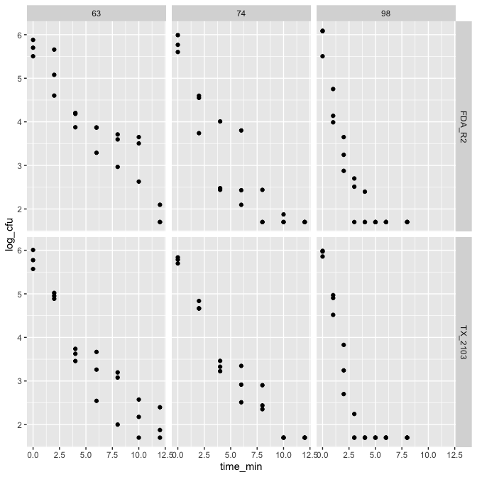

4.1.1 Statistical comparison of 2 strains
# Linear mixed model (paired/blocking by temp * time)
# Goal: Estimate difference while allowing each (temp,time) block to have its own baseline level (random intercept).
df_dyn_test <- df_dyn %>%
mutate(cond = interaction(temp_target_c, time_min, drop = TRUE))
# Model with strain-by-temperature fixed effect
fit <- lme(log_cfu ~ strain * temp_target_c, random = ~ 1 | cond,
weights = varIdent(form = ~1 | temp_target_c),
data = df_dyn_test)
anova(fit)
numDF denDF F-value p-value
(Intercept) 1 107 100.9 <.0001
strain 1 107 0.4 0.5295
temp_target_c 2 19 0.6 0.5618
strain:temp_target_c 2 107 5.6 0.0047
# Estimated strain contrasts within each target temperature
emm <- emmeans(fit, ~ strain | temp_target_c)
contrast_df <- as.data.frame(
summary(pairs(emm), infer = TRUE)
)
contrast_df
temp_target_c = 63:
contrast estimate SE df lower.CL upper.CL t.ratio p.value
FDA_R2 - TX_2103 0.384 0.1304 107 0.125 0.642 2.945 0.0040
temp_target_c = 74:
contrast estimate SE df lower.CL upper.CL t.ratio p.value
FDA_R2 - TX_2103 -0.212 0.1225 107 -0.455 0.031 -1.731 0.0860
temp_target_c = 98:
contrast estimate SE df lower.CL upper.CL t.ratio p.value
FDA_R2 - TX_2103 0.013 0.0857 107 -0.157 0.183 0.150 0.8810
Degrees-of-freedom method: containment
Confidence level used: 0.95
plot_strain_temp <- ggplot(contrast_df, aes(x = estimate, y = temp_target_c)) +
geom_vline(xintercept = 0, linetype = "dashed", linewidth = 0.8) +
geom_errorbarh(aes(xmin = lower.CL, xmax = upper.CL), height = 0.15, linewidth = 0.9) +
scale_x_continuous(breaks = seq(-2, 2, by = 0.1)) +
geom_point(size = 3) +
labs(x = expression("FDA_R2 - TX_2103 ("*log[10]*" CFU/g)"),
y = expression("Target temperature ("*degree*C*")")) +
theme_classic(base_size = 14) +
theme(axis.text=element_text(size=14,color="black"))
plot_strain_temp
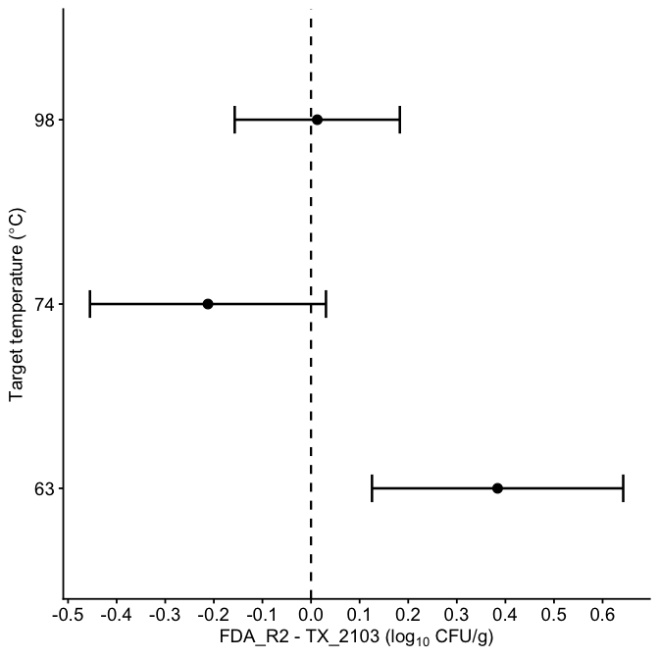
df_63 <- df_dyn %>%
filter(temp_target_c == 63) %>%
mutate(time_min = factor(time_min))
fit_63 <- lme(
log_cfu ~ strain * time_min,
random = ~ 1 | rep,
weights = varIdent(form = ~1 | time_min),
data = df_63
)
emm_63 <- emmeans(fit_63, ~ strain | time_min)
contrast_63 <- as.data.frame(
summary(pairs(emm_63), infer = TRUE)
)
plot_strain_time <- ggplot(contrast_63, aes(x = as.numeric(as.character(time_min)), y = estimate)) +
geom_hline(yintercept = 0, linetype = "dashed", linewidth = 0.8) +
geom_errorbar(aes(ymin = lower.CL, ymax = upper.CL), width = 0.3, linewidth = 0.9) +
geom_point(size = 3) +
geom_line(linewidth = 1) +
scale_x_continuous(breaks = seq(0, 12, 2)) +
labs(
x = "Time (min)",
y = expression("FDA_R2 - TX_2103 ("*log[10]*" CFU/g)")
) +
theme_classic(base_size = 14)+
theme(axis.text=element_text(size=14,color="black"))
combined_plot <- plot_strain_temp + plot_strain_time +
plot_annotation(tag_levels = "A") &
theme(
plot.tag = element_text(size = 16, face = "bold")
)
combined_plot
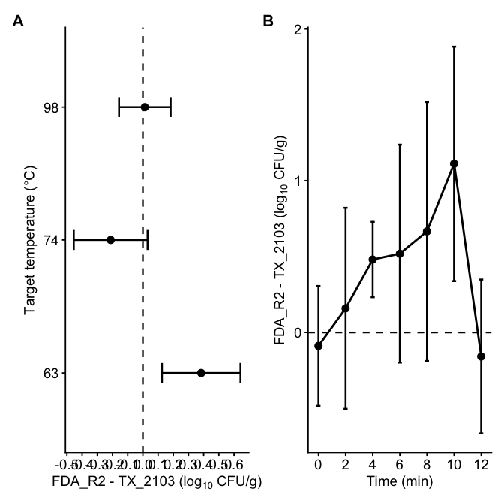
ggsave(
here("Plot", "Figure_strain_comparison_combined.tiff"),
plot = combined_plot,
width = 11,
height = 4,
units = "in",
dpi = 600,
compression = "lzw"
)
No significant different was observed between VP2 and VP3. Strain variable will be removed.

4.2 Inactivation data with strain combined
df_dyn %>%
ggplot(aes(x = time_min, y = log_cfu)) +
geom_point() +
facet_grid(~temp_target_c)
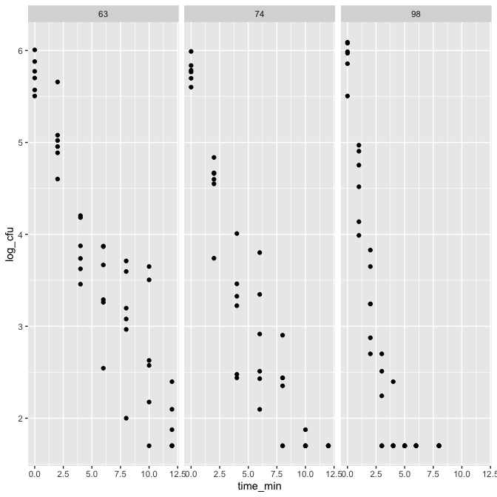

4.3 time-temperature profile
df_temp <- df_comeup %>%
group_by(temp_target_c, time_min) %>%
summarise(temp_mean = mean(temp_recorded_c_ave),
temp_sd = sd(temp_recorded_c_ave), .groups = "drop")
p_temp <- df_temp %>%
ggplot(aes(
x = time_min, y = temp_mean,
color = temp_target_c,
linetype = temp_target_c,
group = temp_target_c
)) +
# Mean and SD ribbon
geom_ribbon(aes(
ymin = temp_mean - temp_sd,
ymax = temp_mean + temp_sd,
fill = temp_target_c
),
alpha = 0.15, color = NA) +
geom_line(size = 0.5) +
geom_point(size = 1) +
labs(
y = bquote(Temperature~(degree*C)),
x = "Time (min)",
color = bquote(Target~Temperature~(degree*C)),
linetype = bquote(Target~Temperature~(degree*C))
) +
scale_color_manual(values = c("63" = "#ED0F54", "74" = "#52DD12", "98" = "#2998E2")) +
scale_fill_manual(values = c("63" = "#ED0F54", "74" = "#52DD12", "98" = "#2998E2")) +
scale_linetype_manual(values = c("63" = "solid", "74" = "dashed", "98" = "longdash")) +
scale_x_continuous(breaks = seq(0, 13, by = 1)) +
scale_y_continuous(breaks = seq(20, 100, by = 10)) +
coord_cartesian(xlim = c(0, 13), ylim = c(20, 100)) +
theme_bw() +
theme(
legend.position = "bottom",
legend.justification = "center",
legend.margin = margin(t = 0, r = 0, b = 0, l = 0),
legend.box.margin = margin(t = -8, r = 0, b = 0, l = 0),
legend.title = element_text(size = 9),
legend.text = element_text(size = 9),
axis.title = element_text(size = 12),
axis.text = element_text(size = 12)) +
guides(fill = "none")
p_temp
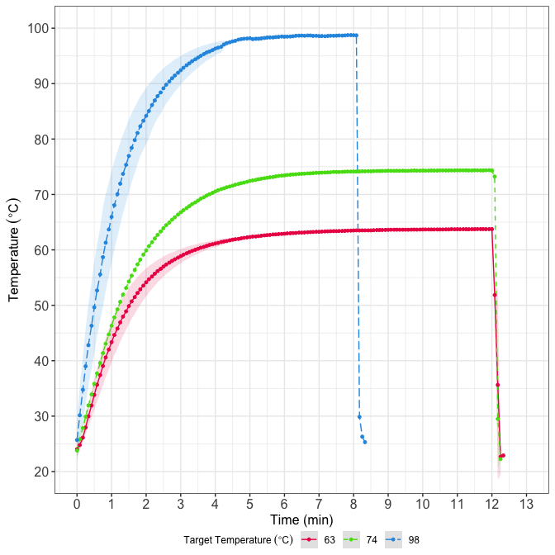
ggsave(file = here("Plot", "ComeUp_Temp_Plot.tiff"), plot = p_temp, width = 6, height = 4, units = "in", dpi = 400)

5. Data preprocessing for modeling
# Left join the come up time df to get the measured temperature
df_dyn2 <- df_dyn %>%
left_join(
df_temp %>% dplyr::select(temp_target_c, time_min, temp_mean),
by = c("temp_target_c", "time_min")
) %>%
mutate(count = as.integer(round(cfu)))
saveRDS (df_dyn2, here("Data", "df_dyn2.RDS"))

5.1 Checking distribution of count
df_dyn2 <- readRDS (here("Data", "df_dyn2.RDS"))
# start with ggplot
ggplot(df_dyn2, aes(count)) +
geom_histogram(binwidth = 10) +
theme_light()
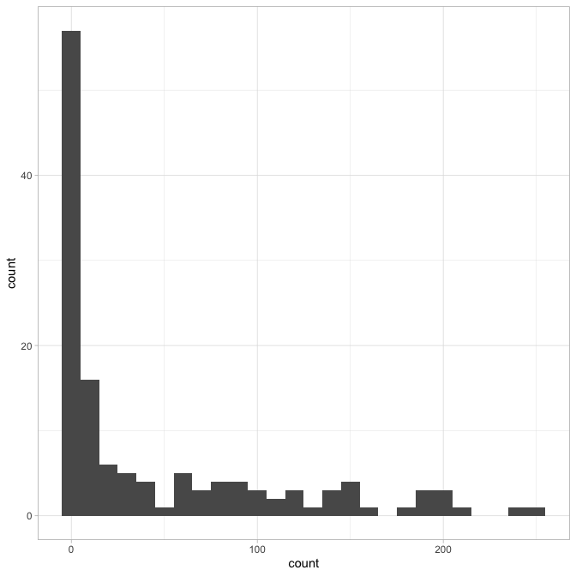
# Check if variance = mean
g <- df_dyn2 %>%
group_by(temp_target_c, time_min, dilution, plated_ml) %>%
summarise(
n = n(),
mean = mean(count, na.rm = TRUE),
var = var(count, na.rm = TRUE),
vmr = var / mean, # variance-to-mean ratio
.groups = "drop"
)
summary(g$vmr)
Min. 1st Qu. Median Mean 3rd Qu. Max.
0.00 1.50 6.73 21.53 38.63 94.48
quantile(g$vmr, c(.5, .75, .9), na.rm = TRUE)
50% 75% 90%
6.73 38.63 52.60
# Variance estimation
g2 <- g %>%
filter(mean > 0, vmr > 1) %>%
mutate(size_hat = mean / (vmr - 1))
# confirm the distribution type with fitdistrplus package
fit_pois <- fitdist(df_dyn2$count, "pois")
fit_nb <- fitdist(df_dyn2$count, "nbinom")
plot(fit_pois)
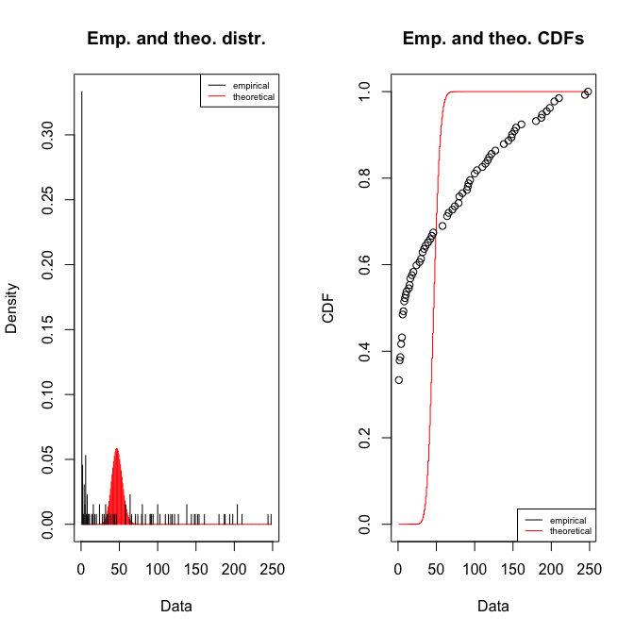
gofstat(fit_pois)
Chi-squared statistic: Inf
Degree of freedom of the Chi-squared distribution: 7
Chi-squared p-value: 0
the p-value may be wrong with some theoretical counts < 5
Chi-squared table:
obscounts theocounts
<= 1 4.40e+01 3.40e-17
<= 4 1.10e+01 1.54e-13
<= 8 1.30e+01 4.78e-10
<= 24 1.10e+01 2.59e-02
<= 58 1.20e+01 1.26e+02
<= 90 1.10e+01 6.02e+00
<= 122 1.10e+01 8.03e-07
<= 187 1.10e+01 0.00e+00
> 187 8.00e+00 0.00e+00
Goodness-of-fit criteria
1-mle-pois
Akaike's Information Criterion 11032
Bayesian Information Criterion 11035
plot(fit_nb)
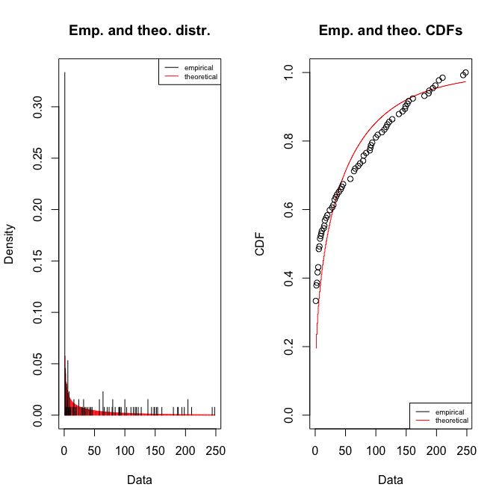
gofstat(fit_nb)
Chi-squared statistic: 30.7
Degree of freedom of the Chi-squared distribution: 6
Chi-squared p-value: 2.91e-05
Chi-squared table:
obscounts theocounts
<= 1 44.00 25.82
<= 4 11.00 13.20
<= 8 13.00 10.93
<= 24 11.00 24.30
<= 58 12.00 24.21
<= 90 11.00 11.77
<= 122 11.00 7.15
<= 187 11.00 7.74
> 187 8.00 6.90
Goodness-of-fit criteria
1-mle-nbinom
Akaike's Information Criterion 1201
Bayesian Information Criterion 1207
exp(0.25)
[1] 1.28
# initial size estimation
summary(g2$size_hat)
Min. 1st Qu. Median Mean 3rd Qu. Max.
0.488 1.261 1.948 6.770 8.561 54.440
quantile(g2$size_hat, c(0.25, 0.5, 0.75), na.rm = TRUE)
25% 50% 75%
1.26 1.95 8.56
Variance-to-mean ratios far exceeding 1, violating Poisson assumptions, also, fitdist function confirms the selection of negative binomial. Therefore, a negative binomial likelihood was used for all subsequent model fitting.

6. Functions for modeling

6.1 Model Fitting
get_nll <- function(p, this_data, known, times,
model_name = "Geeraerd") {
# if (this_data$temp_target_c[1] == 74) {
# browser()
# }
all_pars <- as.list(c(p, known))
# unlog transformation
if ("logN0" %in% names(all_pars)) {
all_pars$N0 <- 10^all_pars$logN0
all_pars$logN0 <- NULL
}
if ("logNmin" %in% names(all_pars)) {
all_pars$N_min <- 10^all_pars$logNmin
all_pars$logNmin <- NULL
}
# Negative binomial distribution require size (dispersion) as parameter estimate
size <- exp(all_pars$log_size)
all_pars$log_size <- NULL
# Temp profile for this target temperature condition
this_temp <- this_data %>%
dplyr::select(time, temperature) %>%
distinct() %>%
arrange(time)
# Predicted data
pred <- predict_inactivation(
simulation_model = model_name,
times = times,
parms = all_pars,
temp_profile = this_temp
)$simulation %>%
as.data.frame()
# Observed data
obs <- this_data %>%
dplyr::select(time, count, dilution, plated_ml)
merged <- merge(
x = obs,
y = pred[, c("time", "logN")],
by = "time",
all.x = TRUE,
suffixes = c("_obs", "_mod")
)
# if (any(is.na(merged$logN)) || any(!is.finite(merged$logN))) return(Inf)
# Predicted concentration from predicted log10 CFU/ml
pred_N <- 10^merged$logN
pred_count <- pred_N * merged$plated_ml * merged$dilution
# if (any(!is.finite(pred_count)) || any(pred_count <= 0)) return(Inf)
pred_count <- pmax(pred_count, 1e-12)
# NB log-likelihood
ll <- dnbinom(merged$count, mu = pred_count, size = size, log = TRUE)
# if (any(!is.finite(ll))) {
# print("out")
# return(Inf)
# }
# print(sum(ll))
-sum(ll, na.rm = TRUE)
}
get_total_nll <- function(p, split_data, known, times_list,
model_name = "Geeraerd") {
nlls <- mapply(
FUN = function(dat, times) {
get_nll(p = p, this_data = dat, known = known, times = times,
model_name = model_name)},
dat = split_data,
times = times_list,
SIMPLIFY = TRUE
)
# if (any(!is.finite(nlls))) return(Inf)
sum(nlls, na.rm = TRUE)
}
global_fit <- function(d, guess, known, model_name = "Geeraerd", upper = Inf, lower = -Inf, niter = 5000) {
d2 <- d %>%
mutate(
time = as.numeric(time_min),
temperature = as.numeric(temp_mean),
time = ifelse(time < 2e-5, 2e-5, time),
temp_target_c = as.factor(temp_target_c)
)
## Split by target temperature
split_data <- split(d2, d2$temp_target_c)
## Precompute times per condition
times_list <- lapply(split_data, function(df) {
df$time %>% unique() %>% sort() %>% na.omit()
})
modMCMC(f = get_total_nll, p = guess, split_data = split_data,
known = known, times_list = times_list, model_name = model_name,
upper = upper, lower = lower, niter = niter
)
}
##Goodness-of-fit
compute_residuals_dyn <- function(data, model_name, bestpar, known_pars) {
bp <- as.list(bestpar)
size <- exp(as.numeric(bp$log_size))
bp$log_size <- NULL
# Unlog parameters if present
if ("logN0" %in% names(bp)) {
bp$N0 <- 10^bp$logN0
bp$logN0 <- NULL
}
if ("logNmin" %in% names(bp)) {
bp$N_min <- 10^bp$logNmin
bp$logNmin <- NULL
}
d2 <- data %>%
mutate(
cond = as.factor(temp_target_c),
time = round(as.numeric(time_min), 3),
temperature = as.numeric(temp_mean)
)
preds <- d2 %>%
split(.$cond) %>%
map_df(function(df) {
temp_prof <- df %>%
dplyr::select(time, temperature) %>%
distinct() %>%
arrange(time)
times_use <- sort(unique(df$time))
sim <- quiet_predict_inactivation(
simulation_model = model_name,
times = times_use,
parms = c(bp, as.list(known_pars)),
temp_profile = temp_prof
)$simulation %>%
as.data.frame() %>%
mutate(time = round(time, 3))
data.frame(cond = df$cond, time = sim$time, m = sim$logN)
}) %>%
distinct(cond, time, .keep_all = TRUE)
d2 %>%
left_join(preds, by = c("cond", "time")) %>%
mutate(pred_count = (10^m) * plated_ml * dilution,
pred_count = ifelse(is.finite(pred_count) & pred_count > 0, pred_count, NA_real_))
}
# AIC and AICc calculation from log-likelihood
compute_fitstats <- function(res_df, bestpar, k, comm_df = NULL) {
size <- exp(bestpar[["log_size"]])
# If comm_df is provided, restrict to exactly those rows
if (!is.null(comm_df)) {
res_df <- res_df %>%
dplyr::semi_join(
comm_df %>% dplyr::distinct(cond, time, dilution, plated_ml, count),
by = c("cond", "time", "dilution", "plated_ml", "count")
)
}
ll <- dnbinom(
x = res_df$count,
mu = res_df$pred_count,
size = size,
log = TRUE
)
logLik <- sum(ll)
n_all <- nrow(res_df)
AIC <- 2 * k - 2 * logLik
AICc <- AIC + (2 * k * (k + 1)) / (n_all - k - 1)
list(logLik = logLik, AIC = AIC, AICc = AICc, n_used = n_all)
}

7. Modeling
##Peleg Weibull - Best fit
df_dyn2 <- readRDS (here("Data", "df_dyn2.RDS"))
known_pe <- c()
guess_pe <- c(k_b = 0.1, n = 1.0, temp_crit = 50, logN0 = 6,log_size = log(1.9))
lower_pe <- c(k_b = 0.001, n = 0.1, temp_crit = 45, logN0 = 5, log_size = log(0.05))
upper_pe <- c(k_b = 20, n = 5, temp_crit = 65, logN0 = 7, log_size = log(20))
set.seed(5025)
invisible(capture.output(my_model_pe <- global_fit(
d = df_dyn2, guess = guess_pe, known = known_pe, model_name = "Peleg",
niter = 5000, lower = lower_pe, upper = upper_pe),type = "output"))
plot(my_model_pe)
summary(my_model_pe)
k_b n temp_crit logN0 log_size
mean 0.05381 0.3625 46.14 5.6386 0.2520
sd 0.00738 0.0486 1.44 0.0649 0.1414
min 0.03993 0.2136 45.01 5.0233 0.0277
max 0.11522 1.0000 63.94 6.7311 0.7134
q025 0.04912 0.3190 45.44 5.5952 0.1528
q050 0.05342 0.3620 45.64 5.6532 0.1985
q075 0.05789 0.3850 46.55 5.6735 0.3797
apply(my_model_pe$pars, 2, quantile, probs = c(0.025, 0.975))
k_b n temp_crit logN0 log_size
2.5% 0.0422 0.285 45.0 5.53 0.0302
97.5% 0.0620 0.438 49.6 5.78 0.5105
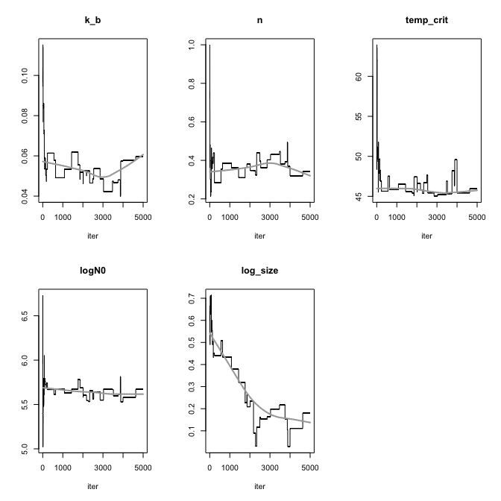

7.0.1 Decimal reduction time calculation
temps <- c(63, 74, 90, 98)
pars <- as.data.frame(my_model_pe$pars)
pars$s <- exp(pars$log_size)
mean(pars$s)
[1] 1.3
sd(pars$s)
[1] 0.194
quantile(pars$s, probs = c(0.025, 0.975))
2.5% 97.5%
1.03 1.67
# compute b(T)
calc_b <- function(T, k_b, temp_crit){
log1p(exp(k_b * (T - temp_crit)))
}
# compute D-value
calc_D <- function(b, n){
(log(10) / b)^(1 / n)
}
# compute posterior samples
post_samples <- pars %>%
mutate(
b63 = calc_b(63, k_b, temp_crit),
b74 = calc_b(74, k_b, temp_crit),
b98 = calc_b(98, k_b, temp_crit),
D63 = calc_D(b63, n),
D74 = calc_D(b74, n),
D98 = calc_D(b98, n)
)
# summarize mean + 95% CrI
summary_table <- post_samples %>%
summarise(
b63_mean = mean(b63),
b63_lwr = quantile(b63, 0.025),
b63_upr = quantile(b63, 0.975),
b63_sd = sd(b63),
b74_mean = mean(b74),
b74_lwr = quantile(b74, 0.025),
b74_upr = quantile(b74, 0.975),
b74_sd = sd(b74),
b98_mean = mean(b98),
b98_lwr = quantile(b98, 0.025),
b98_upr = quantile(b98, 0.975),
b98_sd = sd(b98),
D63_mean = mean(D63),
D63_lwr = quantile(D63, 0.025),
D63_upr = quantile(D63, 0.975),
D63_sd = sd(D63),
D74_mean = mean(D74),
D74_lwr = quantile(D74, 0.025),
D74_upr = quantile(D74, 0.975),
D74_sd = sd(D74),
D98_mean = mean(D98),
D98_lwr = quantile(D98, 0.025),
D98_upr = quantile(D98, 0.975),
D98_sd = sd(D98),
)
summary_table
b63_mean b63_lwr b63_upr b63_sd b74_mean b74_lwr b74_upr b74_sd b98_mean
1 1.24 1.11 1.37 0.0868 1.7 1.47 1.92 0.148 2.85
b98_lwr b98_upr b98_sd D63_mean D63_lwr D63_upr D63_sd D74_mean D74_lwr
1 2.33 3.29 0.321 5.59 4.8 6.55 0.897 2.33 1.8
D74_upr D74_sd D98_mean D98_lwr D98_upr D98_sd
1 2.93 0.347 0.58 0.298 0.973 0.207

7.0.2 Prediction of reduction
### Predicted log10 reduction from model parameters only
#| message: false
#| warning: false
pars <- as.data.frame(my_model_pe$pars)
predict_reduction_one_draw <- function(profile_df, draw_row) {
p <- as.list(draw_row)
p$log_size <- NULL
# Arbitrary starting value only used as a reference point.
# It cancels out when calculating log10 reduction.
p$N0 <- 10^6
p$logN0 <- NULL
temp_prof <- profile_df %>%
dplyr::select(time = time_min, temperature = temp_mean) %>%
dplyr::distinct() %>%
dplyr::arrange(time)
times_use <- seq(0, max(temp_prof$time), by = 0.01)
sim <- suppressWarnings(
quiet_predict_inactivation(
simulation_model = "Peleg",
times = times_use,
parms = p,
temp_profile = temp_prof
)$simulation %>%
as.data.frame()
)
sim %>%
dplyr::mutate(
log_reduction = logN[which.min(time)] - logN
)
}
profiles_split <- split(df_temp, df_temp$temp_target_c)
reduction_all <- purrr::imap_dfr(profiles_split, function(prof, target_name) {
purrr::map_dfr(seq_len(nrow(pars)), function(i) {
predict_reduction_one_draw(
profile_df = prof,
draw_row = pars[i, ]
) %>%
dplyr::mutate(
draw = i,
temp_target_c = target_name
)
})
})
reduction_table_1min <- reduction_all %>%
dplyr::group_by(temp_target_c, time) %>%
dplyr::summarise(
mean_log_reduction = mean(log_reduction, na.rm = TRUE),
lwr_log_reduction = quantile(log_reduction, 0.025, na.rm = TRUE),
upr_log_reduction = quantile(log_reduction, 0.975, na.rm = TRUE),
.groups = "drop"
) %>%
dplyr::filter(abs(time - round(time)) < 1e-8) %>%
dplyr::arrange(temp_target_c, time)
print(reduction_table_1min, n = Inf, width = Inf)
# A tibble: 32 × 5
temp_target_c time mean_log_reduction lwr_log_reduction upr_log_reduction
<chr> <dbl> <dbl> <dbl> <dbl>
1 63 1 0.450 0.371 0.498
2 63 2 0.857 0.747 0.899
3 63 3 1.22 1.09 1.27
4 63 4 1.52 1.38 1.59
5 63 5 1.77 1.62 1.86
6 63 6 1.98 1.83 2.11
7 63 7 2.17 2.00 2.33
8 63 8 2.33 2.16 2.54
9 63 9 2.48 2.30 2.72
10 63 10 2.62 2.41 2.90
11 63 11 2.74 2.50 3.06
12 63 12 2.86 2.59 3.21
13 74 1 0.495 0.413 0.534
14 74 2 1.00 0.889 1.04
15 74 3 1.48 1.36 1.56
16 74 4 1.90 1.75 1.99
17 74 5 2.26 2.09 2.37
18 74 6 2.57 2.39 2.69
19 74 7 2.84 2.65 2.98
20 74 8 3.07 2.87 3.26
21 74 9 3.28 3.08 3.52
22 74 10 3.47 3.26 3.75
23 74 11 3.64 3.41 3.97
24 74 12 3.80 3.54 4.17
25 98 1 0.906 0.806 1.01
26 98 2 1.93 1.71 2.15
27 98 3 2.81 2.51 3.09
28 98 4 3.53 3.18 3.83
29 98 5 4.12 3.76 4.48
30 98 6 4.61 4.25 5.10
31 98 7 5.03 4.67 5.52
32 98 8 5.40 5.00 5.91

7.0.3 Plot using the best parameter set with observed value overlaid
df_dyn_fit <- df_dyn2 %>%
mutate(
temp_target_c = as.factor(temp_target_c),
time = as.numeric(time_min),
temperature = as.numeric(temp_mean)
)
# un-log
fit_p_pe <- as.list(my_model_pe$bestpar)
if ("logN0" %in% names(fit_p_pe)) {
fit_p_pe$N0 <- 10^fit_p_pe$logN0
fit_p_pe$logN0 <- NULL
}
if ("logNmin" %in% names(fit_p_pe)) {
fit_p_pe$N_min <- 10^fit_p_pe$logNmin
fit_p_pe$logNmin <- NULL
}
if ("log_size" %in% names(fit_p_pe)) {
fit_p_pe$log_size <- NULL
}
LOD <- 1.7
plots <- df_dyn_fit %>%
split(.$temp_target_c) %>%
purrr::map(~{
temp_prof <- .x %>%
dplyr::select(time, temperature) %>%
distinct() %>%
arrange(time)
times_pred <- seq(0, max(.x$time, na.rm = TRUE), length.out = 200)
pred <- quiet_predict_inactivation(
simulation_model = "Peleg",
times = times_pred,
parms = c(fit_p_pe, as.list(known_pe)),
temp_profile = temp_prof
)
sim <- pred$simulation %>%
as.data.frame() %>%
mutate(logN_clip = pmax(logN, LOD))
ggplot() +
geom_hline(yintercept = LOD, linetype = "dotted", color = "gray50") +
geom_line(data = sim, aes(x = time, y = logN), linewidth = 0.9) +
geom_point(data = .x, aes(x = time, y = log_cfu), size = 1.6) +
labs(
title = paste0("Target ", as.character(unique(.x$temp_target_c)), "°C"),
x = "time (min)",
y = expression(Log[10]~"CFU/mL")
) +
coord_cartesian(ylim = c(0, 6.5)) +
theme_classic()
})
cowplot::plot_grid(plotlist = plots)
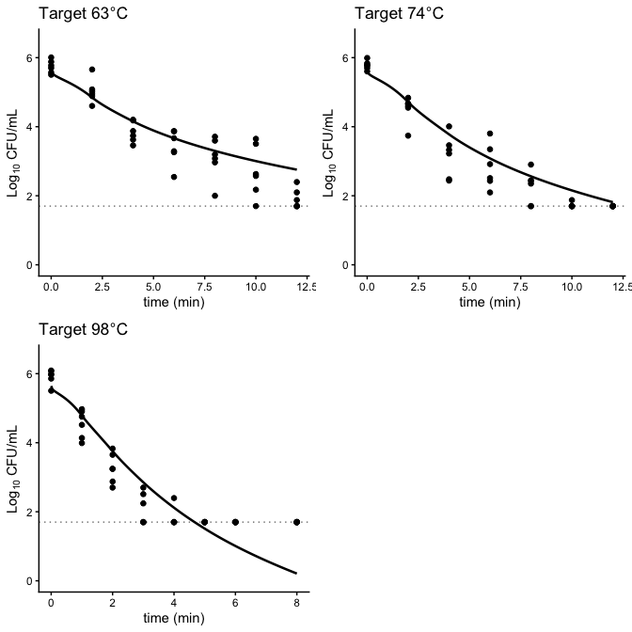

7.0.4 Goodness-of-fit check
df_resid_pe <- compute_residuals_dyn(
data = df_dyn2,
model_name = "Peleg",
bestpar = my_model_pe$bestpar,
known_pars = known_pe
)
# fit stats
fitstats_pe <- compute_fitstats(
res_df = df_resid_pe,
bestpar = my_model_pe$bestpar,
k = 4
)
fitstats_pe$AIC
[1] 1063
fitstats_pe$AICc
[1] 1063

7.0.5 Bacterial reduction estimation given different initial conc.

7.1 Plot for publication
make_interv_pe <- function(m, data, known, model = "Peleg") {
p <- unlist(m)
p <- p[!names(p) %in% c("log_size", "i")]
p["N0"] <- 10^p["logN0"]
data %>%
split(.$temp_target_c) %>%
map(~{
dat <- .x %>%
mutate(
time = as.numeric(time_min),
temperature = as.numeric(temp_mean)
)
temp_prof <- dat %>%
dplyr::select(time, temperature) %>%
distinct() %>%
arrange(time)
times_pred <- seq(0, max(dat$time, na.rm = TRUE), length.out = 200)
predict_inactivation(
simulation_model = model,
times = times_pred,
parms = c(p, known),
temp_profile = temp_prof
)$simulation %>%
as.data.frame()
}) %>%
imap_dfr(~ mutate(.x, temp_target_c = .y))
}
## Posterior predictions
MCMC_preds_pe <- my_model_pe$pars %>%
as_tibble() %>%
slice_sample(n = 1000, replace = TRUE) %>%
mutate(i = row_number()) %>%
split(.$i) %>%
purrr::map_dfr(
~ {
invisible(capture.output(
pred <- make_interv_pe(.x, data = df_dyn2, known = known_pe, model = "Peleg"),
type = "output"
))
pred
},
.id = "i"
) %>%
summarise(
m = median(logN, na.rm = TRUE),
q2.5 = quantile(logN, 0.025, na.rm = TRUE),
q97.5 = quantile(logN, 0.975, na.rm = TRUE),
.by = c("temp_target_c", "time")
)
## rescale temperature to match CFU axis
temp_scaled <- df_temp %>%
mutate(temp_target_c=factor(temp_target_c),
time=as.numeric(time_min),
scal_temp=(temp_mean-20)/(100-20)*6)
LOD <- 1.7 # limit of detection line
make_panel <- function(Ttarget, xlim=NULL, xbreaks=NULL,
show_left_axis=FALSE,
show_right_axis=FALSE,
show_temp_title=FALSE){
## model predictions (clip at 0 for plotting)
pred_sub <- MCMC_preds_pe %>%
filter(temp_target_c==Ttarget) %>%
mutate(m_plot=pmax(m,0),
q2.5_plot=pmax(q2.5,0),
q97.5_plot=pmax(q97.5,0))
## observed data
dat_sub <- df_dyn2 %>%
filter(temp_target_c==Ttarget) %>%
mutate(time=as.numeric(time_min),
logN=as.numeric(log_cfu),
strain=factor(strain))
## temperature profile (already rescaled)
temp_sub <- temp_scaled %>%
filter(temp_target_c==Ttarget)
ggplot() +
## uncertainty ribbon (95% CI)
geom_ribbon(data=pred_sub,
aes(x=time,ymin=q2.5_plot,ymax=q97.5_plot),
fill="gray80",alpha=0.8) +
## median prediction line
geom_line(data=pred_sub,
aes(x=time,y=m_plot),
linewidth=0.9,color="black") +
## observed points (two strains as shapes)
geom_point(data=dat_sub,
aes(x=time,y=logN,shape=strain),
size=1.8,stroke=0.5,color="black",fill="black") +
## temperature curve (scaled to same axis)
geom_line(data=temp_sub,
aes(x=time,y=scal_temp),
linetype="longdash",linewidth=0.6,color="gray35") +
## LOD horizontal line
geom_hline(yintercept=LOD,
linetype="dotted",linewidth=0.6,color="gray45") +
## shape mapping for strains
scale_shape_manual(values=c(16,2)) +
## primary + optional secondary axis
scale_y_continuous(
name=if(show_left_axis) expression(Log[10]~"CFU/g") else NULL, # left axis only for first panel
breaks=seq(0,6,1),
sec.axis=if(show_right_axis) sec_axis( # right axis only for last panel
~./6*80+20,
breaks=seq(20,100,20),
name=if(show_temp_title) "Temperature (°C)" else NULL
) else waiver()
) +
## x-axis
scale_x_continuous(breaks=xbreaks) +
## limits
coord_cartesian(xlim=xlim,ylim=c(0,6)) +
labs(x= "Time (min)",title=paste0("Target ",as.character(Ttarget),"°C")) +
## styling
theme_bw(base_size=12) +
theme(
plot.title=element_text(size=10,face="bold",hjust=0.5),
axis.text.x=element_text(size=12,color="black"),
## left axis visibility control
axis.text.y.left=if(show_left_axis) element_text(size=12,color="black") else element_blank(),
axis.ticks.y.left=if(show_left_axis) element_line(color="black") else element_blank(),
axis.title.y.left=if(show_left_axis) element_text(size=12) else element_blank(),
## right axis visibility control
axis.text.y.right=if(show_right_axis) element_text(size=12,color="gray25") else element_blank(),
axis.ticks.y.right=if(show_right_axis) element_line(color="gray25") else element_blank(),
axis.title.y.right=if(show_right_axis && show_temp_title)
element_text(size=12,margin=margin(l=6)) else element_blank(),
## remove grids + legend
panel.grid.minor=element_blank(),
panel.grid.major=element_blank(),
panel.border=element_rect(linewidth=0.6,color="black"),
legend.position="none"
)
}
## build panels
p1 <- make_panel("63", xlim=c(0,13), xbreaks=seq(0,12,2), show_left_axis=TRUE)
p2 <- make_panel("74", xlim=c(0,13), xbreaks=seq(0,12,2))
p3 <- make_panel("98", xlim=c(0,13), xbreaks=seq(0,12,2), show_right_axis=TRUE, show_temp_title=TRUE)
## combine (tight layout)
p_all <- p1 + p2 + p3 + plot_layout(ncol=3)
p_all
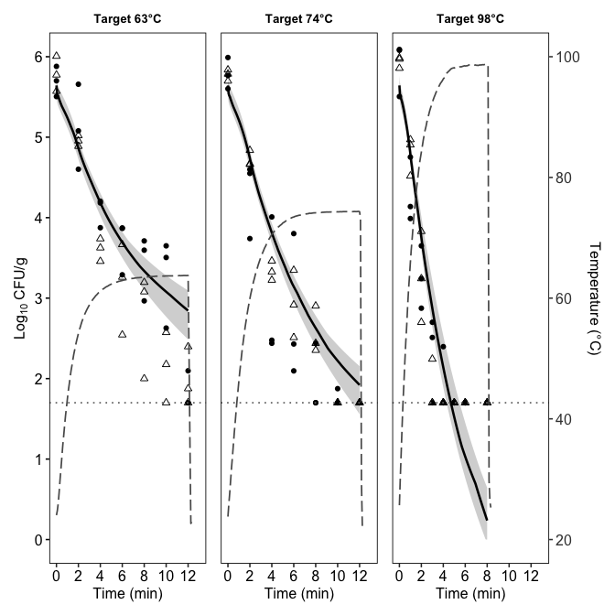
## save
ggsave(filename=here("Plot","Vibrio_Oys_PE_Plot.tiff"),
plot=p_all, width=10, height=4, units="in",
dpi=1000,bg="white")

7.2 Geeraerd
model_name <- "Geeraerd"
known_ge_1 <- c(temp_ref = 63)
lower_ge_1 <- c(D_R = .3, z = 2, logN0 = 5, logNmin = -1, log_size = log(0.05), C_c0 = 1e-6)
upper_ge_1 <- c(D_R = 6, z = 15, logN0 = 7, logNmin = 1.7, log_size = log(20), C_c0 = 1e3)
# Initial guess from the inactivation data plot
guess_ge_1 <- c(D_R = 2.4, z = 6, logN0 = 6, logNmin = 0, log_size = log(1.9), C_c0 = 1)
set.seed(5025)
my_model_ge_1 <- global_fit(df_dyn2, guess_ge_1, known_ge_1, niter = 5000,
lower = lower_ge_1,
upper = upper_ge_1)
number of accepted runs: 454 out of 5000 (9.08%)
saveRDS(my_model_ge_1, here("Result", "model_Geeraerd_1.RDS"))
plot(my_model_ge_1)
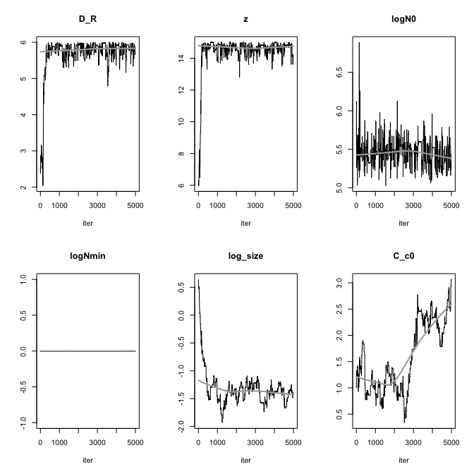
apply(my_model_ge_1$pars, 2, quantile, probs = c(0.025, 0.975))
D_R z logN0 logNmin log_size C_c0
2.5% 2.96 9.75 5.16 0 -1.729 0.61
97.5% 5.99 15.00 5.75 0 -0.292 2.66
summary(my_model_ge_1)
D_R z logN0 logNmin log_size C_c0
mean 5.673 14.43 5.453 0 -1.319 1.575
sd 0.576 1.19 0.162 0 0.326 0.658
min 2.039 5.97 5.027 0 -1.932 0.338
max 5.998 15.00 6.888 0 0.642 3.066
q025 5.671 14.43 5.346 0 -1.487 0.987
q050 5.820 14.68 5.467 0 -1.365 1.395
q075 5.925 14.86 5.549 0 -1.245 2.228
From the summary, the logNmin is unidentifiable in the censored-likelihood formulation, so MCMC pins it to the boundary 0. Let’s try put N_min as the known value 10^0
model_name <- "Geeraerd"
known_ge <- c(temp_ref = 63, N_min = 10^0)
lower_ge <- c(D_R = .3, z = 2, logN0 = 5, log_size = log(0.05), C_c0 = 1e-6)
upper_ge <- c(D_R = 6, z = 15, logN0 = 7, log_size = log(20), C_c0 = 1e3)
# Initial guess from the inactivation data plot
guess_ge <- c(D_R = 2.4, z = 6, logN0 = 6, log_size = log(1.9), C_c0 = 1)
my_model_ge <- global_fit(df_dyn2, guess_ge, known_ge, niter = 5000,
lower = lower_ge,
upper = upper_ge)
number of accepted runs: 463 out of 5000 (9.26%)
saveRDS(my_model_ge, here("Result", "model_Geeraerd.RDS"))
plot(my_model_ge)
summary(my_model_ge)
D_R z logN0 log_size C_c0
mean 5.58 14.31 5.452 -1.372 1.78882
sd 0.83 1.59 0.192 0.338 1.02932
min 1.56 5.66 5.012 -2.342 0.00423
max 6.00 15.00 6.823 0.642 3.84782
q025 5.65 14.48 5.334 -1.482 1.01458
q050 5.82 14.77 5.443 -1.381 1.76686
q075 5.93 14.91 5.553 -1.306 2.53282
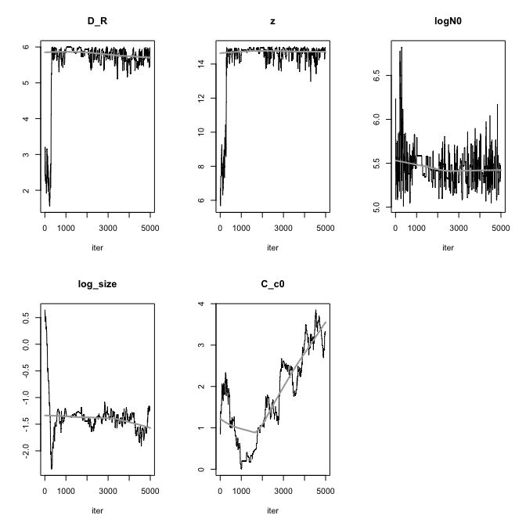

7.3 Geeraerd with no shoulder
model_name <- "Geeraerd"
known_ge_ns <- c(temp_ref = 63, N_min = 10^0, C_c0 = 1e-3)
lower_ge_ns <- c(D_R = .3, z = 2, logN0 = 5, log_size = log(0.05))
upper_ge_ns <- c(D_R = 6, z = 15, logN0 = 7, log_size = log(20))
# Initial guess from the inactivation data plot
guess_ge_ns <- c(D_R = 2.4, z = 6, logN0 = 6, log_size = log(1.9))
set.seed(5025)
my_model_ge_ns <- global_fit(df_dyn2, guess_ge_ns, known_ge_ns, niter = 5000,
lower = lower_ge_ns,
upper = upper_ge_ns)
number of accepted runs: 314 out of 5000 (6.28%)
saveRDS(my_model_ge_ns, here("Result", "model_Geeraerd_no_shoulder.RDS"))
plot(my_model_ge_ns)
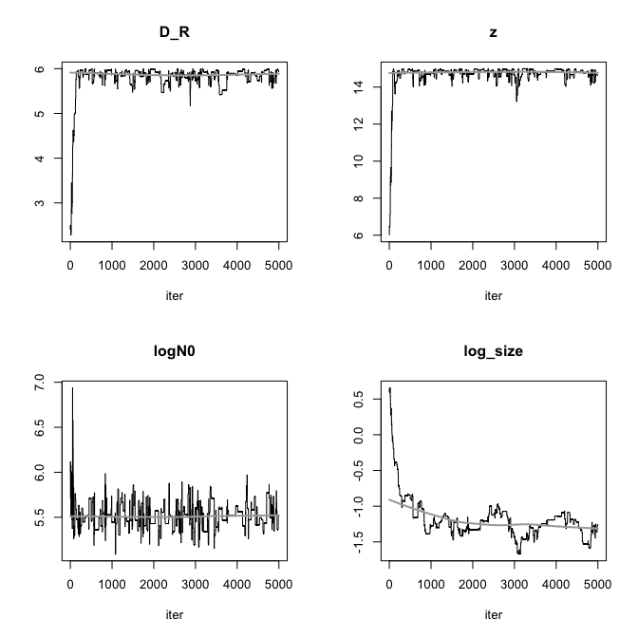
summary(my_model_ge_ns)
D_R z logN0 log_size
mean 5.795 14.675 5.518 -1.185
sd 0.365 0.749 0.143 0.296
min 2.280 6.000 5.090 -1.672
max 6.000 14.994 6.940 0.658
q025 5.761 14.680 5.429 -1.334
q050 5.880 14.815 5.514 -1.224
q075 5.932 14.926 5.592 -1.125

7.3.1 Plot using the best parameter set with observed value overlaid (with shoulder)
# un-log
fit_p_ge <- as.list(my_model_ge$bestpar)
if ("logN0" %in% names(fit_p_ge)) {
fit_p_ge$N0 <- 10^fit_p_ge$logN0
fit_p_ge$logN0 <- NULL
}
if ("logNmin" %in% names(fit_p_ge)) {
fit_p_ge$N_min <- 10^fit_p_ge$logNmin
fit_p_ge$logNmin <- NULL
}
if ("log_size" %in% names(fit_p_ge)) {
fit_p_ge$log_size <- NULL
}
plots <- df_dyn_fit %>%
split(.$temp_target_c) %>%
purrr::map(~{
temp_prof <- .x %>%
dplyr::select(time, temperature) %>%
distinct() %>%
arrange(time)
times_pred <- seq(0, max(.x$time, na.rm = TRUE), length.out = 200)
pred <- quiet_predict_inactivation(
simulation_model = "Geeraerd",
times = times_pred,
parms = c(fit_p_ge, as.list(known_ge)),
temp_profile = temp_prof
)
sim <- pred$simulation %>%
as.data.frame() %>%
mutate(logN_clip = pmax(logN, LOD))
ggplot() +
geom_hline(yintercept = LOD, linetype = "dotted", color = "gray50") +
geom_line(data = sim, aes(x = time, y = logN), linewidth = 0.9) +
geom_point(data = .x, aes(x = time, y = log_cfu), size = 1.6) +
labs(
title = paste0("Target ", as.character(unique(.x$temp_target_c)), "°C"),
x = "time (min)",
y = expression(Log[10]~"CFU/mL")
) +
coord_cartesian(ylim = c(0, 6.5)) +
theme_classic()
})
cowplot::plot_grid(plotlist = plots)
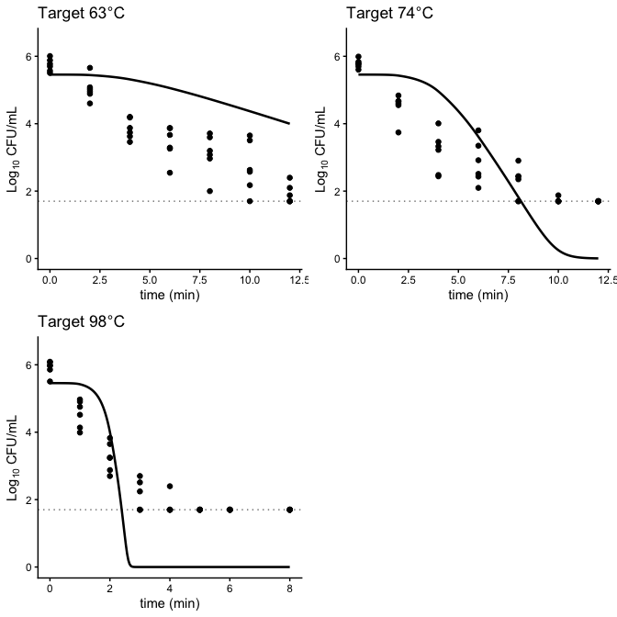

7.3.2 Plot using the best parameter set with observed value overlaid (with no shoulder)
# un-log
fit_p_ge_ns <- as.list(my_model_ge_ns$bestpar)
if ("logN0" %in% names(fit_p_ge_ns)) {
fit_p_ge_ns$N0 <- 10^fit_p_ge_ns$logN0
fit_p_ge_ns$logN0 <- NULL
}
if ("logNmin" %in% names(fit_p_ge_ns)) {
fit_p_ge_ns$N_min <- 10^fit_p_ge_ns$logNmin
fit_p_ge_ns$logNmin <- NULL
}
if ("log_size" %in% names(fit_p_ge_ns)) {
fit_p_ge_ns$log_size <- NULL
}
plots <- df_dyn_fit %>%
split(.$temp_target_c) %>%
purrr::map(~{
temp_prof <- .x %>%
dplyr::select(time, temperature) %>%
distinct() %>%
arrange(time)
times_pred <- seq(0, max(.x$time, na.rm = TRUE), length.out = 200)
pred <- quiet_predict_inactivation(
simulation_model = "Geeraerd",
times = times_pred,
parms = c(fit_p_ge_ns, as.list(known_ge_ns)),
temp_profile = temp_prof
)
sim <- pred$simulation %>%
as.data.frame() %>%
mutate(logN_clip = pmax(logN, LOD))
ggplot() +
geom_hline(yintercept = LOD, linetype = "dotted", color = "gray50") +
geom_line(data = sim, aes(x = time, y = logN), linewidth = 0.9) +
geom_point(data = .x, aes(x = time, y = log_cfu), size = 1.6) +
labs(
title = paste0("Target ", as.character(unique(.x$temp_target_c)), "°C"),
x = "time (min)",
y = expression(Log[10]~"CFU/mL")
) +
coord_cartesian(ylim = c(0, 6.5)) +
theme_classic()
})
cowplot::plot_grid(plotlist = plots)
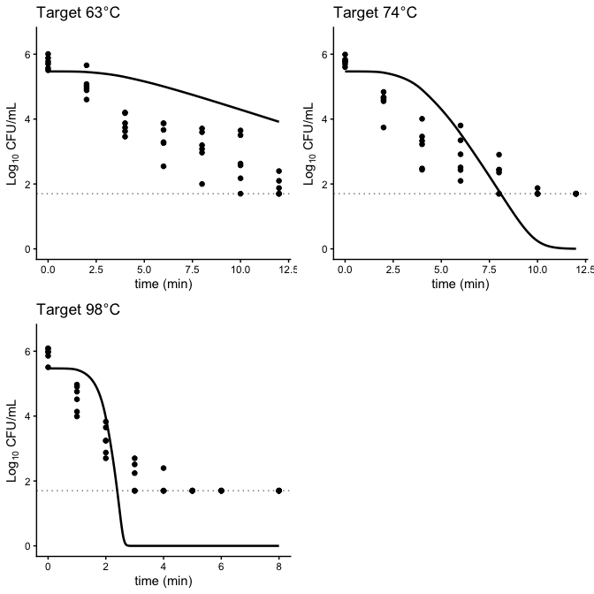

7.3.3 Goodness-of-fit check (with shoulder)
df_resid_ge <- compute_residuals_dyn(
data = df_dyn2,
model_name = "Geeraerd",
bestpar = my_model_ge$bestpar,
known_pars = known_ge
)
# fit stats
fitstats_ge <- compute_fitstats(
res_df = df_resid_ge,
bestpar = my_model_ge$bestpar,
k = 4
)
fitstats_ge$AIC
[1] 1480
fitstats_ge$AICc
[1] 1480

7.3.4 Goodness-of-fit check (with no shoulder)
df_resid_ge_ns <- compute_residuals_dyn(
data = df_dyn2,
model_name = "Geeraerd",
bestpar = my_model_ge_ns$bestpar,
known_pars = known_ge_ns
)
# fit stats
fitstats_ge_ns <- compute_fitstats(
res_df = df_resid_ge_ns,
bestpar = my_model_ge_ns$bestpar,
k = 4
)
fitstats_ge_ns$AIC
[1] 1477
fitstats_ge_ns$AICc
[1] 1478

7.4 Log-linear (Bigelow)
known_b <- c(temp_ref = 63)
guess_b <- c(D_R = 2.5, z = 6, logN0 = 6, log_size = log(1.9))
set.seed(5025)
my_model_b <- global_fit(df_dyn2, guess_b, known_b, model_name ="Bigelow",
niter = 5000,
lower = c(D_R = 2, z = 5, logN0 = 5, log_size = log(0.05)),
upper = c(D_R = 20, z = 15, logN0 = 7, log_size = log(20)))
number of accepted runs: 249 out of 5000 (4.98%)
plot(my_model_b) # check convergence
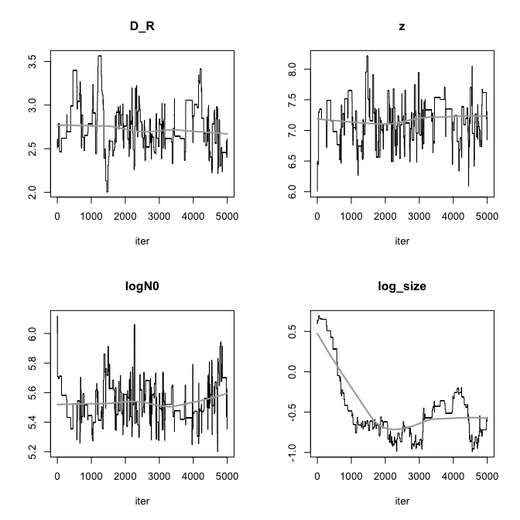
summary(my_model_b)
D_R z logN0 log_size
mean 2.748 7.173 5.536 -0.474
sd 0.278 0.339 0.131 0.414
min 2.007 6.000 5.201 -0.990
max 3.563 8.214 6.119 0.691
q025 2.584 6.950 5.437 -0.728
q050 2.693 7.174 5.521 -0.610
q075 2.917 7.368 5.619 -0.357

7.4.1 Plot using the best parameter set with observed value overlaid
# un-log
fit_p_b <- as.list(my_model_b$bestpar)
if ("logN0" %in% names(fit_p_b)) {
fit_p_b$N0 <- 10^fit_p_b$logN0
fit_p_b$logN0 <- NULL
}
if ("logNmin" %in% names(fit_p_b)) {
fit_p_b$N_min <- 10^fit_p_b$logNmin
fit_p_b$logNmin <- NULL
}
if ("log_size" %in% names(fit_p_b)) {
fit_p_b$log_size <- NULL
}
plots <- df_dyn_fit %>%
split(.$temp_target_c) %>%
purrr::map(~{
temp_prof <- .x %>%
dplyr::select(time, temperature) %>%
distinct() %>%
arrange(time)
times_pred <- seq(0, max(.x$time, na.rm = TRUE), length.out = 200)
pred <- quiet_predict_inactivation(
simulation_model = "Bigelow",
times = times_pred,
parms = c(fit_p_b, as.list(known_b)),
temp_profile = temp_prof
)
sim <- pred$simulation %>%
as.data.frame() %>%
mutate(logN_clip = pmax(logN, LOD))
ggplot() +
geom_hline(yintercept = LOD, linetype = "dotted", color = "gray50") +
geom_line(data = sim, aes(x = time, y = logN), linewidth = 0.9) +
geom_point(data = .x, aes(x = time, y = log_cfu), size = 1.6) +
labs(
title = paste0("Target ", as.character(unique(.x$temp_target_c)), "°C"),
x = "time (min)",
y = expression(Log[10]~"CFU/mL")
) +
coord_cartesian(ylim = c(0, 6.5)) +
theme_classic()
})
cowplot::plot_grid(plotlist = plots)

7.4.2 Goodness-of-fit check
df_resid_b <- compute_residuals_dyn(
data = df_dyn2,
model_name = "Bigelow",
bestpar = my_model_b$bestpar,
known_pars = known_b
)
# NA prediction was produced
df_resid_b %>%
dplyr::filter(!is.finite(pred_count) | is.na(pred_count) | pred_count <= 0)

