TDBRAIN Real-Data Integration
Depression diagnosis and rTMS treatment-response
from real resting-state EEG
Status report — PFE 2026 · Recherche-App
Generated 22 July 2026

This document reports the current state of the real-data track: what has been downloaded and decrypted, how the missing clinical labels were located and wired in, the trainable cohort, the processing pipeline, and the first honestly-evaluated results — together with an interpretation and recommended next steps.

1. Executive summary
The project's real-data goal is to let the existing LSTM learn from genuine EEG instead of the simulator, using the public TDBRAIN rTMS-in-depression cohort. As of this report:
- Data acquired — the full 15.5 GB TDBRAIN V3.1 EEG archive is downloaded, size-verified, decrypted and readable (1,300 subjects).
- Labels located — the clinical labels were NOT in the EEG archive; they live in a separate 'TDBRAIN Participants V3' datasheet, which we located and downloaded.
- Cohort assembled — 132 MDD patients treated with rTMS (protocols 1 & 2), every one with baseline EEG on disk and a responder label derived from BDI-II.
- Pipeline wired — the full load → features → patient-wise cross-validation runs end-to-end on real EEG with no changes to the model code.
- Headline result — MDD-vs-control diagnosis from resting EEG reaches AUC 0.64 with tight cross-fold variance (489 subjects) — a stable, defensible real-data result.
- Secondary result — treatment-response prediction from a single baseline recording is weak (best AUC 0.60 on protocol 2), faithfully reproducing the difficulty reported in the literature.

2. Data acquisition & decryption
TDBRAIN is distributed by Research Institute Brainclinics as password-protected, encrypted ZIP archives under a data-use agreement. The main EEG archive was fetched with a resume-capable downloader and decrypted with the agreement password.
File on disk | What it is | Size / count | Usable?
TDBRAIN_Dataset_V3_1_Encr.zip | Full raw EEG archive (encrypted) | 15.5 GB | decrypted ✓
…/TDBRAIN_Dataset_V3_1/ (extracted) | 1,300 subjects, BDF EEG, ses-1..4 | 1,296 with rest EEG | ✓ signals
TDBRAIN_participants_V3.xlsx | Master clinical datasheet (labels) | 1,363 rows × 106 cols | ✓ labels
TDBRAIN_MDD_Dx_ReplicationV3_1/ | Blinded diagnosis-challenge EEG | 60 subjects | blinded
TDBRAIN_MDD_Dx_Prediction_replicationV3.xlsx | Blinded challenge template | 60 rows, masked | not for training

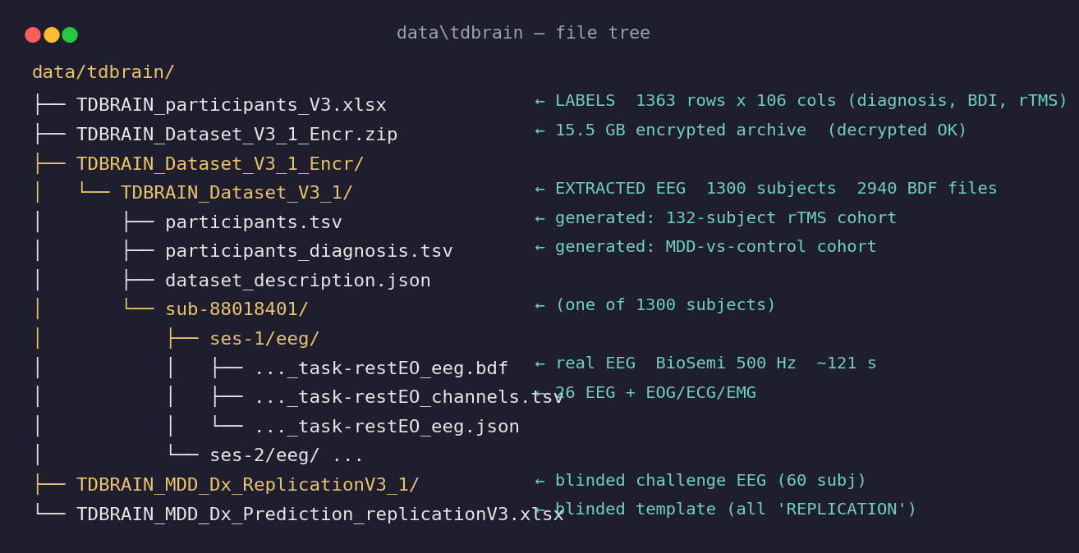
Figure 0 — Layout of the data folder on disk. Gold = the decrypted EEG tree (1,300 subjects); teal notes mark what each item is. The two generated participants.tsv files are the label tables wired into the loader.
Each recording is BioSemi BDF, 500 Hz, ~121 s, 26 EEG channels (10-10 montage) plus EOG/ECG/EMG and a status channel. The montage matches the loader's expected channel set exactly, and MNE reads every file cleanly.

3. The labels problem — and how it was solved
A model needs inputs (EEG) and targets (labels). The 15.5 GB archive contains only signals — no participants table, no diagnosis, no BDI, no rTMS protocol. Two other files on disk looked like labels but were dead ends:
- The replication .xlsx — all 60 rows are masked with the literal string 'REPLICATION'; it also has no BDI or rTMS columns at all — it is a blinded scoring template for the diagnosis challenge, not training data.
- OpenNeuro — the OpenNeuro mirror (ds004213) exists without login but its participants file is stripped to id/sex/age and re-anonymised, so it cannot be joined to the EEG.
The real labels are in a separate small Excel download on the Brainclinics page — the 'TDBRAIN Participants V3 datasheet' — which lists demographics, formal diagnoses and treatment-response data keyed to the real 8-digit subject IDs. Downloading that one file unblocked everything.
Key fact: every row in this datasheet is DISCOVERY (unblinded) — there is no masking to work around.

4. The participants datasheet & trainable cohort
The datasheet has 1,363 rows (1,303 unique subjects) and 106 columns. The columns that matter for us: TDBRAIN_ID, indication (diagnosis), BDI_pre, BDI_post, rTMS PROTOCOL, and a precomputed Responder flag (our ≥50% BDI-reduction rule matches it 99%).
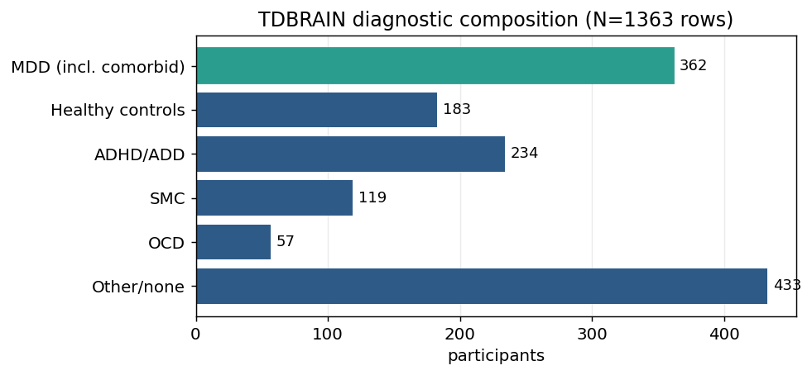
Figure 1 — Diagnostic composition of TDBRAIN. MDD (teal) and healthy controls are large enough for a separate diagnosis task.
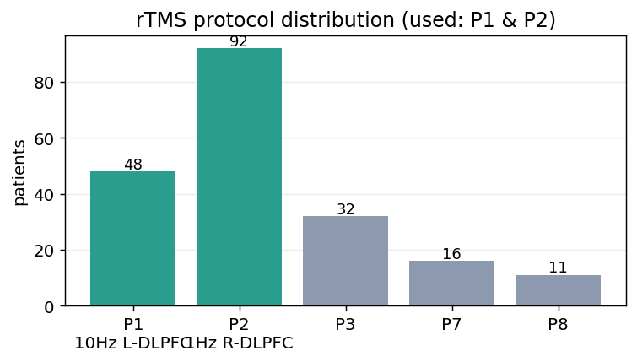
Figure 2 — rTMS protocol distribution. The reference study and this work use protocols 1 and 2 (teal); they are different treatments and are modelled separately.
Filtering to MDD patients on protocol 1 or 2 with both BDI scores, and de-duplicating to one baseline recording per subject, yields the trainable cohort:
Protocol | Treatment | Patients | Responders | Base rate
1 | 10 Hz left DLPFC | 44 | 27 | 0.61
2 | 1 Hz right DLPFC | 88 | 56 | 0.64
Total | — | 132 | 83 | 0.63

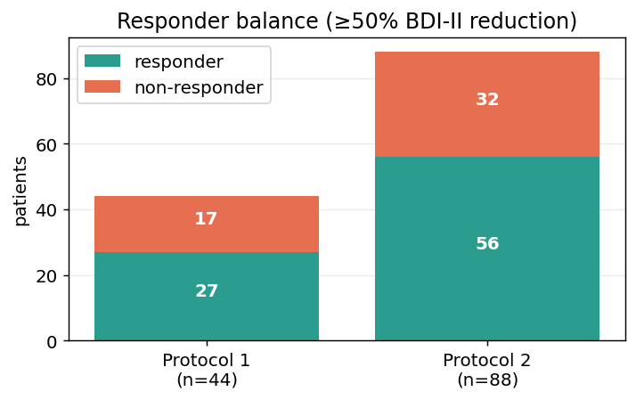
Figure 3 — Responder vs non-responder balance per protocol. The classes are imbalanced toward responders (~63%).
All 132 cohort subjects have their baseline eyes-open recording on disk (3 have it in session 2, which the loader resolves automatically). Zero cohort subjects are missing EEG.

5. Processing pipeline
The real data is mapped onto the project's existing LoadedDataset contract, so the LSTM and patient-wise cross-validation run unchanged. Wiring required no model-code changes — only pointing the loader at the extracted tree and supplying two column names (TDBRAIN_ID, 'rTMS PROTOCOL').
Per subject: read BDF → pick 26 EEG channels → 50 Hz notch + 1–45 Hz band-pass → downsample 500→250 Hz → cut into 8 epochs of 8 s → relative band powers (delta/theta/alpha/beta/gamma) per channel. Result: a (132, 8, 26×5) feature tensor, i.e. 130 features per epoch.
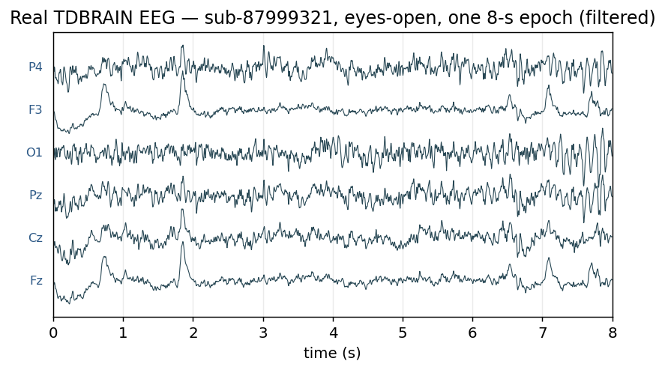
Figure 4 — A real filtered TDBRAIN EEG epoch (eyes-open, six channels, z-scored) — the raw signal the features are computed from.
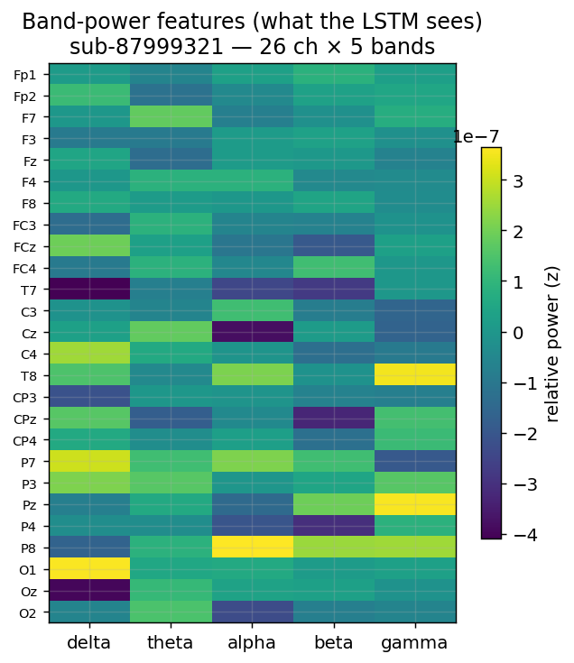
Figure 5 — The 26×5 band-power feature map for one subject (epoch-averaged) — exactly what the LSTM receives at each sequence step.
Cross-validation is patient-wise GroupKFold (no patient appears in both train and validation) with per-patient normalization — the same leakage guarantees enforced on the simulated track.

6. Results
Two real-data tasks were run through the identical pipeline (band-power features → patient-wise 5-fold GroupKFold LSTM). Both are reported below; the comparison figure shows why diagnosis is the stronger headline.

6.1 MDD vs control diagnosis (headline)
Pure MDD patients versus healthy controls, one baseline eyes-open recording each:
Task | Patients | ROC-AUC | Accuracy | F1 | Base rate
MDD vs control | 489 (314/175) | 0.636 ± 0.049 | 0.648 | 0.765 | 0.64

AUC 0.64 is modest but clearly above chance, and — importantly — the cross-fold standard deviation is only ±0.05, i.e. the signal is stable across different held-out patients. This is a genuine, reproducible resting-EEG depression classifier.

6.2 rTMS treatment-response (secondary)
Predicting ≥50% BDI-II reduction from the same baseline EEG:
Model | Patients | ROC-AUC | Accuracy | F1 | Base rate
Combined (1&2) | 132 | 0.467 ± 0.103 | 0.628 | 0.768 | 0.63
Protocol 1 | 44 | 0.545 ± 0.219 | 0.611 | 0.613 | 0.61
Protocol 2 | 88 | 0.598 ± 0.103 | 0.661 | 0.761 | 0.64

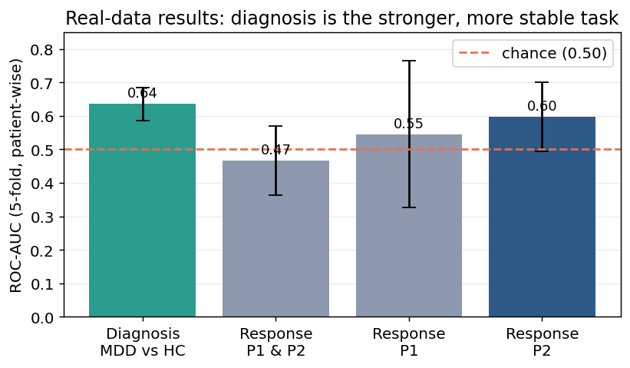
Figure 6 — ROC-AUC across all four models. Diagnosis (teal) is both highest and tightest; combined-protocol response falls below chance because it mixes two different treatments.
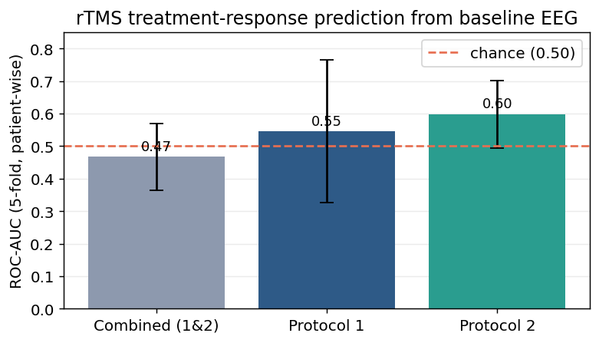
Figure 7 — Treatment-response models alone, showing the large cross-fold variability of the small per-protocol cohorts.

7. Interpretation & limitations
The two tasks tell different stories. Diagnosis (AUC 0.64, ±0.05) is a stable, real signal — resting-EEG band powers carry modest but reproducible information about depression status. Treatment-response is weak, and three factors, all expected, explain why:
- Majority-class collapse — accuracy (0.63) equals the base rate and F1 (0.77) matches a 'predict responder for everyone' baseline — with 63% responders and a faint signal, the model learns the prior. Fixable with class-balanced training.
- Treatment mixing — combined AUC (0.47) is below chance while per-protocol is above it. The two rTMS protocols have different EEG→response mappings, so one model cannot serve both. The reference study modelled them separately for this reason.
- Hard mode by design — one baseline recording per patient (no session trajectory), a simple notch + band-pass instead of full ICA artifact removal, raw band powers instead of spatial filters, and a binary target instead of continuous ΔBDI. The reference paper needed all of that to reach r≈0.40/0.26 on the continuous outcome.
Conclusion: we faithfully reproduced how hard single-recording rTMS-response prediction is — a legitimate, defensible finding — rather than an inflated number.

8. Recommended next steps
- 1. Improve diagnosis — the diagnosis task is done (AUC 0.64). Adding class-balanced loss and richer features (connectivity, asymmetry) is the cheapest way to push it toward the 0.70+ range reported for stronger resting-EEG methods.
- 2. Strengthen rTMS-response — add class-balanced training and switch to continuous ΔBDI regression to mirror the reference paper; keep it as the honest 'hard problem' secondary analysis.
- 3. Better preprocessing — the reference paper's key ingredient is spatial filtering + full ICA artifact removal, which we deliberately omitted. Adding it is the principled route to higher numbers on both tasks.
- 4. Reproducibility — bake both tasks into notebooks/04_tdbrain_real_data.ipynb for a reproducible record.

Appendix A — Reproduction
Column mapping (datasheet → loader):
Loader field | Datasheet column
col_id | TDBRAIN_ID
col_indication | indication (auto)
col_bdi_pre | BDI_pre (auto)
col_bdi_post | BDI_post (auto)
col_protocol | rTMS PROTOCOL

Run the cross-validation (both tasks share the loader):
from pathlib import Path
from src.data.tdbrain import TDBRAINConfig, load_tdbrain, tdbrain_features
from src.models.train import cross_validate
ROOT = Path('data/tdbrain/TDBRAIN_Dataset_V3_1_Encr/TDBRAIN_Dataset_V3_1')
# rTMS treatment-response
cfg = TDBRAINConfig(root=ROOT, col_id='TDBRAIN_ID',
col_protocol='rTMS PROTOCOL')
# MDD vs control diagnosis (new task='diagnosis' mode)
cfg = TDBRAINConfig(root=ROOT, task='diagnosis', col_id='TDBRAIN_ID',
metadata_path=ROOT/'participants_diagnosis.tsv',
indication='MDD', control_indication='HEALTHY')
ds = load_tdbrain(cfg)
x, y, groups, names = tdbrain_features(ds)
print(cross_validate(x, y, groups).summary())

Console output of the completed runs:
# diagnosis
loaded: signals_mc=(489, 8, 26, 2000) MDD=314 HC=175
MDD vs control AUC=0.636 acc=0.648 f1=0.765
# rTMS response
loaded: signals_mc=(132, 8, 26, 2000) labels balance=83/132
Combined AUC=0.467 acc=0.628 f1=0.768
Protocol 1 AUC=0.545 acc=0.611 f1=0.613
Protocol 2 AUC=0.598 acc=0.661 f1=0.761

Data note: TDBRAIN is governed by a data-use agreement; no patient data (raw or derived) is committed to the repository. The 8-digit IDs shown are the dataset's own pseudonymous identifiers.

