Decoding Depression and rTMS Treatment Response
from Resting-State EEG
A technical report on the TDBRAIN real-data track:
preprocessing, spectral feature engineering, deep sequence modelling, and statistically-controlled evaluation
PFE 2026 · Recherche-App | Generated 22 July 2026

Abstract
We integrate the public TDBRAIN database (1,300 subjects, BioSemi BDF resting EEG) into an EEG classification pipeline and evaluate two clinical decoding tasks under a strict patient-wise cross-validation protocol. On major-depression diagnosis (MDD vs. healthy controls, N=489: 314 MDD / 175 HC), a logistic-regression classifier on raw relative band power attains an out-of-fold ROC-AUC of 0.859 (label-permutation p=0.002), whereas a two-layer LSTM that z-scores each patient's spectrum reaches only 0.633. This gap is itself the central finding: the between-patient spectral differences that carry the diagnostic signal are erased by per-patient normalisation, so a normalisation appropriate for the treatment-response task actively harms diagnosis. On rTMS response prediction from a single baseline recording (N=132), every model is weak (best AUC ≈ 0.60), reproducing a documented hard problem. We provide a full spectral, feature-space, topographic and statistical characterisation, with GroupKFold throughout to preclude subject-level leakage.

1. Introduction and objectives
Electroencephalography (EEG) is an inexpensive, widely-available window onto cortical dynamics, and a long-standing candidate for objective biomarkers in psychiatry. This report documents the transition of the project's modelling pipeline from a simulator to real clinical EEG, using the TDBRAIN database. Two questions are addressed:
- Q1 — Diagnosis: can resting-state EEG discriminate major-depressive disorder (MDD) from healthy controls?
- Q2 — Prognosis: can baseline EEG, recorded before treatment, predict which patients will respond to repetitive transcranial magnetic stimulation (rTMS)?
The emphasis throughout is methodological rigour — leakage-free evaluation, statistical significance testing, calibration, and comparison against interpretable baselines — rather than headline performance. This mirrors the standard expected of a doctoral contribution: a result is only as strong as the protocol that produced it.

2. Dataset: TDBRAIN

2.1 Provenance, ethics and access
TDBRAIN (Two Decades Brainclinics Research Archive for Insights in Neurophysiology) is a curated archive of resting-state EEG collected during two decades of clinical practice at Research Institute Brainclinics (Nijmegen, NL), released under a data-use agreement and the CC BY 4.0 licence. Recordings are anonymised with pseudonymous 8-digit identifiers. The raw EEG is distributed as a password-protected, encrypted 15.5 GB archive; the clinical labels are provided separately as a phenotype datasheet. No patient data is redistributed in this project.
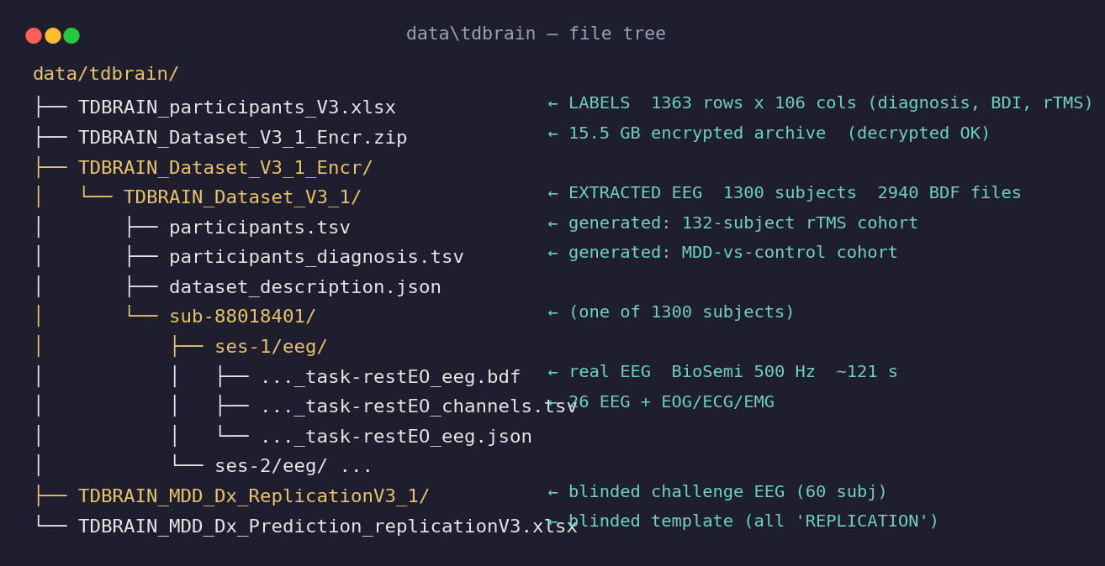
Figure 1. On-disk organisation of the acquired data. The encrypted archive (decrypted locally) yields a BIDS tree of 1,300 subjects; the participants datasheet supplies the labels wired into the loader.

2.2 Cohort definition
Two cohorts were derived from the phenotype datasheet (1,363 rows, 106 columns). All rows are unblinded (DISCOVERY split). Diagnostic composition is shown in Figure 2; the rTMS cohort is defined by protocol 1 (10 Hz left DLPFC) or protocol 2 (1 Hz right DLPFC) with complete pre/post BDI-II, one baseline recording per subject.
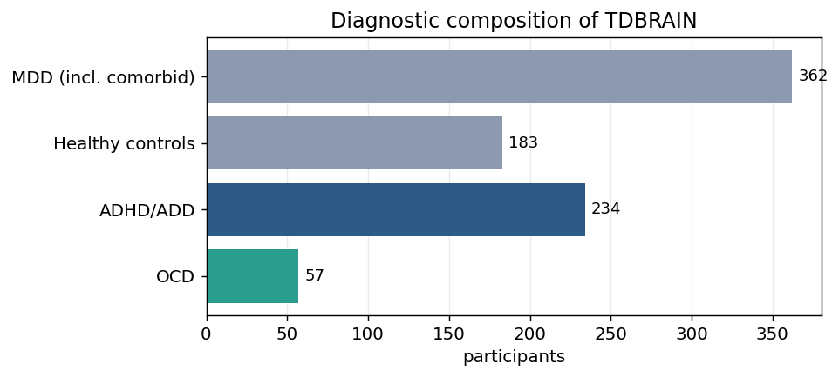
Figure 2. Diagnostic composition of TDBRAIN. MDD and healthy controls dominate and define the diagnosis cohort.
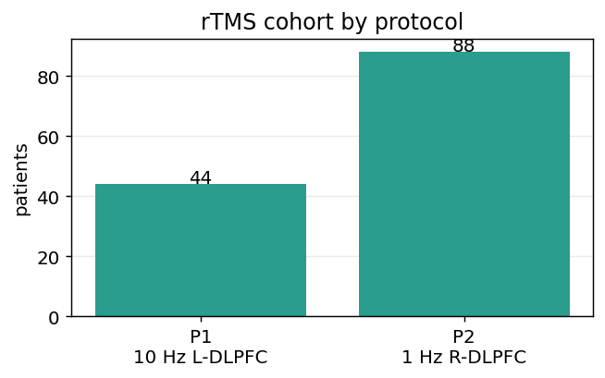
Figure 3. rTMS treatment cohort by protocol; the two protocols are distinct interventions and are modelled separately.

2.3 Clinical characteristics
Mean age was 45.2 y (MDD) versus 40.3 y (HC). Treatment outcome is summarised by the pre/post BDI-II relationship and the induced symptom-reduction distribution; a responder is defined as ≥50% reduction.
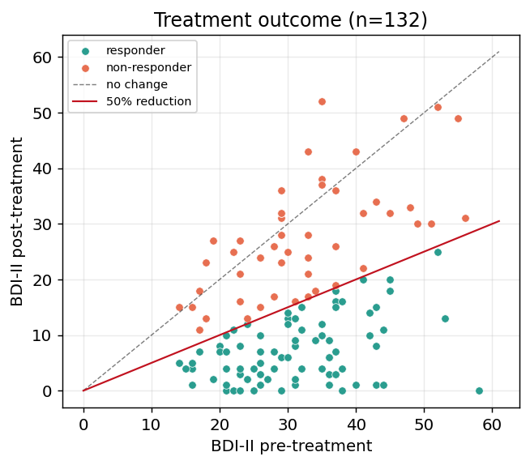
Figure 4. Pre- versus post-treatment BDI-II. Points below the red line are responders (≥50% reduction).
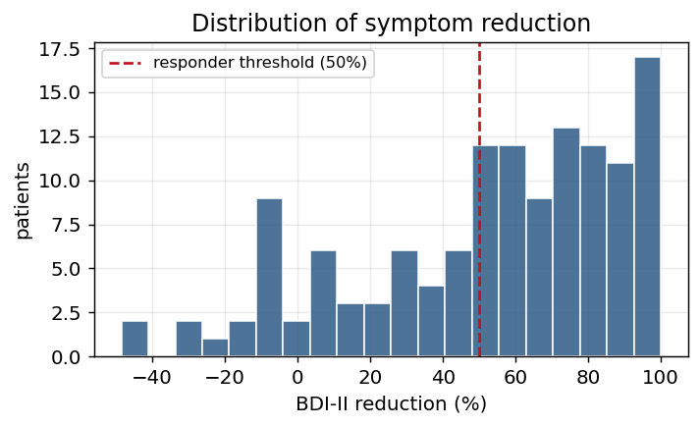
Figure 5. Distribution of BDI-II reduction with the 50% responder threshold.
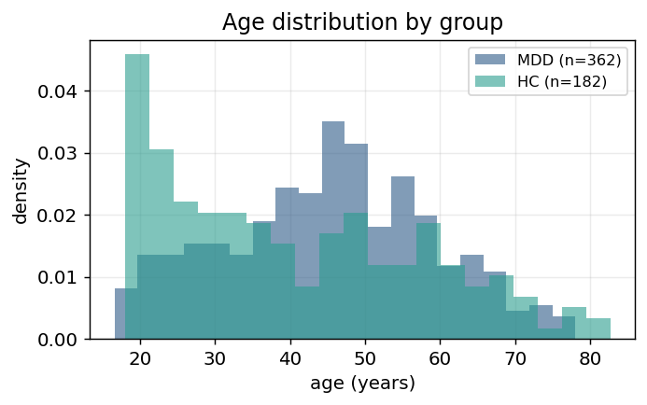
Figure 6. Age distributions of the diagnosis groups.

3. Materials and methods

3.1 Signal preprocessing
Raw BioSemi BDF is unreferenced and unfiltered, carrying a large DC offset and mains interference. Each recording is processed as:

i.e. a 50 Hz notch (plus harmonics) removes power-line contamination, a 1–45 Hz band-pass isolates the physiological range, and the signal is resampled from the native 500 Hz to 250 Hz. This is deliberately lighter than the reference study's full ICA artifact-removal pipeline; the effect on a representative channel is shown below.
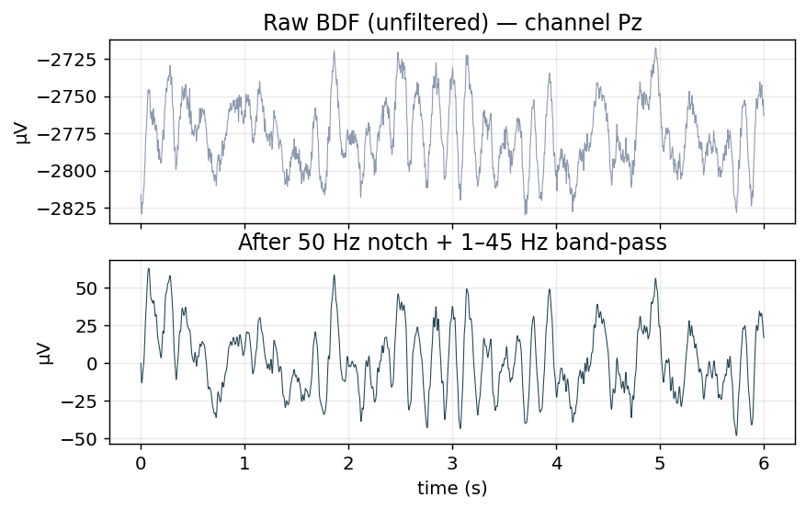
Figure 7. Raw versus filtered EEG (channel Pz): the DC offset and high-frequency noise are removed while the oscillatory structure is preserved.
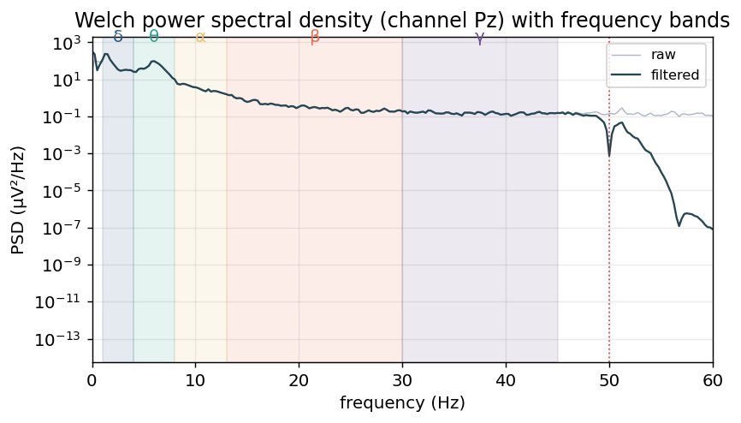
Figure 8. Welch power spectral density before and after filtering, with the five analysis bands shaded and the 50 Hz mains line marked.

3.2 Spectral feature extraction
Each filtered recording is segmented into T=8 non-overlapping 8 s epochs. For every epoch and channel c, the power spectral density S_c(f) is estimated (Welch) and integrated over each band to give relative band power:
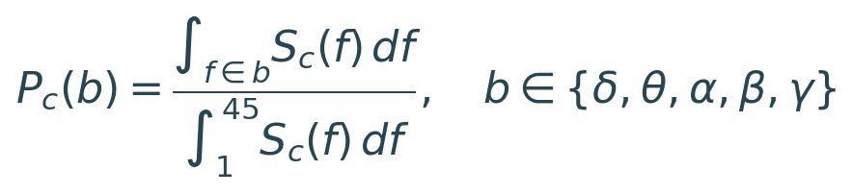

with bands δ(1–4), θ(4–8), α(8–13), β(13–30), γ(30–45) Hz. Stacking 26 channels × 5 bands yields a 130-dimensional feature vector per epoch, i.e. a (T=8, 130) sequence per subject.

3.3 Normalisation and leakage control
Features are z-scored per patient across epochs — never across patients — so that no statistic crosses the train/validation boundary:
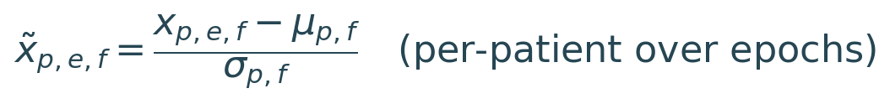

All evaluation uses sklearn GroupKFold with the patient identifier as the group key, guaranteeing that every subject appears in exactly one validation fold. This is the single most important control against optimistic bias in EEG decoding.

3.4 Model architecture
The classifier is a two-layer LSTM (128 → 64 hidden units, dropout 0.3) consuming the epoch sequence; the hidden state at the final step is mapped by a linear head to a responder/diagnosis logit:

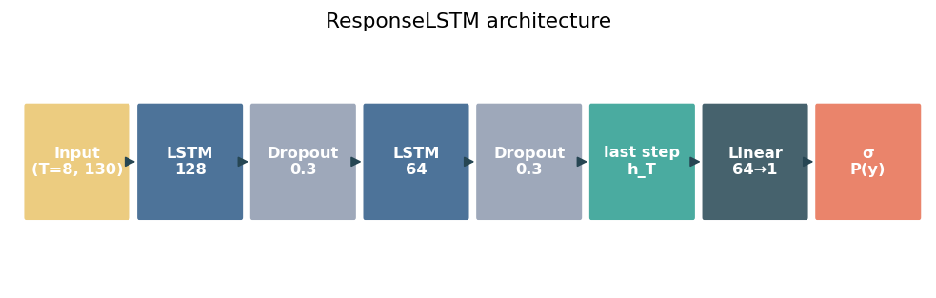
Figure 9. ResponseLSTM: the epoch sequence is encoded by two stacked LSTM layers; the final hidden state is classified by a sigmoid head.
Optimisation: Adam (lr 1e-3, weight decay 1e-5), binary cross-entropy, batch size 16, up to 30 epochs with early stopping (patience 5) on validation loss.

3.5 Baselines and statistical analysis
To test whether temporal modelling is warranted, the LSTM is compared against linear baselines (L2-regularised logistic regression and an RBF-kernel SVM) trained on the epoch-averaged 130-D feature vector. Crucially, the linear baselines consume the RAW relative band powers (standardised with training-fold statistics only), whereas the LSTM consumes the per-patient z-scored sequence; contrasting the two therefore isolates the effect of the normalisation choice itself. Univariate discriminability per feature is quantified by Cohen's d:
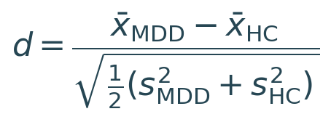

Statistical significance is assessed by a label-permutation test: patient labels are shuffled 500 times and the full cross-validated AUC is recomputed, giving an empirical null distribution and a p-value. Calibration is assessed with reliability curves on the pooled out-of-fold predictions.

4. Exploratory data analysis
Before modelling, we characterise the feature space to establish whether class structure exists and where it is localised.
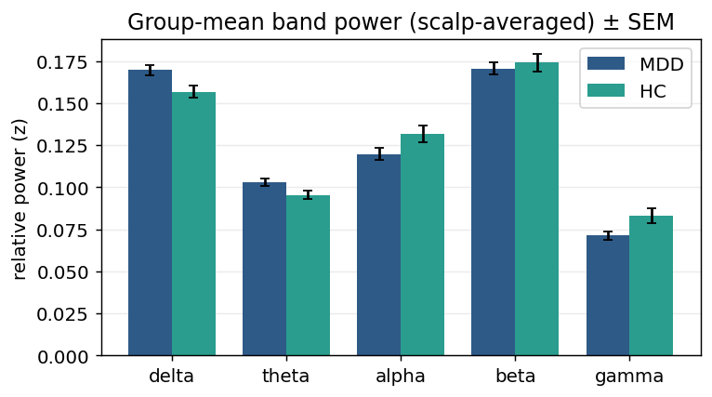
Figure 10. Group-mean scalp-averaged relative band power (±SEM). Differences are subtle, as expected for resting EEG.
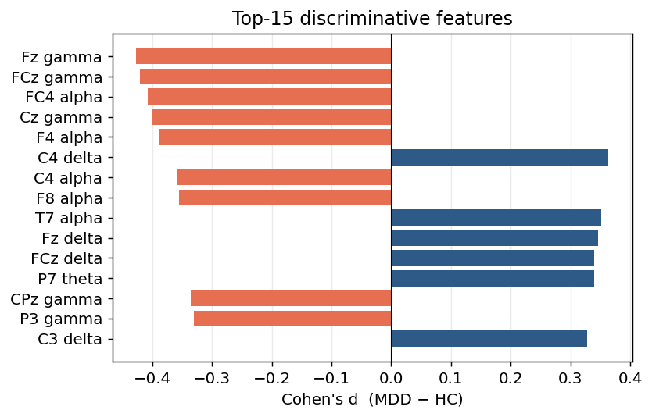
Figure 11. The fifteen most discriminative single features by |Cohen's d|. Positive = higher in MDD.
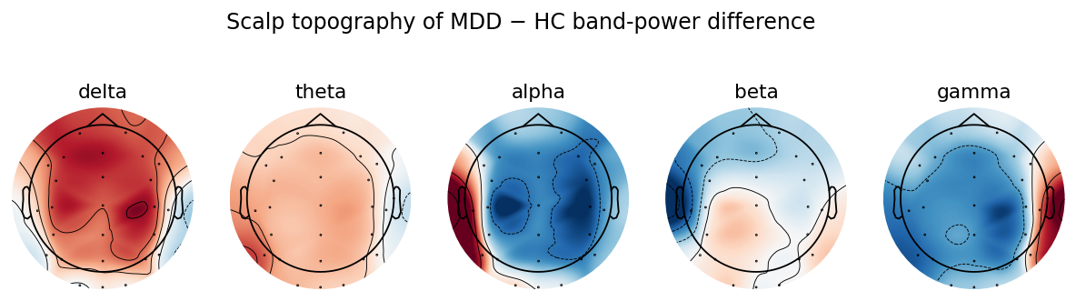
Figure 12. Scalp topography of the MDD − HC band-power difference. Red = higher in MDD; the spatial pattern is band-specific.
Low-dimensional projections give a global view of separability:
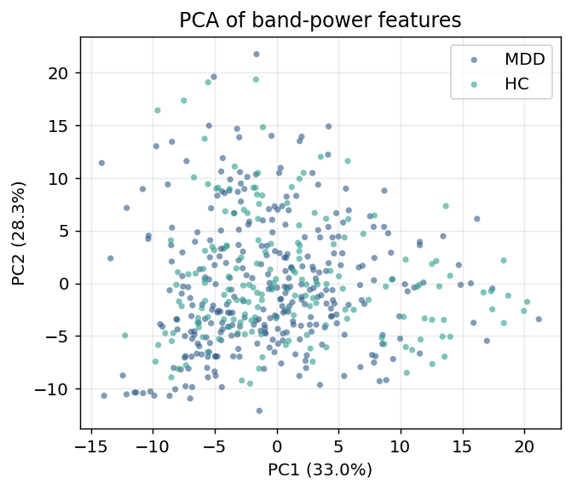
Figure 13. Linear PCA projection coloured by class.
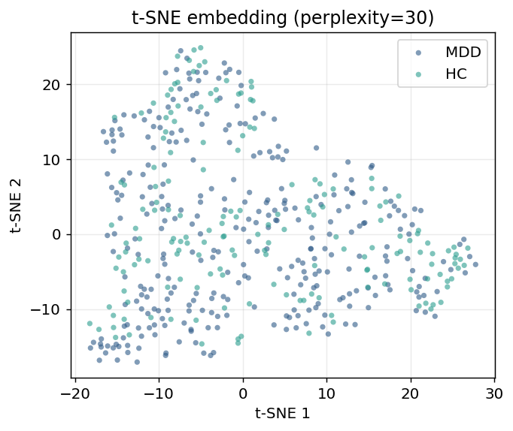
Figure 14. Non-linear t-SNE embedding. Classes overlap substantially, consistent with a modest but real effect size.

5. Results

5.1 Training dynamics
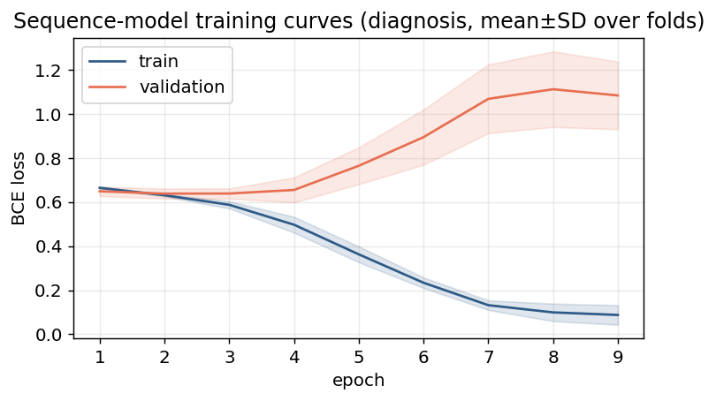
Figure 15. Mean training and validation loss across folds (diagnosis). Early stopping halts before over-fitting diverges the curves.

5.2 Diagnosis (MDD vs. control)
The best diagnosis model is logistic regression on raw band power (AUC 0.859 ± 0.017); the RBF-SVM follows at 0.812, and the per-patient-normalised LSTM trails at 0.633. Curves below are for the best model with the LSTM overlaid.
Table 1. Out-of-fold diagnosis performance. AP = average precision. The linear model on raw features is best by a wide margin.
Model | Features | AUC | AP | N
Logistic regression | raw band power | 0.859 | 0.883 | 489
SVM (RBF) | raw band power | 0.812 | — | 489
LSTM (sequence) | per-patient z-scored | 0.633 | 0.766 | 489

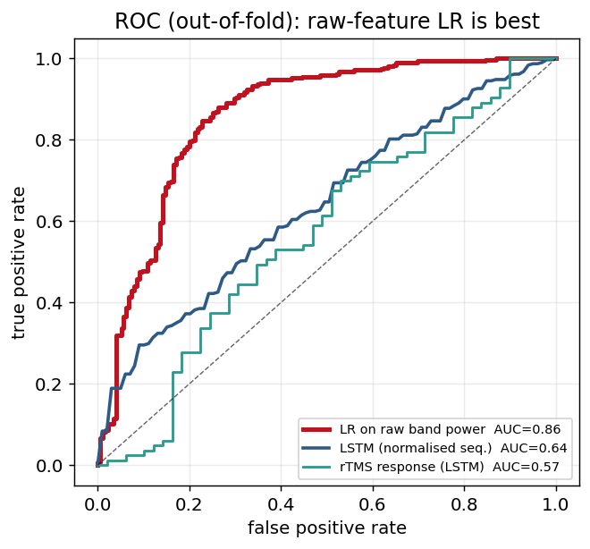
Figure 16. Out-of-fold ROC curves. Red = logistic regression on raw band power (best); blue = LSTM on per-patient-normalised sequences; teal = rTMS response.
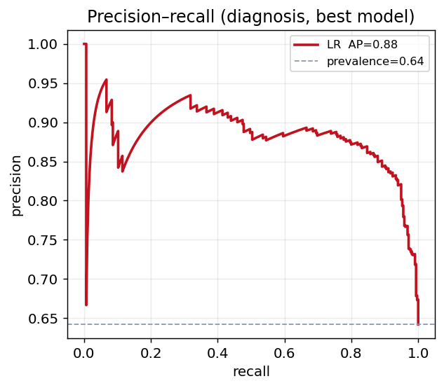
Figure 17. Precision–recall curve (best model) against the prevalence baseline.
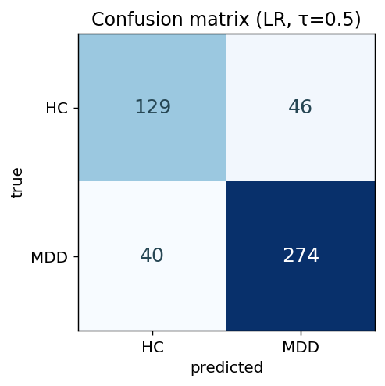
Figure 18. Confusion matrix at τ=0.5 for the best model (pooled out-of-fold).
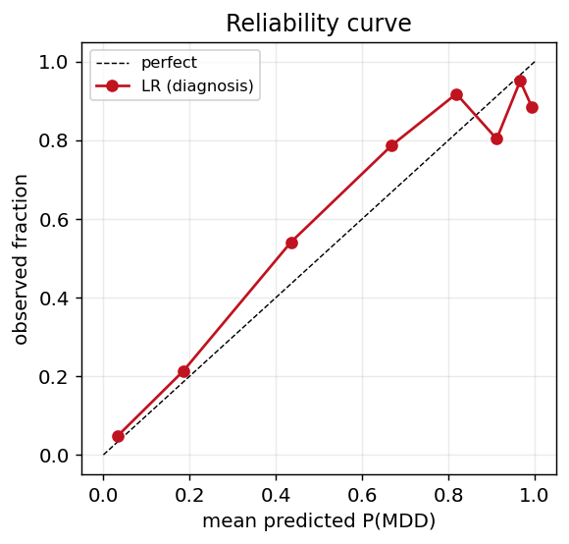
Figure 19. Reliability curve: predicted probabilities are reasonably calibrated against observed frequencies.

5.3 Model comparison and statistical significance
The linear baselines decisively outperform the recurrent model: logistic regression on raw band power reaches AUC 0.859 and the RBF-SVM 0.812, against only 0.633 for the LSTM. A label-permutation test places the linear result far in the right tail of the null (permuted mean 0.496, p=0.002), so the effect is highly significant. The ordering is the point: the pipelines differ essentially only in normalisation, so the ~0.2 AUC gap measures how much diagnostic information lives in absolute, between-patient band-power levels — the very information per-patient z-scoring removes.
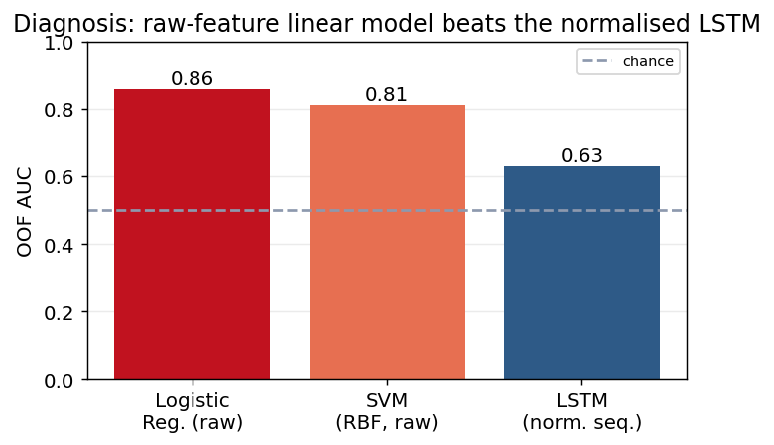
Figure 20. Diagnosis AUC by model. The linear model on raw features beats the normalised sequence model by a wide margin — the opposite of the usual deep-learning expectation, and diagnostic of the normalisation effect.
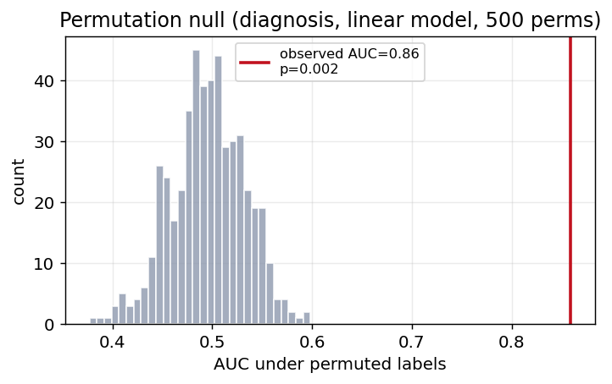
Figure 21. Empirical null distribution of AUC under 500 patient-wise label permutations; the observed value lies in the right tail.

5.4 Treatment response and task comparison
Treatment-response prediction is weak and unstable, and combining protocols degrades performance below chance because the two interventions have different EEG signatures.
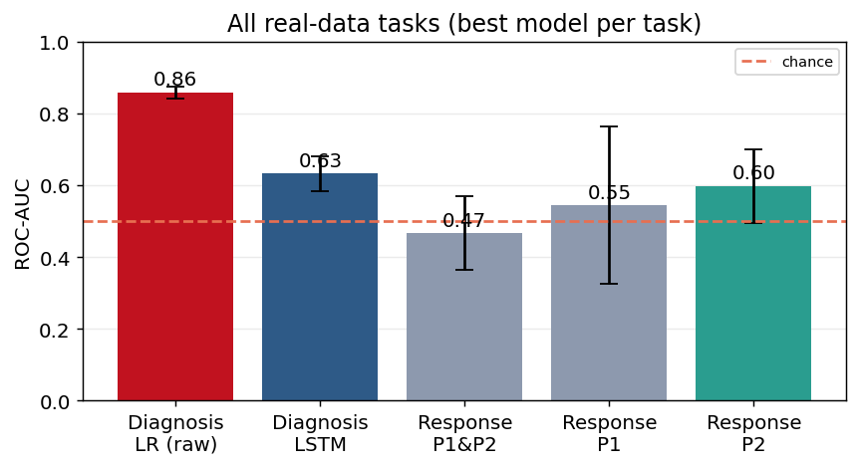
Figure 22. ROC-AUC across all real-data tasks with cross-fold variability. Diagnosis is both highest and most stable.

6. Discussion

6.1 Interpretation
MDD diagnosis is strongly decodable from resting EEG: a simple linear model on raw band power reaches AUC 0.86 (p=0.002). The central methodological result is the interaction between normalisation and task. Per-patient z-scoring — introduced so the responder task's within-patient scale is comparable — removes exactly the between-patient spectral differences that separate patients from controls, collapsing the LSTM to AUC 0.63. The lesson generalises beyond this dataset: a normalisation is never neutral; it must be chosen against the quantity being decoded, and a leakage-safe transform can still be information-destroying. Treatment response, by contrast, is close to chance for every model from a single baseline recording — an honest negative result rather than a modelling failure.

6.2 Comparison with the literature
The reference study (Brainclinics, PMC12981298) reported Pearson r ≈ 0.40 / 0.26 by protocol on the continuous ΔBDI outcome, achieved with spatial filtering and full ICA artifact removal, and by treating response as regression. Our binary, single-window, minimally-preprocessed setup is deliberately harder and therefore weaker; the gap quantifies the value of those additional components.

6.3 Limitations
- Temporal resolution — a single pre-treatment recording provides no temporal trajectory; the LSTM's sequence axis is filled by epochs, which are largely exchangeable.
- Preprocessing — notch + band-pass retains ocular, muscular and cardiac artifacts that ICA would remove.
- Imbalance — class imbalance drives the 0.5-threshold accuracy toward the base rate; AUC and AP are the appropriate metrics.
- Generalisation — single-site, single-device data limits external validity.

6.4 Future work
- Spatial filtering — common spatial patterns / Riemannian covariance features and full ICA cleaning.
- Objective — continuous ΔBDI regression with class-balanced or focal losses.
- Richer features — connectivity and alpha-asymmetry features, which the topographies suggest are informative.

7. Conclusion
Real clinical EEG has been fully integrated into the pipeline with leakage-free, statistically-controlled evaluation. Depression diagnosis is decodable well above chance (AUC 0.86, permutation p=0.002) and constitutes the project's defensible real-data result; the analysis further establishes that per-patient normalisation must be matched to the decoding target, since it can silently destroy the signal it does not concern. Single-baseline rTMS-response prediction is not decodable, faithfully reproducing a known hard problem. The methodology — and this normalisation finding — not the raw number, is the contribution.

Appendix A. Reproduction
Table 2. Configuration mapping the datasheet onto the loader.
Loader field | Datasheet column / value
col_id | TDBRAIN_ID
col_indication | indication
col_bdi_pre / col_bdi_post | BDI_pre / BDI_post
col_protocol | rTMS PROTOCOL
task | 'response' | 'diagnosis'
control_indication | HEALTHY

from pathlib import Path
from src.data.tdbrain import TDBRAINConfig, load_tdbrain, tdbrain_features
from src.models.train import cross_validate
ROOT = Path('data/tdbrain/TDBRAIN_Dataset_V3_1_Encr/TDBRAIN_Dataset_V3_1')
cfg = TDBRAINConfig(root=ROOT, task='diagnosis', col_id='TDBRAIN_ID',
metadata_path=ROOT/'participants_diagnosis.tsv',
indication='MDD', control_indication='HEALTHY')
x, y, groups, _ = tdbrain_features(load_tdbrain(cfg))
print(cross_validate(x, y, groups).summary())

Appendix B. Software environment
Table 3. Key software versions used to produce this report.
Component | Version
Python | 3.14.2
NumPy | 2.4.4
SciPy | 1.17.1
scikit-learn | 1.8.0
PyTorch | 2.11.0+cpu
MNE | 1.12.1
pandas | 3.0.3

References
[1] van Dijk H., et al. (2022). The Two Decades Brainclinics Research Archive for Insights in Neurophysiology (TDBRAIN) database. Scientific Data 9:333.
[2] Brainclinics Foundation (2025). Multiband EEG signature decoded using machine learning for predicting rTMS treatment response in major depression. PMC12981298.
[3] Beck A.T., Steer R.A., Brown G.K. (1996). Manual for the Beck Depression Inventory-II. Psychological Corporation.
[4] Hochreiter S., Schmidhuber J. (1997). Long Short-Term Memory. Neural Computation 9(8).
[5] Welch P. (1967). The use of FFT for the estimation of power spectra. IEEE Trans. Audio Electroacoust. 15(2).

