#### 

**IUBAT – International University of Business Agriculture and Technology**

#### Assignment No: 1

#### Title of Assignment:

#### DFA for string pattern ab*cb* and

#### Implementation of DFA in C program for the string pattern ab*cb*

**Course Name: Theory of Computation**

**Course Code: CSC 397**

**Submitted To:**

**Dr. Ehteshamul Haque**

Faculty, Dept. of CSE

**Submitted By:**

**Naimul Ferdous**

**ID: 13303042**

**Sec-C, CSC397**

**Submission Date: 02.10.2017**

**Formal definition of Deterministic finite automaton (DFA)**

A Deterministic finite automaton M is a 5-tuple (Q, ∑, δ, q0, F) where

1. Q is a finite set of states called the states,
2. ∑ is a finite set of input symbols called the alphabet,
3. δ: Q x ∑→ Q is the transition function
4. q0 ∈ Q is the start state, and
5. F ⊆ Q is the set of accept states.

**DFA for the string pattern ab*cb\***

**Complete State Diagram:**

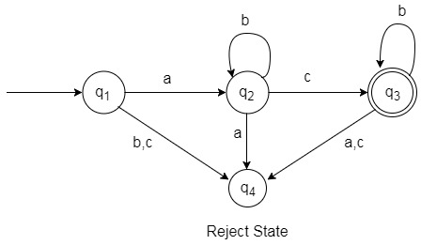

Here,

1. Q= {q1, q2, q3, q4}
2. ∑= {a, b, c}

∑*= {ac, abc, acb, abcb, abbcbb, abbbcbbb, abcbbb, abbbcb…………}

1. q0= q1∈ Q
2. F= {q3}⊆ Q

**Transition Table:**

|  |  |  |  |
| --- | --- | --- | --- |
| **CurrentStates \ Input** | **A** | **b** | **c** |
| **q1** | q2 | q4 | q4 |
| **q2** | q4 | q2 | q3 |
| **q3** | q4 | q3 | q4 |

**Implementation using C program:**

#include<stdio.h>

#define EOS '\0'

int main()

{

char c, inpstr[50];

int i, q;

printf("Enter String: ");

scanf("%s",inpstr);

q=1;

i=0;

c=inpstr[i];

printf("\n");

printf("%s ", inpstr);

while(c!=EOS)

{

if(q==1 && c=='a')

{

q=2;

}

else if(q==2 && c=='b')

{

q=2;

}

else if(q==2 && c=='c')

{

q=3;

}

else if(q==3 && c=='b')

{

q=3;

}

else

{

q=4;

break;

}

i++;

c=inpstr[i];

}

if(q==4)

printf(" Illegal");

else

printf(" Legal");

printf("\n");

return 0;

}

**Specimen Input with Results:**

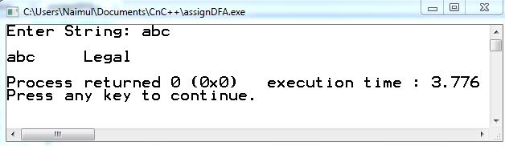

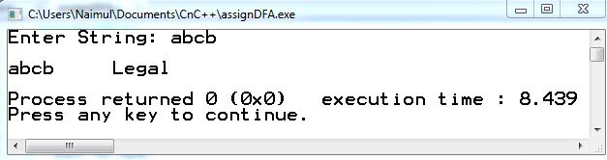

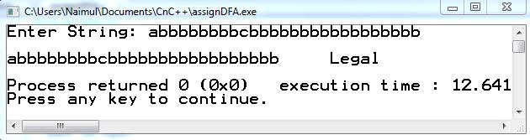

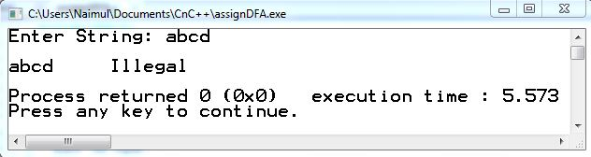

**Conclusion:**

In DFA, for each input symbol, one can determine the state to which the machine will move. Hence, it is called Deterministic Automaton. As it has a finite number of states, the machine is called Deterministic Finite Machine or Deterministic Finite Automaton.