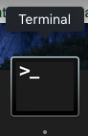Lets learn about **TERMINAL !!!**

# Which is this little app right here: 🡪 🡪 🡪

# **You can also find this app by hitting:**

# command + (space bar) and *searching* TERMINAL duh

That should be obvious dumbass. But if it’s not for some reason,

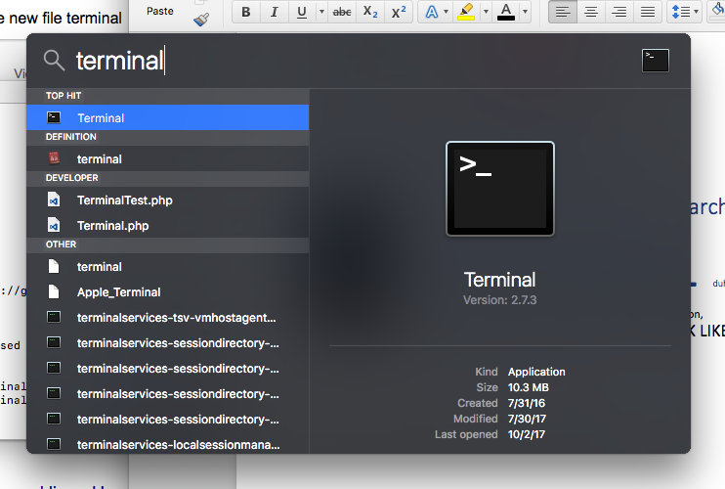THIS IS WHAT THE SEARCH WOULD LOOK LIKE

All right kiddo, now that you have terminal open, this what your perty face will be looking at:

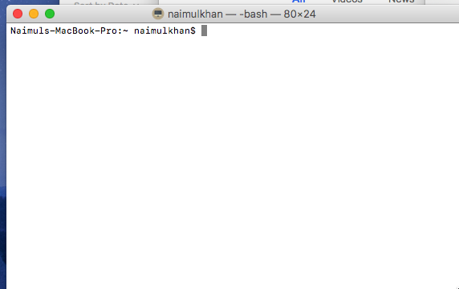(kind of boring, right?) 🡪 WRONG ASSHOLE, this here is POWER in the mechanical form!! You can fucking launch missiles with this shit (don’t tell Trump though)!!

… but we wont be worrying much about that—not right now at least.

* Here the first thing you see is:
  + Naimuls-Macbook-Pro:~ naimulkhan$
  + The green is the name of the machine (computer, virtual machine) that you’re working on
  + The red is the name of the folder your in
  + The yellow, symbolized by the $, is called the *selector*—which if you didn’t have a peanut for a brain, you’d realize it means that some shit is selected.

OK, time for some COMMANDS:

HERE ARE SOME BASIC THINGS YOU CAN DO 🡪

*1. Change directories*

(Directories is just a fancy fucking name for folder. You see, I keep my porn hidden in a directory called “work stuff”—sounds more professional than saying folder—and much less convicting)

1.1 SO HOW THE FUCK DO YOU CHANGE DIRECTORIES?!

You use the “cd” function (short for CHANGE DIRECTORY—see what they did there?) .

* Syntax 🡪 *cd documents*
  + This will move me to the desktop documents
* NOTE: **you can only change directories to an immediate child folder of the folder you’re in**—you cant just all willy nilly write the name of a folder or second cousin that exists somewhere on your computer and expect to be magically swept to the directory!!!

**FOR EXAMPLE:** lets say I am in the **document**s folder, and then inside that folder there’s another one called **essays** and inside that one there is one that is **school** and inside that one there is one there is one called **English** – so the folders look like this:

[ Documents 🡪 Essays 🡪 School 🡪 English ]



If I am in the **Documents** folder, me writing:

cd school

will NOT put me inside the **school** directory, I’ll get an error.



*See the line in the middle? It’s an error—NO SUCH FILE OR DIRECTORY—that’s the definition of WRONG*

IF I wanted to go to **school** (don’t live in Africa) and also I’d list the entire filepath from the folder you’re in… so this would work:

cd essays/school



And now you’re in **school, (illustrated by the fact is says school after the first colon… also don’t do drugs**

**BUT WHAT IF I DON’T KNOW WHICH FOLDERS ARE IN MY FOLDER?**