

Project report for the Degree of B.Sc. Engineering

Project Title:

**Automated Watering System**

By

**Name: Naimul Hasan**

**Student ID: 16CSE030**

**Course Code: CSE466**

Department of Computer Science & Engineering

Bangabandhu Sheikh Mujibur Rahman Science and Technology University

Gopalganj, Bangladesh

Date of submission: 22.2.2022

Group Project:

**Automated Watering System**

**by**

**Naimul Hasan**

**Mohammad Hasib Ullah**

**Taufikul Ashik**

**Rashedul Islam**

**Shovon Debnath**

**Shakib Hossen**

**Hasinur Rahman**

To

  Md Martuza Ahamad

Assistant Professor, Dept. of CSE

Submitted to the Department of Computer Science & Engineering

Bangabandhu Sheikh Mujibur Rahman Science and Technology University in partial fulfillment to the requirements for the degree of

B.Sc. Engineering

**ACKNOWLEDGEMENT**

I would like to thank my Fathar and Mother for buying me toys not being angry when I broke them and took out the motor and other electronic parts for curiosity. I would like to thank the youtubers and blog writers who provides amazing explanation and working principal of electronic component and devices.

Naimul Hasan

February, 2022

**ABSTRACT**

When it comes to gardening the most hardest thing is the plants needs water on regular basis and they need the right amount of water. As it takes quite a while and its very hard for busy peoples and when no one is at home to take care of the garden. So we will be making a Device that will Water our plants everyday by examining the soil moisture and the time of the day. It uses a motor or solenoid valve depending on what the user needs, and provides the right volume of water at the right time everyday.

**TABLE OF CONTENTS**

|  |  |  |
| --- | --- | --- |
| Chapter 1 | Introduction and Overview | 01 |
| 1.1 | Introduction & Background | 01 |
| 1.2 | Motivation and Aim | 02 |
| 1.3 | Objectives | 02 |
|  |  |  |
| Chapter 2 | **Methodology** | **03** |
| 2.1 | Required Components | 03 |
| 2.2 | Description and Working Principal of Components | 04 |
| 2.2.1 | Arduino Uno R3 | 04 |
| 2.2.2 | Real Time Clock (RTC DS3231) | 05 |
| 2.2.3 | Soil Moisture Sensor | 05 |
| 2..2.4 | Relay | 06 |
| 2.2.5 | Water Flow Sensor | 06 |
| 2.2.6 | 12V DC Water Pump | 07 |
| 2.2.7 | 12V Power Supply | 07 |
| 2.2.8 | 12V Solinoid Valve | 07 |
|  |  |  |
| Chapter 3 | **Implementation** | ­**08** |
| 3.1 | Connecting/Assembling Hardware Components | 08 |
| 3.2 | Flow Chart | 10 |
| 3.3 | Programing /Coding | 11 |
|  |  |  |
| Chapter 4 | **Conclusion and Future Scope** | **14** |
| 4.1 | Conclusion | 14 |
| 4.2 | Future scope | 14 |

**CHAPTER ONE**

**INTRODUCTION AND OVERVIEW**

Plants either Flower of fruit or vegetable are amazing and works as a source of happiness along with the fragments and food.

**1.1 Introduction and Background**

In the lockdown I started my own garden and with many other thing I realized its really amazing to have your own garden. A small flower or fruit can give you the happiness that thousands of flower or fruits that are brought from market can not give.

While doing these, the main problem I faced was watering them regularly and most of the time I was either underwatering them or over watering them, which had a great impact on those plants.

Another problem is when no one at home or everyone goes in a tour or somewhere else then its hard to get someone else to water your garden or plants as those could be indoor or on terries.

Facing these problems I realized I needed an automated system to solve this problem. So I along with my friends came up with a project which can water the plants regularly and properly

**1.2 Motivation and Aim**

Necessity is the mother of invention. The motivation I got was from the problems I faced when I started gardening. Watering plants properly and the right time is very imortant.

Our aim is to build a Device that will water the plants/pots by calculating how much water they needs. For this calculation the device will take sample from the soil of the pot and measure the Moisture in the soil. After the calculation the device needs to turn on the Pump or the solenoid valve which works as a Tap and let flow the calculated amount of water through the pipe to the pots and then turn them off. While doing this we have to make sure the plants are not being watered repeatedly or at the wrong time like at noon or night. When the water tank is empty we have to make sure we are taking that into account.

**1.3 Objectives**

The major objectives of the project:

* Measure the Soil moisture from the pot of the plants.
* Calculate how much water is needed for all those plants.
* Check if it is the right time to water the plants or not
* Water the plants using DC pump/ Solinoid Valve and tubes.
* Measure the water flowing to the plants and make sure we are giving the exact calculated amount of water.
* If there is any anomaly, like if the Tank is empty, electricity is lost, tap water pressure is less, then we have to make sure we are handling those issues.

**CHAPTER TWO**

**METHODOLOGY**

**Methodology** refers to the overarching strategy and rationale of your research **project**. It involves studying the methods used in your field and the theories or principles behind them, in order to develop an approach that matches your objectives.

**3.1 Required Components**

Components used for this Project:

1. **Arduino Uno R3**
2. **Real Time Clock (DS3231 RTC)**
3. **Soil Moisture Sensor**
4. **Two Chennel Relay**
5. **Water Flow Sensor (Hall Effect)**
6. **12V DC Water Pump**
7. **12V Power Supply**
8. **12V Solinoid Valve(Optional Component)**
9. **DC Socket**
10. **1cm Rubber Tube**
11. **Jumper Wires**
12. **Cocksheet**
13. **Glue Gun**
14. **Multimeter**

**2.2 Description and Working Principal of Components**

**1. Arduino Uno R3**

The Arduino UNO R3 is frequently used microcontroller board in the family of an Arduino. The Arduino Uno R3 pin diagram is shown below. It comprises 14-digit I/O pins. From these pins, 6-pins can be utilized like PWM outputs. This board includes 14 digital input/output pins, Analog inputs-6, a USB connection, quartz crystal-16 MHz, a power jack, a USB connection, a power jack a RESET button.

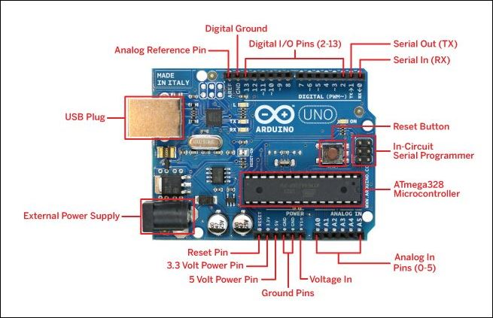

It can be powered up in 4 ways. Its analog pins can take analog input and output of range 0-1023. The Digital pins gives high and low pulse as output and to read and write analog data some of the pins supports PWM.

**2. Real Time Clock (DS3231)**

It manages all timekeeping functions and features a simple two-wire I2C interface which can be easily interfaced with any microcontroller of your choice. The chip maintains seconds, minutes, hours, day, date, month, and year information. The date at the end of the month is automatically adjusted for months with fewer than 31 days, including corrections for leap year.

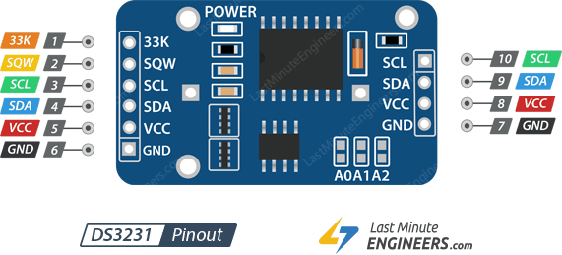

Here SCL is Serial Clock and SDA is Serial Data.

**3. Soil Moisture Sensor**

A typical soil moisture sensor has two components.

* **The Probe**

The sensor contains a fork-shaped probe with two exposed conductors that goes into the soil or anywhere else where the water content is to be measured.

It acts as a variable resistor whose resistance varies according to the soil moisture.

* **The Module**

The module produces an output voltage according to the resistance of the probe and is made available at an Analog Output (AO) pin.

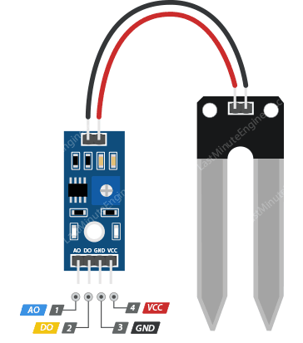

**4. Two Chennel Relay**

A relay is an electromagnetic switch operated by a relatively small current that can control much larger current. It turns the switch of the larger current on and off using the electromagnetic field that is controlled by Arduino.

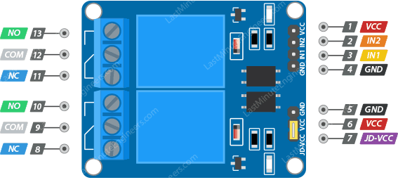

Input: IN1 & IN2 pins are used to control the relay. These are active low pins, meaning the relay will be activated when you pull the pin LOW and it will become inactive when you pull the pin HIGH.

Output Terminals:

* COM - pin is connected to the signal you are planning to switch.
* NC - pin is connected to the COM pin by default, unless you send a signal from the Arduino to the relay module to break the connection.
* NO - pin is open by default, unless you send a signal from the Arduino to the relay module to make the connection.

**5. Water Flow Sensor**

By using a flow sensor with a microcontroller like Arduino, we can calculate the flow rate, and check the volume of liquid that has passed through a pipe, and control it as required.

The water flow sensor works on the principle of hall-effect. It is integrated with a magnetic hall-effect sensor, which generates an electric pulse with every revolution.

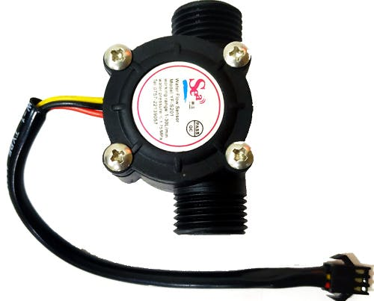

**6. 12V DC Water Pump**

DC water pump is a machine that transports liquid or pressurizes liquid. The Pump we used is a centrifugal pump. A centrifugal pump is powered by a device called an impeller. The impeller is a bit like a turbine. It has many curved blades, which channel the water through the pump.

The impeller spins very fast. The curved blades channel water into the eye, or center of the impeller, but that water flows along to the outside of the blades. Because the impeller moves fast, the centrifugal force compresses the water against the outside of the blade. This pressure causes the water to rocket forward in a high-speed jet out of the impeller. This speed creates pressure on the outlet side of the pump, pushing the water through the pipe.

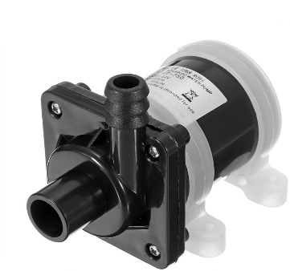

**7. 12V Power Supply**

It converts 220-240AC to 12V DC power using Full bridge rectifier, transformer and Capacitor mainly.

**6. 12V Solinoid Valve**

It Converts DC current to Electromagnetic force to pull the round long magnetic/ switch

that turns on or off the valve.

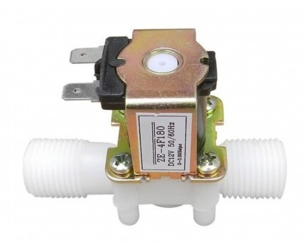

**CHAPTER THREE**

**IMPLEMENTATION**

The implementation phase involves putting the project plan into action. Development phase of this project can be divided into Two parts, Hardware connection and Coding.

**3.1 Connecting/Assemble the hardware**

The Process of Connecting the components are stated below:

1. **First we Connect RTCs SDA and SDL pin to Arduinos 12C SDA and SCL port.**
2. **Connect AO(analog output) pin of Soil Moisture sensor module to the Analog pin A0 of Arduino.**
3. **Connect VCC pin of Soil Moisture sensor module to the Digital pin 7 of Arduino.**
4. **Connect IN! pin of Relay to the Digital pin 6 of the Arduino.**
5. **Add DC socket with the 12V power Supply and connect the ground output to the COM1 (Common) port of the Relay.**
6. **Connect a wire with the NO1(Normally Open) pin of the Relay.**
7. **Insert the Data pin of Water Flow Sensor to the Digital Pin 2 of Arduino.**
8. **Insert Two Jumper Wires in 5V and GND port of the Arduino and connect all the remaining VCC and Ground of Relay, Moisture Sensor, RTC and Flow Sensor.**
9. **Place all of these components in the board/box that we made with Cocksheet and make holes for the Wire of Moisture Sensor Probe, Flow Sensor and DC Pump.**
10. **Make two more holes for DC Socket and USB Cable for the Arduino.**
11. **Connect DC pump with the Positive wire from DC Socket and Ground with the wire coming from the NO1 pin of the Relay Module.**
12. **Add a Rubber Tube from DC pump to the Inlet of Flow Sensor and another Tube in the outlet which will go to the Soil Pots.**

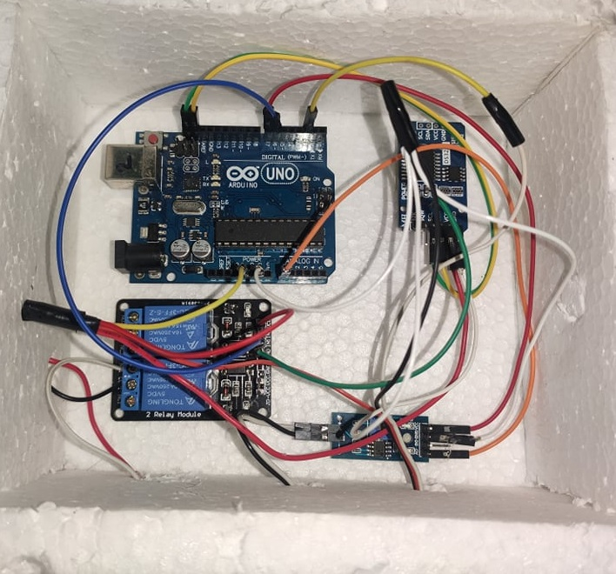

**3.2 Flow Chart**

Start

No

Is the time now morning/ evening?

Yes

Sample The Soil moisture

Calculate How much water is needed

Water the plants

No

Enough Water is Given?

Yes

Wait 5 hours

**4.3 Programming the Arduino**

1. **Import RTC DS3231 Library**



1. **Define Pin Numbers.**

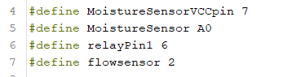

1. **Declare and Define variables**

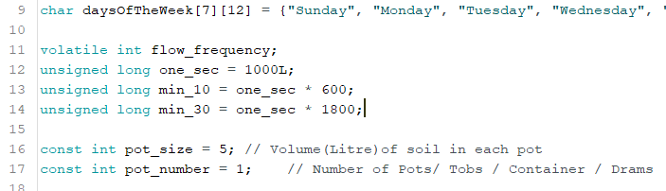

1. **Setup PinModes and RTC**

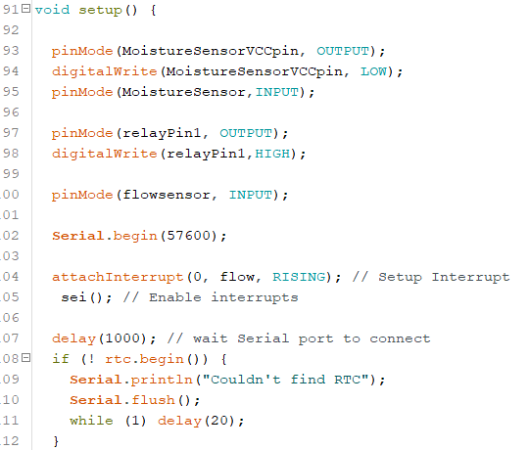

1. **Measure Soil Moisture.**

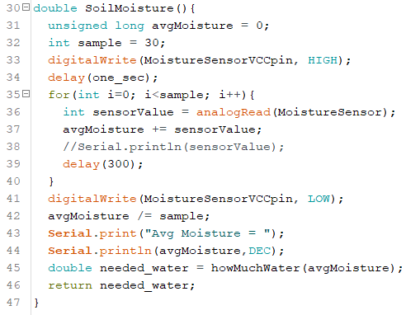

1. **Calculate the Total Amount of water needed.**

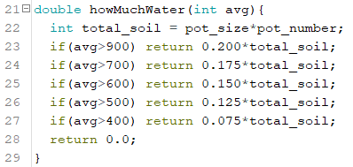

1. **Water the plants**

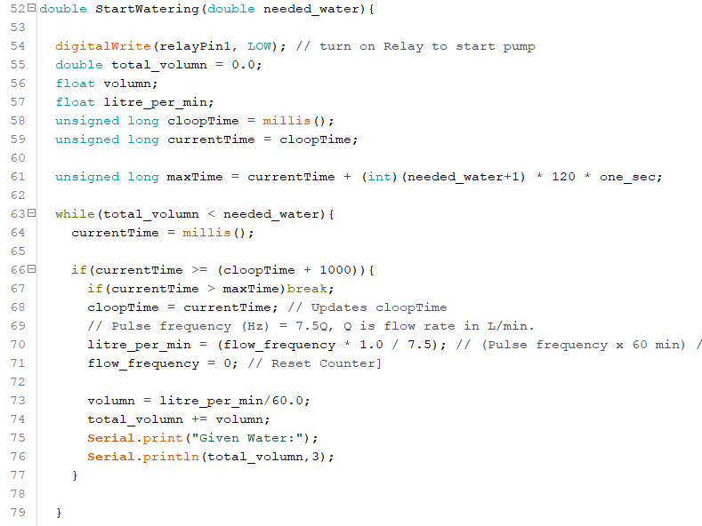

1. **Loop and check the time and call the necessary functions**

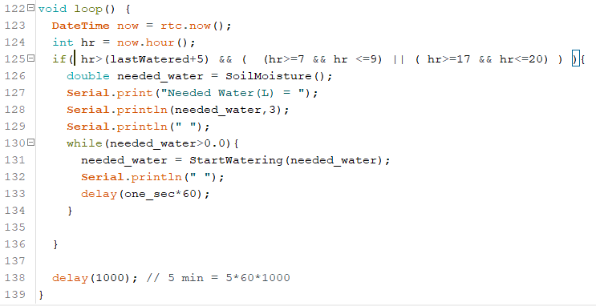

**CHAPTER FOUR**

**CONCLUSION & FUTURE SCOPE**

**4.1 Conclusion:**

The Project was running successful and showed very good result in the test run. We have made encloser for the Project and it’s a ready to use prototype.

**4.1 Future Work:**

This Project has a lot of potential and for that we have much bigger plan with this. We have to incorporate it with wifi module (esp8266) so that users can set the number of plants and the pot size from web interface and also they can check the history or watering.

We can use Weather Prediction for rain and temperature to decide the amount of water it should give.