**EAST WEST UNIVERSITY**

**CSE 435**

**PROJECT NAME: ONLINE SHOPPING [LTSA tool]**

**Mini project : 2**

**SUBMITTED TO:**

**Dr. Shamim H Ripon**

**Submitted by :**

**Md. Naimul Islam ID: 201-2-60-061**

**Anika Thasin ID: 2017-2-60-117**

**Arpa Datta ID: 2017-2-60-064**

**Project Title:** **Online Shopping**

**Project Details:**

In this project we made an online shopping system. There are 3 modules called admin panel, user login panel and customer shopping. Admin can add, delete, manages the products. A customer can login, register and buy products in the customer module.

**Sequence Diagram 1: User login**

This diagram represents the user login system. A user can visit the website then the user will request to login. A user must have to login before registration. If the information is correct only then the registration will be successful, otherwise the user will get a return message of fail registration. Then a user can update his information, if their information is correct only then update will be successful.

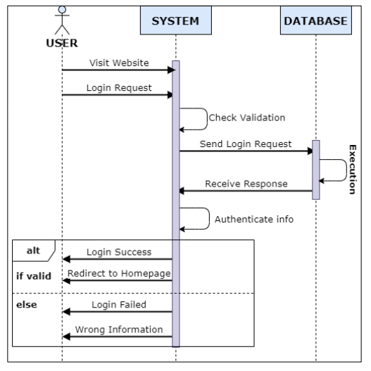

**Sequence diagram: 1**

**CODE :**

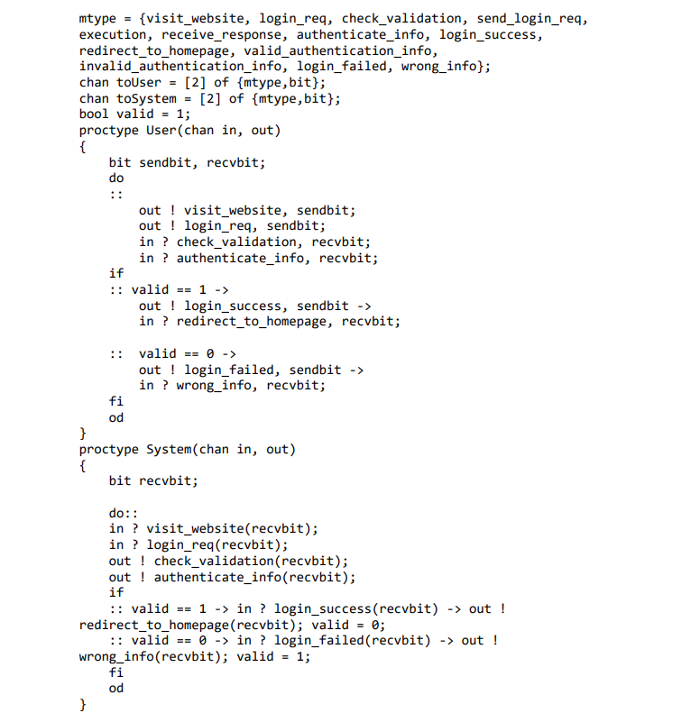

**AUTOMATA FOR USER :**

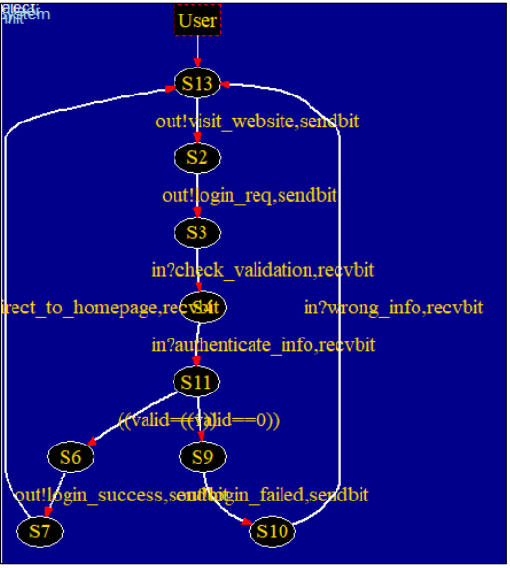

**AUTOMATA FOR SYSTEM :**

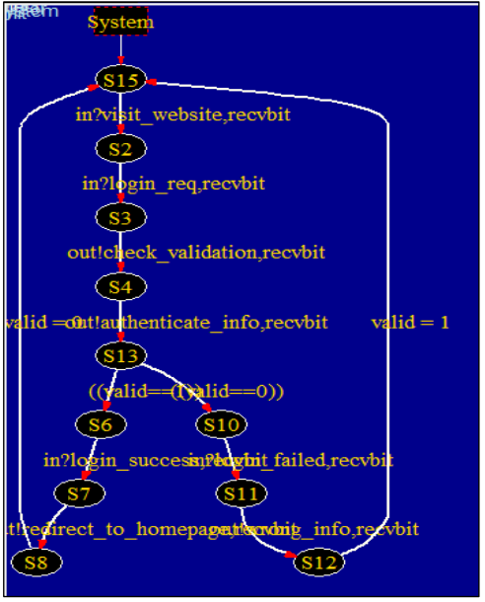

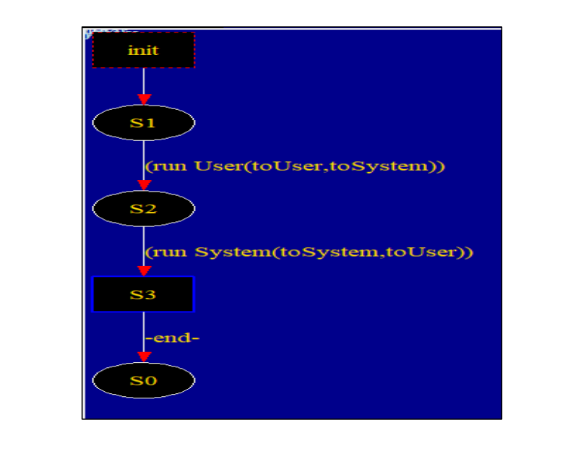

**Process Simulation:**

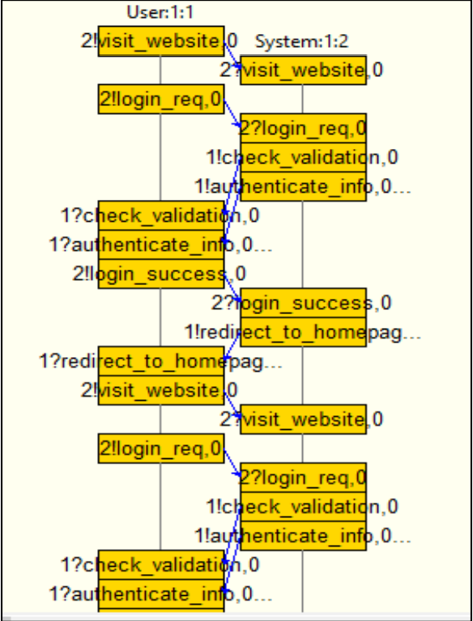

**Process console:**

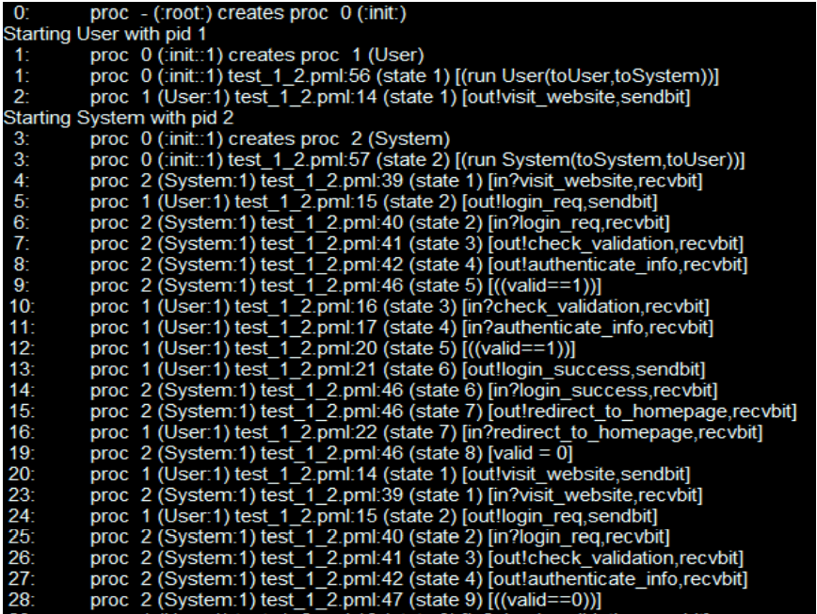

**Sequence Diagram:** **Shopping**

This diagram shows that users can borrow their necessary equipment. If the product is available then it gives a message, the user checkout that product, and the user will be connected to the homepage. If the product is not available, it gives a message the product is stock out then the user tries for another product. This information also stores in database

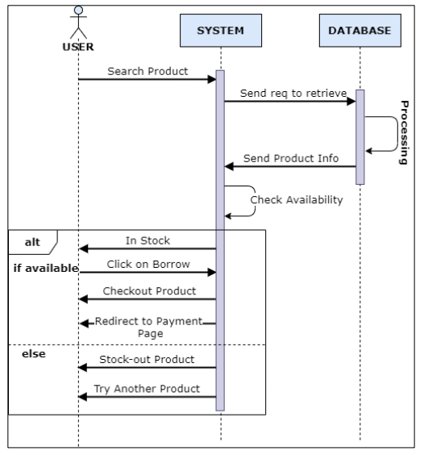

**Sequence diagram: 2**

**CODE:**

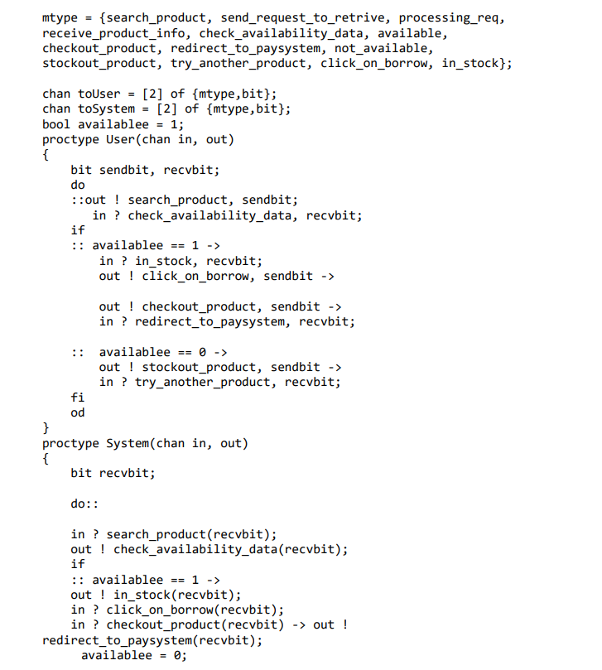

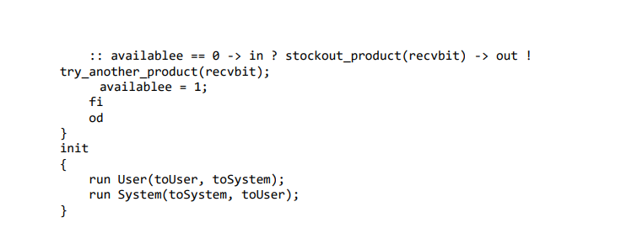

**AUTOMATA :**

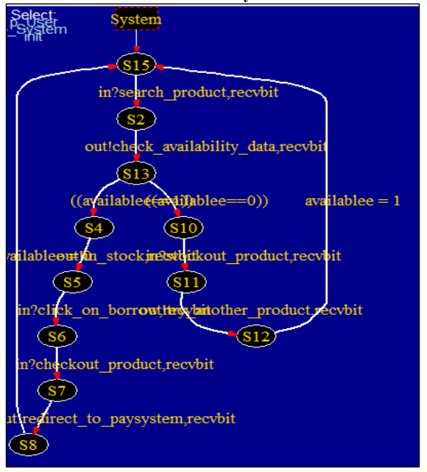

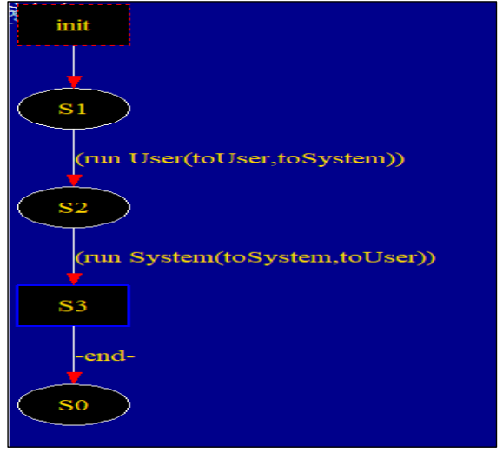

**Process Simulation:**

D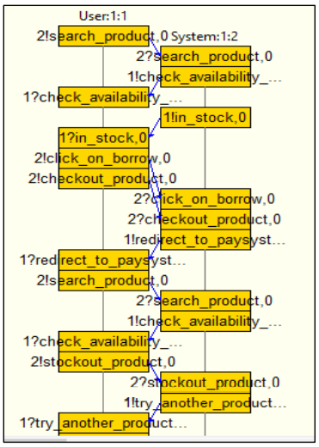

**Process console:**

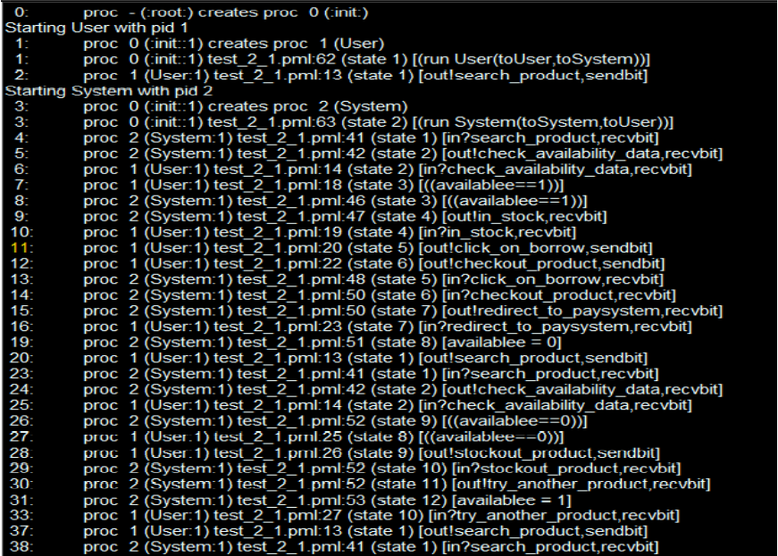

**Sequence diagram 3**: admin-login

**This sequence diagram represents the admin panel of that system. In this diagram admin also can login, reject pending product, and delete product description. This information also stores in database.**

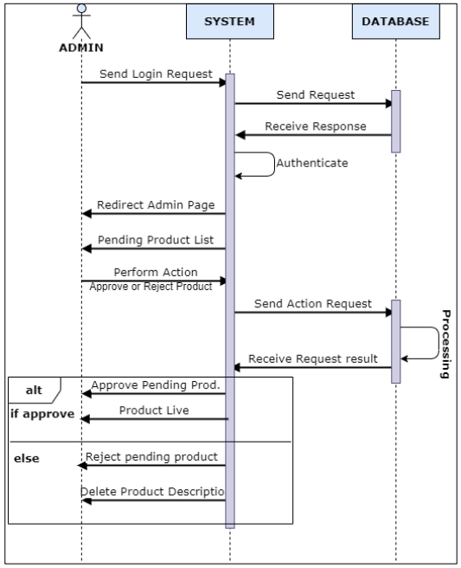

**Sequence diagram 3**

**CODE :**

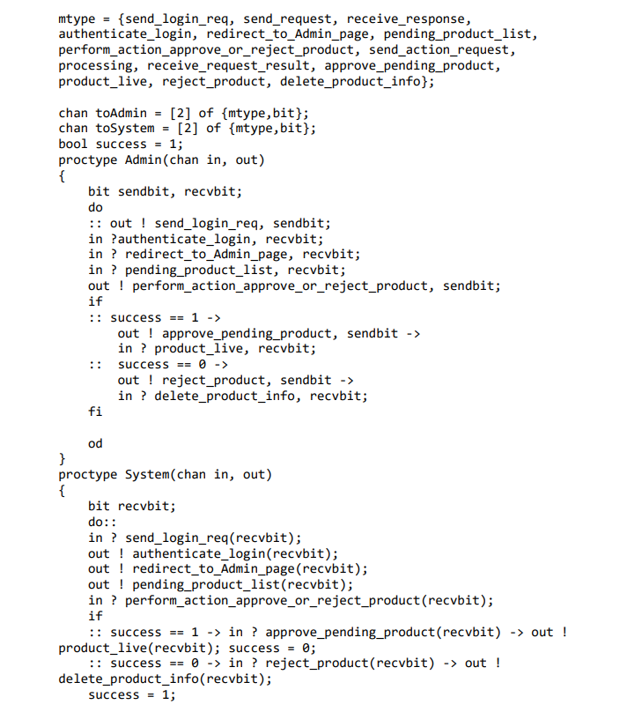

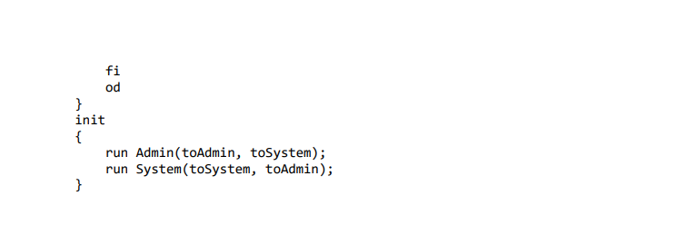

**AUTOMETA FOR USER:**

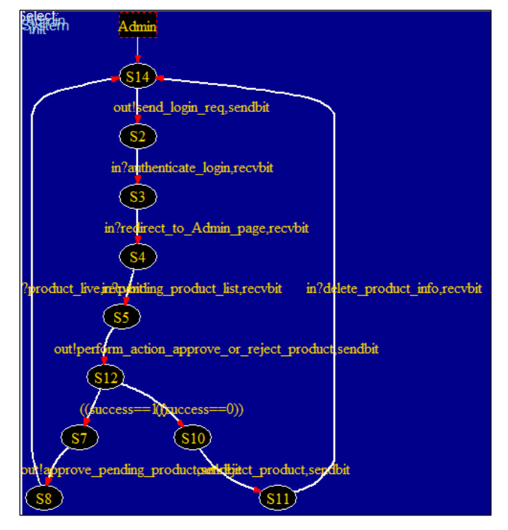

**ATOMETA FOR SYSTEM:**

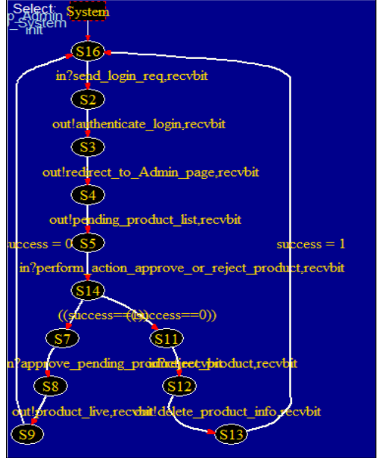

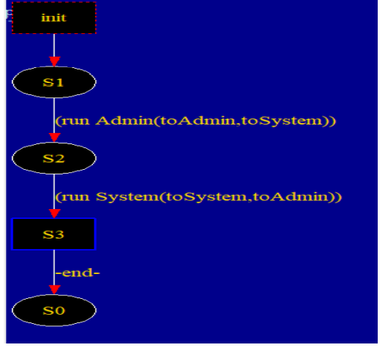

**PROCESS SIMULATION:**

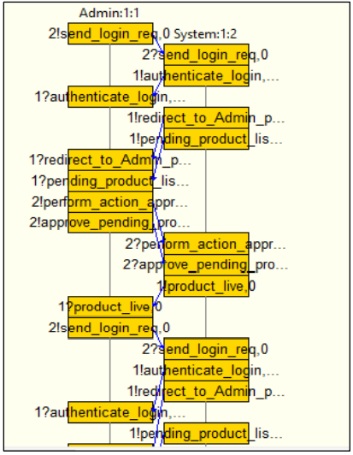

**PROCESS CONSOLE:**

