Cancer Risk Prediction System

Introduction

Cancer remains one of the most critical global health challenges, contributing significantly to morbidity and mortality worldwide. Early identification of individuals at high risk of developing cancer plays a vital role in improving survival rates and optimizing healthcare resources. With the rapid growth of digital medical records and lifestyle-related data, machine learning has emerged as a powerful tool for extracting meaningful patterns from complex datasets. By analyzing multiple risk factors simultaneously, machine learning models can support healthcare professionals in making data-driven decisions.
This project focuses on the design and development of an end-to-end cancer risk prediction system using machine learning techniques. The system analyzes demographic, lifestyle, and genetic attributes to estimate the likelihood of cancer occurrence. In addition to predictive modeling, the project emphasizes statistical validation, model optimization, real-time prediction, and deployment through an interactive web interface. The ultimate goal is to demonstrate how machine learning can be effectively integrated into healthcare applications to assist in early risk assessment and awareness.

Problem Statement
Traditional cancer risk assessment methods rely heavily on manual analysis, clinical experience, and limited rule-based systems. These approaches may be time-consuming, subjective, and unable to fully capture complex relationships among multiple risk factors. There is a need for an automated, scalable, and data-driven system that can evaluate cancer risk efficiently and consistently.
The problem addressed in this project is the absence of a simple and accessible predictive system that leverages historical health and lifestyle data to estimate cancer risk accurately.

Proposed System
The proposed system is a machine learning-based cancer risk prediction platform that processes patient-related data and predicts the likelihood of cancer. The system integrates data preprocessing, statistical analysis, multiple machine learning models, and a user-friendly web interface. A trained and optimized model is saved using pickling techniques and reused for real-time predictions. The system allows users to input patient details and instantly receive prediction results along with probability scores.

Advantages of the Proposed System
- Provides fast and automated cancer risk prediction
- Reduces dependency on manual assessment
- Supports early awareness and preventive decision-making
- Handles multiple risk factors simultaneously
- User-friendly and accessible through a web interface
- Scalable and reusable through model serialization (pickling)

System Design
The system follows a modular architecture:
User Input → Preprocessing → ML Model → Prediction → Output
Each component operates independently, ensuring maintainability and scalability.

Dataset
- The dataset used in this project was downloaded from Kaggle, a popular open-source data science platform. It contains structured medical and lifestyle-related data suitable for supervised machine learning classification tasks. Click here to visit Kaggle
- The Characteristics of dataset is Combination of numerical and categorical features. Labelled target variable for supervised learning.
- Features Used
  - Age
  - Body Mass Index (BMI)
  - Gender
  - Smoking status
  - Cancer history
  - Genetic risk level
  - Alcohol intake per week
  - Physical activity hours per week
- Target Variable
  - Diagnosis: 0 – No Cancer, 1 – Cancer
Age | Gender | BMI | Smoking | GeneticRisk | Physical Activity | Alcohol_Intake | CancerHistory | Diagnosis
58 | 1 | 16.085313 | 0 | 1 | 8.146251 | 4.148219 | 1 | 1
71 | 0 | 30.8287 | 0 | 1 | 9.361630 | 3.51983 | 0 | 0
48 | 1 | 38.7850 | 0 | 2 | 5.135179 | 4.728368 | 0 | 0
32 | 0 | 30.040296 | 0 | 0 | 9.502792 | 2.044636 | 0 | 0
… | … | … | … | … | … | … | … | …
61 | 1 | 23.663104 | 0 | 0 | 2.525860 | 2.856600 | 1 | 0
1500 rows × 9 columns

Meta Data
- Age: Integer values representing the patient's age, ranging from 20 to 80.
- Gender: Binary values representing gender, where 0 indicates Male and 1 indicates Female.
- BMI: Continuous values representing Body Mass Index, ranging from 15 to 40.
- Smoking: Binary values indicating smoking status, where 0 means No and 1 means Yes.
- GeneticRisk: Categorical values representing genetic risk levels for cancer, with 0 indicating Low, 1 indicating Medium, and 2 indicating High.
- PhysicalActivity: Continuous values representing the number of hours per week spent on physical activities, ranging from 0 to 10.
- Alcohol_Intake: Continuous values representing the number of alcohol units consumed per week, ranging from 0 to 5.
- CancerHistory: Binary values indicating whether the patient has a personal history of cancer, where 0 means No and 1 means Yes.
- Diagnosis: Binary values indicating the cancer diagnosis status, where 0 indicates No Cancer and 1 indicates Cancer.

Methodologies
The project follows a systematic machine learning workflow:
- Data loading and inspection
- Exploratory Data Analysis (EDA)
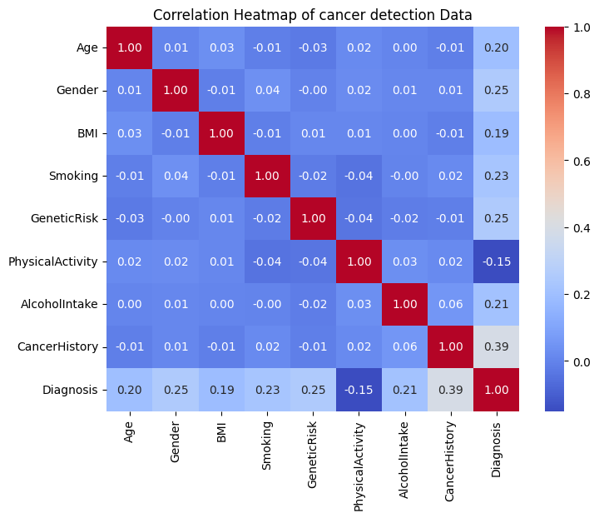
- Statistical hypothesis testing
- For statistical hypothesis testing used The Chi-Square (χ²) test (a non-parametric statistical tool used for categorical data to determine if there's a significant relationship between variables or if observed frequencies match expected ones)
- Model training and selection
- Logistic Regression
- Decision Tree Classifier
- Random Forest Classifier
- Model evaluation
- Model serialization (pickling)
- Deployment using a web interface

Model Training and Testing
Multiple machine learning models were trained and tested to identify the most suitable approach:
- Logistic Regression (baseline and interpretable model)
- Decision Tree Classifier (rule-based model)
- Random Forest Classifier (ensemble model)
The dataset was split into training and testing sets using an 80:20 ratio with stratification to preserve class distribution. The Random Forest model was selected as the final model due to its superior performance and ability to capture non-linear relationships among features.

Evaluation Metrics
The performance of the models was evaluated using the following metrics:
- Accuracy
- Precision
- Recall
- F1-score
- Confusion Matrix
- Cross-validation F1-score
Special emphasis was placed on recall to minimize false negatives due to the medical nature of the problem.

System Requirements
Hardware Requirements
- Processor: Intel i3 or higher
- RAM: Minimum 8 GB
- Storage: 5 GB free disk space
Software Requirements
- Operating System: Windows / Linux / macOS
- Python 3.8 or above
- Web browser (Chrome / Edge / Firefox)
Required Modules
The following software modules and libraries are required to develop, train, deploy, and run the Cancer Risk Prediction System:
- NumPy
- Pandas
- Matplotlib (Used for plotting graphs and visualizing data distributions)
- Seaborn (Used for statistical visualizations such as heatmaps and categorical plots.)
- Scikit-learn
Used for:
- Data preprocessing (LabelEncoder, StandardScaler)
- Model training (Logistic Regression, Decision Tree, Random Forest)
- Model evaluation (accuracy, confusion matrix, classification report)
- Cross-validation
- Pickle (Used to serialize (save) and deserialize (load) the trained machine learning model and preprocessing objects.)

Technology Used for Deployment
The system is deployed using modern cloud-based tools:
- Streamlit for web application development
- GitHub for version control and code hosting
- Streamlit Cloud for cloud deployment

Frontend UI
The frontend is developed using Streamlit, providing an interactive and intuitive interface. Users can input patient information through form fields and receive instant predictions. The interface clearly displays results and probability scores, making the system suitable for demonstration and academic evaluation Click here for Streamlit.

Results
The final Random Forest model achieved satisfactory performance with balanced accuracy and F1-score. The system demonstrated reliable predictions for both cancer and non-cancer cases. Cross-validation confirmed the stability and robustness of the model. The deployed application successfully provides real-time predictions based on user input.
OUT PUT:
===== Logistic Regression =====
Training Accuracy: 0.855
Testing Accuracy: 0.843
===== Decision Tree =====
Testing Accuracy: 0.827
Confusion Matrix:
[[170 19]
[ 33 78]]
===== Random Forest =====
Accuracy: 0.94
Confusion Matrix:
[[184 5]
[ 13 98]]
Random Forest CV F1 - score: 0.89
===== User Input Prediction =====
⚠️ Cancer Detected (Probability: 0.79)
The Cancer Risk Prediction System was successfully implemented, evaluated, and deployed as a web-based application. The project demonstrates an end-to-end machine learning pipeline, starting from data analysis to real-time prediction through a deployed user interface.
GitHub Repository
All project files, including source code, model files, and README, are hosted on GitHub for transparency and reproducibility.
GitHub Repository Link: https://github.com/naimullah123/cancer-risk-prediction-app
Live Application Link
The application has been deployed on Streamlit Cloud and is publicly accessible.
Live Application URL:
🌐 https://cancer-risk-prediction-app-ks5um9tuvgubcfl9opxc9y.streamlit.app/

Conclusion
This project successfully demonstrates the implementation of an end-to-end machine learning system for cancer risk prediction. By combining statistical analysis, machine learning models, model serialization, and web deployment, the system offers a practical and scalable solution. The project highlights the potential of machine learning in healthcare applications and serves as a strong foundation for further research and real-world deployment.

