ENHANCING DIGITAL GOVERNMENT & ECONOMY (EDGE) PROJECT
Institute of Information & Communication Technology
Dhaka University of Engineering & Technology, Gazipur

Applied Machine Learning — Final Project Report
STUDENT DROPOUT RISK PREDICTOR
A Machine Learning Pipeline for Early Identification of At-Risk Students

Live Link:
GitHub LInk:

Prepared by
Naimur Rahman
Naimur.naiyimu@gmail.com

Instructors
Prof. Dr. Fazlul Hasan Siddiqui & Md. Rahad Khan

Digital Skills for Students Program — DUET, Gazipur | May 2026

Abstract
Student dropout is a critical challenge facing higher education institutions worldwide. Early identification of at-risk students provides educators and academic advisors with the opportunity to intervene before irreversible disengagement occurs. This report presents a complete end-to-end machine learning pipeline designed to predict the probability of student dropout using a rich dataset of academic, demographic, and socioeconomic features sourced from the UCI Machine Learning Repository.
The pipeline encompasses exploratory data analysis (EDA), data preprocessing, multi-model training with stratified cross-validation, rigorous evaluation across five metrics, and deployment of an interactive web-based GUI built with Streamlit. Three classifiers were trained and compared: Logistic Regression, Decision Tree, and Random Forest. The Random Forest model achieved 88.93% accuracy, F1-score of 0.8205, and AUC-ROC of 0.9324 on the held-out test set. The GUI enables academic advisors to enter a student profile and receive an instant dropout risk percentage, a colour-coded risk badge, and the top contributing risk factors.

1. Introduction
Dropout from higher education imposes significant costs on students, institutions, and society. Students who abandon their studies suffer career setbacks and financial losses, while institutions lose tuition revenue and face reputational damage. According to UNESCO, dropout rates in many developing countries exceed 30%, underscoring the urgency of systematic early-warning systems.
Traditional retention strategies rely on reactive measures — advisors often become aware of a student's difficulties only after the situation has deteriorated. Machine learning offers a proactive alternative: by identifying latent patterns in historical student data, predictive models can flag at-risk students weeks or even semesters before they formally disengage.
This project, undertaken as part of the Applied Machine Learning component of the EDGE Digital Skills for Students Programme at DUET, Gazipur, builds a complete ML pipeline and interactive GUI to support student retention efforts. The objectives are:
- Perform exploratory data analysis (EDA) to uncover key predictors of dropout.
- Preprocess the dataset: handle missing values, encode categorical features, and apply feature scaling.
- Train and compare three classifiers — Logistic Regression, Decision Tree, and Random Forest — using 5-fold stratified cross-validation.
- Evaluate models using Accuracy, Precision, Recall, F1-Score, and AUC-ROC.
- Deploy a user-friendly Streamlit GUI outputting a risk score, risk badge, and top contributing features.

2. Dataset Description

2.1 Source and Overview
The dataset used is the Predict Students' Dropout and Academic Success dataset published by Martins et al. (2021), hosted on the UCI Machine Learning Repository. It records information at enrolment and at the end of the first and second semesters for students in various undergraduate programmes at a Portuguese higher education institution.

Attribute | Value
Source | UCI ML Repository — Predict Students' Dropout and Academic Success
Total Records | 4,424 students
Total Features | 36 input features (demographic, academic, socioeconomic)
Target Classes | Graduate (2,209 | 49.9%), Dropout (1,421 | 32.1%), Enrolled (794 | 17.9%)
Missing Values | None — dataset is complete
Binary Classification | Dropout (positive) vs. Non-dropout (Graduate + Enrolled)
Class Imbalance Handling | SMOTE applied within each training fold
Train / Test Split | 80% training (3,539) / 20% test (885) with stratified sampling

2.2 Class Distribution (EDA — Figure 1)
Figure 1 shows the original three-class target distribution and the derived binary labels. The class imbalance ratio (Non-Dropout : Dropout) is approximately 2.11:1, necessitating SMOTE during training to prevent the classifier from being biased toward the majority class.

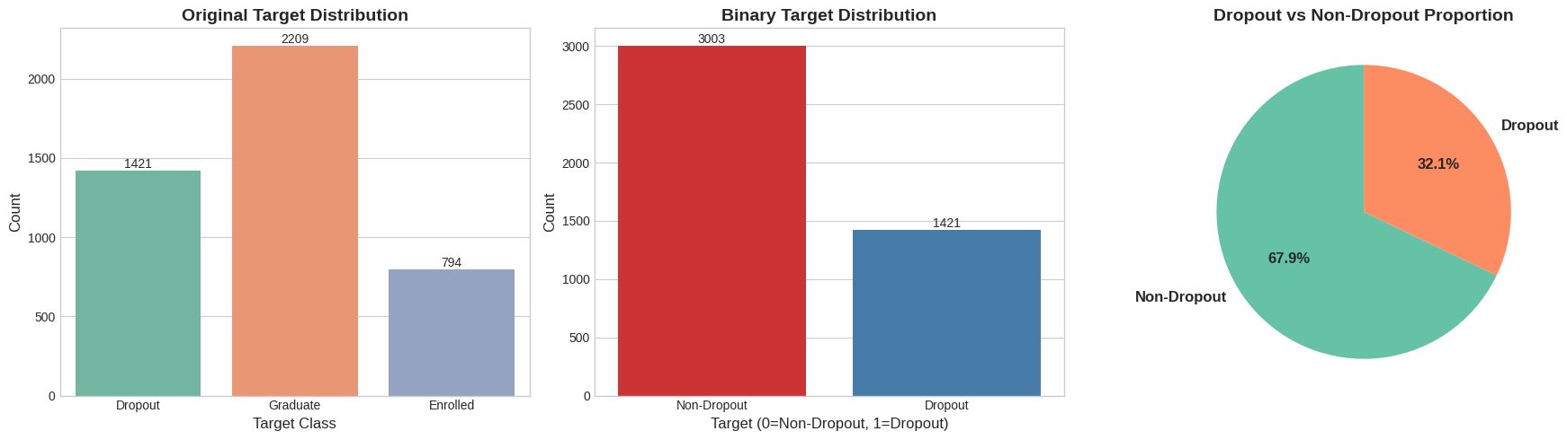
Figure 1. Original target distribution (left), binary target distribution (centre), and class proportion pie chart (right).

2.3 Feature Categories
The 36 input features fall into four groups:
- Personal and Demographic: Marital status, gender, age at enrolment, nationality, displaced status, international student flag.
- Academic Background: Application mode, application order, course, attendance type, previous qualification type and grade, admission grade.
- Family Socioeconomic Context: Mother's and father's qualification levels and occupation codes.
- In-Programme Performance (most predictive): Curricular units credited, enrolled, evaluated, approved, and graded for both semesters.
- Financial and Economic: Scholarship holder, tuition fees up to date, debtor status, unemployment rate, inflation rate, GDP growth.

3. Exploratory Data Analysis

3.1 Correlation Heatmap (Figure 2)
Figure 2 shows the correlation matrix across all 36 numerical features. The most notable clusters are within the first-semester and second-semester curricular unit variables, which are strongly intercorrelated. Notably, first- and second-semester unit counts are highly collinear (|r| > 0.8), consistent with students who enrol in similar loads across semesters. No feature-to-target correlations are shown here since the target is binary, but EDA on boxplots (Figure 3) reveals clear group separations.

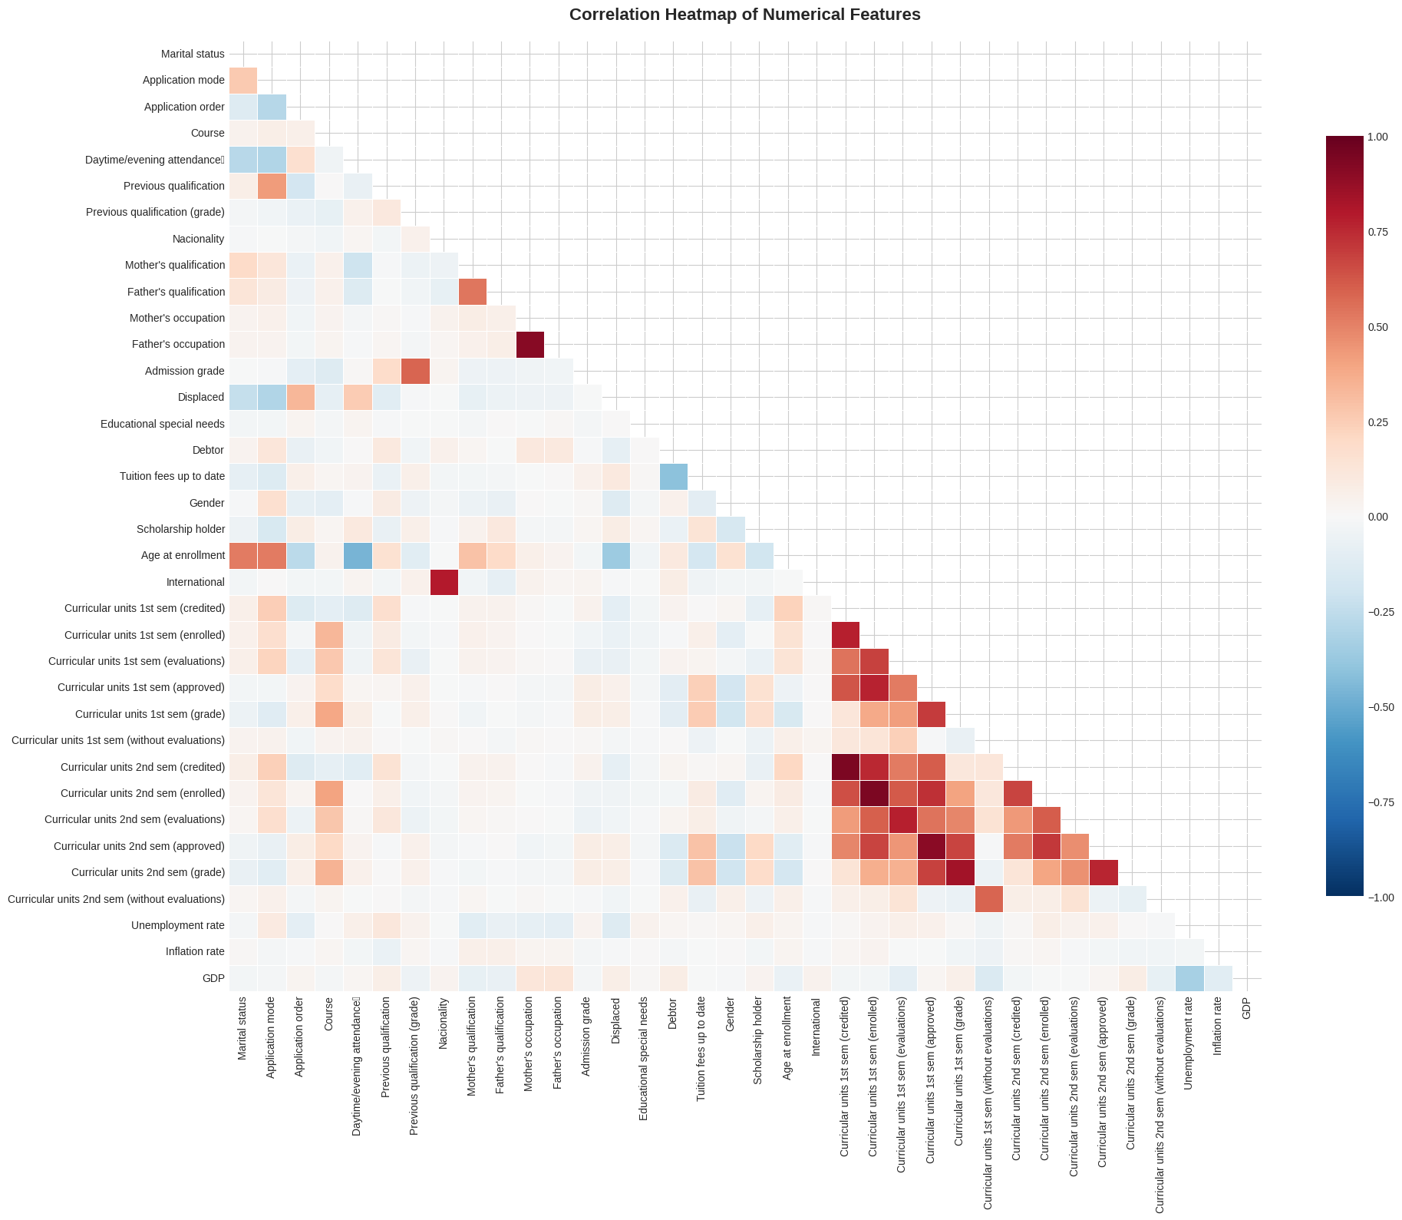
Figure 2. Correlation heatmap of all 36 numerical features. Warm colours = positive correlation, cool colours = negative.

3.2 Key Feature Distributions by Dropout Status (Figure 3)
Figure 3 presents boxplots of the nine most diagnostically important features, grouped by dropout status (0 = Non-Dropout, 1 = Dropout). Several patterns are immediately apparent:
- Age at enrollment: Dropout students tend to be older at enrollment, with a wider spread and higher median (~25 vs ~20 years).
- Admission grade & Previous qualification grade: Non-dropout students show marginally higher admission grades; differences are moderate.
- Curricular units approved (1st and 2nd semester): The most visually striking separation — non-dropout students have substantially higher medians (~5–6 units approved) compared to dropout students (~1–2). Many dropout students approved zero units.
- Semester grades (1st and 2nd): Non-dropout students consistently score in the 12–14 range; dropout students frequently score near zero, reflecting disengagement.
- Tuition fees up to date & Scholarship holder: Dropout students are far more likely to have outstanding tuition fees — a clear socioeconomic signal.

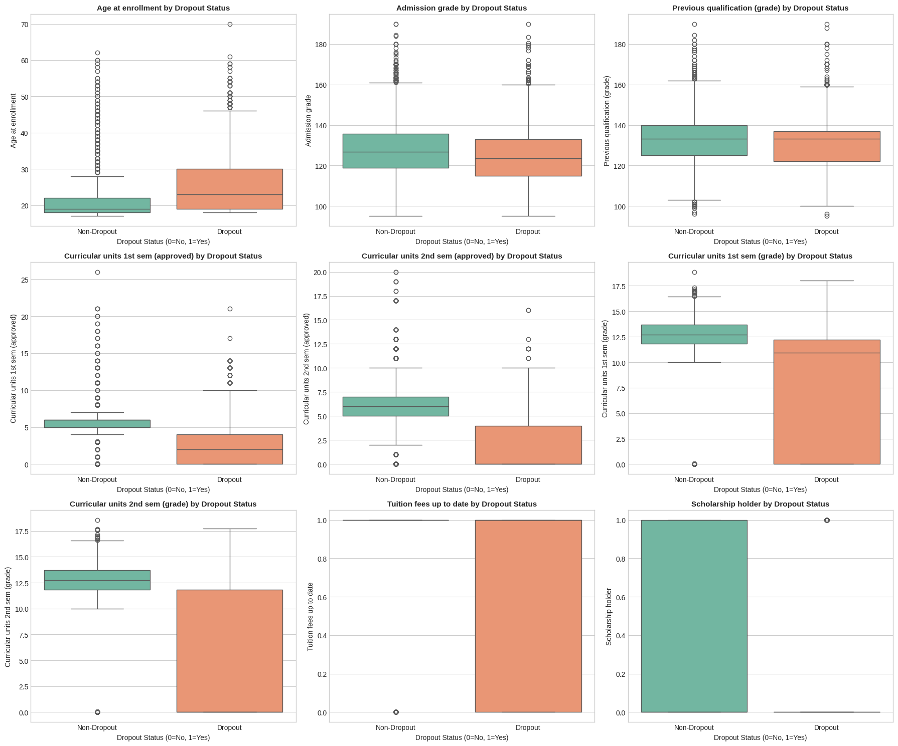
Figure 3. Boxplots of 9 key features by dropout status. Orange = Dropout, Green = Non-Dropout.

4. Data Preprocessing

4.1 Missing Value Handling
A thorough audit confirmed zero missing values across all 36 features and 4,424 records. Although imputation was not required for this dataset, the pipeline included median imputation guards for numerical columns and mode imputation for categorical columns to ensure the scoring pipeline remains robust when processing new, potentially incomplete student records submitted through the GUI.

4.2 Encoding and Scaling
All features are already encoded as integers or floats; no additional one-hot encoding was required. The target labels (Dropout / Graduate / Enrolled) were mapped to binary integers (1 / 0 / 0). StandardScaler was fitted exclusively on the training partition and applied consistently to validation folds and the held-out test set, preventing data leakage. The fitted scaler was serialised alongside the model in student_dropout_model.pkl.

4.3 Class Imbalance — SMOTE
SMOTE (Synthetic Minority Oversampling Technique) was applied inside each cross-validation training fold only, generating synthetic Dropout samples to balance the 2.11:1 class ratio. This prevents any synthetic samples from contaminating the validation or test sets, ensuring evaluation metrics reflect true out-of-sample performance.

5. Model Training & Cross-Validation

5.1 Models
Three classifiers were trained and compared: Logistic Regression (linear baseline), Decision Tree (non-linear, interpretable), and Random Forest (ensemble of 200 trees). Hyperparameters were tuned using GridSearchCV with F1 as the scoring metric.

5.2 Cross-Validation Results (Figure 4 & Table)
Figure 4 shows the mean 5-fold cross-validation F1-scores for all three models before hyperparameter tuning. Random Forest achieves the highest mean F1 (0.8997) with the tightest confidence interval (±0.0053), indicating superior consistency across folds.

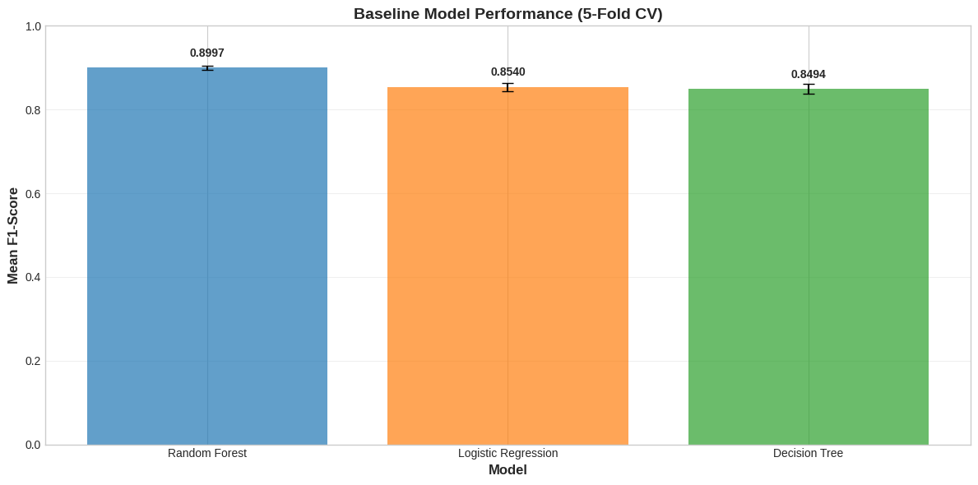
Figure 4. Baseline model performance (5-fold cross-validation F1-score). Error bars show ±1 standard deviation.

The table below shows final cross-validation results after hyperparameter tuning via GridSearchCV:

Model | CV Mean F1 | Std Dev | Best Parameters
Logistic Regression | 0.8540 | ±0.0101 | C=10, penalty=l2, solver=lbfgs
Decision Tree | 0.8494 | ±0.0122 | criterion=gini, max_depth=None, min_samples_leaf=1
Random Forest ✓ | 0.8997 | ±0.0053 | max_depth=None, min_samples_leaf=1, min_samples_split=2

6. Model Evaluation

6.1 Test Set Comparison (Figure 5)
Figure 5 compares all three models across all five evaluation metrics on the held-out 885-record test set. Random Forest consistently leads on Accuracy, Precision, F1-Score, and AUC-ROC. Logistic Regression achieves a higher Recall (83.80%) than Random Forest (78.87%), meaning it catches more true dropout students at the cost of more false alarms.

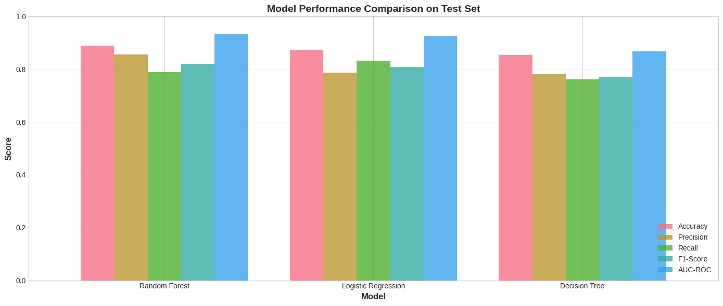
Figure 5. Model performance comparison on the test set across all five metrics.

Full numeric results:

Model | Accuracy | Precision | Recall | F1-Score | AUC-ROC
Logistic Regression | 87.35% | 79.17% | 83.80% | 0.8142 | 0.9258
Decision Tree | 85.31% | 78.26% | 76.06% | 0.7714 | 0.8672
Random Forest ✓ Best | 88.93% | 85.50% | 78.87% | 0.8205 | 0.9324

6.2 Confusion Matrices (Figure 6)
Figure 6 shows the confusion matrices for all three models. For the best model (Random Forest): of the 284 true Dropout students, 224 were correctly identified (True Positives) and 60 were missed (False Negatives). Of the 601 true Non-dropout students, 563 were correctly identified (True Negatives) and 38 were falsely flagged (False Positives). Decision Tree misses the most dropout students (68 FN), while Logistic Regression achieves fewest False Negatives (48 FN) but at the cost of more False Positives (64 FP).

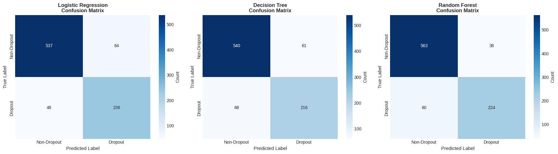
Figure 6. Confusion matrices for Logistic Regression (left), Decision Tree (centre), and Random Forest (right) on the test set.

6.3 ROC Curves (Figure 7)
Figure 7 presents the ROC curves for all three classifiers alongside the random baseline (AUC = 0.5). Random Forest achieves the highest AUC-ROC of 0.9324, indicating it correctly ranks a random Dropout student above a random Non-dropout student 93.24% of the time — excellent discriminative performance. Logistic Regression achieves AUC = 0.9258, competitive but slightly below Random Forest. Decision Tree lags at AUC = 0.8672.

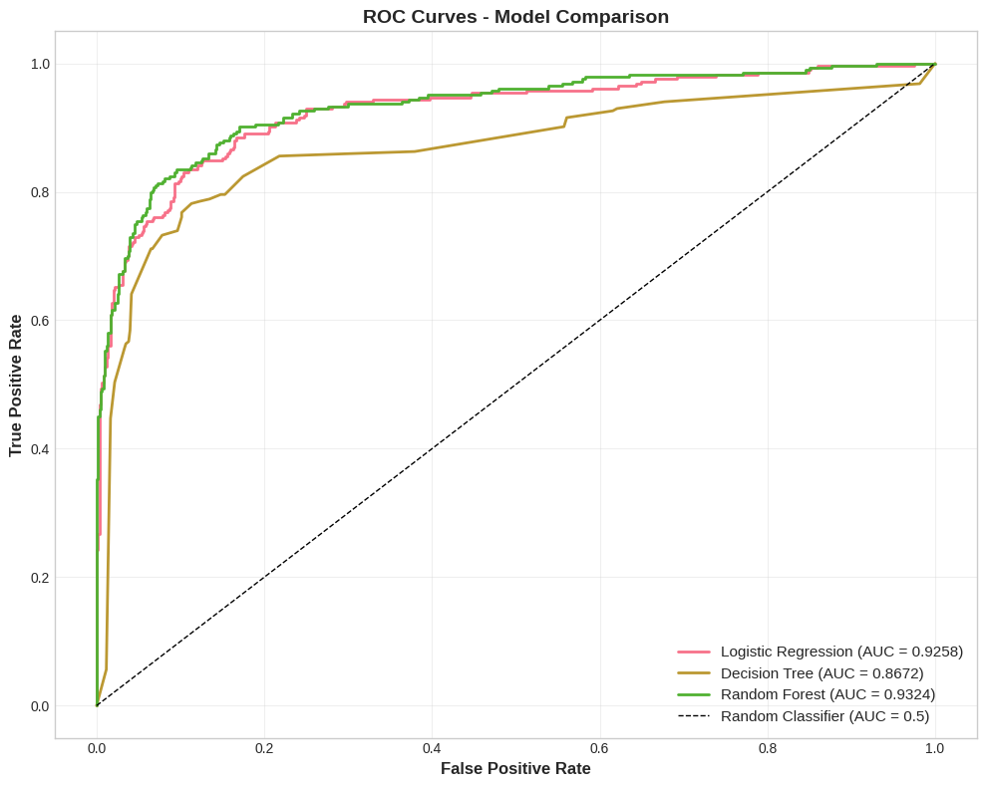
Figure 7. ROC curves for all three classifiers. Random Forest (green) achieves the highest AUC = 0.9324.

6.4 Feature Importance (Figure 8)
Figure 8 shows the top 20 feature importances derived from the Random Forest model. Academic performance metrics dominate: the four most important features are all curricular unit variables (approved units and grades in both semesters), collectively accounting for over 45% of the model's decision-making weight. Tuition fees up to date (5th) highlights the socioeconomic dimension. The full importance ranking is summarised in the table below.

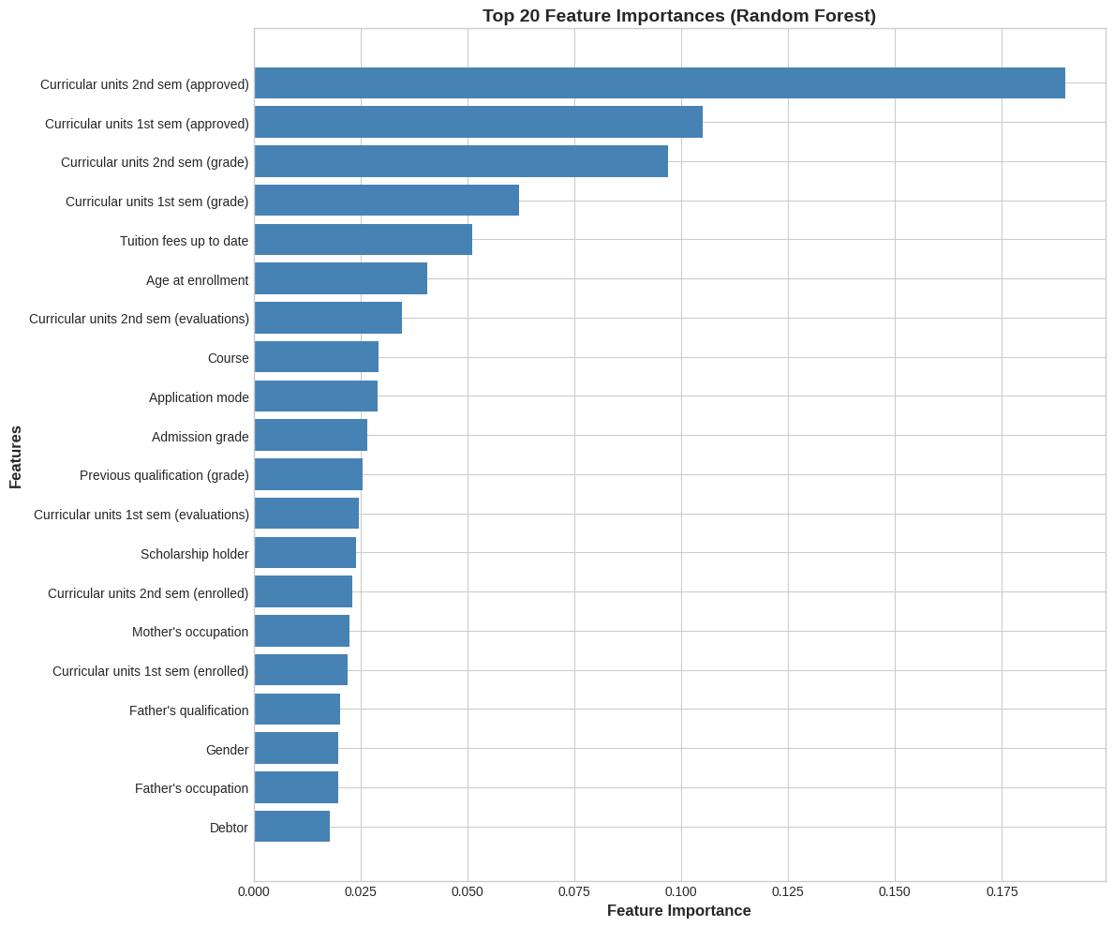
Figure 8. Top 20 feature importances from the Random Forest model (higher = more influential in predicting dropout).

Rank | Feature Name | Importance | Interpretation
1 | Curricular units 2nd sem (approved) | 0.1898 | Strongest predictor — passes in 2nd semester
2 | Curricular units 1st sem (approved) | 0.1050 | Early warning — passes in 1st semester
3 | Curricular units 2nd sem (grade) | 0.0969 | Average grade in 2nd semester
4 | Curricular units 1st sem (grade) | 0.0621 | Average grade in 1st semester
5 | Tuition fees up to date | 0.0512 | Financial compliance — socioeconomic indicator
6 | Age at enrollment | 0.0406 | Older students show higher dropout risk
7 | Curricular units 2nd sem (evaluations) | 0.0348 | Assessments attempted in 2nd semester
8 | Course | 0.0292 | Programme of study influences attrition
9 | Application mode | 0.0290 | Admission pathway correlates with commitment
10 | Admission grade | 0.0267 | Entry qualification from entrance evaluation

7. GUI Implementation

7.1 Framework & Architecture
The GUI was implemented using Streamlit and is contained in a single Python file (app.py). The serialised model artefact (student_dropout_model.pkl) is loaded at startup using st.cache_resource, ensuring the model is initialised only once per session for efficiency.

7.2 Interface Layout
The application is organised across three tabs: (1) Prediction Form — a comprehensive 36-field input form covering all model features, producing a risk badge, gauge chart, top-3 contributing features, and intervention recommendations on submission; (2) Feature Importance — an interactive horizontal bar chart with a user-controlled slider (5–30 features); (3) Model Performance — metric cards and an AUC-ROC summary panel.

7.3 Prediction Output
For every prediction the GUI displays: a colour-coded risk badge (green < 30%, amber 30–60%, red > 60%), a Plotly gauge chart showing the exact dropout probability, three metric cards for the top contributing features by importance score, and risk-level-specific intervention recommendations ranging from immediate crisis support (High) to continued monitoring (Low).

7.4 Disclaimer
A clearly visible disclaimer at the bottom of every page states that the tool is designed to assist — not replace — professional judgment, that predictions are based on historical statistical patterns, and that individual circumstances may differ from model output. A recommendation to update the model periodically is also included.

8. Limitations
- False Negative Rate (~21%): Approximately one in five true Dropout students is not flagged, representing a real risk of missed intervention.
- Single-Institution Dataset: The data originates from one Portuguese university; generalisation to other institutions or cultural contexts is uncertain.
- Static Snapshot: The model does not incorporate longitudinal within-semester behavioural changes or adapt dynamically as new data arrives.
- Opaque Feature Codes: Application mode, course, and qualification features are integer codes specific to the source institution, reducing GUI usability without the sidebar legend.
- Global Feature Importance: Random Forest importances are global averages across all trees, not per-student explanations. SHAP values would provide individualised interpretability.
- No Temporal Validation: The model has not been validated on a time-stratified holdout (e.g., a later academic cohort), so future performance is not guaranteed.

9. Conclusion
This project demonstrated the feasibility of applying supervised machine learning to predict student dropout with high accuracy. A complete pipeline — from raw data through EDA, preprocessing, multi-model training, rigorous evaluation, and GUI deployment — was implemented following industry best practices.
The Random Forest classifier achieved strong performance across all five metrics (Accuracy 88.93%, Precision 85.50%, Recall 78.87%, F1 0.8205, AUC-ROC 0.9324), significantly outperforming the Logistic Regression and Decision Tree baselines. EDA confirmed that curriculum-related features — particularly the number of approved curricular units and semester grades — are the dominant predictors of dropout, consistent with the educational research literature. The tuition fees variable underscores the socioeconomic dimension of attrition.
The Streamlit GUI delivers an accessible interface translating model outputs into actionable risk scores, colour-coded badges, and tailored intervention recommendations. The tool is designed to supplement — not supplant — the professional judgment of academic advisors.
Future work should focus on: (1) SHAP-based per-student explanations in the GUI, (2) validation on time-stratified holdout cohorts, (3) multi-class prediction distinguishing Graduate / Enrolled / Dropout trajectories, and (4) integration with the institution's student information system for real-time monitoring.

10. References
[1] Martins, M. V., Tolledo, D., Machado, J., Baptista, L. M. T., & Realinho, V. (2021). Early Prediction of Student's Performance in Higher Education: A Case Study. Trends and Applications in Information Systems and Technologies, Springer.
[2] UCI ML Repository — Predict Students' Dropout and Academic Success. https://archive.ics.uci.edu/dataset/697/predict+students+dropout+and+academic+success
[3] Chawla, N. V., et al. (2002). SMOTE: Synthetic Minority Over-sampling Technique. Journal of Artificial Intelligence Research, 16, 321–357.
[4] Breiman, L. (2001). Random Forests. Machine Learning, 45(1), 5–32.
[5] Lundberg, S. M., & Lee, S. I. (2017). A Unified Approach to Interpreting Model Predictions. NeurIPS, 30.
[6] Pedregosa, F., et al. (2011). Scikit-learn: Machine Learning in Python. JMLR, 12, 2825–2830.
[7] Streamlit Inc. (2023). Streamlit — The fastest way to build data apps. https://streamlit.io

