

Mobile SDK Specifications for Android
(Version 4.0)

MOLPay Sdn Bhd (948015-X)
B-13-3A, Jalan Multimedia 7/AH,
CityPark, i-City, 40000 Shah Alam,
Selangor Darul Ehsan, Malaysia.
 | +603-55218438  +603-55218437  sales@molpay.com  www.molpay.com
Table of Contents

1. Prerequisite 2
2. System Requirements 2
3. MOLPay Android Payment Library 2
3.1 Payment Flow Error! Bookmark not defined.
3.2 Declaring Permissions in AndroidManifest.xml 3
3.3 Adding the Library and Importing Classes 3
3.4 Listing Payment Channels 3
3.5 Initiate the payment (sending payment request) 4
3.6 Payment Result (Auto-return Payment Status) 5
3.7 Payment Result (Manual Payment Status Request) 5

Prerequisite
Please provide below information to verify merchant identity from MOLPay Server in order for merchant’s app to use the payment channel:

- merchant ID
- verify key
- appname
- username
- password

All the values above are in one word without whitespace.
The information should be submitted to MOLPay support team and the email address is support@molpay.com

System Requirements
- Minimum required android OS vesion: 2.3
- Internet Connection is essential for the MOLPay SDK to successfully connected with the MOLPay API

MOLPay Android Payment Library
This section explains details about the library API, and it explains the instructions and example to be follow to develop an Android apps that using mobile payment channel.

The information should be submitted to MOLPay support team and the email address is support@molpay.com

How the Library Works
The flow of the library is as below:
- Library is in JAR format;
- Initiate the library;
- Merchant app to pass buyer’s information to the SDK library and will be sent to MOLPay server;
- After payment is completed, MOLPay will return the result for transaction id and payment status;
- Library will return the result back to application.

Declaring Permissions and Activity in AndroidManifest.xml
To use the payment channel, Internet Permission is required for the application to avoid any error during payment make.

3.2.1 Declaring Permission
<uses-permission android:name=”android.permission.INTERNET”/>

3.2.1 Declaring Activity
<activity
android:name="com.molpay.molpaylib.MOLPayActivity"
android:configChanges="keyboardHidden|orientation|screenSize">
</activity>

Adding the Library, Files and Importing Classes
Assuming that user is using the eclipse as development tools for the android application, the steps will be as follow :

- Create folder name’s libs and copy the molpay.jar into the folder.
- Right click on your project and select “Properties”
- Select “Java Build Path”
- Select the “Libraries” tab
- Select the “Add External Jars...” button
- Choose the “molpay.jar” , “gson.jar” and / or “android-support-v13” files from MOLPay SDK folder and click “open”
- Select “Order and Export” and tick all newly add jars and click “ok”
- Copy res folder and paste in the project res folder
- Copy all layout in the layout folder and paste in the project layout folder

*Please be careful when does copy and paste steps so that your project files not be replaced by MOLPay sdk files.
*If any errors occur, try clean the project.

You are required to import appropriate classes into your application classes as example show below:

import com.molpay.molpaylib.MOLPayActivity;
import com.molpay.molpaylib.settings.MerchantInfo;

Listing Payment Channels
There are 2 ways for buyer to select the payment channel. First is to list out all available channels in this SDK. Second is to pass a specific channel to the SDK.

Listing all the channels

bundle.putString("Channel", "multi"); Type: String

Specific channel

bundle.putString("Channel", "MB2u"); Type: String

* Note: Please refer to MOLPay API for the full lists of “Channel” value.

Initiate the Payment Activity
MOLPayActivity is to start payment activity. For example:

public static final int REQUEST_CODE=1; //Any number

Intent intent = new Intent(this, MOLPayActivity.class); startActivityForResult(intent, REQUEST_CODE);

To pass the payment information to the activity, please refer to following example:
Intent intent = new Intent(this, MOLPayActivity.class);
Bundle bundle = new Bundle();

//Merchant Info
bundle.putString("MerchantId", merchantId) Type: String
bundle.putString("AppName", appName); Type: String
bundle.putString("VerifyKey", verifykey); Type: String
bundle.putString("Username", username); Type: String
bundle.putString("Password", password); Type: String //register

//Buyer Info
bundle.putString("OrderId", orderid ); Type: String
bundle.putString("BillName", bill_Name); Type: String
bundle.putString("BillDesc", bill_Desc); Type: String
bundle.putString("BillMobile", bill_Mobile); Type: String
bundle.putString("BillEmail", bill_Email); Type: String
bundle.putString("Channel", Channel); Type: String
bundle.putString("Currency", Currency); Type: String
bundle.putString("Country", Country); Type: String
bundle.putFloat("Amount", Amount); Type: Float
intent.putExtras(bundle);

startActivityForResult(intent, REQUEST_CODE);

* Note: Please refer to MOLPay API for the full lists of “Channel” value.

To Start the MOLPay SDK as the example below:

Intent intent = new Intent(this, MOLPayActivity.class);
Bundle bundle = new Bundle();
intent.putExtras(bundle);
startActivityForResult(intent, REQUEST_CODE);

* Note: Hitting the back button while MOLPay SDK is running will cause the payment page to exit after a warning dialog box

Payment Result (Auto-return Payment Status)
You can either implement auto-return payment result or manual request for the payment result.

To receive the result automatically from library, you need to call onActivityResult.

public class MainActivity extends FragmentActivity implements
@Override
protected void onActivityResult(int requestCode, int resultCode, Intent data) {
if (resultCode == RESULT_OK && requestCode == REQUEST_CODE) {
Bundle bundle = data.getExtras().getBundle("bundle");
String amount = bundle.getString(MerchantInfo.PAY_AMOUNT);
String transaction_id = bundle.getString(MerchantInfo.TXN_ID);
String transaction_status = bundle.getString(MerchantInfo.STATUS_CODE);
String error_desc = bundle.getString(MerchantInfo.ERR_DESC);

//transaction_status = 00 (SUCCESS), 11(FAIL)
}

Payment Result (Manual Payment Status Request)
To use manual approach, developer needs to pass the request status information to the fragment, please refer to following example:

String merchant_id = MerchandId (String);
String txn_id = TransactionId (String);
float amount = Amount (float);
String verifyKey = VerifyKey (String);

String [] request = {merchant_id, txn_id, ""+amount, verifyKey};
new RequestResult().execute(request);

private class RequestResult extends AsyncTask<String, Void, Boolean> {

String HTMLResult;

@Override
protected Boolean doInBackground(String... param) {

String merchant_id = ""+param[0];
String txn_id = ""+param[1];
float amount = Float.parseFloat(param[2]);
String verifyKey =""+param[3];

HTMLResult = JSONnString.requestResult(merchant_id, txn_id, amount, verifyKey);

return true;
}

@Override
protected void onPostExecute(Boolean result) {
super.onPostExecute(result);
if (result)
{
try {
JSONObject jsonObj = new JSONObject(HTMLResult);
String transactionID = jsonObj.getString("txn_ID");
String amount = jsonObj.getString("amount");
String status_code = jsonObj.getString("status_code");
String app_code = jsonObj.getString("app_code"); }
catch (JSONException e) { e.printStackTrace();
}
}
}
}

If multiple or duplicated order ID found in MOLPay system, the latest transaction status will be returned.

MOLPay SDK Screenshots
Order details

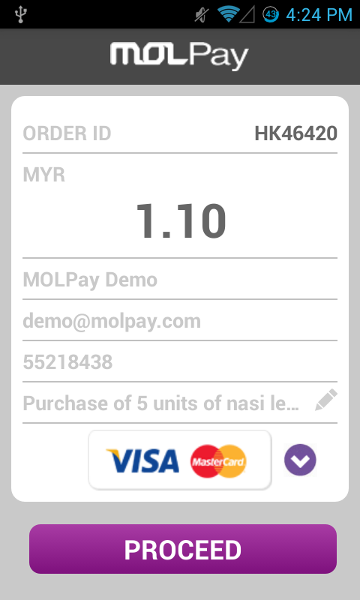

List of Channels

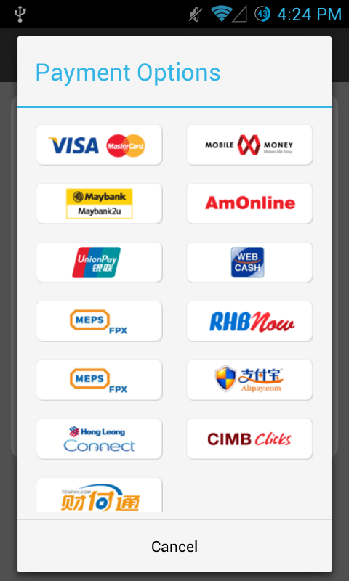

Credit / Debit Card

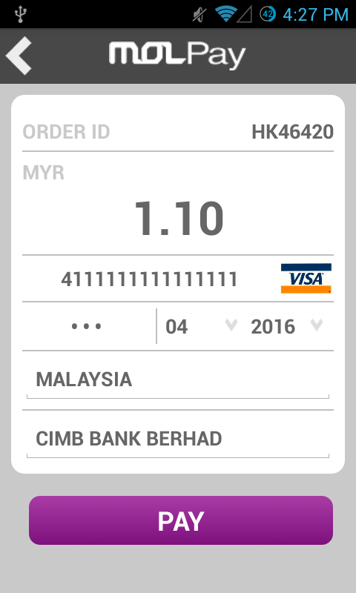

Payment Page

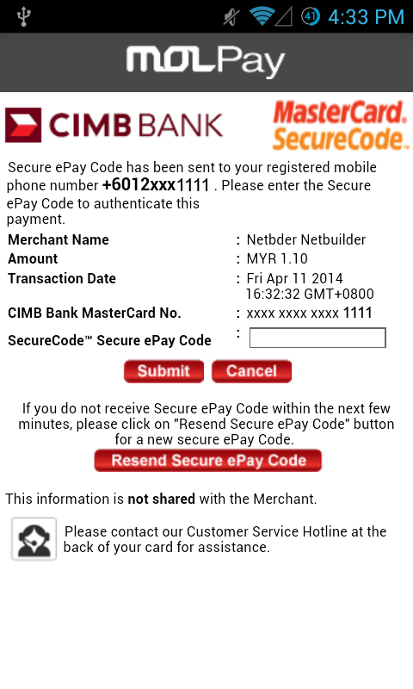

List of Channels Code
- MM-Weblink (mobilemoney)
- MB2u (Maybank)
- AMB-W2W (Ambank)
- PM-ASIA (UnionPay)
- WEBCASH (Webcash)
- RHB-ONL (RHB Bank)
- FPX (FPX)
- Alipay (Alipay)
- HLB-ONL (Hong Leong Bank)
- CIMB-Clicks (CIMB Bank)
- Tenpay (Tenpay)
- credit ( VISA / MasterCard – Credit or Debit)
- multi (List all channels)

