Exploratory Data Analysis (EDA) on HR Employee Dataset
What is EDA?
Exploratory Data Analysis (EDA) is the process of exploring and understanding a dataset before applying any machine learning model.

It helps us:

Understand the structure of data
Detect missing values or errors
Discover patterns and relationships
Generate insights and hypotheses
In this notebook, we will perform EDA on the Superstore dataset which allows us to explore and analyze the HR Employee dataset so we can understand the workforce better, detect issues, find patterns, and uncover the factors that contribute to employee attrition.

We will explore:

Data loading and overview
Data cleaning
Descriptive statistics
Data visualization
Insight extraction

Dataset Description
The Employee Attrition & HR Analytics Dataset contains detailed information about employees working in an organization. It is designed to help understand the factors that influence employee attrition (whether an employee stays or leaves).
The dataset includes 35 features, covering demographic details, job-related characteristics, work environment ratings, and historical employment information.

What the Dataset Contains
The dataset includes information across the following categories:
1. Personal & Demographic Information
- Age
- Gender
- Marital Status
- DistanceFromHome
2. Employment & Job Details
- Department
- JobRole
- BusinessTravel
- JobLevel
- JobSatisfaction
- WorkLifeBalance
- JobInvolvement
- YearsAtCompany
- YearsWithCurrManager
- YearsInCurrentRole
3. Performance & Productivity
- PerformanceRating
- TrainingTimesLastYear
- EnvironmentSatisfaction
- RelationshipSatisfaction
4. Compensation & Benefits
- MonthlyIncome
- HourlyRate
- DailyRate
- MonthlyRate
- StockOptionLevel
5. Experience & Career Growth
- TotalWorkingYears
- YearsSinceLastPromotion
6. Target Variable
- Attrition (Yes/No) → Indicates whether an employee left the company.

Problem Statement
Employees leaving a company can negatively impact business operations. The aim of this project is to analyze the HR dataset to identify why employees leave and what factors contribute most to attrition. This will help the organization create effective retention strategies and improve employee satisfaction.
Objectives of the Analysis
- To explore and understand the structure of the HR dataset, including employee demographics, job details, and satisfaction metrics.
- To identify key factors associated with employee attrition, such as income, job role, work-life balance, and experience.
- To analyze relationships between different variables using visualizations and statistical summaries.
- To compare characteristics of employees who stay vs. those who leave the organization.
- To generate meaningful insights that can help HR teams develop effective employee retention strategies.

Import Libraries:
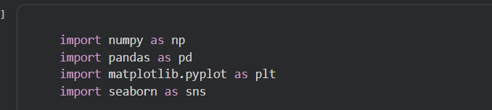
This code imports essential Python libraries for numerical computation, data analysis, and data visualization.
Uploading the HR Dataset:
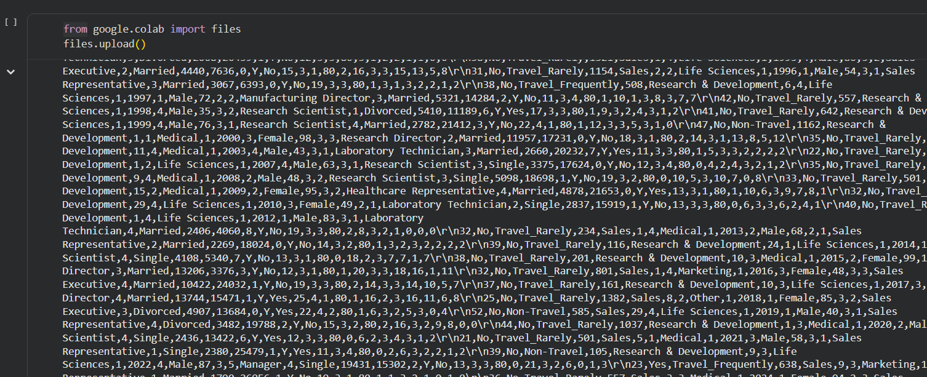
Loading the HR Dataset:
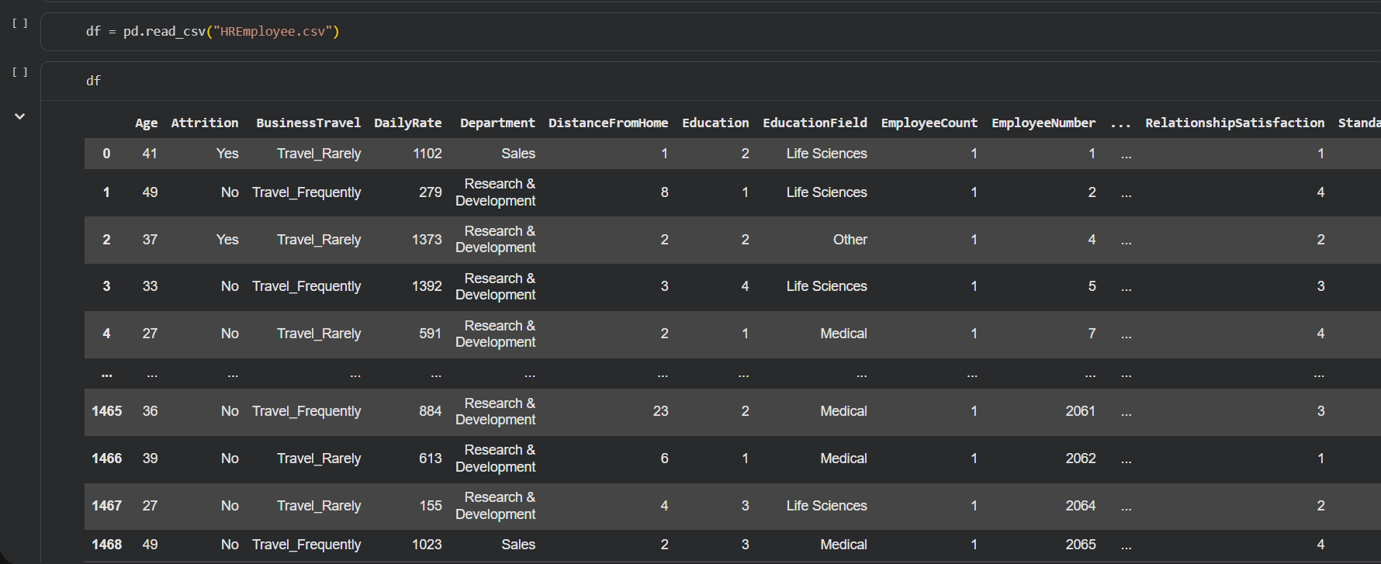
This code loads the HR Employee dataset from a CSV file into a pandas DataFrame for analysis.

head():
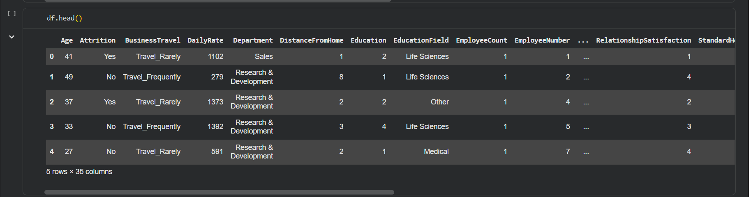
Displays the first five rows of the dataset for a quick preview of its structure and values.
Isnull().sum():
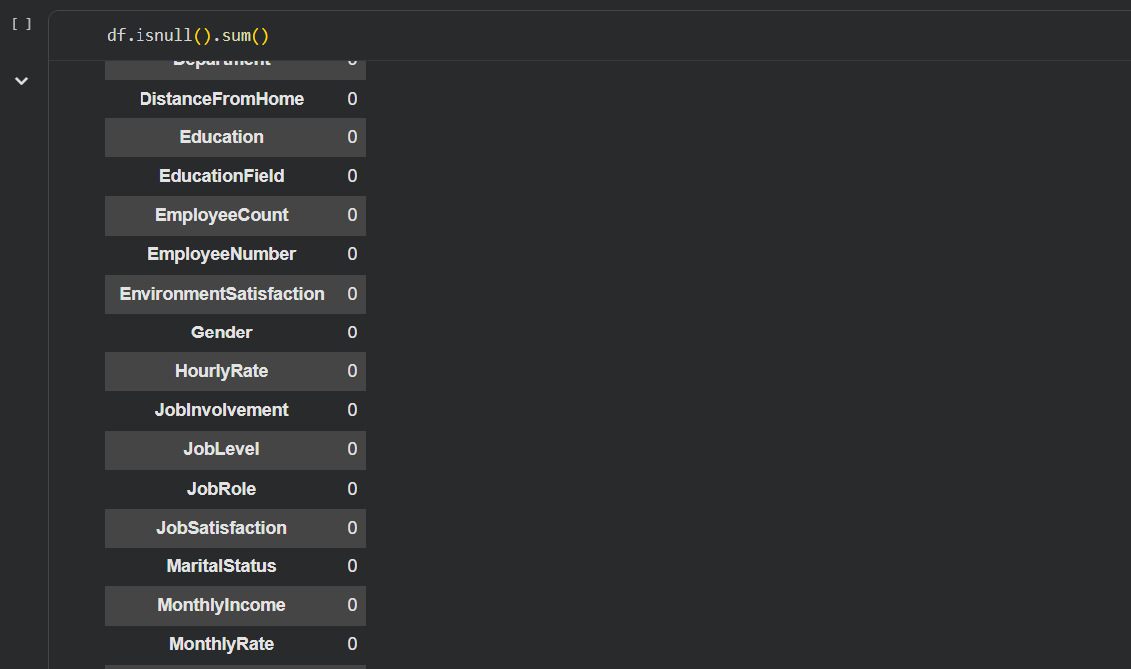
This code calculates and displays the total count of missing values (nulls) for each column in the pandas DataFrame.
tail():
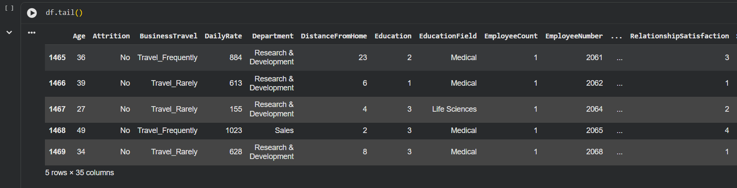
The first code snippet counts the number of missing values in each column of the DataFrame, while the second displays the last five rows of the DataFrame.
Info():
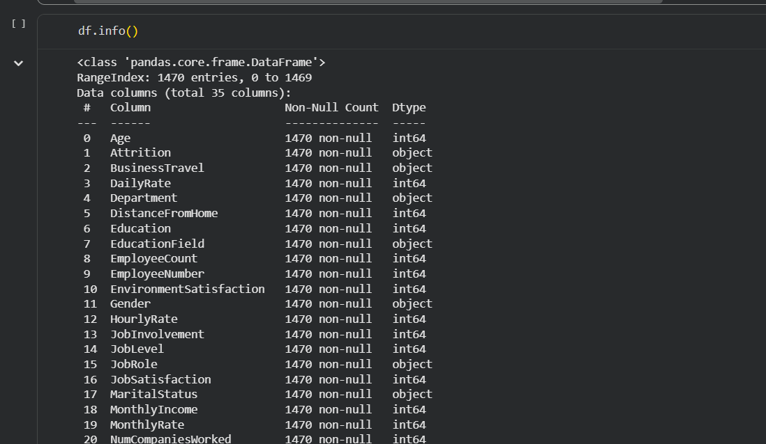
This code provides a concise summary of the DataFrame, including the number of entries, total columns, non-null counts per column, and the data type of each column.
describe():
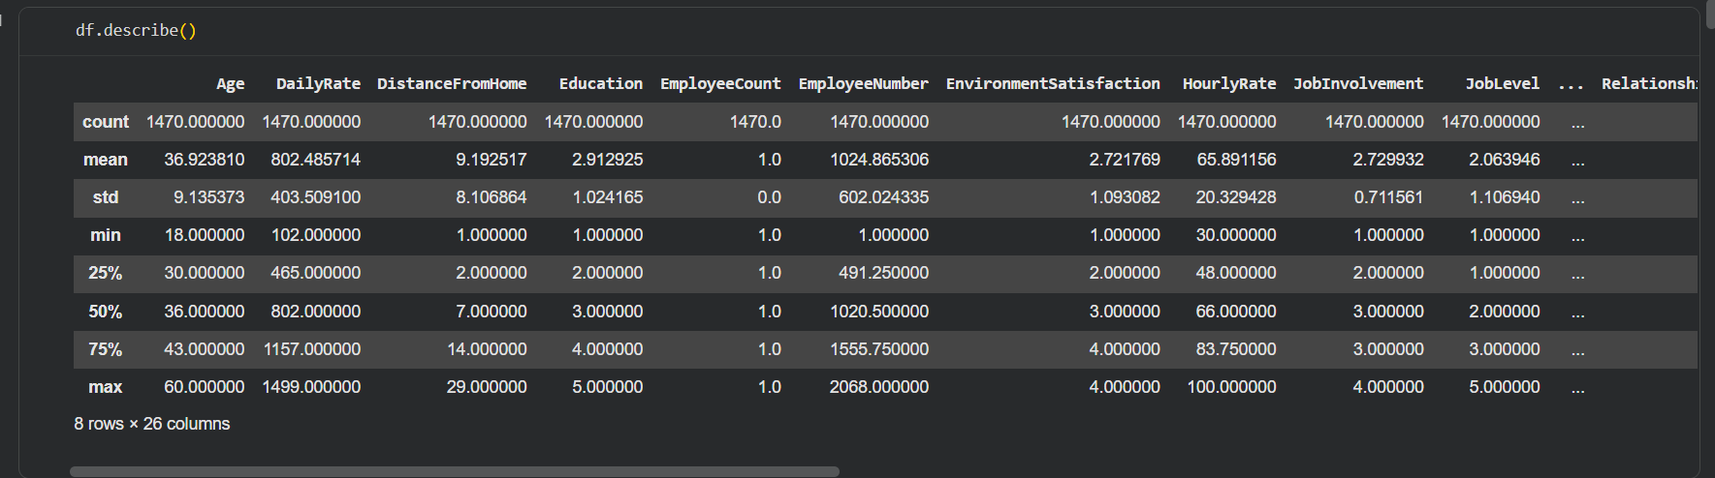
Generating descriptive statistics for the numerical columns of the DataFrame, including count, mean, standard deviation, minimum, maximum, and quartile values.

shape() and columns():
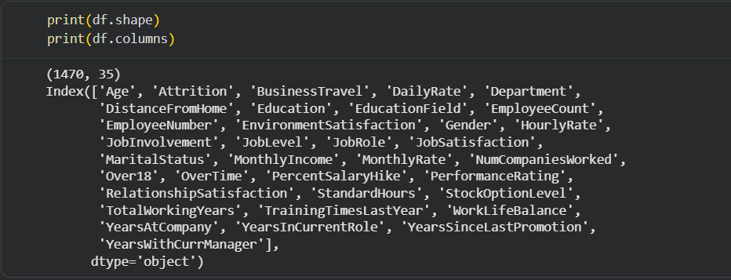
Printing the dimensions (rows, columns) of the DataFrame. I'm also listing all the column names present in the DataFrame.
duplicated().sum():

Printing the number of duplicate rows found in the DataFrame.
Average Age by Employee Attrition Status
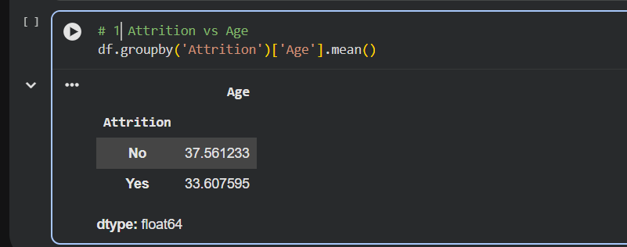
Employees who left the company were on average about 4 years younger than those who stayed.

Average Monthly Income by Employee Attrition Status
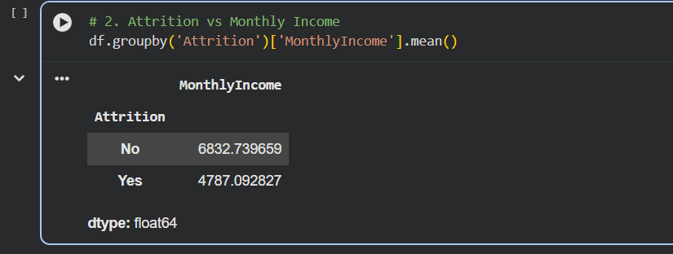
Employees who left the company earned significantly less on average than those who stayed.
Average Years at Company by Employee Attrition Status
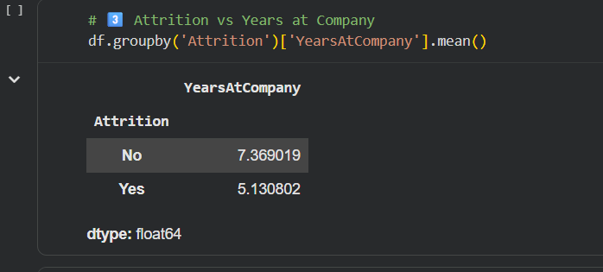
Employees who left the company had significantly fewer years of tenure compared to those who stayed.

Average Monthly Income by Department
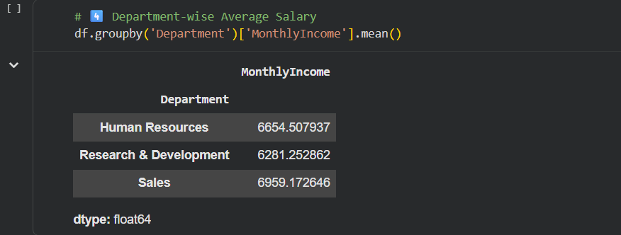
The Sales department has the highest average salary, followed by Human Resources and Research & Development.
Average Monthly Income by Job Role
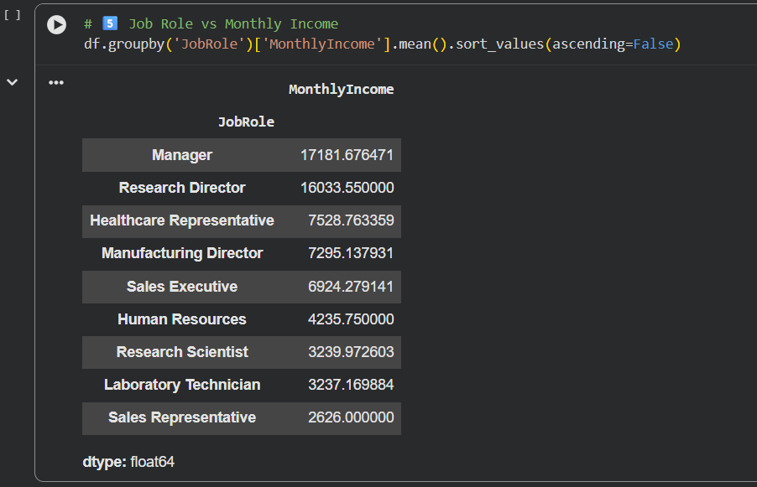
Managers and Research Directors earn significantly higher average salaries than other roles, while Sales Representatives have the lowest average income.

Average Job Satisfaction by Job Role
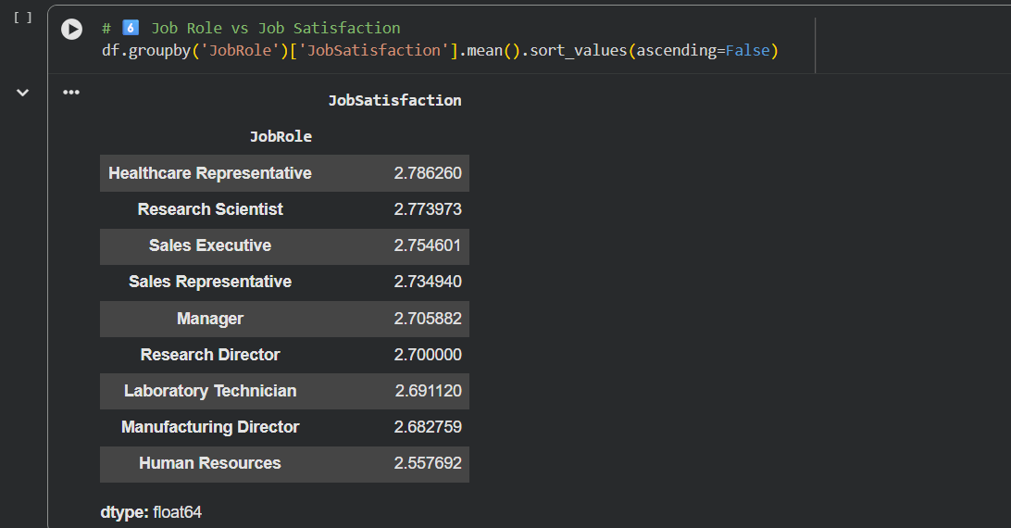
Healthcare Representatives report the highest job satisfaction, while Human Resources personnel report the lowest.
Average Work-Life Balance by Department
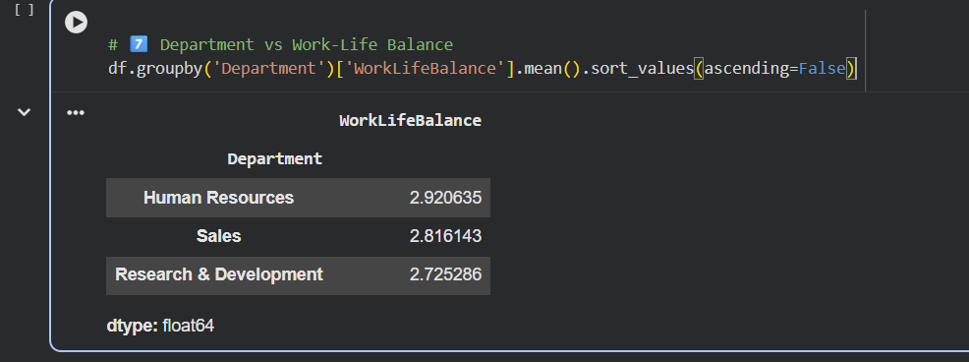
Human Resources department reports the highest work-life balance, while Research & Development reports the lowest.

Average Job Level by Education
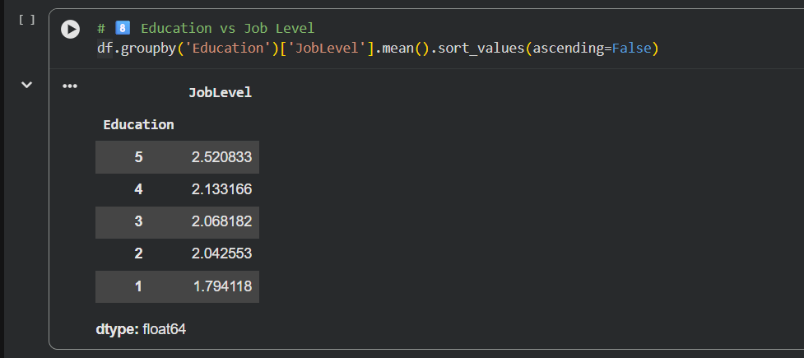
Higher education levels strongly correlate with higher job positions within the company.
Average Performance Rating by Environment Satisfaction Level
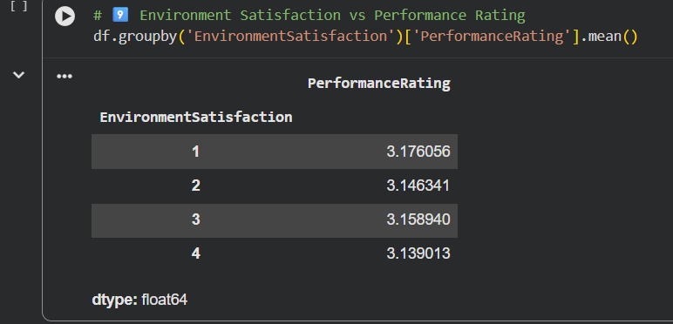
Environment satisfaction shows minimal correlation with performance ratings, with all satisfaction levels having similar average ratings.

Average Monthly Income by Gender
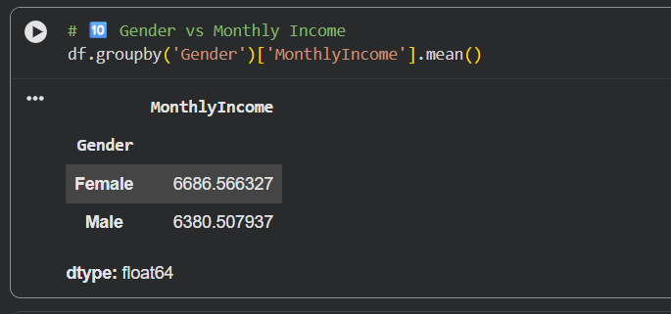
Female employees earn a slightly higher average monthly income than male employees in the company.
Marital Status vs Employee Attrition
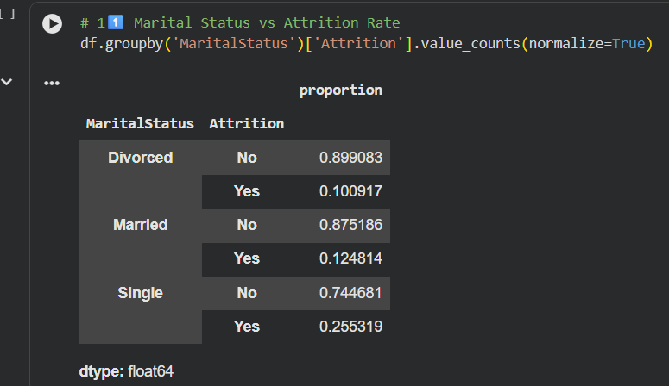
This code calculates the proportion of employees who stayed or left within each marital-status group using normalized value counts.

Years Since Last Promotion vs Job Satisfaction
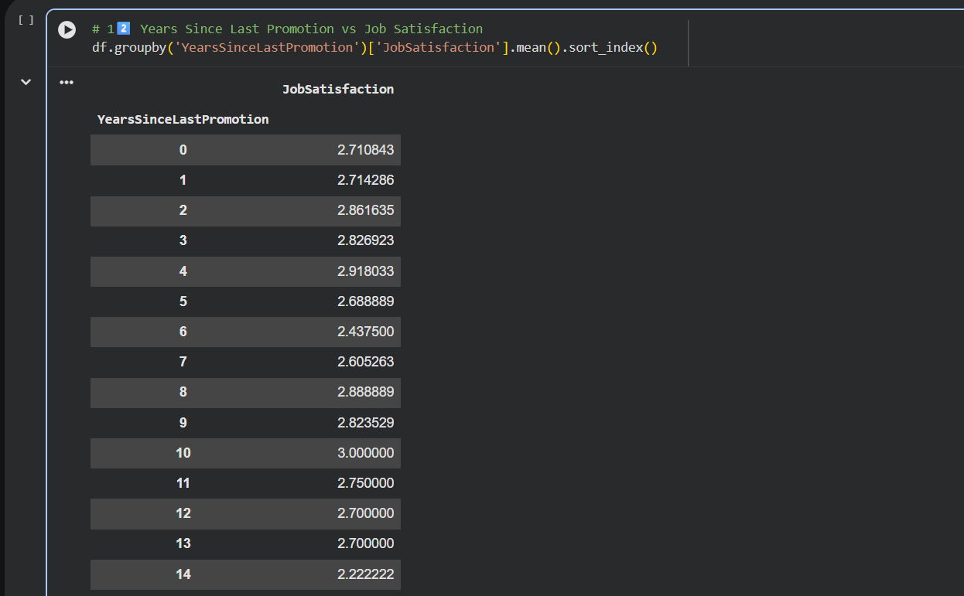
This code computes the average job satisfaction score for employees grouped by the number of years since their last promotion.

INSIGHTS
Line Plot of Employee Age Distribution Across Employee Numbers
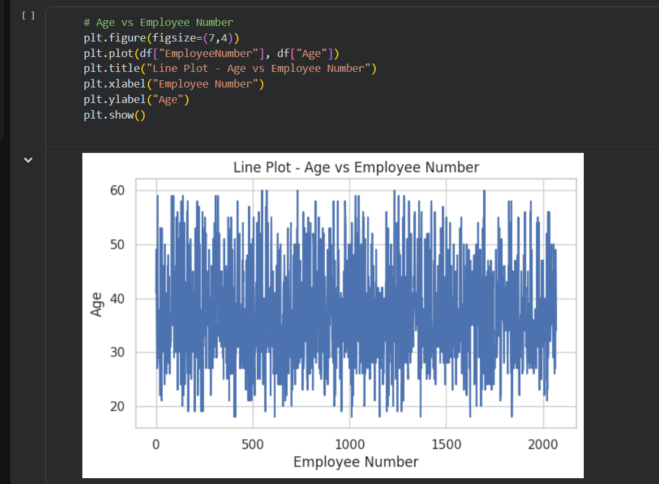
A line chart visualizing how employee ages vary across the sequence of employee numbers.

Scatter Plot of Monthly Income Across Different Age Groups
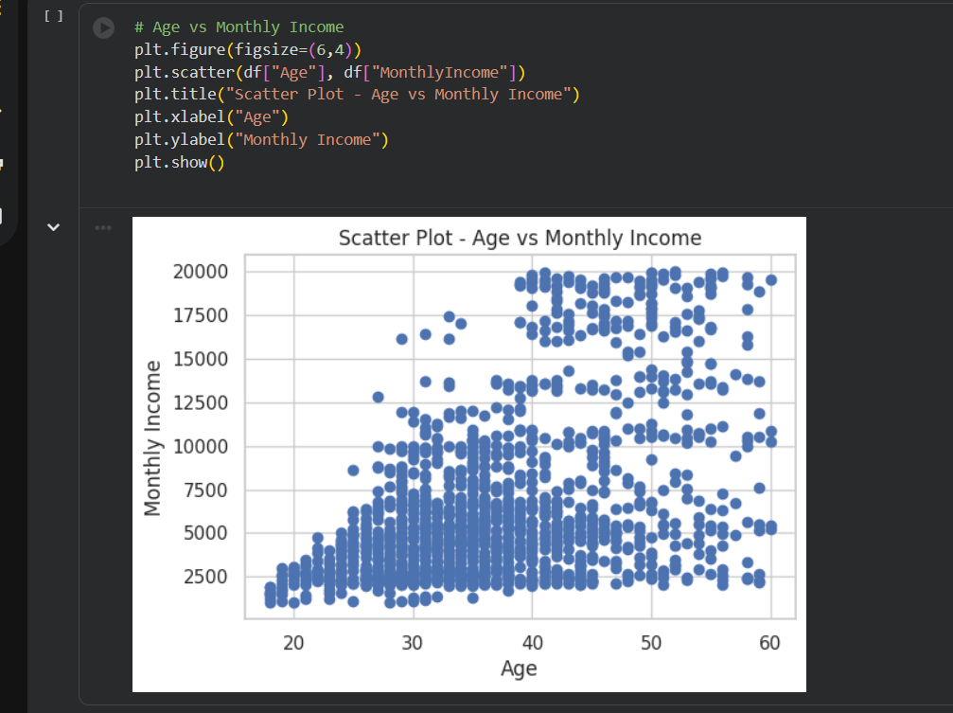
A scatter plot showing how employees’ monthly income varies across different ages.

Bar Chart Showing the Distribution of Employee Attrition
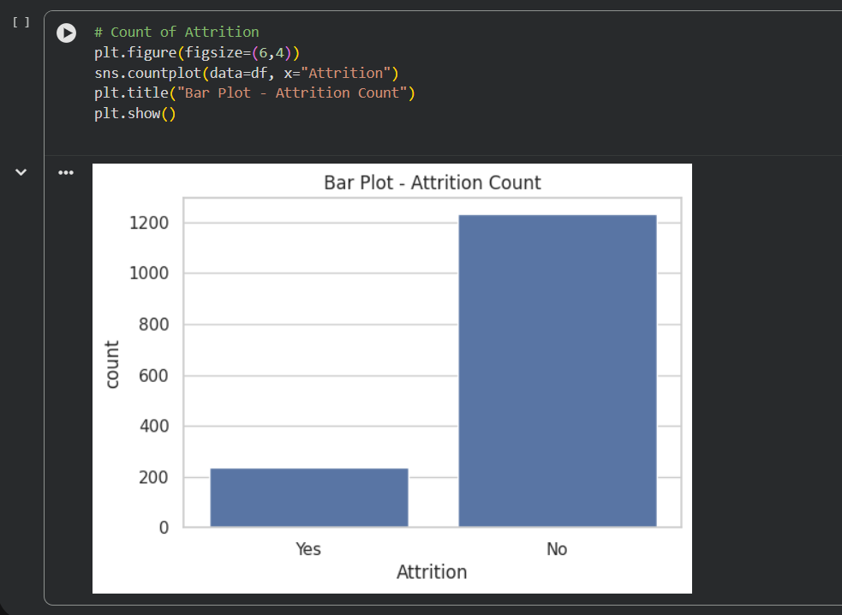
A bar plot illustrating how many employees have left the company versus those who stayed.

Average Monthly Income by Department – Horizontal Bar Chart
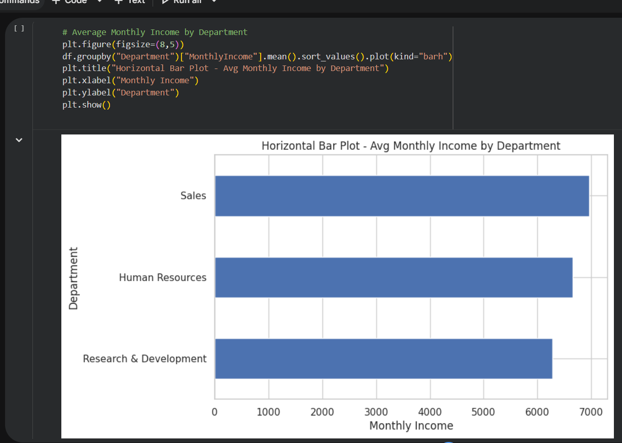
This code calculates the average monthly income for each department and visualizes it using a horizontal bar plot.

Histogram – Age Distribution
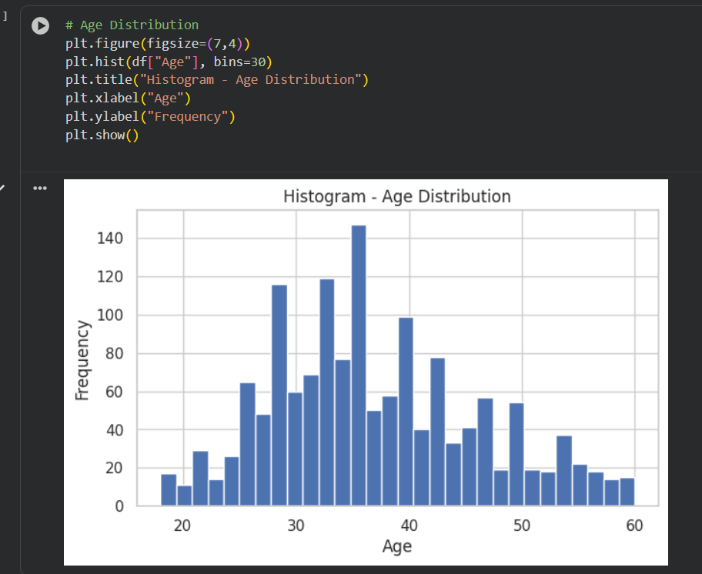
This code creates a histogram to visualize the distribution of employee ages in the dataset.
If you'd like, I can format similar headings/descriptions for all your plots.

Boxplot – Monthly Income by Attrition
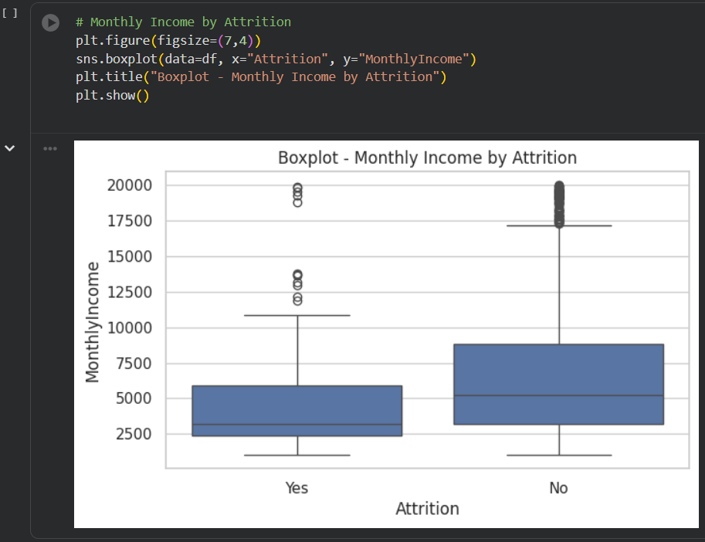
This code generates a boxplot to compare the distribution of monthly income between employees who left the company and those who stayed.

Pie Chart for Employee Attrition Distribution
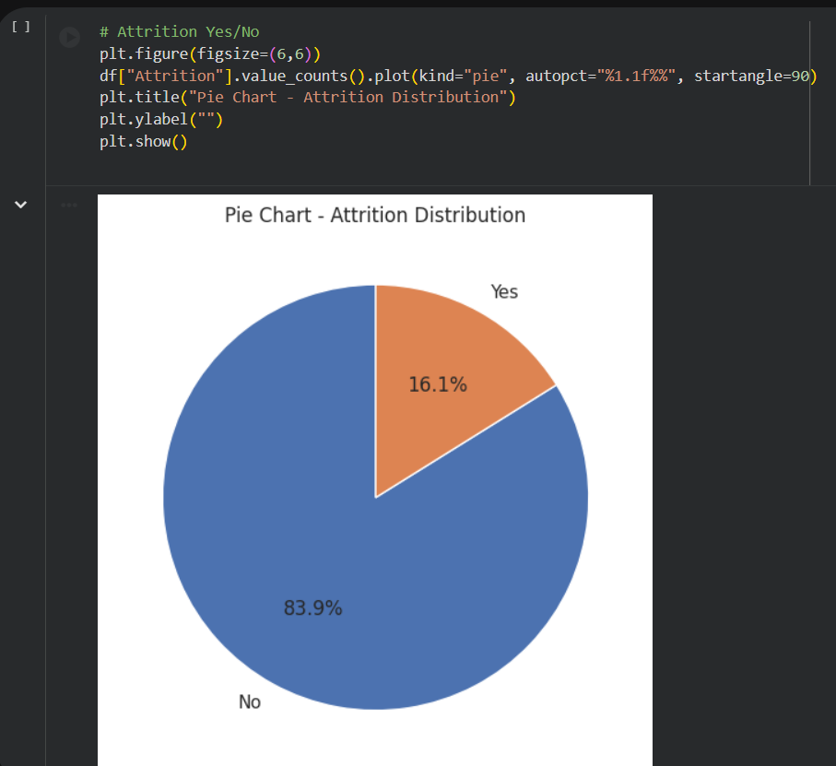
This code generates a pie chart showing the percentage distribution of employees who stayed versus those who left the organization.

Age Distribution Analysis Using Histogram and Boxplot

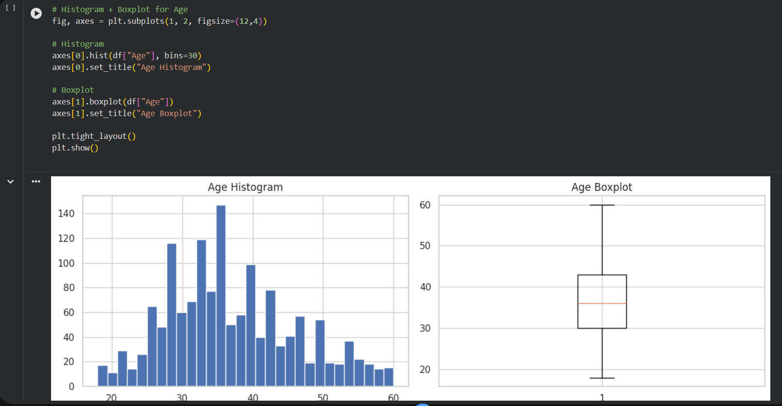
This code visualizes the age distribution by plotting both a histogram for frequency patterns and a boxplot for identifying spread and outliers.

Correlation Heatmap of Numerical Features
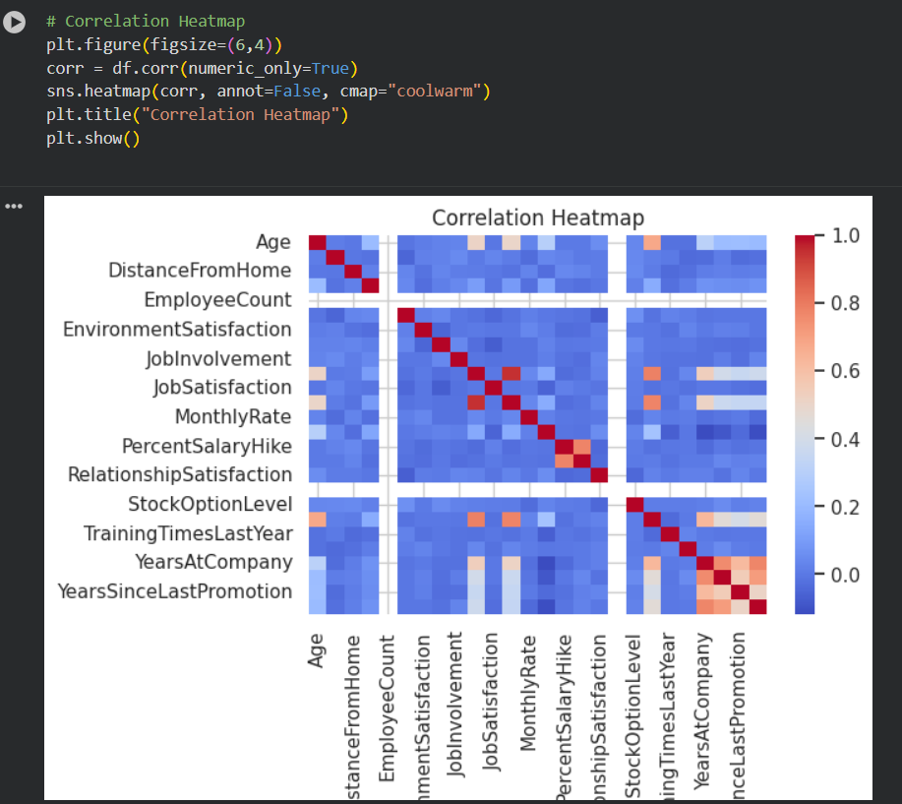
This code generates a heatmap to visualize the strength and direction of correlations among all numerical variables in the dataset.

Styled Line Chart: Age vs. Employee Number
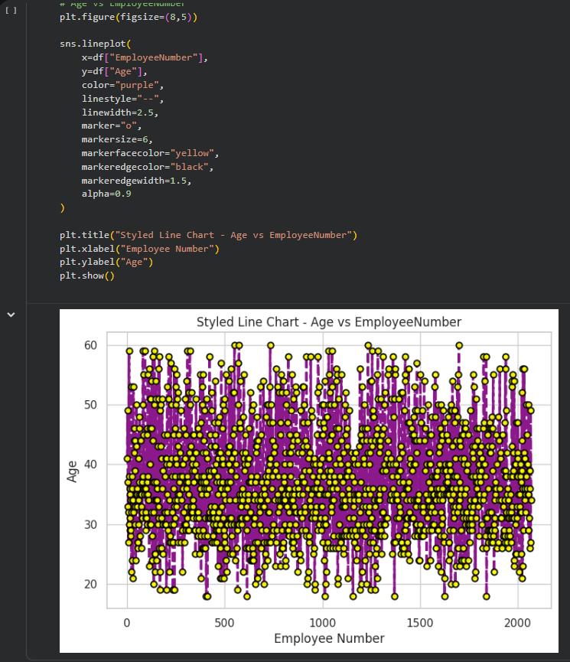
This code generates a customized Seaborn line plot to visualize how employee ages vary across employee numbers using enhanced styling and markers.

Scatter Plot: Age vs. Monthly Income with Attrition Highlight
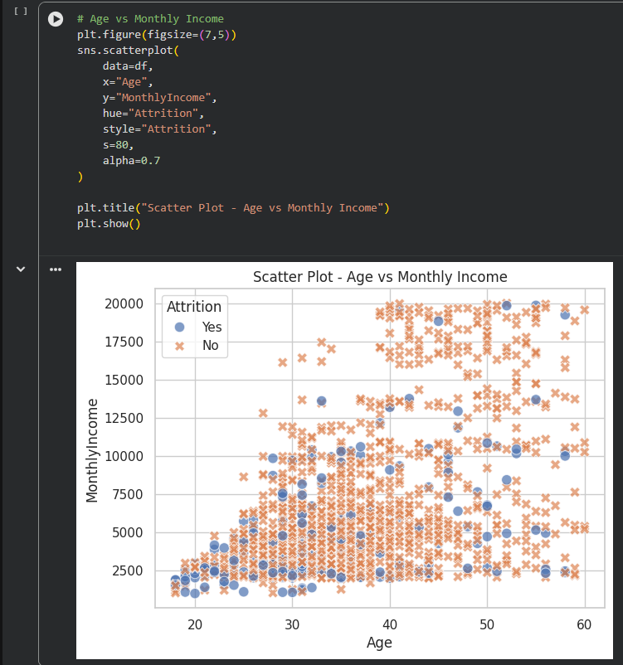
This code creates a Seaborn scatter plot to visualize the relationship between age and monthly income, with color and style differentiating employees based on attrition status.

Conclusion
The analysis provides meaningful insights into employee behavior, satisfaction, and attrition patterns to support data-driven HR decisions.
Key Insights
- Younger employees show a slightly higher chance of leaving the company.
- Frequent business travel may contribute to employee burnout.
- The Research & Development department has the largest workforce.
- Higher job levels strongly correlate with higher monthly income.
- Satisfaction scores vary across roles, indicating uneven work conditions.
- Employees living farther from the office may face more workplace stress.
- Monthly income, job level, and working years show strong positive correlations.

