Report On

VR Third Person Controller

Submitted in partial fulfillment of the requirements of the Course project in Semester VII of Final Year Artificial Intelligence and Data Science

by

Ronak Kela (Roll No. 08)

Naina Roy (Roll No. 24) Khushi Upadhyay (Roll No. 30)

Supervisor Prof. Sejal D’mello



## University of Mumbai Vidyavardhini's College of Engineering & Technology

**Department of Artificial Intelligence and Data Science**



**(2023-24)**

# Vidyavardhini's College of Engineering & Technology Department of Artificial Intelligence and Data Science

**CERTIFICATE**

This is to certify that the project entitled “VR Third Person Controller” is a bonafide work of "Ronak Kela (Roll No. 08), Naina Roy (Roll No. 24), Khushi Upadhyay (Roll No. 30)" submitted to the University of Mumbai in partial fulfillment of the requirement for the Course project in semester VII of Final Year Artificial Intelligence and Data Science Engineering.

**Supervisor**

Prof. Sejal D’mello

Dr. Tatwadarshi P. N. Head of Department

# Abstract

In the realm of virtual reality (VR), immersion is key to providing users with a captivating experience. A third-person controller developed in Unity has been designed to strike a balance between realism and comfort within VR environments. This controller includes dynamic camera control, ensuring users have an optimal view of their VR character and surroundings, which minimizes motion sickness and enhances the overall experience. It offers intuitive locomotion options, allowing users to move seamlessly through the virtual world, including walking, running, and strafing. The controller offers an intuitive and customizable movement system, combining immersion with comfortable navigation. Key features include dynamic camera control, character movement, user customization, interaction with objects, and realistic feedback. This controller bridges the gap between first-person and third-person perspectives, providing a unique and enjoyable VR experience for various applications.

# Table of Contents

|  |  |  |  |
| --- | --- | --- | --- |
| **Chapter No.** |  | **Title** | **Page**  **No.** |
| **1** |  | **Chapter # 1** | 5 |
|  | 1.1 | Problem Statement | 5 |
| **2** |  | **Chapter # 2** | 6 |
|  | 2.1 | Description and Working | 6 |
|  | 2.2 | Software & Hardware Used | 7 |
| **3** |  | **Chapter # 3** | 8 |
|  | 3.1 | Result | 8 |
|  | 3.2 | Conclusion and Future Work | 9 |
| **4** |  | **Chapter # 4** | 10 |
|  |  | **References** | 10 |

**Chapter # 1**

## 1.1 Problem Statement:

The challenge lies in providing a seamless and immersive virtual reality (VR) experience that balances user comfort with immersion. While Unity offers a robust platform for VR development, the absence of a well-integrated third-person controller often results in motion sickness and discomfort for users. Navigating VR environments in a first-person perspective can be disorienting, and traditional third-person controllers are not optimized for VR. Consequently, there is a pressing need to develop and implement an efficient third-person controller in Unity that addresses these challenges, offering an intuitive and customizable solution to enhance the user experience in VR applications across various domains.

# Chapter # 2

## Description and Working:

A third-person controller for virtual reality (VR) in Unity is a specialized system designed to improve user interaction within VR environments. It offers a more balanced approach between immersion and user comfort by providing a dynamic and user-customizable perspective that follows a virtual character from behind. This controller system addresses the challenge of VR discomfort and disorientation often experienced when using a traditional first-person perspective in VR.

1. **Dynamic Camera Control:** The core of the third-person controller is its dynamic camera control. It positions the virtual camera behind the user's VR character and adjusts its orientation in real-time based on the character's movement. This ensures the user always has an optimal view of their character and surroundings.
2. **User Input Integration:** The controller integrates user input, usually from handheld controllers or sensors, to control the character's movement within the VR environment. Users can navigate by walking, running, or strafing, depending on their physical movements.
3. **Customization Options:** To accommodate individual preferences and comfort levels, the third-person controller typically offers customization options. Users can adjust movement speed, camera distance, and other parameters, allowing for a personalized VR experience.
4. **Interaction with Objects:** Beyond movement, the controller often includes features for interacting with objects in the virtual environment. Users can pick up, manipulate, and interact with virtual objects, enhancing their sense of immersion.
5. **Realistic Feedback:** Haptic feedback and sound effects are integrated into the controller to provide users with a heightened sense of presence and engagement. These feedback mechanisms respond to in-game events or interactions with objects.
6. **Motion Sickness Mitigation:** By providing a stable and predictable perspective, the third-person controller helps mitigate motion sickness, a common issue in VR. Users are less likely to experience discomfort or disorientation compared to a first-person perspective.
7. **Unity Integration:** The entire system is built and integrated into Unity, a popular game engine for VR development. Unity's powerful capabilities for 3D rendering, physics simulation, and real-time rendering complement the third-person controller's functionality.

## Software & Hardware used:

Software:

* + - Windows 10 OS
    - Unity Hardware:
    - 64 bit Operating System
    - 6GB RAM
    - Intel i5 processor

# Chapter # 3

* 1. **Results:**

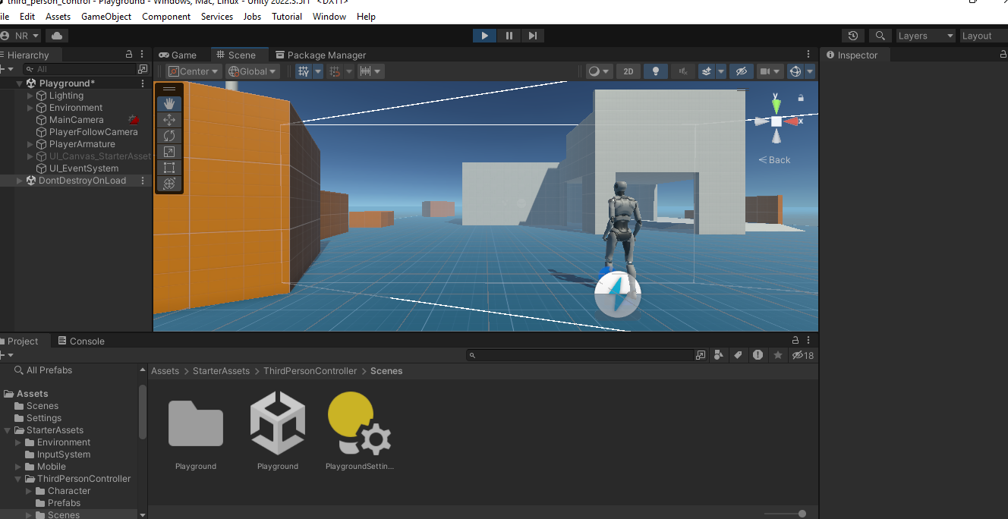

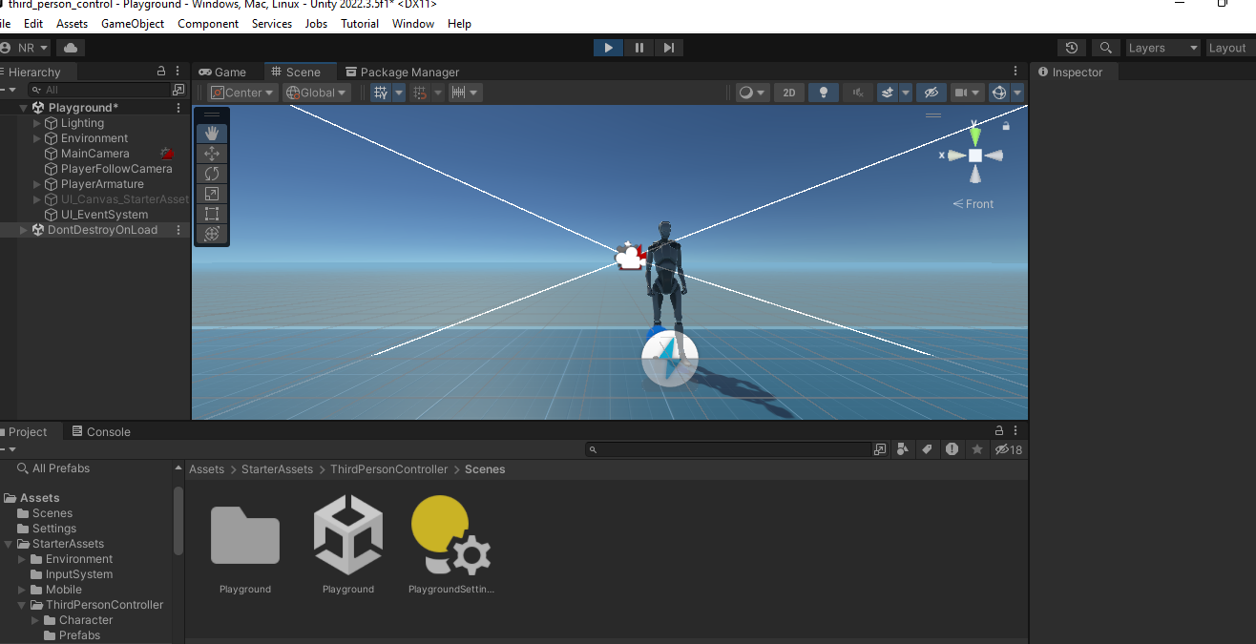

## CONCLUSION AND FUTURE SCOPE:

In conclusion, the development of a third-person controller for virtual reality (VR) projects in Unity is a significant step towards improving the VR user experience. By offering dynamic camera control, intuitive movement, customization options, and interaction features, this controller bridges the gap between the immersive qualities of VR and the comfort required for extended use. It mitigates motion sickness, providing a stable and comfortable VR experience.

The integration of haptic feedback and sound effects enhances the sense of presence and engagement, further immersing users in virtual environments. Unity's capabilities in 3D rendering, physics simulation, and real-time rendering make it a suitable platform for implementing this controller.

# Chapter # 4

**REFERENCES**

1. Wilburn, B., Joshi, N., Vaish, V., Talvala, E., Antunez, E., Barth, A., Adams, A., Horowitz, M., Levoy, M. (2005). High Performance Imaging Using Large Camera Arrays. ACM Transactions on Graphics. Vol. 24, No. 3. pp. 765-776Sze S M 1969 Physics of Semiconductor Devices (New York: Wiley–Interscience)
2. Thacker, C., McCreight, E., Lampson, B., Sproull, R. and Boggs, D. (1979). Alto: A personal computer. Computer Structures: Principles and Examples, second edition, pp.549-572.

[3] Stoakley, R., Conway, M., Pausch, R. (1995). Virtual Reality on a WIM: Interactive Worlds in Miniature. University of Virginia.

1. Shibata, T. (2002). Head Mounted Display. Displays. 23. pp. 57-64.
2. Seetzen, H., Heidrich, W., Stuerzlinger, W., Ward, G., Whitehead, L., Trentacoste, M., Ghosh, A. and Vorozcovs, A. (2004). High Dynamic Range Display Systems. TOG, 23(3), p.760.