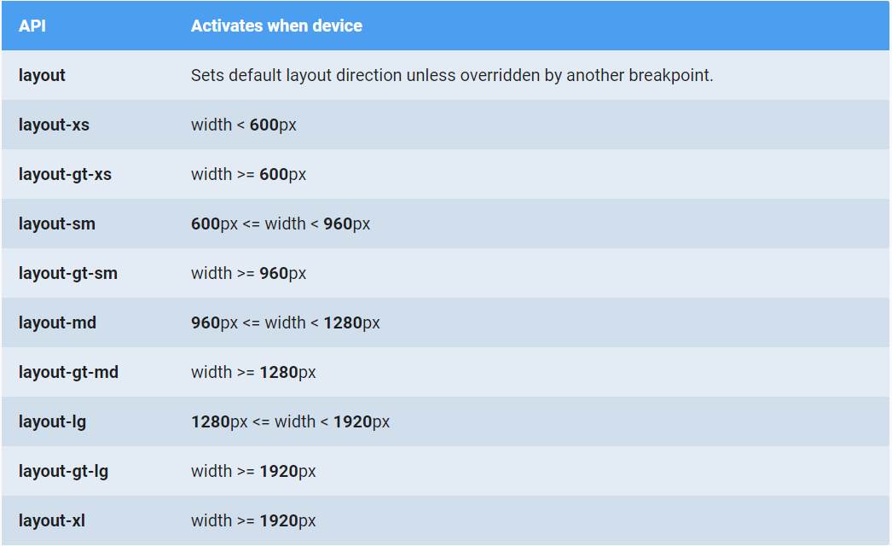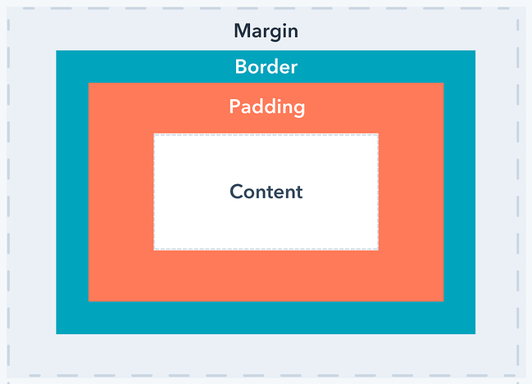<https://github.com/angular/flex-layout/wiki/fxShow-API>

<https://material.angularjs.org/latest/layout/options>

<https://www.digitalocean.com/community/tutorials/angular-flex-layout>

<https://www.excellarate.com/blogs/getting-started-with-angular-flex-layout/#:~:text=Angular%20Flex%2DLayout%20is%20a,for%20use%20in%20your%20templates>.

<https://tburleson-layouts-demos.firebaseapp.com/#/issues>

flex layout

column, elements are rows

row, elemnts are columns

<div fxFlex="<flex-grow> <flex-shrink> <flex-basic>"></div>

-flex grow specifies how much the flexbox item will grow relative to the rest of the flexbox items inside the same flex container, when there is enough space.

### -flex-shrink

flex shrink specifies how much the flexbox item should shrink relative to the rest of the flexbox items in the same flex container, when there isn’t enough space.

flex-basis

In CSS, the flex-basis property specifies the initial default size of the flex box item before it is changed by other flexbox properties like flex grow and shrink.

-you can use wrap so that the columns or rows continue to the other line

-fxLayoutGap

Space btw elements

-fxFlexOrder

Order elements(you can change the order by breakpoints)

Flexbox only works with 1 dimention while grid works with two dimentions

-I will not work with flexlayout

Gridlayout